Cash Account XML Statement
SK Format Specification
Version 3.0
Company | Name | Role
Slovak Banking Association Work Group
Table 1: Document Authors.

Revision History
Version | Date | Author | Description
2.3  Rev.1 | 9/27/2012 | Czech Banking Association | Final version of the czech standard, background document for the slovak standard.
2.3  Rev.2 | 5/13/2012 | Vršanský Ondrej | - In-depth review of the document, creation of the IssueLog.  - Inclusion of XML elements that weren’t covered by the original document.  - Enriched the information about individual elements with their exact interpretation within the SK standard (cardinality, type and content constraints)  - Concentration of the whole SK standard into one document.  - Replacement of the “sample” Excel with a sample XML.  - Enhanced the document design (header, footer, logo, …)
2.3  Rev. 3 | 6/6/2013 | Vršanský Ondrej | - Revision of the document according to the final SK standard..
2.3  Rev. 4 | 9/27/2014 | Vršanský Ondrej | - A complete redesign of the document.  - Translation of the document into english language.  - Reformulated the “character set” rule in chapter 1.2 (originally chapter 6, page 11).  - Removed the “XML header” sample (chapter 6, page 11); a complete XML sample in chapter 4.4 is provided instead.  - Included the Legend chapter 1.3 and Glossary chapter 1.4.  - Changed the rules for publishing a new version of the standard (chapter 1.5).  - Included a statement type clasifier into the <GrpHdr>/<MsgId> element.  - Reformulated the description of the <GrpHdr>/<AddtlInf> element and removed it from the sample file.  - Included a statement definition ID into the <Stmt>/<Id> element.  - Changed the <Stmt>/<FrToDt> element to mandatory.  - Removed the time portion of the <Stmt>/<FrToDt> subelements from the standard.  - Set the <Acct>/<IBAN> as mandatory (and thus prohibited the <Othr> branch).  - Introduced a set of standardized subject identifiers (chapter 4.3.1) to be used to identify the account owner (and, if necessary, any other party).  - Included the <SchmeNm> and <Issr> subelements of the account servicer and related agent’s <Othr> IDs into the standard.  - Included the <SchmeNm> and <Issr> subelements of an <Othr> identifier of <MsgRcpt>/<Id> and <Acct>/<Ownr>/<Id> into the standard.  - Included the “ITBD”, “OPBD” and “OPAV” balance types into the standard.  - Allowed the <DtTm> option of the <Ntry>/<BookDt> choice.  - Set the <Prtry> subelement of the <BkTxCd> element (both on the <Ntry> and <TxDtls> level and in the <RtrInf>) as mandatory. Its <Issr> subelement was also set as mandatory with a constant value.  - Removed the <Ntry>/<AmtDtls> branch from the standard.  - Reformulated the descriptions of the <MsgId> and <PmtInfId> subelements of the <Ntry>/<NtryDtls>[1]/<Btch> element.  - Constrained the cardinality of the <TxDtls> element.  - Reformulated the descriptions of the <MsgId>, <PmtInfId>, <InstrId>, <EndToEndId>, <TxId> and <ClrSysRef> subelements of the <TxDtls>/<Refs> element.  - Restored the cardinality of the <RltdPties>/<Prtry> element to [0..n].  - Constrained the cardinality of the number of <Othr> identifiers of any “related” party to 1.  - Allowed the <Prtry> option of the <SchmeNm> choice of an <Othr> identifier of a “related” party and included the <Issr> element into the standard.  - Reformulated the descriptions of the <Othr> identifiers of <CdtrAcct> and <DbtrAcct>.  - Corrected the description of the ultimate creditor <Othr> identifier.  - Removed the <RcvgAgt> from the standard. Instead, the <IntrmyAgt1> and <SttlmPlc> were included.  - Aligned the specification of structured remittance info with SEPA rules.  - Introduced the R-Message type into the <RtrInf>/<AddtlInf> element.  - Redefined the placement of card transaction details as follows:  - CardAssociation: RelatedParties / Proprietary [Tp = "CardAssociation"]  - Issuer RelatedAgents / Proprietary [Tp = "CardIssuer"]  - CardHolder RelatedParties / InitiatingParty  - Merchant RelatedParties / TradingParty  - PointOfTrade RelatedAgents / Proprietary [Tp = "CardAcquier"] / Branch  - Acquier RelatedAgents / Proprietary [Tp = "CardAcquier"]  - Unified the formatting of all Date and DateTime elements.  - Added the “Call Center” channel into the specification of the transaction codes.  - Introduced new transaction codes regarding interest and taxes.
2.3  Rev. 5 | 21.11.2014 | Vršanský Ondrej | - Corrected a few minor typo-errors and replaced the term “Current account” in the document title (and on a few other places in the document) with the term “Cash account”.
2.4  Rev. 1 | 20.1.2016 | Ľubomír Ďuran | - Fixed date in <MsgId> element in Sample files  - Added new optional element <TxDtls><RltdDts><TxDtTm>  - Fixed length for <Ustrd> element  - Changed the < AddtlInf> element to optional  - Fixed description of elements <PmtInfId> and <InstrId>  - Fixed description of <CdtDbtInd> under <Chrgs> elements  - Added version of the document  - Fixed date in <Stmt><Id> element  - Fixed length of <AdrLine> element  - Fixed cardinality of <AdrLine> element  - Fixed transaction codes for interests  - Fixed values in RelatedAgents / Proprietary to [TP=”CardIssuer”] and [TP=”CardAcquier”] for Card transaction  - Time zone is set as not covered by the standard  - For details see external file “Zmeny vo verzii 2.4”
2.5  Rev. 1 | 18.1.2018 | Ľubomír Ďuran | - Added elements Name and Identification of Payment initiation service providers.  - Added new optional element <SubTp><Cd>  - Added new sample of statement pagination  - For details see external file “Zmeny vo verzii 2.5”
2.6  Rev. 1 | 11.5.2021 | Ľubomír Ďuran | - Added new codes of Instant SEPA payments and fees in chapter 4.3.3  - Fixed missing code for Cash operation – Other 003 in chapter 4.3.3  - For details see external file “Zmeny vo verzii 2.6”
3.0  Rev. 1 | 2.2.2024 | Ľubomír Ďuran | - Update to camt.053.001.08 schema
Table 2: Revision History.

Contents
1. Introduction 7
1.1. Document Structure 7
1.2. Character set 8
1.3. Legend 8
1.4. Glossary 8
1.5. Further maintenance of the standard 9
2. Statement attributes description 10
2.1. Mapping of the attributes into XML 10
3. Statement XML structure 19
3.1. Root element 19
3.2. GroupHeader 20
3.2.1. MessageRecipient 22
3.2.1.1. PostalAddress 23
3.2.1.2. Identification 25
3.2.1.2.1. OrganisationIdentification 26
3.2.1.2.2. PrivateIdentification 27
3.3. Statement 28
3.3.1. Account 31
3.3.1.1. Owner 33
3.3.1.1.1. PostalAddress 34
3.3.1.1.2. Identification 36
3.3.1.1.2.1. OrganisationIdentification 37
3.3.1.1.2.2. PrivateIdentification 38
3.3.1.2. Servicer 39
3.3.1.2.1. PostalAddress 41
3.3.2. Interest 43
3.3.3. Balance 45
3.3.4. TransactionsSummary 48
3.3.5. Entry 50
3.3.5.1. BankTransactionCode 53
3.3.5.2. Charges 54
3.3.5.3. EntryDetails – Instance 1 56
3.3.5.3.1. TransactionDetails 57
3.3.5.3.1.1. References 60
3.3.5.3.1.2. AmountDetails 64
3.3.5.3.1.3. BankTransactionCode 67
3.3.5.3.1.4. Charges 68
3.3.5.3.1.5. RelatedParties 70
3.3.5.3.1.5.1. InitiatingParty 72
3.3.5.3.1.5.2. Debtor 73
3.3.5.3.1.5.2.1. PostalAddress 74
3.3.5.3.1.5.2.2. Identification 76
3.3.5.3.1.5.2.2.1. OrganisationIdentification 77
3.3.5.3.1.5.2.2.2. PrivateIdentification 78
3.3.5.3.1.5.3. DebtorAccount 79
3.3.5.3.1.5.4. UltimateDebtor 80
3.3.5.3.1.5.4.1. PostalAddress 81
3.3.5.3.1.5.4.2. Identification 83
3.3.5.3.1.5.4.2.1. OrganisationIdentification 84
3.3.5.3.1.5.4.2.2. PrivateIdentification 85
3.3.5.3.1.5.5. Creditor 86
3.3.5.3.1.5.5.1. PostalAddress 87
3.3.5.3.1.5.5.2. Identification 89
3.3.5.3.1.5.5.2.1. OrganisationIdentification 90
3.3.5.3.1.5.5.2.2. PrivateIdentification 91
3.3.5.3.1.5.6. CreditorAccount 92
3.3.5.3.1.5.7. UltimateCreditor 94
3.3.5.3.1.5.7.1. PostalAddress 95
3.3.5.3.1.5.7.2. Identification 97
3.3.5.3.1.5.7.2.1. OrganisationIdentification 98
3.3.5.3.1.5.7.2.2. PrivateIdentification 99
3.3.5.3.1.5.8. TradingParty 100
3.3.5.3.1.5.8.1. Identification 101
3.3.5.3.1.5.8.1.1. OrganisationIdentification 101
3.3.5.3.1.5.8.1.2. PrivateIdentification 102
3.3.5.3.1.6. RelatedAgents 104
3.3.5.3.1.6.1. DebtorAgent 105
3.3.5.3.1.6.1.1. PostalAddress 107
3.3.5.3.1.6.2. CreditorAgent 109
3.3.5.3.1.6.2.1. PostalAddress 111
3.3.5.3.1.6.3. IntermediaryAgent1 113
3.3.5.3.1.6.3.1. PostalAddress 115
3.3.5.3.1.6.4. SettlementPlace 117
3.3.5.3.1.6.4.1. PostalAddress 119
3.3.5.3.1.6.5. Proprietary 122
3.3.5.3.1.7. Purpose 123
3.3.5.3.1.8. RemittanceInfo 124
3.3.5.3.1.8.1. Structured 125
3.3.5.3.1.9. RelatedDates 127
3.3.5.3.1.10. ReturnInformation 128
3.3.5.3.1.10.1. OriginalBankTransactionCode 129
3.3.5.3.1.10.2. Originator 130
3.3.5.3.1.10.2.1. PostalAddress 131
3.3.5.3.1.11. CardTransaction 133
3.3.5.3.1.11.1. Card 133
3.3.5.3.1.11.2. POI 136
3.3.5.3.1.11.3. Transaction 138
4. External sources and appendices 140
4.1. ISO 20022 140
4.1.1. camt.053 140
4.1.2. Code lists 140
4.2. SEPA 140
4.2.1. SCT 140
4.2.2. SDD 140
4.3. SK code-books 140
4.3.1. Regulated subject identifiers 140
4.3.2. Balance types 141
4.3.3. Transaction codes 141
4.4. Sample statements 142
4.4.1. A statement without pagination 142
4.4.2. A statement divided into three parts using pagination 142

Introduction
The Slovak Payments legislation obliges the payment service providers to notify their payment services consumers about transactions realised on their accounts and defines the minimal mandatory set of attributes to be included in these notifications. The most typical way to comply with this legislation is to provide the client with a transaction statement that covers all required information for a given time period. These statements are being generated either periodically (forming a continuous sequence) or ad-hoc on a customer’s request.
While the legislation defines the “minimal information content” of a statement, it lacks any further instructions regarding internal statements structure and/or format. As a result, a wide range of proprietary implementations emerged on the market, varying both in the internal content and format and in the delivery logistics. While this variety poses no problems for a retail customer, it complicates the statements processing and reconciliation within corporations that typically have to deal with statements from a multitude of accounts in different banks.
On a global scale, the need for standardization of bank statements increased with the growing use of electronic statements and the related prospect of their automated processing. Since 2004, the ISO 20022 standard – in particular the camt.053 schema – defines an international standard for cash account statements structure. All information relevant can be found at www.iso20022.org.
Since 2002, the European Payments Council (further referred as “EPC”) defines rulebooks and standards that constitute the Single European Payment Area (further referred as “SEPA”). All SEPA interbank and bank-to-customer messages were based on the ISO 20022 standard. In October 2009, SEPA issued a “recommendation” to use the camt.053 schema for bank-to-customer currenct account transaction statements. All information regarding EPC and SEPA can be found at http://www.europeanpaymentscouncil.eu/index.cfm.
As in many other countries, the final specification of the national standard for cash account electronic statements was developed under the supervision of the Slovak Banking Association. A close cooperation with the Czech Banking Association in specifying the czech national standard, on which the slovak standard is based, ensured further harmonization of both standards to the benefit of all legal or corporate entities with organisational units in both countries. On top of that, the specification was repeatedly being consulted with experts that were participating on equivatent projects in other countries. This document is the result of this process.
The use of this standard is not obligatory by any part of the Slovak legislation; however, it is highly recommended due to its cost-reduction effects for all parties involved.

Document Structure
The document is divided into three sections:
- Structure of the XML file (Chapter 2.1). The structure of this chapter reflects the structure of the camt.053 schema; on each level, following information is provided:
- an XPath to the described node
- a picture of the node structure
- a table with information about the node attributes and sub-elements with following columns:
- MDR Page: the page of the node according to the ISO 20022 camt.053 MDR (see chapter 4.1.1).
- ISO name: the ISO name of the node according to the ISO 20022 camt.053 MDR (see chapter 4.1.1).
  - one or more “+” signs before the node name signalize that the node is a sub-node of the first preceding node with one-less “+” signs”. The number of „+“ signs denotes the level of node „indentation“ compared to the node decribed by the particular chapter.
- XML Tag : the name of the XML tag according to the ISO 20022 camt.053 MDR (see chapter 4.1.1).
  - the XML tag name is stated withouth the „<“ and „>“ characters.
- Cardinality describes the allowed node cardinality:
  - [x..y] states that the node is present a minimum of x and a maximum of y times, e.g.:
    - [0..0] means that the node is forbidden
    - [0..1] means that the node is optional
    - [0..n] means that the node can be present any number of times
    - [1..1] means that the node is mandatory
    - [1..n] means that the node is mandatory but can be repeated any number of times
    - [3..3] means that the node is present exactly three times
- Data type describes the node data type
  - If the data type field is striked-through with two diagonal lines, the node data type is complex and its individual parts are further described either on the next table rows (in which case they are indented by an additional „+“ sign) or in a separate chapter (referenced in the last table column).
- Rules Lists rules and constraints on top of the ISO 20022 camt.053 MDR. The rules can constrain:
  - cardinality (e.g. [0..n] -> [0..1])
  - data type (e.g. String [35] -> String [5])
  - value (e.g. „only „Yes“ a „No“ values allowed“)
  - semantics (e.g. „for card transactions, this is the card number“)
- External Sources and Appendices (Chapter 4).

Character set
Following characters are ensured to be correctly recognised and passed on, unchanged, throughout the entire end-to-end chain:
a b c d e f g h i j k l m n o p q r s t u v w x y z
A B C D E F G H I J K L M N O P Q R S T U V W X Y Z
0 1 2 3 4 5 6 7 8 9
/ - ? : ( ) . , ' +
Space
Other characters might be removed or replaced if not recognised by the system.

Legend
The national standard regulates only a subset of the elements available within the ISO schema. To clearly distinguish the elements that the standard defines as mandatry from the optional (but still regulated) ones and finally from those it prohibits, following colors are used for the apropriate document sections:
- elements prohibited by the national standard
- elements that the standard allows but somehow regulates
- elements that the standard doesn’t regulate

Glossary
Term | Description
ISO | International Organisation for Standardisation or one of its products. In the context of this document, this refers to the ISO 20022 standard.
camt.053 | An ISO 20022 standard for bank-to-customer cash account statements.
MDR | „Message Definition Report“ – an ISO document containing the interpretation rules of an ISO standard (such as the camt.053 XSD schema).
EU | European Union
EPC | „European Payments Council“ – an EU body that defines SEPA rulebooks and standards.
SEPA | „Single Euro Payment Area“.
SCT | SEPA Credit Transfer. SEPA standard for payments initiated by the debtor.
SDD | SEPA Direct Debit. SEPA standard for payments initiated by the creditor.
SDD Core | SEPA scheme for debiting retail customers.
SDD B2B | SEPA scheme for debiting corporate customers.
CID | SDD Creditor ID.
SBA | Slovak Banking Association.
XML | „Extensible markup Language“ – a wide-spread standard for structured data transfer.
XSD | XML Schema Definition – an XML standard for XML structure specification.
XPath | Standard language used to reference information stored in an XML structure.
Bulk payment | A group of payments that are booked on the debtor account as a single debit.
Indirect debit | Pre-SEPA national standard for payments initiated by the creditor.
SIPO | „Sústredené inkaso platieb obyvateľstva“ - a special type of indirect debit commonly used in CZ and SK.
TPS, SIPS, EuroSIPS | Pre-SEPA Domestic Payments.
ZPS | Foreign Payments
Card Association | The card „trademark holder“ (VISA, MasterCard, ...).
Card Issuer | The bank that issued the card to a customer
Card Holder | The customer to which the card was „issued“
Card Merchant | The company that accepts card transactions as payments for its services.
Card Acquier | The bank that provides the merchant with the POS machines.
ATM | Automatic Teller Machine. A standalone machine belonging to the card issuer that provides cash withdrawals and other card services.
POS | Point-of-Sale. A machine belonging to the card acquier and installed by the merchant that provides carrd payments, cashbacks and other card services.
Cash Advance | A cash withdrawal service with a payment card as the authentification tool provided by the card issuer.
Cashback | A cash withdrawal service with a payment card as the authentification tool provided by the card acquier.
PISP | Payment initiation service provider. Third party which allows users to initiate payments via its own system.
Table 3: Glossary.

Further maintenance of the standard
The national standard for cash account electronic statements was developed and will be further maintained under the auspices of the Slovak Banking Association and its specification will be published on its website (www.sbaonline.sk). The standard will be reviewed once in a year; all necessary changes will become valid 8 months after their publication.

Statement attributes description

Mapping of the attributes into XML
Class | Attribute |  |  | XPath
Message | ID |  |  | / Document / BkToCstmrStmt / GrpHdr / MsgId
 | CreationDateTime |  |  | / Document / BkToCstmrStmt / GrpHdr / CreDtTm
 | PageNo |  |  | / Document / BkToCstmrStmt / GrpHdr / MsgPgntn / PgNb
 | IsLastPage |  |  | / Document / BkToCstmrStmt / GrpHdr / MsgPgntn / LastPgInd
 | AdditionalInfo |  |  | / Document / BkToCstmrStmt / GrpHdr / AddtlInf
Reci-pient | Name |  |  | / Document / BkToCstmrStmt / GrpHdr / MsgRcpt / Nm
 | BIC |  |  | / Document / BkToCstmrStmt / GrpHdr / MsgRcpt / Id / OrgId / AnyBIC
 | LEI |  |  | / Document / BkToCstmrStmt / GrpHdr / MsgRcpt / Id / OrgId / LEI
 | UnstructuredAddress |  |  | / Document / BkToCstmrStmt / GrpHdr / MsgRcpt / PstlAdr / AdrLine
Recipient Structured Address | StreetName |  |  | / Document / BkToCstmrStmt / GrpHdr / MsgRcpt / PstlAdr / StrtNm
 | BuildingNo |  |  | / Document / BkToCstmrStmt / GrpHdr / MsgRcpt / PstlAdr / BldgNb
 | PostCode |  |  | / Document / BkToCstmrStmt / GrpHdr / MsgRcpt / PstlAdr / PstCd
 | TownName |  |  | / Document / BkToCstmrStmt / GrpHdr / MsgRcpt / PstlAdr / TwnNm
 | Country |  |  | / Document / BkToCstmrStmt / GrpHdr / MsgRcpt / PstlAdr / Ctry
RecipientOtherID | ID | Corporate subjects |  | / Document / BkToCstmrStmt / GrpHdr / MsgRcpt / Id / OrgId / Othr / Id
 |  | Persona |  | / Document / BkToCstmrStmt / GrpHdr / MsgRcpt / Id / PrvtId / Othr / Id
 | SchemeType |  |  | Represents the choice between the <Cd> and <Prtry> elements
 | Scheme Name | Corporate subjects | Cd | / Document / BkToCstmrStmt / GrpHdr / MsgRcpt / Id / OrgId / Othr / SchmeNm / Cd
 |  |  | Prtry | / Document / BkToCstmrStmt / GrpHdr / MsgRcpt / Id / OrgId / Othr / SchmeNm / Prtry
 |  | Persona | Cd | / Document / BkToCstmrStmt / GrpHdr / MsgRcpt / Id / PrvtId / Othr / SchmeNm / Cd
 |  |  | Prtry | / Document / BkToCstmrStmt / GrpHdr / MsgRcpt / Id / PrvtId / Othr / SchmeNm / Prtry
 | Issuer | Corporate subjects |  | / Document / BkToCstmrStmt / GrpHdr / MsgRcpt / Id / OrgId / Othr / Issr
 |  | Persona |  | / Document / BkToCstmrStmt / GrpHdr / MsgRcpt / Id / PrvtId / Othr / Issr
Statement | ID |  |  | / Document / BkToCstmrStmt / Stmt / Id
 | PageNumber |  |  | / Document / BkToCstmrStmt / Stmt / StmtPgntn / PgNb
 | LastPageIndicator |  |  | / Document / BkToCstmrStmt / Stmt / StmtPgntn / LastPgInd
 | ElectronicSeqNo |  |  | / Document / BkToCstmrStmt / Stmt / ElectrncSeqNb
 | LegalSeqNo |  |  | / Document / BkToCstmrStmt / Stmt / LglSeqNb
 | CreationDateTime |  |  | / Document / BkToCstmrStmt / Stmt / CreDtTm
 | FromDate |  |  | / Document / BkToCstmrStmt / Stmt / FrToDt / FrDtTm
 | ToDate |  |  | / Document / BkToCstmrStmt / Stmt / FrToDt / ToDtTm
 | EntriesCount |  |  | / Document / BkToCstmrStmt / Stmt / TxsSummry / TtlNtries / NbOfNtries
 | EntriesSum |  |  | / Document / BkToCstmrStmt / Stmt / TxsSummry / TtlNtries / TtlNetNtry / Amt
 | EntriesSumCRDBIndicator |  |  | / Document / BkToCstmrStmt / Stmt / TxsSummry / TtlNtries / TtlNetNtry / CdtDbtInd
 | EntriesAbsoluteSum |  |  | / Document / BkToCstmrStmt / Stmt / TxsSummry / TtlNtries / Sum
 | CreditsCount |  |  | / Document / BkToCstmrStmt / Stmt / TxsSummry / TtlCdtNtries / NbOfNtries
 | CreditsSum |  |  | / Document / BkToCstmrStmt / Stmt / TxsSummry / TtlCdtNtries / Sum
 | DebitsCount |  |  | / Document / BkToCstmrStmt / Stmt / TxsSummry / TtlDbtNtries / NbOfNtries
 | DebitsSum |  |  | / Document / BkToCstmrStmt / Stmt / TxsSummry / TtlDbtNtries / Sum
Account | IBAN |  |  | / Document / BkToCstmrStmt / Stmt / Acct / Id / IBAN
 | ISOType |  |  | / Document / BkToCstmrStmt / Stmt / Acct / Tp / Cd
 | ProprietaryType |  |  | / Document / BkToCstmrStmt / Stmt / Acct / Tp / Prtry
 | Currency |  |  | / Document / BkToCstmrStmt / Stmt / Acct / Ccy
 | Name |  |  | / Document / BkToCstmrStmt / Stmt / Acct / Nm
 | Proxy |  |  | / Document / BkToCstmrStmt / Stmt / Acct / Prxy
Owner | Name |  |  | / Document / BkToCstmrStmt / Stmt / Acct / Ownr / Nm
 | BIC |  |  | / Document / BkToCstmrStmt / Stmt / Acct / Ownr / Id / OrgId / AnyBIC
 | LEI |  |  | / Document / BkToCstmrStmt / Stmt / Acct / Ownr / Id / OrgId / LEI
 | ClientID | Corporate subjects |  | / Document / BkToCstmrStmt / Stmt / Acct / Ownr / Id / OrgId / Othr [SchmeNm / Cd = ‘BANK’] / Id
 |  | Persona |  | / Document / BkToCstmrStmt / Stmt / Acct / Ownr / Id / PrvtId / Othr [SchmeNm / Cd = ‘BANK’] / Id
 | ICO | Corporate subjects |  | / Document / BkToCstmrStmt / Stmt / Acct / Ownr / Id / OrgId / Othr [SchmeNm / Prtry = ‘ICO’] / Id
 |  | Persona |  | / Document / BkToCstmrStmt / Stmt / Acct / Ownr / Id / PrvtId / Othr [SchmeNm / Prtry = ‘ICO’] / Id
 | UnstructuredAddress |  |  | / Document / BkToCstmrStmt / Stmt / Acct / Ownr / PstlAdr / AdrLine
Owner Structured Address | StreetName |  |  | / Document / BkToCstmrStmt / Stmt / Acct / Ownr / PstlAdr / StrtNm
 | BuildingNo |  |  | / Document / BkToCstmrStmt / Stmt / Acct / Ownr / PstlAdr / BldgNb
 | PostCode |  |  | / Document / BkToCstmrStmt / Stmt / Acct / Ownr / PstlAdr / PstCd
 | TownName |  |  | / Document / BkToCstmrStmt / Stmt / Acct / Ownr / PstlAdr / TwnNm
 | Country |  |  | / Document / BkToCstmrStmt / Stmt / Acct / Ownr / PstlAdr / Ctry
Owner OtherID | ID | Corporate subjects |  | / Document / BkToCstmrStmt / Stmt / Acct / Ownr / Id / OrgId / Othr / Id
 |  | Persona |  | / Document / BkToCstmrStmt / Stmt / Acct / Ownr / Id / PrvtId / Othr / Id
 | SchemeType |  |  | Represents the choice between the <Cd> and <Prtry> elements
 | Scheme Name | Corporate subjects | Cd | / Document / BkToCstmrStmt / Stmt / Acct / Ownr / Id / OrgId / Othr / SchmeNm / Cd
 |  |  | Prtry | / Document / BkToCstmrStmt / Stmt / Acct / Ownr / Id / OrgId / Othr / SchmeNm / Prtry
 |  | Persona | Cd | / Document / BkToCstmrStmt / Stmt / Acct / Ownr / Id / PrvtId / Othr / SchmeNm / Cd
 |  |  | Prtry | / Document / BkToCstmrStmt / Stmt / Acct / Ownr / Id / PrvtId / Othr / SchmeNm / Prtry
 | Issuer | Corporate subjects |  | / Document / BkToCstmrStmt / Stmt / Acct / Ownr / Id / OrgId / Othr / Issr
 |  | Persona |  | / Document / BkToCstmrStmt / Stmt / Acct / Ownr / Id / PrvtId / Othr / Issr
Corpo-ration | DIČ |  |  | / Document / BkToCstmrStmt / Stmt / Acct / Ownr / Id / OrgId / Othr [SchmeNm / Cd = ‘TXID’] / Id
 | BIC |  |  | / Document / BkToCstmrStmt / Stmt / Acct / Ownr / Id / OrgId / BICorBEI
Person | RC |  |  | / Document / BkToCstmrStmt / Stmt / Acct / Ownr / Id / PrvtId / Othr [SchmeNm / Prtry = ‘RC’] / Id
 | OP |  |  | / Document / BkToCstmrStmt / Stmt / Acct / Ownr / Id / PrvtId / Othr [SchmeNm / Cd = ‘NIDN’] / Id
 | Password |  |  | / Document / BkToCstmrStmt / Stmt / Acct / Ownr / Id / PrvtId / Othr [SchmeNm / Cd = ‘CCPT’] / Id
 | DrivingLicence |  |  | / Document / BkToCstmrStmt / Stmt / Acct / Ownr / Id / PrvtId / Othr [SchmeNm / Cd = ‘DRLC’] / Id
Servicer | BICFI |  |  | / Document / BkToCstmrStmt / Stmt / Acct / Svcr / FinInstnId / BICFI
 | LEI |  |  | / Document / BkToCstmrStmt / Stmt / Acct / Svcr / FinInstnId / LEI
 | Name |  |  | / Document / BkToCstmrStmt / Stmt / Acct / Svcr / FinInstnId / Nm
 | UnstructuredAddress |  |  | / Document / BkToCstmrStmt / Stmt / Acct / Svcr / FinInstnId / PstlAdr / AdrLine
Servicer Structured Address | StreetName |  |  | / Document / BkToCstmrStmt / Stmt / Acct / Svcr / FinInstnId / PstlAdr / StrtNm
 | BuildingNo |  |  | / Document / BkToCstmrStmt / Stmt / Acct / Svcr / FinInstnId / PstlAdr / BldgNb
 | PostCode |  |  | / Document / BkToCstmrStmt / Stmt / Acct / Svcr / FinInstnId / PstlAdr / PstCd
 | TownName |  |  | / Document / BkToCstmrStmt / Stmt / Acct / Svcr / FinInstnId / PstlAdr / TwnNm
 | Country |  |  | / Document / BkToCstmrStmt / Stmt / Acct / Svcr / FinInstnId / PstlAdr / Ctry
Servicer OtherID | ID |  |  | / Document / BkToCstmrStmt / Stmt / Acct / Svcr / FinInstnId / Othr / Id
 | SchemeType |  |  | Represents the choice between the <Cd> and <Prtry> elements
 | SchemeName |  | Cd | / Document / BkToCstmrStmt / Stmt / Acct / Svcr / FinInstnId / Othr / SchmeNm / Cd
 |  |  | Prtry | / Document / BkToCstmrStmt / Stmt / Acct / Svcr / FinInstnId / Othr / SchmeNm / Prtry
 | Issuer |  |  | / Document / BkToCstmrStmt / Stmt / Acct / Svcr / FinInstnId / Othr / Issr
Interest | Rate |  |  | / Document / BkToCstmrStmt / Stmt / Intrst / Rate / Tp / Pctg
 | ValidFrom |  |  | / Document / BkToCstmrStmt / Stmt / Intrst / FrToDt / FrDtTm
 | ValidTo |  |  | / Document / BkToCstmrStmt / Stmt / Intrst / FrToDt / ToDtTm
Balance | Type |  |  | / Document / BkToCstmrStmt / Stmt / Bal / Tp / CdOrPrtry / Cd
 | SubType |  |  | / Document / BkToCstmrStmt / Stmt / Bal / Tp / SubTp / Cd
 | Amount |  |  | / Document / BkToCstmrStmt / Stmt / Bal / Amt
 | Currency |  |  | / Document / BkToCstmrStmt / Stmt / Bal / Amt / @Ccy
 | CRDBIndicator |  |  | / Document / BkToCstmrStmt / Stmt / Bal / CdtDbtInd
 | Date |  |  | / Document / BkToCstmrStmt / Stmt / Bal / Dt / Dt
 | Timestamp |  |  | / Document / BkToCstmrStmt / Stmt / Bal / Dt / DtTm
Credit Line | Amount |  |  | / Document / BkToCstmrStmt / Stmt / Bal / CdtLine / Amt
 | Currency |  |  | / Document / BkToCstmrStmt / Stmt / Bal / CdtLine / Amt / @Ccy
 | Included |  |  | / Document / BkToCstmrStmt / Stmt / Bal / CdtLine / Incl
Entry | MovementID |  |  | / Document / BkToCstmrStmt / Stmt / Ntry / NtryRef
 | Amount |  |  | / Document / BkToCstmrStmt / Stmt / Ntry / Amt
 | Currency |  |  | / Document / BkToCstmrStmt / Stmt / Ntry / Amt / @Ccy
 | CRDBIndicator |  |  | / Document / BkToCstmrStmt / Stmt / Ntry / CdtDbtInd
 | ReversalIndicator |  |  | / Document / BkToCstmrStmt / Stmt / Ntry / RvslInd
 | Status |  |  | / Document / BkToCstmrStmt / Stmt / Ntry / Sts / Cd
 | BookingDate |  |  | / Document / BkToCstmrStmt / Stmt / Ntry / BookDt / Dt
 | ValueDate |  |  | / Document / BkToCstmrStmt / Stmt / Ntry / ValDt / Dt
 | ValueTimestamp |  |  | / Document / BkToCstmrStmt / Stmt / Ntry / ValDt / DtTm
 | TransactionCode |  |  | / Document / BkToCstmrStmt / Stmt / Ntry / BkTxCd / Prtry / Cd
Bulk Entry | Reference |  |  | / Document / BkToCstmrStmt / Stmt / Ntry / AcctSvcRef
 | InstructionMsgID |  |  | / Document / BkToCstmrStmt / Stmt / Ntry / NtryDtls [1] / Btch / MsgId
 | InstructionID |  |  | / Document / BkToCstmrStmt / Stmt / Ntry / NtryDtls [1] / Btch / PmtInfId
 | TransactionsCount |  |  | / Document / BkToCstmrStmt / Stmt / Ntry / NtryDtls [1] / Btch / NbOfTxs
Bulk Charge | Amount |  |  | / Document / BkToCstmrStmt / Stmt / Ntry / Chrgs / Rcrd / Amt
 | Currency |  |  | / Document / BkToCstmrStmt / Stmt / Ntry / Chrgs / Rcrd / Amt / @Ccy
 | CRDBIndicator |  |  | / Document / BkToCstmrStmt / Stmt / Ntry / Chrgs / Rcrd / CdtDbtInd
 | ChargeInIndicator |  |  | / Document / BkToCstmrStmt / Stmt / Ntry / Chrgs / Rcrd / ChrgInclInd
 | Bearer |  |  | / Document / BkToCstmrStmt / Stmt / Ntry / Chrgs / Rcrd / Br
Transaction | InstructionMsgID |  |  | / Document / BkToCstmrStmt / Stmt / Ntry / NtryDtls [1] / TxDtls / Refs / MsgId
 | InstructionID |  |  | / Document / BkToCstmrStmt / Stmt / Ntry / NtryDtls [1] / TxDtls / Refs / PmtInfId
 | InstructionSystemID |  |  | / Document / BkToCstmrStmt / Stmt / Ntry / NtryDtls [1] / TxDtls / Refs / InstrId
 | ServicerReference |  |  | / Document / BkToCstmrStmt / Stmt / Ntry / NtryDtls [1] / TxDtls / Refs / AcctSvcrRef
 | EndToEndID |  |  | / Document / BkToCstmrStmt / Stmt / Ntry / NtryDtls [1] / TxDtls / Refs / EndToEndId
 | UETR |  |  | / Document / BkToCstmrStmt / Stmt / Ntry / NtryDtls [1] / TxDtls / Refs / UETR
 | InstructorReference |  |  | / Document / BkToCstmrStmt / Stmt / Ntry / NtryDtls [1] / TxDtls / Refs / TxId
 | ChequeNumber |  |  | / Document / BkToCstmrStmt / Stmt / Ntry / NtryDtls [1] / TxDtls / Refs / ChqNb
 | ClearingSystemReference |  |  | / Document / BkToCstmrStmt / Stmt / Ntry / NtryDtls [1] / TxDtls / Refs / ClrSysRef
 | AccountServicerTransactionID |  |  | / Document / BkToCstmrStmt / Stmt / Ntry / NtryDtls [1] / TxDtls / Refs / AcctSvcrTxId
 | InstructedAmount |  |  | / Document / BkToCstmrStmt / Stmt / Ntry / NtryDtls [1] / TxDtls / AmtDtls / InstdAmt / Amt
 | InstructedCurrency |  |  | / Document / BkToCstmrStmt / Stmt / Ntry / NtryDtls [1] / TxDtls / AmtDtls / InstdAmt / Amt / @Ccy
 | TransactionAmount |  |  | / Document / BkToCstmrStmt / Stmt / Ntry / NtryDtls [1] / TxDtls / AmtDtls / TxAmt / Amt
 | TransactionCurrency |  |  | / Document / BkToCstmrStmt / Stmt / Ntry / NtryDtls [1] / TxDtls / AmtDtls / TxAmt / Amt / @Ccy
 | CounterValueAmount |  |  | / Document / BkToCstmrStmt / Stmt / Ntry / NtryDtls [1] / TxDtls / AmtDtls / CntrValAmt / Amt
 | CounterValueCurrency |  |  | / Document / BkToCstmrStmt / Stmt / Ntry / NtryDtls [1] / TxDtls / AmtDtls / CntrValAmt / Amt / @Ccy
 | ExchangeRate |  |  | / Document / BkToCstmrStmt / Stmt / Ntry / NtryDtls [1] / TxDtls / AmtDtls / CntrValAmt / CcyXchg / XchgRate
 | ExchangeRateSourceCurrency |  |  | / Document / BkToCstmrStmt / Stmt / Ntry / NtryDtls [1] / TxDtls / AmtDtls / CntrValAmt / CcyXchg / ScrCcy
 | ExchangeRateTargetCurrency |  |  | / Document / BkToCstmrStmt / Stmt / Ntry / NtryDtls [1] / TxDtls / AmtDtls / CntrValAmt / CcyXchg / TrgtCcy
 | TransactionCode |  |  | / Document / BkToCstmrStmt / Stmt / Ntry / NtryDtls [1] / TxDtls / BkTxCd / Prtry / Cd
 | CardTransaction |  |  | / Document / BkToCstmrStmt / Stmt / Ntry / NtryDtls [1] / TxDtls / CardTx
 | AdditionalInfo |  |  | / Document / BkToCstmrStmt / Stmt / Ntry / NtryDtls [1] / TxDtls / AddtlTxInf
Charge | Amount |  |  | / Document / BkToCstmrStmt / Stmt / Ntry / NtryDtls [1] / TxDtls / Chrgs / Rcrd / Amt
 | Currency |  |  | / Document / BkToCstmrStmt / Stmt / Ntry / NtryDtls [1] / TxDtls / Chrgs / Rcrd / Amt / @Ccy
 | CRDBIndicator |  |  | / Document / BkToCstmrStmt / Stmt / Ntry / NtryDtls [1] / TxDtls / Chrgs / Rcrd / CdtDbtInd
 | ChargeInIndicator |  |  | / Document / BkToCstmrStmt / Stmt / Ntry / NtryDtls [1] / TxDtls / Chrgs / Rcrd / ChrgInclInd
 | Bearer |  |  | / Document / BkToCstmrStmt / Stmt / Ntry / NtryDtls [1] / TxDtls / Chrgs / Br
Debtor | Name |  |  | / Document / BkToCstmrStmt / Stmt / Ntry / NtryDtls [1] / TxDtls / RltdPties / Dbtr / Pty / Nm
 | BIC |  |  | / Document / BkToCstmrStmt / Stmt / Ntry / NtryDtls [1] / TxDtls / RltdPties / Dbtr / Pty / Id / OrgId / AnyBIC
 | LEI |  |  | / Document / BkToCstmrStmt / Stmt / Ntry / NtryDtls [1] / TxDtls / RltdPties / Dbtr / Pty / Id / OrgId / LEI
 | UnstructuredAddress |  |  | / Document / BkToCstmrStmt / Stmt / Ntry / NtryDtls [1] / TxDtls / RltdPties / Dbtr / Pty / PstlAdr / AdrLine
Debtor Structured Address | StreetName |  |  | / Document / BkToCstmrStmt / Stmt / Ntry / NtryDtls [1] / TxDtls / RltdPties / Dbtr / Pty / PstlAdr / StrtNm
 | BuildingNo |  |  | / Document / BkToCstmrStmt / Stmt / Ntry / NtryDtls [1] / TxDtls / RltdPties / Dbtr / Pty / PstlAdr / BldgNb
 | PostCode |  |  | / Document / BkToCstmrStmt / Stmt / Ntry / NtryDtls [1] / TxDtls / RltdPties / Dbtr / Pty / PstlAdr / PstCd
 | TownName |  |  | / Document / BkToCstmrStmt / Stmt / Ntry / NtryDtls [1] / TxDtls / RltdPties / Dbtr / Pty / PstlAdr / TwnNm
 | Country |  |  | / Document / BkToCstmrStmt / Stmt / Ntry / NtryDtls [1] / TxDtls / RltdPties / Dbtr / Pty / PstlAdr / Ctry
Debtor OtherID | ID | Corporate subjects |  | / Document / BkToCstmrStmt / Stmt / Ntry / NtryDtls [1] / TxDtls / RltdPties / Dbtr / Pty / Id / OrgId / Othr / Id
 |  | Persona |  | / Document / BkToCstmrStmt / Stmt / Ntry / NtryDtls [1] / TxDtls / RltdPties / Dbtr / Pty / Id / PrvtId / Othr / Id
 | SchemeType |  |  | Represents the choice between the <Cd> and <Prtry> elements
 | Scheme Name | Corporate subjects | Cd | / Document / BkToCstmrStmt / Stmt / Ntry / NtryDtls [1] / TxDtls / RltdPties / Dbtr / Pty / Id / OrgId / Othr / SchmeNm / Cd
 |  |  | Prtry | / Document / BkToCstmrStmt / Stmt / Ntry / NtryDtls [1] / TxDtls / RltdPties / Dbtr / Pty / Id / OrgId / Othr / SchmeNm / Prtry
 |  | Persona | Cd | / Document / BkToCstmrStmt / Stmt / Ntry / NtryDtls [1] / TxDtls / RltdPties / Dbtr / Pty / Id / PrvtId / Othr / SchmeNm / Cd
 |  |  | Prtry | / Document / BkToCstmrStmt / Stmt / Ntry / NtryDtls [1] / TxDtls / RltdPties / Dbtr / Pty / Id / PrvtId / Othr / SchmeNm / Prtry
 | Issuer | Corporate subjects |  | / Document / BkToCstmrStmt / Stmt / Ntry / NtryDtls [1] / TxDtls / RltdPties / Dbtr / Pty / Id / OrgId / Othr / Issr
 |  | Persona |  | / Document / BkToCstmrStmt / Stmt / Ntry / NtryDtls [1] / TxDtls / RltdPties / Dbtr / Pty / Id / PrvtId / Othr / Issr
Debtor Account | IBAN |  |  | / Document / BkToCstmrStmt / Stmt / Ntry / NtryDtls [1] / TxDtls / RltdPties / DbtrAcct / Id / IBAN
 | Name |  |  | / Document / BkToCstmrStmt / Stmt / Ntry / NtryDtls [1] / TxDtls / RltdPties / DbtrAcct / Nm
Debtor Account OtherID | ID |  |  | / Document / BkToCstmrStmt / Stmt / Ntry / NtryDtls [1] / TxDtls / RltdPties / DbtrAcct / Id / Othr / Id
 | SchemeType |  |  | Represents the choice between the <Cd> and <Prtry> elements
 | Scheme Name |  | Cd | / Document / BkToCstmrStmt / Stmt / Ntry / NtryDtls [1] / TxDtls / RltdPties / DbtrAcct / Id / Othr / SchmeNm / Cd
 |  |  | Prtry | / Document / BkToCstmrStmt / Stmt / Ntry / NtryDtls [1] / TxDtls / RltdPties / DbtrAcct / Id / Othr / SchmeNm / Prtry
 | Issuer |  |  | / Document / BkToCstmrStmt / Stmt / Ntry / NtryDtls [1] / TxDtls / RltdPties / DbtrAcct / Id / Othr / Issr
Ultimate Debtor | Name |  |  | / Document / BkToCstmrStmt / Stmt / Ntry / NtryDtls [1] / TxDtls / RltdPties / UltmtDbtr / Pty / Nm
 | BIC |  |  | / Document / BkToCstmrStmt / Stmt / Ntry / NtryDtls [1] / TxDtls / RltdPties / UltmtDbtr / Pty / Id / OrgId / AnyBIC
 | LEI |  |  | / Document / BkToCstmrStmt / Stmt / Ntry / NtryDtls [1] / TxDtls / RltdPties / UltmtDbtr / Pty / Id / OrgId / LEI
 | UnstructuredAddress |  |  | / Document / BkToCstmrStmt / Stmt / Ntry / NtryDtls [1] / TxDtls / RltdPties / UltmtDbtr / Pty / PstlAdr / AdrLine
Ultimate Debtor Structured Address | StreetName |  |  | / Document / BkToCstmrStmt / Stmt / Ntry / NtryDtls [1] / TxDtls / RltdPties / UltmtDbtr / Pty / PstlAdr / StrtNm
 | BuildingNo |  |  | / Document / BkToCstmrStmt / Stmt / Ntry / NtryDtls [1] / TxDtls / RltdPties / UltmtDbtr / Pty / PstlAdr / BldgNb
 | PostCode |  |  | / Document / BkToCstmrStmt / Stmt / Ntry / NtryDtls [1] / TxDtls / RltdPties / UltmtDbtr / Pty / PstlAdr / PstCd
 | TownName |  |  | / Document / BkToCstmrStmt / Stmt / Ntry / NtryDtls [1] / TxDtls / RltdPties / UltmtDbtr / Pty / PstlAdr / TwnNm
 | Country |  |  | / Document / BkToCstmrStmt / Stmt / Ntry / NtryDtls [1] / TxDtls / RltdPties / UltmtDbtr / Pty / PstlAdr / Ctry
Ultimate Debtor OtherID | ID | Corporate subjects |  | / Document / BkToCstmrStmt / Stmt / Ntry / NtryDtls [1] / TxDtls / RltdPties / UltmtDbtr / Pty / Id / OrgId / Othr / Id
 |  | Persona |  | / Document / BkToCstmrStmt / Stmt / Ntry / NtryDtls [1] / TxDtls / RltdPties / UltmtDbtr / Pty / Id / PrvtId / Othr / Id
 | SchemeType |  |  | Represents the choice between the <Cd> and <Prtry> elements
 | Scheme Name | Corporate subjects | Cd | / Document / BkToCstmrStmt / Stmt / Ntry / NtryDtls [1] / TxDtls / RltdPties / UltmtDbtr / Pty / Id / OrgId / Othr / SchmeNm / Cd
 |  |  | Prtry | / Document / BkToCstmrStmt / Stmt / Ntry / NtryDtls [1] / TxDtls / RltdPties / UltmtDbtr / Pty / Id / OrgId / Othr / SchmeNm / Prtry
 |  | Persona | Cd | / Document / BkToCstmrStmt / Stmt / Ntry / NtryDtls [1] / TxDtls / RltdPties / UltmtDbtr / Pty / Id / PrvtId / Othr / SchmeNm / Cd
 |  |  | Prtry | / Document / BkToCstmrStmt / Stmt / Ntry / NtryDtls [1] / TxDtls / RltdPties / UltmtDbtr / Pty / Id / PrvtId / Othr / SchmeNm / Prtry
 | Issuer | Corporate subjects |  | / Document / BkToCstmrStmt / Stmt / Ntry / NtryDtls [1] / TxDtls / RltdPties / UltmtDbtr / Pty / Id / OrgId / Othr / Issr
 |  | Persona |  | / Document / BkToCstmrStmt / Stmt / Ntry / NtryDtls [1] / TxDtls / RltdPties / UltmtDbtr / Pty / Id / PrvtId / Othr / Issr
Creditor | Name |  |  | / Document / BkToCstmrStmt / Stmt / Ntry / NtryDtls [1] / TxDtls / RltdPties / Cdtr / Pty / Nm
 | BIC |  |  | / Document / BkToCstmrStmt / Stmt / Ntry / NtryDtls [1] / TxDtls / RltdPties / Cdtr / Pty / Id / OrgId / AnyBIC
 | LEI |  |  | / Document / BkToCstmrStmt / Stmt / Ntry / NtryDtls [1] / TxDtls / RltdPties / Cdtr / Pty / Id / OrgId / LEI
 | UnstructuredAddress |  |  | / Document / BkToCstmrStmt / Stmt / Ntry / NtryDtls [1] / TxDtls / RltdPties / Cdtr / Pty / PstlAdr / AdrLine
Creditor Structured Address | StreetName |  |  | / Document / BkToCstmrStmt / Stmt / Ntry / NtryDtls [1] / TxDtls / RltdPties / Cdtr / Pty / PstlAdr / StrtNm
 | BuildingNo |  |  | / Document / BkToCstmrStmt / Stmt / Ntry / NtryDtls [1] / TxDtls / RltdPties / Cdtr / Pty / PstlAdr / BldgNb
 | PostCode |  |  | / Document / BkToCstmrStmt / Stmt / Ntry / NtryDtls [1] / TxDtls / RltdPties / Cdtr / Pty / PstlAdr / PstCd
 | TownName |  |  | / Document / BkToCstmrStmt / Stmt / Ntry / NtryDtls [1] / TxDtls / RltdPties / Cdtr / Pty / PstlAdr / TwnNm
 | Country |  |  | / Document / BkToCstmrStmt / Stmt / Ntry / NtryDtls [1] / TxDtls / RltdPties / Cdtr / Pty / PstlAdr / Ctry
Creditor OtherID | ID | Corporate subjects |  | / Document / BkToCstmrStmt / Stmt / Ntry / NtryDtls [1] / TxDtls / RltdPties / Cdtr / Pty / Id / OrgId / Othr / Id
 |  | Persona |  | / Document / BkToCstmrStmt / Stmt / Ntry / NtryDtls [1] / TxDtls / RltdPties / Cdtr / Pty / Id / PrvtId / Othr / Id
 | SchemeType |  |  | Represents the choice between the <Cd> and <Prtry> elements
 | Scheme Name | Corporate subjects | Cd | / Document / BkToCstmrStmt / Stmt / Ntry / NtryDtls [1] / TxDtls / RltdPties / Cdtr/ Pty / Id / OrgId / Othr / SchmeNm / Cd
 |  |  | Prtry | / Document / BkToCstmrStmt / Stmt / Ntry / NtryDtls [1] / TxDtls / RltdPties / Cdtr / Pty / Id / OrgId / Othr / SchmeNm / Prtry
 |  | Persona | Cd | / Document / BkToCstmrStmt / Stmt / Ntry / NtryDtls [1] / TxDtls / RltdPties / Cdtr / Pty / Id / PrvtId / Othr / SchmeNm / Cd
 |  |  | Prtry | / Document / BkToCstmrStmt / Stmt / Ntry / NtryDtls [1] / TxDtls / RltdPties / Cdtr / Pty / Id / PrvtId / Othr / SchmeNm / Prtry
 | Issuer | Corporate subjects |  | / Document / BkToCstmrStmt / Stmt / Ntry / NtryDtls [1] / TxDtls / RltdPties / Cdtr / Pty / Id / OrgId / Othr / Issr
 |  | Persona |  | / Document / BkToCstmrStmt / Stmt / Ntry / NtryDtls [1] / TxDtls / RltdPties / Cdtr / Pty / Id / PrvtId / Othr / Issr
Creditor Account | IBAN |  |  | / Document / BkToCstmrStmt / Stmt / Ntry / NtryDtls [1] / TxDtls / RltdPties / CdtrAcct / Id / IBAN
 | Name |  |  | / Document / BkToCstmrStmt / Stmt / Ntry / NtryDtls [1] / TxDtls / RltdPties / CdtrAcct / Nm
Creditor Account OtherID | ID |  |  | / Document / BkToCstmrStmt / Stmt / Ntry / NtryDtls [1] / TxDtls / RltdPties / CdtrAcct / Id / Othr / Id
 | SchemeType |  |  | Represents the choice between the <Cd> and <Prtry> elements
 | Scheme Name |  | Cd | / Document / BkToCstmrStmt / Stmt / Ntry / NtryDtls [1] / TxDtls / RltdPties / CdtrAcct / Id / Othr / SchmeNm / Cd
 |  |  | Prtry | / Document / BkToCstmrStmt / Stmt / Ntry / NtryDtls [1] / TxDtls / RltdPties / CdtrAcct / Id / Othr / SchmeNm / Prtry
 | Issuer |  |  | / Document / BkToCstmrStmt / Stmt / Ntry / NtryDtls [1] / TxDtls / RltdPties / CdtrAcct / Id / Othr / Issr
Ultimate Creditor | Name |  |  | / Document / BkToCstmrStmt / Stmt / Ntry / NtryDtls [1] / TxDtls / RltdPties / UltmtCdtr / Pty / Nm
 | BIC |  |  | / Document / BkToCstmrStmt / Stmt / Ntry / NtryDtls [1] / TxDtls / RltdPties / UltmtCdtr / Pty / Id / OrgId / AnyBIC
 | LEI |  |  | / Document / BkToCstmrStmt / Stmt / Ntry / NtryDtls [1] / TxDtls / RltdPties / UltmtCdtr / Pty / Id / OrgId / LEI
 | UnstructuredAddress |  |  | / Document / BkToCstmrStmt / Stmt / Ntry / NtryDtls [1] / TxDtls / RltdPties / UltmtCdtr / Pty / PstlAdr / AdrLine
Ultimate Creditor Structured Address | StreetName |  |  | / Document / BkToCstmrStmt / Stmt / Ntry / NtryDtls [1] / TxDtls / RltdPties / UltmtCdtr / Pty / PstlAdr / StrtNm
 | BuildingNo |  |  | / Document / BkToCstmrStmt / Stmt / Ntry / NtryDtls [1] / TxDtls / RltdPties / UltmtCdtr / Pty / PstlAdr / BldgNb
 | PostCode |  |  | / Document / BkToCstmrStmt / Stmt / Ntry / NtryDtls [1] / TxDtls / RltdPties / UltmtCdtr / Pty / PstlAdr / PstCd
 | TownName |  |  | / Document / BkToCstmrStmt / Stmt / Ntry / NtryDtls [1] / TxDtls / RltdPties / UltmtCdtr / Pty / PstlAdr / TwnNm
 | Country |  |  | / Document / BkToCstmrStmt / Stmt / Ntry / NtryDtls [1] / TxDtls / RltdPties / UltmtCdtr / Pty / PstlAdr / Ctry
Ultimate Creditor OtherID | ID | Corporate subjects |  | / Document / BkToCstmrStmt / Stmt / Ntry / NtryDtls [1] / TxDtls / RltdPties / UltmtCdtr / Pty / Id / OrgId / Othr / Id
 |  | Persona |  | / Document / BkToCstmrStmt / Stmt / Ntry / NtryDtls [1] / TxDtls / RltdPties / UltmtCdtr / Pty / Id / PrvtId / Othr / Id
 | SchemeType |  |  | Represents the choice between the <Cd> and <Prtry> elements
 | Scheme Name | Corporate subjects | Cd | / Document / BkToCstmrStmt / Stmt / Ntry / NtryDtls [1] / TxDtls / RltdPties / UltmtCdtr / Pty / Id / OrgId / Othr / SchmeNm / Cd
 |  |  | Prtry | / Document / BkToCstmrStmt / Stmt / Ntry / NtryDtls [1] / TxDtls / RltdPties / UltmtCdtr / Pty / Id / OrgId / Othr / SchmeNm / Prtry
 |  | Persona | Cd | / Document / BkToCstmrStmt / Stmt / Ntry / NtryDtls [1] / TxDtls / RltdPties / UltmtCdtr / Pty / Id / PrvtId / Othr / SchmeNm / Cd
 |  |  | Prtry | / Document / BkToCstmrStmt / Stmt / Ntry / NtryDtls [1] / TxDtls / RltdPties / UltmtCdtr / Pty / Id / PrvtId / Othr / SchmeNm / Prtry
 | Issuer | Corporate subjects |  | / Document / BkToCstmrStmt / Stmt / Ntry / NtryDtls [1] / TxDtls / RltdPties / UltmtCdtr / Pty / Id / OrgId / Othr / Issr
 |  | Persona |  | / Document / BkToCstmrStmt / Stmt / Ntry / NtryDtls [1] / TxDtls / RltdPties / UltmtCdtr / Pty / Id / PrvtId / Othr / Issr
Debtor Agent | Name |  |  | / Document / BkToCstmrStmt / Stmt / Ntry / NtryDtls [1] / TxDtls / RltdAgts / DbtrAgt / FinInstnId / Nm
 | BIC |  |  | / Document / BkToCstmrStmt / Stmt / Ntry / NtryDtls [1] / TxDtls / RltdAgts / DbtrAgt / FinInstnId / BICFI
 | LEI |  |  | / Document / BkToCstmrStmt / Stmt / Ntry / NtryDtls [1] / TxDtls / RltdAgts / DbtrAgt / FinInstnId / LEI
 | UnstructuredAddress |  |  | / Document / BkToCstmrStmt / Stmt / Ntry / NtryDtls [1] / TxDtls / RltdAgts / DbtrAgt / FinInstnId / PstlAdr / AdrLine
Debtor Agent Structured Address | StreetName |  |  | / Document / BkToCstmrStmt / Stmt / Ntry / NtryDtls [1] / TxDtls / RltdAgts / DbtrAgt / FinInstnId / PstlAdr / StrtNm
 | BuildingNo |  |  | / Document / BkToCstmrStmt / Stmt / Ntry / NtryDtls [1] / TxDtls / RltdAgts / DbtrAgt / FinInstnId / PstlAdr / BldgNb
 | PostCode |  |  | / Document / BkToCstmrStmt / Stmt / Ntry / NtryDtls [1] / TxDtls / RltdAgts / DbtrAgt / FinInstnId / PstlAdr / PstCd
 | TownName |  |  | / Document / BkToCstmrStmt / Stmt / Ntry / NtryDtls [1] / TxDtls / RltdAgts / DbtrAgt / FinInstnId / PstlAdr / TwnNm
 | Country |  |  | / Document / BkToCstmrStmt / Stmt / Ntry / NtryDtls [1] / TxDtls / RltdAgts / DbtrAgt / FinInstnId / PstlAdr / Ctry
Debtor Agent OtherID | ID |  |  | / Document / BkToCstmrStmt / Stmt / Ntry / NtryDtls [1] / TxDtls / RltdAgts / DbtrAgt / FinInstnId / Othr / Id
 | SchemeType |  |  | Represents the choice between the <Cd> and <Prtry> elements
 | Scheme Name |  | Cd | / Document / BkToCstmrStmt / Stmt / Ntry / NtryDtls [1] / TxDtls / RltdAgts / DbtrAgt / FinInstnId / Othr / SchmeNm / Cd
 |  |  | Prtry | / Document / BkToCstmrStmt / Stmt / Ntry / NtryDtls [1] / TxDtls / RltdAgts / DbtrAgt / FinInstnId / Othr / SchmeNm / Prtry
 | Issuer |  |  | / Document / BkToCstmrStmt / Stmt / Ntry / NtryDtls [1] / TxDtls / RltdAgts / DbtrAgt / FinInstnId / Othr / Issr
Creditor Agent | Name |  |  | / Document / BkToCstmrStmt / Stmt / Ntry / NtryDtls [1] / TxDtls / RltdAgts / CdtrAgt / FinInstnId / Nm
 | BIC |  |  | / Document / BkToCstmrStmt / Stmt / Ntry / NtryDtls [1] / TxDtls / RltdAgts / CdtrAgt / FinInstnId / BICFI
 | LEI |  |  | / Document / BkToCstmrStmt / Stmt / Ntry / NtryDtls [1] / TxDtls / RltdAgts / CdtrAgt / FinInstnId / LEI
 | UnstructuredAddress |  |  | / Document / BkToCstmrStmt / Stmt / Ntry / NtryDtls [1] / TxDtls / RltdAgts / CdtrAgt / FinInstnId / PstlAdr / AdrLine
Creditor Agent Structured Address | StreetName |  |  | / Document / BkToCstmrStmt / Stmt / Ntry / NtryDtls [1] / TxDtls / RltdAgts / CdtrAgt / FinInstnId / PstlAdr / StrtNm
 | BuildingNo |  |  | / Document / BkToCstmrStmt / Stmt / Ntry / NtryDtls [1] / TxDtls / RltdAgts / CdtrAgt / FinInstnId / PstlAdr / BldgNb
 | PostCode |  |  | / Document / BkToCstmrStmt / Stmt / Ntry / NtryDtls [1] / TxDtls / RltdAgts / CdtrAgt / FinInstnId / PstlAdr / PstCd
 | TownName |  |  | / Document / BkToCstmrStmt / Stmt / Ntry / NtryDtls [1] / TxDtls / RltdAgts / CdtrAgt / FinInstnId / PstlAdr / TwnNm
 | Country |  |  | / Document / BkToCstmrStmt / Stmt / Ntry / NtryDtls [1] / TxDtls / RltdAgts / CdtrAgt / FinInstnId / PstlAdr / Ctry
Creditor Agent OtherID | ID |  |  | / Document / BkToCstmrStmt / Stmt / Ntry / NtryDtls [1] / TxDtls / RltdAgts / CdtrAgt / FinInstnId / Othr / Id
 | SchemeType |  |  | Represents the choice between the <Cd> and <Prtry> elements
 | Scheme Name |  | Cd | / Document / BkToCstmrStmt / Stmt / Ntry / NtryDtls [1] / TxDtls / RltdAgts / CdtrAgt / FinInstnId / Othr / SchmeNm / Cd
 |  |  | Prtry | / Document / BkToCstmrStmt / Stmt / Ntry / NtryDtls [1] / TxDtls / RltdAgts / CdtrAgt / FinInstnId / Othr / SchmeNm / Prtry
 | Issuer |  |  | / Document / BkToCstmrStmt / Stmt / Ntry / NtryDtls [1] / TxDtls / RltdAgts / CdtrAgt / FinInstnId / Othr / Issr
Intermediary Agent1 | Name |  |  | / Document / BkToCstmrStmt / Stmt / Ntry / NtryDtls [1] / TxDtls / RltdAgts / IntrmyAgt1 / FinInstnId / Nm
 | BIC |  |  | / Document / BkToCstmrStmt / Stmt / Ntry / NtryDtls [1] / TxDtls / RltdAgts / IntrmyAgt1 / FinInstnId / BICFI
 | LEI |  |  | / Document / BkToCstmrStmt / Stmt / Ntry / NtryDtls [1] / TxDtls / RltdAgts / IntrmyAgt1 / FinInstnId / LEI
 | UnstructuredAddress |  |  | / Document / BkToCstmrStmt / Stmt / Ntry / NtryDtls [1] / TxDtls / RltdAgts / IntrmyAgt1 / FinInstnId / PstlAdr / AdrLine
Intermed. Agent1 Structured Address | StreetName |  |  | / Document / BkToCstmrStmt / Stmt / Ntry / NtryDtls [1] / TxDtls / RltdAgts / IntrmyAgt1 / FinInstnId / PstlAdr / StrtNm
 | BuildingNo |  |  | / Document / BkToCstmrStmt / Stmt / Ntry / NtryDtls [1] / TxDtls / RltdAgts / IntrmyAgt1 / FinInstnId / PstlAdr / BldgNb
 | PostCode |  |  | / Document / BkToCstmrStmt / Stmt / Ntry / NtryDtls [1] / TxDtls / RltdAgts / IntrmyAgt1 / FinInstnId / PstlAdr / PstCd
 | TownName |  |  | / Document / BkToCstmrStmt / Stmt / Ntry / NtryDtls [1] / TxDtls / RltdAgts / IntrmyAgt1 / FinInstnId / PstlAdr / TwnNm
 | Country |  |  | / Document / BkToCstmrStmt / Stmt / Ntry / NtryDtls [1] / TxDtls / RltdAgts / IntrmyAgt1 / FinInstnId / PstlAdr / Ctry
Intermediary Agent1 OtherID | ID |  |  | / Document / BkToCstmrStmt / Stmt / Ntry / NtryDtls [1] / TxDtls / RltdAgts / IntrmyAgt1 / FinInstnId / Othr / Id
 | SchemeType |  |  | Represents the choice between the <Cd> and <Prtry> elements
 | Scheme Name |  | Cd | / Document / BkToCstmrStmt / Stmt / Ntry / NtryDtls [1] / TxDtls / RltdAgts / IntrmyAgt1 / FinInstnId / Othr / SchmeNm / Cd
 |  |  | Prtry | / Document / BkToCstmrStmt / Stmt / Ntry / NtryDtls [1] / TxDtls / RltdAgts / IntrmyAgt1 / FinInstnId / Othr / SchmeNm / Prtry
 | Issuer |  |  | / Document / BkToCstmrStmt / Stmt / Ntry / NtryDtls [1] / TxDtls / RltdAgts / IntrmyAgt1 / FinInstnId / Othr / Issr
Settlement Place | Name |  |  | / Document / BkToCstmrStmt / Stmt / Ntry / NtryDtls [1] / TxDtls / RltdAgts /SttlmPlc / FinInstnId / Nm
 | BIC |  |  | / Document / BkToCstmrStmt / Stmt / Ntry / NtryDtls [1] / TxDtls / RltdAgts / SttlmPlc / FinInstnId / BICFI
 | LEI |  |  | / Document / BkToCstmrStmt / Stmt / Ntry / NtryDtls [1] / TxDtls / RltdAgts / SttlmPlc / FinInstnId / LEI
 | UnstructuredAddress |  |  | / Document / BkToCstmrStmt / Stmt / Ntry / NtryDtls [1] / TxDtls / RltdAgts / SttlmPlc / FinInstnId / PstlAdr / AdrLine
Settlement Place Structured Address | StreetName |  |  | / Document / BkToCstmrStmt / Stmt / Ntry / NtryDtls [1] / TxDtls / RltdAgts / SttlmPlc / FinInstnId / PstlAdr / StrtNm
 | BuildingNo |  |  | / Document / BkToCstmrStmt / Stmt / Ntry / NtryDtls [1] / TxDtls / RltdAgts / SttlmPlc / FinInstnId / PstlAdr / BldgNb
 | PostCode |  |  | / Document / BkToCstmrStmt / Stmt / Ntry / NtryDtls [1] / TxDtls / RltdAgts / SttlmPlc / FinInstnId / PstlAdr / PstCd
 | TownName |  |  | / Document / BkToCstmrStmt / Stmt / Ntry / NtryDtls [1] / TxDtls / RltdAgts / SttlmPlc / FinInstnId / PstlAdr / TwnNm
 | Country |  |  | / Document / BkToCstmrStmt / Stmt / Ntry / NtryDtls [1] / TxDtls / RltdAgts / SttlmPlc / FinInstnId / PstlAdr / Ctry
Settlement Place OtherID | ID |  |  | / Document / BkToCstmrStmt / Stmt / Ntry / NtryDtls [1] / TxDtls / RltdAgts / SttlmPlc / FinInstnId / Othr / Id
 | SchemeType |  |  | Represents the choice between the <Cd> and <Prtry> elements
 | Scheme Name |  | Cd | / Document / BkToCstmrStmt / Stmt / Ntry / NtryDtls [1] / TxDtls / RltdAgts / SttlmPlc / FinInstnId / Othr / SchmeNm / Cd
 |  |  | Prtry | / Document / BkToCstmrStmt / Stmt / Ntry / NtryDtls [1] / TxDtls / RltdAgts / SttlmPlc / FinInstnId / Othr / SchmeNm / Prtry
 | Issuer |  |  | / Document / BkToCstmrStmt / Stmt / Ntry / NtryDtls [1] / TxDtls / RltdAgts / SttlmPlc / FinInstnId / Othr / Issr
Remittance Info | Unstructured |  |  | / Document / BkToCstmrStmt / Stmt / Ntry / NtryDtls [1] / TxDtls / RmtInf / Ustrd
 | StructuredReference |  |  | / Document / BkToCstmrStmt / Stmt / Ntry / NtryDtls [1] / TxDtls / RmtInf / Strd / CdtrRefInf / Ref
 | StructuredIssuer |  |  | / Document / BkToCstmrStmt / Stmt / Ntry / NtryDtls [1] / TxDtls / RmtInf / Strd / CdtrRefInf / Tp / Issr
Related Dates | TransactionDateTime |  |  | / Document / BkToCstmrStmt / Stmt / Ntry / NtryDtls [1] / TxDtls / RltdDts / TxDtTm
SEPA Transaction | Purpose |  |  | / Document / BkToCstmrStmt / Stmt / Ntry / NtryDtls [1] / TxDtls / Purp / Cd
Return Info | OriginalTransactionCode |  |  | / Document / BkToCstmrStmt / Stmt / Ntry / NtryDtls [1] / TxDtls / RtrInf / Orgnl BkTxCd / Prtry / Cd
 | Reason |  |  | / Document / BkToCstmrStmt / Stmt / Ntry / NtryDtls [1] / TxDtls / RtrInf / Rsn / Cd
Originator | Name |  |  | / Document / BkToCstmrStmt / Stmt / Ntry / NtryDtls [1] / TxDtls / RtrInf / Orgtr / Nm
 | UnstructuredAddress |  |  | / Document / BkToCstmrStmt / Stmt / Ntry / NtryDtls [1] / TxDtls / RtrInf / Orgtr / PstlAdr / AdrLine
Originator Structured Address | StreetName |  |  | / Document / BkToCstmrStmt / Stmt / Ntry / NtryDtls [1] / TxDtls / RtrInf / Orgtr / PstlAdr / StrtNm
 | BuildingNo |  |  | / Document / BkToCstmrStmt / Stmt / Ntry / NtryDtls [1] / TxDtls / RtrInf / Orgtr / PstlAdr / BldgNb
 | PostCode |  |  | / Document / BkToCstmrStmt / Stmt / Ntry / NtryDtls [1] / TxDtls / RtrInf / Orgtr / PstlAdr / PstCd
 | TownName |  |  | / Document / BkToCstmrStmt / Stmt / Ntry / NtryDtls [1] / TxDtls / RtrInf / Orgtr / PstlAdr / TwnNm
 | Country |  |  | / Document / BkToCstmrStmt / Stmt / Ntry / NtryDtls [1] / TxDtls / RtrInf / Orgtr / PstlAdr / Ctry
SDD Transaction | CreditorID | Corporate subjects |  | / Document / BkToCstmrStmt / Stmt / Ntry / NtryDtls [1] / TxDtls / RtrInf / Orgtr / Id / OrgId / Othr / Id
 |  | Persona |  | / Document / BkToCstmrStmt / Stmt / Ntry / NtryDtls [1] / TxDtls / RtrInf / Orgtr / Id / PrvtId / Othr / Id
 | MandateReference |  |  | / Document / BkToCstmrStmt / Stmt / Ntry / NtryDtls [1] / TxDtls / Refs / MndtId
Card Transaction | CashbackAmount |  |  | / Document / BkToCstmrStmt / Stmt / Ntry / NtryDtls [1] / TxDtls / AmtDtls / PrtryAmt / Amt
 | CashbackCurrency |  |  | / Document / BkToCstmrStmt / Stmt / Ntry / NtryDtls [1] / TxDtls / AmtDtls / PrtryAmt / Amt / @Ccy
Card Issuer | BIC |  |  | / Document / BkToCstmrStmt / Stmt / Ntry / NtryDtls [1] / TxDtls / RltdAgts / Prtry [Tp = “CardIssuer”] / Agt / FinInstnId / BIC
 | Name |  |  | / Document / BkToCstmrStmt / Stmt / Ntry / NtryDtls [1] / TxDtls / RltdAgts / Prtry [Tp = “CardIssuer”] / Agt / FinInstnId / Nm
Card Acquier | BIC |  |  | / Document / BkToCstmrStmt / Stmt / Ntry / NtryDtls [1] / TxDtls / RltdAgts / Prtry [Tp = “CardAcquier”] / Agt / FinInstnId / BIC
 | Name |  |  | / Document / BkToCstmrStmt / Stmt / Ntry / NtryDtls [1] / TxDtls / RltdAgts / Prtry [Tp = “CardAcquier”] / Agt / FinInstnId / Nm
PISP (third party) / Merchant | BIC |  |  | / Document / BkToCstmrStmt / Stmt / Ntry / NtryDtls [1] / TxDtls / RltdPties / TradgPty / Id / OrgId / BICOrBEI
 | OtherID | Corporate subjects |  | / Document / BkToCstmrStmt / Stmt / Ntry / NtryDtls [1] / TxDtls / RltdPties / TradgPty / Id / OrgId / Othr / Id
 |  | Persona |  | / Document / BkToCstmrStmt / Stmt / Ntry / NtryDtls [1] / TxDtls / RltdPties / TradgPty / Id / PrvtId / Othr / Id
 | Name |  |  | / Document / BkToCstmrStmt / Stmt / Ntry / NtryDtls [1] / TxDtls / RltdPties / TradgPty / Nm
CardTx | PAN |  |  | / Document / BkToCstmrStmt / Stmt / Ntry / NtryDtls [1] / TxDtls / CardTx / Card / PlainCardData / PAN
 | ExpiryDate |  |  | / Document / BkToCstmrStmt / Stmt / Ntry / NtryDtls [1] / TxDtls / CardTx / Card / PlainCardData / XpryDt
 | CardBrand |  |  | / Document / BkToCstmrStmt / Stmt / Ntry / NtryDtls [1] / TxDtls / CardTx / Card / AddtlCardData
 | CardHolder |  |  | / Document / BkToCstmrStmt / Stmt / Ntry / NtryDtls [1] / TxDtls / CardTx / Card / CardBrnd / Id
 | POIid |  |  | / Document / BkToCstmrStmt / Stmt / Ntry / NtryDtls [1] / TxDtls / CardTx / POI / Id / Id
 | POItype |  |  | / Document / BkToCstmrStmt / Stmt / Ntry / NtryDtls [1] / TxDtls / CardTx / POI / Id / Tp
 | POIname |  |  | / Document / BkToCstmrStmt / Stmt / Ntry / NtryDtls [1] / TxDtls / CardTx / POI / Id / ShrtNm
 | Merchant category code |  |  | / Document / BkToCstmrStmt / Stmt / Ntry / NtryDtls [1] / TxDtls / CardTx / Tx / Indv / TxCtgy

Statement XML structure

Root element
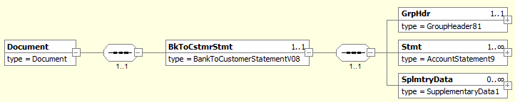
MDR Page | Item Name | XML Tag | Cardi-nality | Data type | Restrictions vs. ISO standard and additional info
 | Document root | Document | [1..1]
 | +Message root | BkToCstmrStmt | [1..1]
43 | ++GroupHeader | GrpHdr | [1..1] |  | See chapter 3.2.
43 | ++Statement | Stmt | [1..n] |  | See chapter 3.3.
71 | ++ SupplementaryData | SplmtryData | [0..n]

GroupHeader
Xpath | / Document / BkToCstmrStmt / GrpHdr

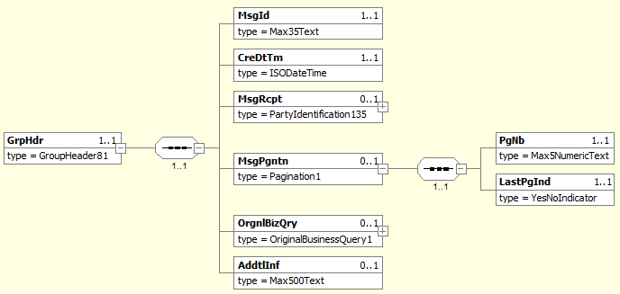
MDR Page | Item Name | XML Tag | Cardi-nality | Data type |  | Restrictions vs. ISO standard and additional info
269 | MessageIdentification | MsgId | [1..1] | String [35] |  | A unique identifier of the message. A message consists of one or more XML files in the camt.053 format (see MessagePagination) that share the same message ID.  Format: [BIC]-[Product]-[RRMMDD]-[ID], where:  - [BIC] (11 characters) is the BIC-11 identifier of the bank that generated the message.  - [Product] (3 characters) can be used to distinguish different “types” of XML statements that may differ in some aspects of their internal structure and/or semantics (still within the boundaries of the national standard). Three ‘x’ (xxx) represent a “NULL” value.  - [RRMMDD] (6 digits) is the date the message was generated.  - ID (1 to 12 characters) is a unique message identifier within the day.
269 | CreationDateTime | CreDtTm | [1..1] | DateTime |  | Date and time at which the message creation was finished.  Format: [YYYY]-[MM]-[DD]T[hh]:[mm]:[ss].[f]TZD, where:  - YYYY (4 digits), MM (2 digits) and DD (2 digits) are the year, month and day  - hh (two digits), mm (two digits), ss (2 digits) and f (1 digit) are the hour, minute, second and fraction of second  - TZD – Time zone is not covered by the standard
269 | MessageRecipient | MsgRcpt | [0..1] |  |  | Information about the message recipient (may differ from the account owner).  See chapter 3.2.1.
270 | MessagePagination | MsgPgntn | [0..1] |  |  | Mandatory if the message is split into several files.  If present on an unpaginated message, The <PgNo> must be set to 1 and the <LastPgInd> must be true.
272 | +PageNumber | PgNb | [1..1] | String [5] |  | Only digits allowed.  Sequence number of the message “part”.
272 | +LastPageIndicator | LastPgInd | [1..1] | Boolean |  | true if this is the last part of the message.
270 | OriginalBusinessQuery | OrgnlBizQry | [0..1] |  |  | Unique identification, as assigned by the original requestor, to unambiguously identify the  business query message.
270 | AdditionalInformation | AddtInf | [0..1] |  | String [500] | For periodically generated statements, this can contain the statement generation frequency (period length). The format and internal structure of this element is not covered by the standard.

MessageRecipient
Xpath | / Document / BkToCstmrStmt / GrpHdr / MsgRcpt

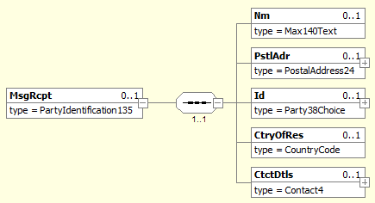
MDR Page | Item Name | XML Tag | Cardi-nality | Data type | Restrictions vs. ISO standard and additional info
282 | Name | Nm | [0..1] | String [140]
282 | PostalAddress | PstlAdr | [0..1] |  | See chapter 3.2.1.1
283 | Identification | Id | [0..1] |  | See chapter 3.2.1.2.
283 | CountryOfResidence | CtryOfRes | [0..1] | String [2]
284 | ContactDetails | CtctDtls | [0..1]

PostalAddress
Xpath | / Document / BkToCstmrStmt / GrpHdr / MsgRcpt / PstlAdr

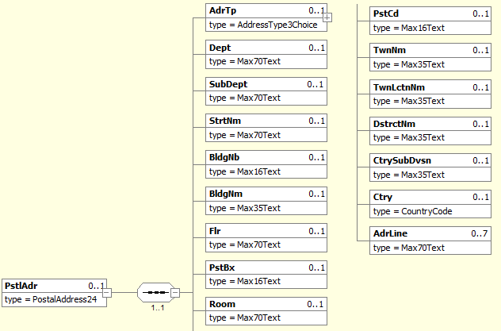
MDR Page | Item Name |  | XML Tag | Cardi-nality | Data type | Restrictions vs. ISO standard and additional info
292 | AddressType |  | AdrTp | [0..1] |  | If structured address is used, tags AddressLine are prohibited. If AddressLine is used, structured address is prohibited except Country.  Where hybrid address is allowed, the combination of structured address and 2 occurence of AddressLine may be present.
293 | +Code | Only one of these elements is present | Cd | [1..1] | String Enumeration
293 | +Proprietary |  | Prtry | [1..1]
248 | ++ Identification |  | Id | [1..1] | String [4] | Specifies an alphanumeric string with a length of 4 characters  [a-zA-Z0-9]{4}
248 | ++ Issuer |  | Issr | [1..1] | String [35]
248 | ++SchemeName |  | SchmeNm | [0..1] | String [35]
293 | Department |  | Dept | [0..1] | String [70]
293 | SubDepartment |  | SubDept | [0..1] | String [70]
294 | StreetName |  | StrtNm | [0..1] | String [70]
294 | BuildingNumber |  | BldgNb | [0..1] | String [16]
294 | BuildingName |  | BldgNm | [0..1] | String [35]
294 | Floor |  | Flr | [0..1] | String [70]
294 | PostBox |  | PstBx | [0..1] | String [16]
294 | Room |  | Room | [0..1] | String [70]
294 | PostCode |  | PstCd | [0..1] | String [16]
294 | TownName |  | TwnNm | [0..1] | String [35] | If structured address is used, at least TownName and Country is needed.
295 | TownLocationName |  | TwnLctnNm | [0..1] | String [35]
295 | DistrictName |  | DstrctNm | [0..1] | String [35]
295 | CountrySubDivision |  | CtrySubDvsn | [0..1] | String [35]
295 | Country |  | Ctry | [0..1] | String [2] | International country code according to ISO 3166-1 alpha-2.  Format [A-Z]{2,2}. In address, Country and TownName or one occurence of AddressLine is needed.
295 | AddressLine |  | AdrLine | [0..7] | String [70] | Unstructured address line. If used, structured address is prohibited except Country.  Where hybrid address is allowed, the combination of structured address and 2 occurence of AddressLine may be present.

Identification
Xpath | / Document / BkToCstmrStmt / GrpHdr / MsgRcpt / Id

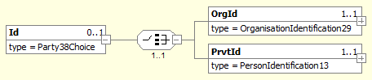
MDR Page | Item Name |  | XML Tag | Cardi-nality | Data type | Restrictions vs. ISO standard and additional info
284 | OrganisationIdentification | Only one of these elements is present | OrgId | [1..1] |  | Identifies a corporate subject.  See chapter 3.2.1.2.1.
285 | PrivateIdentification |  | PrvtId | [1..1] |  | Identifies a person.  See chapter 3.2.1.2.2.

OrganisationIdentification
Xpath | / Document / BkToCstmrStmt / GrpHdr / MsgRcpt / Id / OrgId

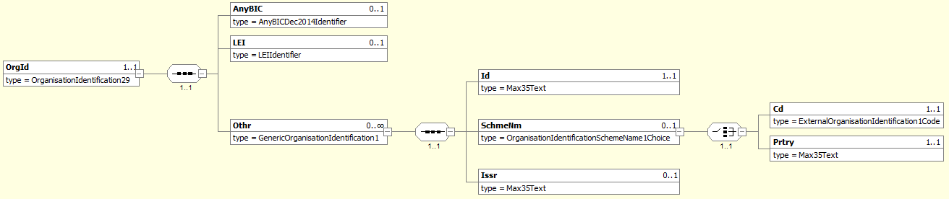

MDR Page | Item Name |  | XML Tag | Cardi-nality | Data type | Restrictions vs. ISO standard and additional info
280 | AnyBIC |  | AnyBIC | [0..1] | String [11] | Recipient’s BIC according to ISO 9362.  Format [A-Z0-9]{4,4}[A-Z]{2,2}[A-Z0-9]{2,2}([A-Z0-9]{3,3}){0,1}
280 | LEI |  | LEI | [0..1] | String [20] | Legal Entity Identifier according to ISO 17442  Format [A-Z0-9]{18,18}[0-9]{2,2}
280 | Other |  | Othr | [0..n] |  | Regulated identifiers must be provided according to Table 4, other identifiers according to ISO rules.
281 | +Identification |  | Id | [1..1] | String [35] | The ID itself.
281 | +SchemeName |  | SchmeNm | [0..1]
281 | ++Code | Only one of these elements is present | Cd | [1..1] | String [4] | ID clasifier according to ISO 20022 “ExternaOrganisationIdentification” code-book.
281 | ++Proprietary |  | Prtry | [1..1] | String [35] | Proprietary ID clasifier.
281 | +Issuer |  | Issr | [0..1] | String [35] | Issuer of the ID.

PrivateIdentification
Xpath | / Document / BkToCstmrStmt / GrpHdr / MsgRcpt / Id / PrvId

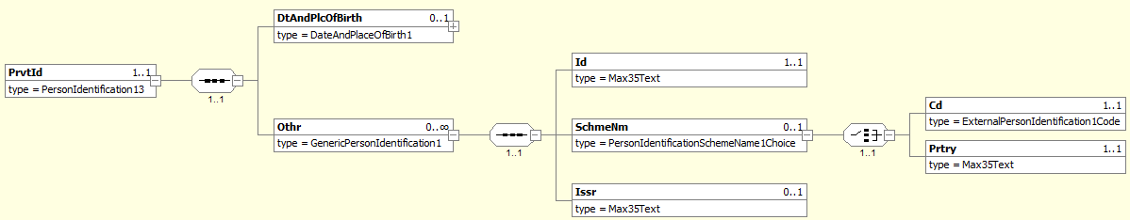
MDR Page | Item Name |  | XML Tag | Cardi-nality | Data type | Restrictions vs. ISO standard and additional info
287 | DateAndPlaceOfBirth |  | DtAndPlcOfBirth | [0..1]
288 | Other |  | Othr | [0..n] |  | Regulated identifiers must be provided according to Table 5, other identifiers according to ISO rules.
288 | +Identification |  | Id | [1..1] | String [35] | The ID itself
288 | +SchemeName |  | SchmeNm | [0..1]
289 | ++Code | Only one of these elements is present | Cd | [1..1] | String [4] | ID clasifier according to ISO 20022 “ExternaPersonIdentification” code-book.
289 | ++Proprietary |  | Prtry | [1..1] | String [35] | Proprietary ID clasifier.
289 | +Issuer |  | Issr | [0..1] | String [35] | Issuer of the ID.

Statement
Xpath | / Document / BkToCstmrStmt / Stmt
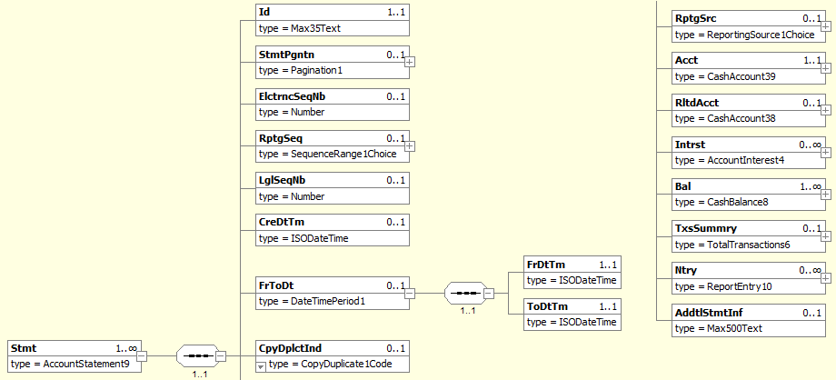
MDR Page | Item Name | XML Tag | Cardi-nality | Data type | Restrictions vs. ISO standard and additional info
46 | Identification | Id | [1..1] | String [35] | A unique statement identifier.  Format [IBAN]-[Seq]-[YYMMDD], where:  - IBAN (24 characters) is the account number in SK IBAN format  - [Seq] identifies the sequence to which the statement belongs. If the statement was produced out-of-sequemce, this parameter will have the value of “xxx” (three ‘x’).  - YY (2 digits), MM (2 digits) a DD (2 digits) are the year, month and day of the last business day covered by the statement.
46 | StatementPagination | StmtPgntn | [0..1]
272 | +PageNumber | PgNb | [1..1] | String [5] | Only digits allowed.  Sequence number of the message “part”.
272 | +LastPageIndicator | LastPgInd | [1..1] | Boolean | true if this is the last part of the message.
46 | ElectronicSequenceNumber | ElctrncSeqNb | [0..1] | Number [18,0]
46 | ReportingSequence | RptgSeq | [0..1]
47 | LegalSequenceNumber | LglSeqNb | [0..1] | Number [18,0] | A sequential statement order number within a given statement sequence and a year.  Mandatory for sequential statements, optional for on-demand statements.
47 | CreationDateTime | CreDtTm | [1..1] | DateTime | Date and time at which the statement creation finished.  Format [YYYY]-[MM]-[DD]T[hh]:[mm]:[ss].[f]TZD, where:  - YYYY (4 digits), MM (2 digits) a DD (2 digits) are the year, month and day  - hh (2 digits), mm (2 digits), ss (2 digits) a f (1 digit) are the hour, minute, second and fraction of a second  - TZD – Time zone is not covered by the standard
47 | FromToDate | FrToDt | [1..1] |  | Always present.  Specifies the interval of business dates covered by the statement.
234 | +FromDateTime | FrDtTm | [1..1] | DateTime | First business date covered by the statement.  Format [YYYY]-[MM]-[DD]Thh:mm:ss.fTZD, where:  - YYYY (4 digits), MM (2 digits) a DD (2 digits) are the year, month and day  - the time and time zone are not covered by the standard
235 | +ToDateTime | ToDtTm | [1..1] | DateTime | Last business date coverd by the statement.  Format [YYYY]-[MM]-[DD]Thh:mm:ss.fTZD, where:  - YYYY (4 digits), MM (2 digits) a DD (2 digits) are the year, month and day  - the time and time zone are not covered by the standard
47 | CopyDuplicateIndicator | CpyDplctInd | [0..1] | String Enumeration
48 | ReportingSource | RptgSrc | [0..1]
48 | Account | Acct | [1..1] |  | See chapter 3.3.1.
48 | RelatedAccount | RltdAcct | [0..1]
49 | Interest | Intrst | [0..1] |  | See chapter 3.3.2.
56 | Balance | Bal | [1..n] |  | See chapter 3.3.3.
58 | TransactionsSummary | TxsSummry | [0..1] |  | If the message is split into several files, this element may be present only on the last “page”.  See chapter 3.3.4.
59 | Entry | Ntry | [0..n] |  | See chapter 3.3.5.
71 | AdditionalStatementInformation | AddtlStmtInf | [0..1] | String [500] | Statement frequency.

Account
Xpath | / Document / BkToCstmrStmt / Stmt / Acct

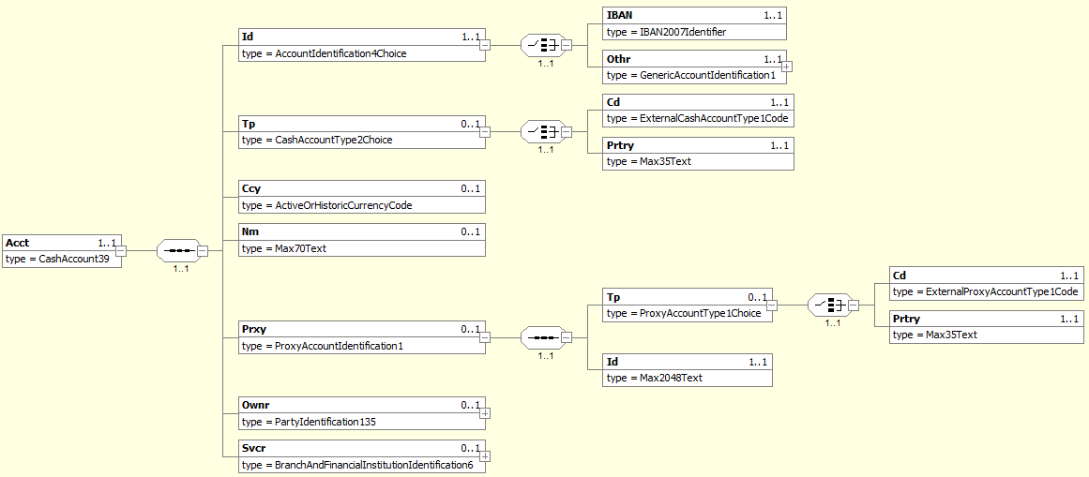
MDR Page | Item Name |  |  | XML Tag | Cardi-nality | Data type | Restrictions vs. ISO standard and additional info
115 | Identification |  |  | Id | [1..1]
120 | +IBAN |  | Only one of these elements is present | IBAN | [1..1] | String [34] | Always present.
120 | +Other |  |  | Othr | [0..0] |  | Prohibited.
116 | Type |  |  | Tp | [0..1]
113 | +Code |  | Only one of these elements is present | Code | [1..1] | String [4] | ISO account clasifier.  Only values from ISO code-book “ExternalCashAccountType” are allowed.
113 | +Proprietary |  |  | Prtry | [1..1] | String Enumeration | Proprietary account clasifier.
116 | Currency |  |  | Ccy | [0..1] | String [3] | International currency code according to ISO 4217.
116 | Name |  |  | Nm | [0..1] | String [70]
116 | Proxy |  |  | Prxy | [0..1] |  | Specifies an alternate assumed name for the identification of the account.
114 | +Type |  |  | Tp | [0..1] |  | Type of the proxy identification.
115 | ++Code | Only one of these elements is present |  | Code | [1..1] | String [4] | Name of the identification scheme, in a coded form as published in an external list.
115 | ++Proprietary |  |  | Prtry | [1..1] | String Enumeration | Name of the identification scheme, in a free text form.
115 | +Identification |  |  | Id | [1..1] | String [2048] | Identification used to indicate the account identification under another specified name.
117 | Owner |  |  | Ownr | [0..1] |  | See chapter 3.3.1.1.
117 | Servicer |  |  | Svcr | [0..1] |  | See chapter 3.3.1.2.

Owner
Xpath | / Document / BkToCstmrStmt / Stmt / Acct / Ownr

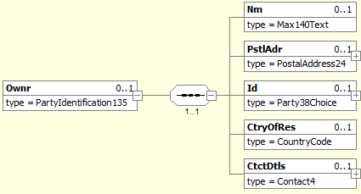
MDR Page | Item Name | XML Tag | Cardi-nality | Data type | Restrictions vs. ISO standard and additional info
282 | Name | Nm | [0..1] | String [140]
282 | PostalAddress | PstlAdr | [0..1] |  | See chapter 3.3.1.1.1.
283 | Identification | Id | [0..1] |  | See chapter 3.3.1.1.2.
283 | CountryOfResidence | CtryOfRes | [0..1] | String [2]
284 | ContactDetails | CtctDtls | [0..1]

PostalAddress
Xpath | / Document / BkToCstmrStmt / Stmt / Acct / Ownr / PstlAdr

MDR Page | Item Name |  | XML Tag | Cardi-nality | Data type | Restrictions vs. ISO standard and additional info
292 | AddressType |  | AdrTp | [0..1] |  | If structured address is used, tags AddressLine are prohibited. If AddressLine is used, structured address is prohibited except Country.  Where hybrid address is allowed, the combination of structured address and 2 occurence of AddressLine may be present.
293 | +Code | Only one of these elements is present | Cd | [1..1] | String Enumeration
293 | +Proprietary |  | Prtry | [1..1]
248 | ++ Identification |  | Id | [1..1] | String [4] | Specifies an alphanumeric string with a length of 4 characters  [a-zA-Z0-9]{4}
248 | ++ Issuer |  | Issr | [1..1] | String [35]
248 | ++SchemeName |  | SchmeNm | [0..1] | String [35]
293 | Department |  | Dept | [0..1] | String [70]
293 | SubDepartment |  | SubDept | [0..1] | String [70]
294 | StreetName |  | StrtNm | [0..1] | String [70]
294 | BuildingNumber |  | BldgNb | [0..1] | String [16]
294 | BuildingName |  | BldgNm | [0..1] | String [35]
294 | Floor |  | Flr | [0..1] | String [70]
294 | PostBox |  | PstBx | [0..1] | String [16]
294 | Room |  | Room | [0..1] | String [70]
294 | PostCode |  | PstCd | [0..1] | String [16]
294 | TownName |  | TwnNm | [0..1] | String [35] | If structured address is used, at least TownName and Country is needed.
295 | TownLocationName |  | TwnLctnNm | [0..1] | String [35]
295 | DistrictName |  | DstrctNm | [0..1] | String [35]
295 | CountrySubDivision |  | CtrySubDvsn | [0..1] | String [35]
295 | Country |  | Ctry | [0..1] | String [2] | International country code according to ISO 3166-1 alpha-2.  Format [A-Z]{2,2}. In address, Country and TownName or one occurence of AddressLine is needed.
295 | AddressLine |  | AdrLine | [0..7] | String [70] | Unstructured address line. If used, structured address is prohibited except Country.  Where hybrid address is allowed, the combination of structured address and 2 occurence of AddressLine may be present.

Identification
Xpath | / Document / BkToCstmrStmt / Stmt / Acct / Ownr / Id

MDR Page | Item Name |  | XML Tag | Cardi-nality | Data type | Restrictions vs. ISO standard and additional info
284 | OrganisationIdentification | Only one of these elements is present | OrgId | [1..1] |  | Identifies a corporate subject.  See chapter 3.3.1.1.2.1.
285 | PrivateIdentification |  | PrvtId | [1..1] |  | Identifies a person.  See chapter 3.3.1.1.2.2.

OrganisationIdentification
Xpath | / Document / BkToCstmrStmt / Stmt / Acct / Ownr / Id / OrgId

MDR Page | Item Name |  | XML Tag | Cardi-nality | Data type | Restrictions vs. ISO standard and additional info
280 | AnyBIC |  | AnyBIC | [0..1] | String [11] | Recipient’s BIC according to ISO 9362.  Format [A-Z0-9]{4,4}[A-Z]{2,2}[A-Z0-9]{2,2}([A-Z0-9]{3,3}){0,1}
280 | LEI |  | LEI | [0..1] | String [20] | Legal Entity Identifier according to ISO 17442  Format [A-Z0-9]{18,18}[0-9]{2,2}
280 | Other |  | Othr | [0..n] |  | Regulated identifiers must be provided according to Table 4, other identifiers according to ISO rules.
281 | +Identification |  | Id | [1..1] | String [35] | The ID itself.
281 | +SchemeName |  | SchmeNm | [0..1]
281 | ++Code | Only one of these elements is present | Cd | [1..1] | String [4] | ID clasifier according to ISO 20022 “ExternaOrganisationIdentification” code-book.
281 | ++Proprietary |  | Prtry | [1..1] | String [35] | Proprietary ID clasifier.
281 | +Issuer |  | Issr | [0..1] | String [35] | Issuer of the ID.

PrivateIdentification
Xpath | / Document / BkToCstmrStmt / Stmt / Acct / Ownr / Id / PrvId

MDR Page | Item Name |  | XML Tag | Cardi-nality | Data type | Restrictions vs. ISO standard and additional info
287 | DateAndPlaceOfBirth |  | DtAndPlcOfBirth | [0..1]
288 | Other |  | Othr | [0..n] |  | Regulated identifiers must be provided according to Table 5, other identifiers according to ISO rules.
288 | +Identification |  | Id | [1..1] | String [35] | The ID itself
288 | +SchemeName |  | SchmeNm | [0..1]
289 | ++Code | Only one of these elements is present | Cd | [1..1] | String [4] | ID clasifier according to ISO 20022 “ExternaPersonIdentification” code-book.
289 | ++Proprietary |  | Prtry | [1..1] | String [35] | Proprietary ID clasifier.
289 | +Issuer |  | Issr | [0..1] | String [35] | Issuer of the ID.

Servicer
Xpath | / Document / BkToCstmrStmt / Stmt / Acct / Svcr

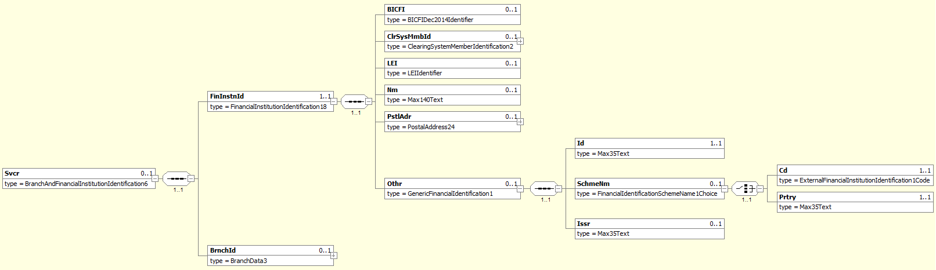
MDR Page | Item Name |  | XML Tag | Cardi-nality | Data type | Restrictions vs. ISO standard and additional info
242 | FinancialInstitutionIdentification |  | FinInstnId | [1..1]
238 | +BICFI |  | BICFI | [0..1] | String [11] | Account Servicer BIC according to ISO 9362.  Format: [A-Z0-9]{4,4}[A-Z]{2,2}[A-Z0-9]{2,2}([A-Z0-9]{3,3}){0,1}
239 | +ClearingSystemMemberIdentification |  | ClrSysMmbId | [0..1]
239 | +LEI |  | LEI | [0..1] | String [20] | Legal Entity Identifier according to ISO 17442  Format [A-Z0-9]{18,18}[0-9]{2,2}
239 | +Name |  | Nm | [0..1] | String [140] | Account Servicer Name.
239 | +PostalAddress |  | PstlAdr | [0..1] |  | See chapter 3.3.1.2.1.
240 | +Other |  | Othr | [0..1]
243 | ++Identification |  | Id | [1..1] | String [35] | Account Servicer EuroSIPS code.
244 | ++SchemeName |  | SchmeNm | [0..1]
244 | +++Code | Only one of these elements is present | Cd | [0..0] | String [4] | Prohibited.
244 | +++Proprietary |  | Prtry | [1..1] | String [35] | Always present, always equals “EuroSIPS Bank Code”.
244 | ++Issuer |  | Issr | [0..1] | String [35] | Always equals “NBS”.
243 | BranchIdentification |  | BrnchId | [0..1]

PostalAddress
Xpath | / Document / BkToCstmrStmt / Stmt / Acct / Svcr / PstlAdr

MDR Page | Item Name |  | XML Tag | Cardi-nality | Data type | Restrictions vs. ISO standard and additional info
292 | AddressType |  | AdrTp | [0..1] |  | If structured address is used, tags AddressLine are prohibited. If AddressLine is used, structured address is prohibited except Country.  Where hybrid address is allowed, the combination of structured address and 2 occurence of AddressLine may be present.
293 | +Code | Only one of these elements is present | Cd | [1..1] | String Enumeration
293 | +Proprietary |  | Prtry | [1..1]
248 | ++ Identification |  | Id | [1..1] | String [4] | Specifies an alphanumeric string with a length of 4 characters  [a-zA-Z0-9]{4}
248 | ++ Issuer |  | Issr | [1..1] | String [35]
248 | ++SchemeName |  | SchmeNm | [0..1] | String [35]
293 | Department |  | Dept | [0..1] | String [70]
293 | SubDepartment |  | SubDept | [0..1] | String [70]
294 | StreetName |  | StrtNm | [0..1] | String [70]
294 | BuildingNumber |  | BldgNb | [0..1] | String [16]
294 | BuildingName |  | BldgNm | [0..1] | String [35]
294 | Floor |  | Flr | [0..1] | String [70]
294 | PostBox |  | PstBx | [0..1] | String [16]
294 | Room |  | Room | [0..1] | String [70]
294 | PostCode |  | PstCd | [0..1] | String [16]
294 | TownName |  | TwnNm | [0..1] | String [35] | If structured address is used, at least TownName and Country is needed.
295 | TownLocationName |  | TwnLctnNm | [0..1] | String [35]
295 | DistrictName |  | DstrctNm | [0..1] | String [35]
295 | CountrySubDivision |  | CtrySubDvsn | [0..1] | String [35]
295 | Country |  | Ctry | [0..1] | String [2] | International country code according to ISO 3166-1 alpha-2.  Format [A-Z]{2,2}. In address, Country and TownName or one occurence of AddressLine is needed.
295 | AddressLine |  | AdrLine | [0..7] | String [70] | Unstructured address line. If used, structured address is prohibited except Country.  Where hybrid address is allowed, the combination of structured address and 2 occurence of AddressLine may be present.

Interest
Xpath | / Document / BkToCstmrStmt / Stmt / Intrst

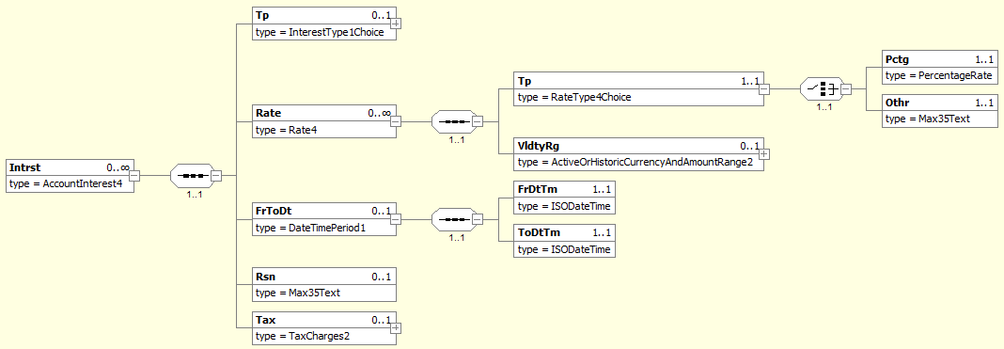
MDR Page | Item Name | XML Tag | Cardi-nality | Data type | Restrictions vs. ISO standard and additional info
50 | Type | Tp | [0..1]
51 | Rate | Rate | [0..n]
51 | +Type | Tp | [1..1]
297 | ++Percentage | Pctg | [1..1] | Number [11, 0..10] | Always present.
297 | ++Other | Othr | [0..0] | String [35] | Prohibited.
52 | +ValidityRange | VldtyRg | [0..1]
55 | FromToDate | FrToDt | [0..1] |  | Interest rate validity range.
234 | +FromDateTime | FrDtTm | [1..1] | DateTime | First business date on which the interest was applied.  Format [YYYY]-[MM]-[DD]Thh:mm:ss.fTZD, where:  - YYYY (4 digits), MM (2 digits) a DD (2 digits) are the year, month and day  - the time and time zone are not covered by the standard
235 | +ToDateTime | ToDtTm | [1..1] | DateTime | Last business date on which the interest was applied.  Format [YYYY]-[MM]-[DD]Thh:mm:ss.fTZD, where:  - YYYY (4 digits), MM (2 digits) a DD (2 digits) are the year, month and day  - the time and time zone are not covered by the standard
55 | Reason | Rsn | [0..1] | String [35]
55 | Tax | Tax | [0..1] |  | Provides details on the tax applied to charges.

Balance
Xpath | / Document / BkToCstmrStmt / Stmt / Bal

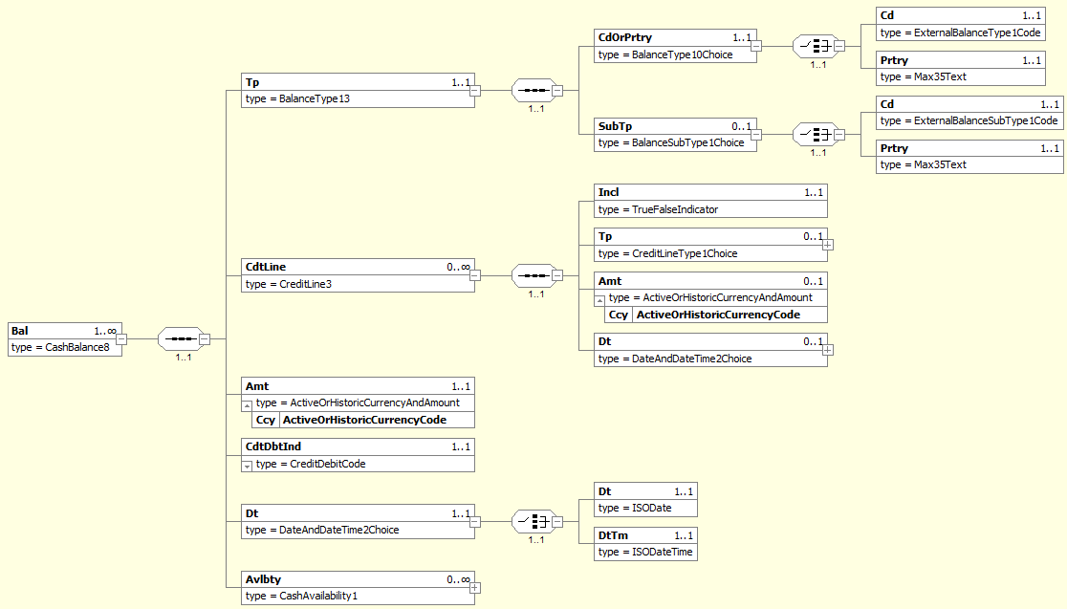
MDR Page | Item Name |  | XML Tag | Cardi-nality | Data type | Restrictions vs. ISO standard and additional info
56 | Type |  | Tp | [1..1]
139 | +CodeOrProprietary |  | CdOrPrtry | [1..1]
139 | ++Code |  | Cd | [1..1] | String Enumeration | Identifies the balance type.  Only values from Table 6 allowed..
139 | ++Proprietary |  | Prtry | [0..0] | String [35] | Prohibited.
139 | +SubType |  | SubTp | [0..1]
139 | ++Code |  | Cd | [1..1] | String [4] | Identifies the balance subtype. Only code INTM is allowed and defines the balance as an intermediate balance in multi-page statement.  Can be used as a more detailed alternative to intermediate balance type ITBD used in tag CdOrPrtry / Cd. When the code ITBD is present in tag CdOrPrtry / Cd, tag SubType is prohibited.  For other codes from CdOrPrtry / Cd, the SubType defines the certain balance as an intermediate balance.
139 | ++Proprietary |  | Prtry | [0..0] | String [35] | Prohibited.
57 | CreditLine |  | CdtLine | [0..1]
140 | +Included |  | Incl | [1..1] | Boolean | Indicates whether the credit line is included in the balance or not.
140 | +Type |  | Tp | [0..1]
140 | +Amount |  | Amt | [0..1] | Number [18,0..5]
140 | +@Currency |  | Ccy | [1..1] | String [3] | International currency code according to ISO 4217.
141 | +Date |  | Dt | [1..1]
57 | Amount |  | Amt | [1..1] | Number [18, 0..5] | Absolute balance amount.  Cannot be negative.
57 | @Currency |  | Ccy | [1..1] | String [3] | Balance currency.  An attribute of the Amount element.  International currency code according to ISO 4217.
58 | CreditDebitIndicator |  | CdtDbtInd | [1..1] | String Enumeration | Indicates, whether the balance is positive or negative.  Only following values are allowed:  - „CRDT“ for positive (and zero) balances  - „DBIT“ for negative balances
58 | Date |  | Dt | [1..1]
234 | +Date | Only one of these elements is present | Dt | [1..1] | Date | The balance reference date.  For CLBD and CLAV balances, this is the actual balance validity date; valid values are dates between Stmt / FrToDt / FrDtTm and Stmt / FrToDt / ToDtTm (inclusive).  For PRCD balances, the value must be equal to Stmt / FrToDt / FrDtTm; the balance validity date is one business day before Stmt / FrToDt / FrDtTm (previous business day closing balance PRCD is equal to opening balance of actual business day OPBD)  Format [YYYY]-[MM]-[DD], where:  - YYYY (4 digits), MM (2 digits) a DD (2 digits) are the year, month and day.
234 | +DateTime |  | DtTm | [1..1] | DateTime | The balance validity timestamp, usually used with ITBD balances.  Format: [YYYY]-[MM]-[DD]T[hh]:[mm]:[ss].[f]TZD, where:  - YYYY (4 digits), MM (2 digits) and DD (2 digits) are the year, month and day  - hh (two digits), mm (two digits), ss (2 digits) and f (1 digit) are the hour, minute, second and fraction of second  - TZD – Time zone is not covered by the standard
58 | Availability |  | Avlbty | [0..n]

TransactionsSummary
Xpath | / Document / BkToCstmrStmt / Stmt / TxsSummry

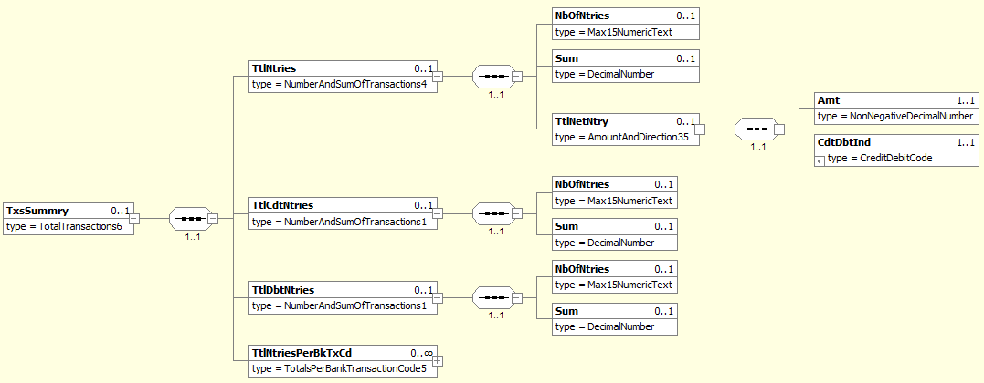
MDR Page | Item Name | XML Tag | Cardi-nality | Data type | Restrictions vs. ISO standard and additional info
264 | TotalEntries | TtlNtries | [0..1]
265 | +NumberOfEntries | NbOfNtries | [0..1] | String [15] | Only digits allowed (format [0-9]{1,15}).  Total number of movements within the statement.
265 | +Sum | Sum | [0..1] | Number [18, 0..17] | Sum of absolute values of all movements within the statement.
265 | +TotalNetEntry | TtlNetNtry | [0..1]
137 | ++Amount | Amt | [1..1] | Number [18, 0..17] | Resulting amount of the netted amounts for all debit and credit entries.
137 | ++CreditDebitIndicator | CdtDbtInd | [1..1] | String Enumeration | Mandatory if the <TtlNetNtry><Amt> element is present.  Indicates, whether the value of <TtlNetNtry><Amt> is positive or negative.  Only following values are allowed:  - „CRDT“ for positive (and zero) amounts  - „DBIT“ for negative amounts
265 | TotalCreditEntries | TtlCdtNtries | [0..1]
251 | +NumberOfEntries | NbOfNtries | [0..1] | String [15] | Only digits allowed (format [0-9]{1,15}).  Total number of credits within the statement.
251 | +Sum | Sum | [0..1] | Number [18, 0..17] | Sum of all credits within the statement.
265 | TotalDebitEntries | TtlDbtNtries | [0..1]
251 | +NumberOfEntries | NbOfNtries | [0..1] | String [15] | Only digits allowed (format [0-9]{1,15}).  Total number of debits within the statement.
251 | +Sum | Sum | [0..1] | Number [18, 0..17] | Sum of all debits within the statement.
266 | TotalEntriesPer-BankTransactionCode | TtlNtriesPerBkTxCd | [0..n]

Entry
Xpath | / Document / BkToCstmrStmt / Stmt / Ntry

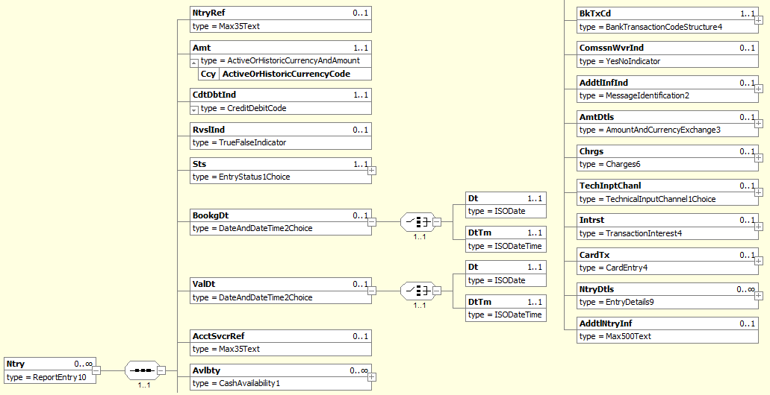
MDR Page | Item Name |  |  | XML Tag | Cardi-nality | Data type | Restrictions vs. ISO standard and additional info
60 | EntryReference |  |  | NtryRef | [0..1] | String [35] | A unique movement identifier.
61 | Amount |  |  | Amt | [1..1] | Number [18, 0..5] | Absolute movement amount.  Cannot be negative.
61 | @Currency |  |  | Ccy | [1..1] | String [3] | Movement currency.  An attribute of the Amount element.  International currency code according to ISO 4217.
61 | CreditDebitIndicator |  |  | CdtDbtInd | [1..1] | String Enumeration | Indicates whether the movement is a credit or a debit.  Only following values are allowed:  - „CRDT“ for credits (and zero movements)  - „DBIT“ for debits
61 | ReversalIndicator |  |  | RvslInd | [0..1] | Boolean | Indicates whether the movement is a reversal. Do not confuse this with a SEPA R-Message indicated by the <RtrInf> element on the <TxDtls> level.  Defaults to false.
61 | Status |  |  | Sts | [1..1]
328 | +Code | Only one of these elements is present |  | Cd | [1..1] | String [4] | Always “BOOK”.
328 | +Proprietary |  |  | Prtry | [1..1] | String [35] | Prohibited.
62 | BookingDate |  |  | BookDt | [0..1]
234 | +Date |  | Only one of these elements is present | Dt | [1..1] | Date | Movement posting date.  Format: [YYYY]-[MM]-[DD], where:  - YYYY (4 digits), MM (2 digits) and DD (2 digits) are the year, month and day
234 | +DateTime |  |  | DtTm | [1..1] | DateTime | Movement posting timestamp.  Format: [YYYY]-[MM]-[DD]T[hh]:[mm]:[ss].[f]TZD, where:  - YYYY (4 digits), MM (2 digits) and DD (2 digits) are the year, month and day  - hh (two digits), mm (two digits), ss (2 digits) and f (1 digit) are the hour, minute, second and fraction of second  - TZD – Time zone is not covered by the standard
62 | ValueDate |  |  | ValDt | [0..1]
234 | +Date |  | Only one of these elements is present | Dt | [1..1] | Date | Movement value date.  Format: [YYYY]-[MM]-[DD], where:  - YYYY (4 digits), MM (2 digits) and DD (2 digits) are the year, month and day
234 | +DateTime |  |  | DtTm | [0..0] | DateTime | Movement value timestamp.  Format: [YYYY]-[MM]-[DD]T[hh]:[mm]:[ss].[f]TZD, where:  - YYYY (4 digits), MM (2 digits) and DD (2 digits) are the year, month and day  - hh (two digits), mm (two digits), ss (2 digits) and f (1 digit) are the hour, minute, second and fraction of second  - TZD – Time zone is not covered by the standard
62 | AccountServicerReference |  |  | AcctSvcrRef | [0..1] | String [35] | Allowed only for bulk payments.  System bulk reference assigned by the debtor agent.
63 | Availability |  |  | Avlbty | [0..n]
63 | BankTransactionCode |  |  | BkTxCd | [1..1] |  | See chapter 3.3.5.1.
64 | CommissionWaiverIndicator |  |  | ComssnWvrInd | [0..1] | Boolean
64 | AdditionalInformationIndicator |  |  | AddtInfInd | [0..1]
64 | AmountDetails |  |  | AmtDtls | [0..1] |  | Allowed only for bulk payments.  The contents of this element is not regulated.
66 | Charges |  |  | Chrgs | [0..n] |  | Allowed only for bulk payments.  See chapter 3.3.5.2.
66 | TechnicalInputChannel |  |  | TechInptChanl | [0..1]
67 | Interest |  |  | Intrst | [0..n]
68 | CardTransaction |  |  | CardTx | [0..n] |  | Details of the card transaction.
70 | EntryDetails |  |  | NtryDtls | [0..n] |  | All SBA regulations refer to the first instance of <NtryDtls> (see chapter 3.3.5.3). Subsequent instances are not regulated.
70 | AdditionalEntryInformation |  |  | AddtNtryInf | [0..1] | String [500]

BankTransactionCode
Xpath | / Document / BkToCstmrStmt / Stmt / Ntry / BkTxCd

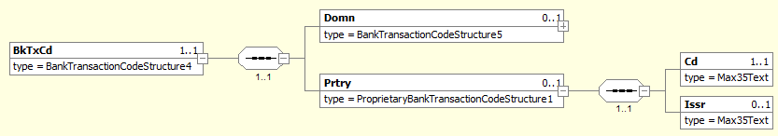
MDR Page | Item Name | XML Tag | Cardi-nality | Data type | Restrictions vs. ISO standard and additional info
142 | Domain | Domn | [0..1]
142 | Proprietary | Prtry | [1..1] |  | Always present.
142 | +Code | Cd | [1..1] | String [11] | The movement SBA transaction code.  For a list of allowed values see chapter 4.3.3.
142 | +Issuer | Issr | [1..1] | String [35] | Always “SBA”.

Charges
Xpath | / Document / BkToCstmrStmt / Stmt / Ntry / Chrgs

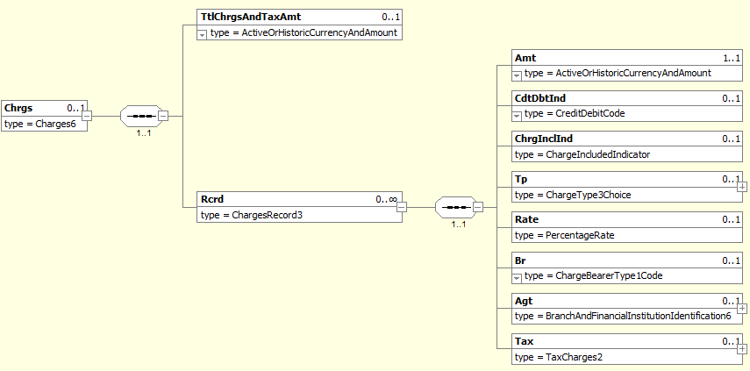
MDR Page | Item Name | XML Tag | Cardi-nality | Data type | Restrictions vs. ISO standard and additional info
228 | TotalChargesAndTaxAmount | TtlChrgsAndTaxAmt | [0..1]
228 | Record | Rcrd | [0..n]
230 | +Amount | Amt | [1..1] | Number [18, 0..5] | Absolute charge amount.  Cannot be negative.
230 | +@Currency | Ccy | [1..1] | String [3] | Charge currency.  An attribute of the Amount element.  International currency code according to ISO 4217
230 | +CreditDebitIndicator | CdtDbtInd | [0..1] | String Enumeration | Indicates whether the charge is being levied or returned.  Only following values are allowed:  - „CRDT“ for returned charges  - „DBIT“ for levied (and zero) charges  If omitted, it defaults to “DBIT”.
230 | +ChargeIncludedIndicator | ChrgInclInd | [0..1] | Boolean | Indicates whether the charge should be included in the amount or is added as pre-advice.  - True: Included  - False: Pre-advised
230 | +Type | Tp | [0..1]
231 | +Rate | Rate | [0..1] | Number [11, 0..10]
231 | +Bearer | Br | [0..1] | String Enumeration | Identifies the party that will bear the charge.  Only following values are allowed:  - “DEBT” – the debtor bears all charges  - “CRED” – the creditor bears all charges  - “SHAR” – each party bears the charges of its agent  - “SLEV” – the charges are distributed according to a billateral agreement between the creditor and debtor agents.
232 | + Agent | Agt | [0..1]
232 | +Tax | Tax | [0..1]

EntryDetails – Instance 1
Xpath | / Document / BkToCstmrStmt / Stmt / Ntry / NtryDtls [1]

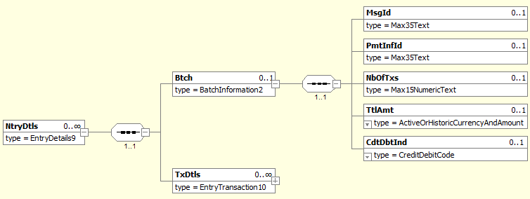
MDR Page | Item Name | XML Tag | Cardi-nality | Data type | Restrictions vs. ISO standard and additional info
223 | Batch | Btch | [0..1] |  | Allowed only for bulk payments.
223 | +MessageIdentification | MsgId | [0..1] | String [35] | Payment instruction message ID.
223 | +PaymentInformationIdentification | PmtInfId | [0..1] | String [35] | Payment instruction ID assigned by the instructing party.
224 | +NumberOfTransactions | NbOfTxs | [0..1] | String [15] | Only digits allowed.  Number of transactions in the bulk payment.
224 | +TotalAmount | TtlAmt | [0..1] | Number [18, 0..5]
224 | +CreditDebitIndicator | CdtDbtIndTxInf | [0..1] | String Enumeration
224 | TransactionDetails | TxDtls | [0..n] |  | More than one instance allowed only for bulk payments.  See chapter 3.3.5.3.1.

TransactionDetails
Xpath | / Document / BkToCstmrStmt / Stmt / Ntry / NtryDtls [1] / TxDtls

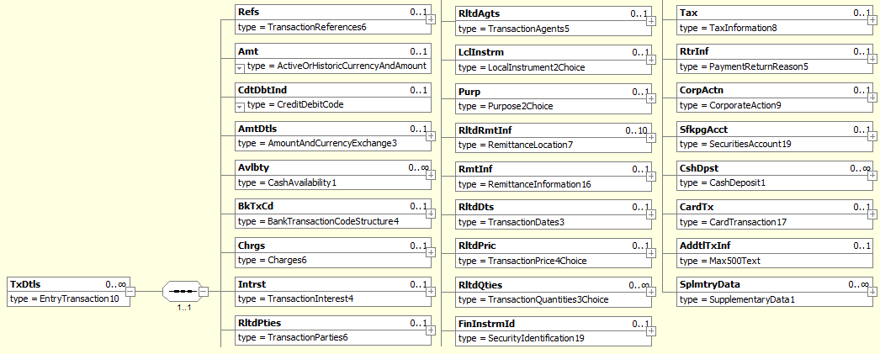
MDR Page | Item Name | XML Tag | Cardi-nality | Data type | Restrictions vs. ISO standard and additional info
192 | References | Refs | [0..1] |  | See chapter 3.3.5.3.1.1.
195 | Amount | Amt | [0..1] | Number [18,0..5]
195 | @Currency | Ccy | [1..1] | String [3] | International currency code according to ISO 4217.
195 | CreditDebitIndicator | CdtDbtInd | [0..1] | String Enumeration | Indicates whether the charge is being levied or returned.  Only following values are allowed:  - „CRDT“ for returned charges  - „DBIT“ for levied (and zero) charges  If omitted, it defaults to “DBIT”.
196 | AmountDetails | AmtDtls | [0..1] |  | See chapter 3.3.5.3.1.2.
198 | Availability | Avlbty | [0..n]
199 | BankTransactionCode | BkTxCd | [0..1] |  | See chapter 3.3.5.3.1.3.
199 | Charges | Chrgs | [0..n] |  | See chapter 3.3.5.3.1.4.
199 | Interest | Intrst | [0..n]
200 | RelatedParties | RltdPties | [0..1] |  | See chapter 3.3.5.3.1.5.
204 | RelatedAgents | RltdAgts | [0..1] |  | See chapter 3.3.5.3.1.6.
209 | LocalInstrument | LclInstrm | [0..1]
209 | Purpose | Purp | [0..1] |  | Allowed only for SEPA payments.  See chapter 3.3.5.3.1.7.
210 | RelatedRemittanceInformation | RltdRmtInf | [0..n]
210 | RemittanceInformation | RmtInf | [0..1] |  | See chapter 3.3.5.3.1.8.
210 | RelatedDates | RltdDts | [0..1] |  | See chapter 3.3.5.3.1.9
212 | RelatedPrice | RltdPric | [0..1]
214 | RelatedQuantities | RltsQties | [0..n]
215 | FinancialInstrumentIdentification | FinInstrmId | [0..1]
216 | Tax | Tax | [0..1]
217 | ReturnInformation | RtrInf | [0..1] |  | Allowed only for SEPA R-Messages.  See chapter 3.3.5.3.1.10
218 | CorporateAction | CorpActn | [0..1]
218 | SafekeepingAccount | SfkpgAcct | [0..1]
218 | CashDeposit | CshDpst | [0..1]
219 | CardTransaction | CardTx | [0..1] |  | Transactional data used to uniquely identify a card transaction  See chapter 3.3.5.3.1.11
222 | AdditionalTransactionInformation | Addtl | [0..1] | String [500]
222 | SupplementaryData | SplmtryData | [0..1]

References
Xpath | / Document / BkToCstmrStmt / Stmt / Ntry / NtryDtls [1] / TxDtls / Refs

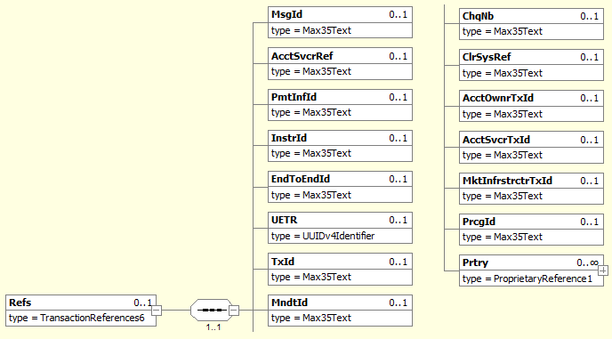
MDR Page | Item Name | XML Tag | Cardi-nality | Data type | Restrictions vs. ISO standard and additional info
192 | MessageIdentification | MsgId | [0..1] | String [35] | Payment instruction message ID.
192 | AccountServicerReference | AcctSvcrRef | [0..1] | String [35] | Payment reference assigned by the account–servicing agent.
192 | PaymentInformationIdentification | PmtInfId | [0..1] | String [35] | Payment instruction ID assigned by the instructing agent.
193 | InstructionIdentification | InstrId | [0..1] | String [35] | Payment instruction ID assigned by the instructing party.  Value can be obtained from the client’s payment order.
193 | EndToEndIndentification | EndToEndId | [0..1] | String [35] | Payment reference assigned by the instructing party.  It may contain EuroSIPS credit-side symbols, although the conditions, under which the symbols are recognised, differ between banks.  The most rigorous formatting specification, that should be recognised by all participants, requires all three symbols to be present (event those without a value) in a strict order and no other text apart from the symbols may be present in the reference. The corresponding regular expression is:  ^/VS[0-9]{0,10}/SS[0-9]{0,10}/KS[0-9]{0,4}$  Some more liberal specifications allow for:  - skipping the label if the symbol has no value:  - ^(/VS[0-9]{0,10})?(/SS[0-9]{0,10})?(/KS[0-9]{0,4})?$  - text around the symbols:  - /VS[0-9]{0,10}/SS[0-9]{0,10}/KS[0-9]{0,4}  - or a combination of both:  - (/VS[0-9]{0,10})?(/SS[0-9]{0,10})?(/KS[0-9]{0,4})?  The most liberal specification allows any subset of the symbols to be present in any order and with free text anywhere between and around them. The corresponding regular expression is too long to be readable; instead, a free-form description of the formatting follows:  The EuroSIPS credit-side symbols are recognizable by dedicated labels. All labels are case-sensitive. If a label does not exist or exists more than once within the reference or if the first character after the label is not a digit, the related symbol is considered non-existent. The symbol starts with the first digit after the label and ends before the first non-digit character or by reaching the maximal symbol length. The labels and maximal lengths for individual symbols are as follows:  Symbol Label Maximal length  Variable /VS 10  Specific /SS 10  Constant /KS 4
193 | UETR | UETR | [0..1] | String [36] | Universally unique identifier to provide an end-to-end reference of a payment transaction.  UUID version 4, as described in IETC RFC 4122  [a-f0-9]{8}-[a-f0-9]{4}-4[a-f0-9]{3}-[89ab][a-f0-9]{3}-[a-f0-9]{12}
193 | TransactionIdentification | TxId | [0..1] | String [35] | Transaction reference assigned by the instructing application. For incoming transactions, this is the instructing agent; for outgoing transactions, this is the instructing “front-end” application. For card transactions, this is the Point-of-Trade (ATM or POS) or the Acquier’s transactions processing system.  A system equivalent of the End-to-End ID.
193 | MandateIdentification | MndtId | [0..1] | String [35] | Allowed only for SDD transactions.  A unique mandate identifier.
194 | ChequeNumber | ChqNb | [0..1] | String [35] | Cheque number.
194 | ClearingSystemReference | ClrSysRef | [0..1] | String [35] | Transaction reference assigned by the clearing system.
194 | AccountOwnerTransactionIdentification | AcctOwnrTxId | [0..1] | String [35] | Transaction reference assigned by Account owner.
194 | AccountServicerTransactionIdentification | AcctSvcrTxId | [0..1] | String [35] | Transaction reference assigned by Account servicer. Used for ID of transaction in processing, especially when the ID is different comparing to ID when transaction is settled.
194 | MarketInfrastructureTransactionIdentification | MktInfrstrctrTxId | [0..1] | String [35] | Identification of a securities transaction assigned by a market infrastructure other than a central securities depository, for example, Target2-Securities.
194 | ProcessingIdentification | PrcgId | [0..1] | String [35] | Identification of the securities transaction assigned by the processor of the instruction.
194 | Proprietary | Prtry | [0..1]

AmountDetails
Xpath | / Document / BkToCstmrStmt / Stmt / Ntry / NtryDtls [1] / TxDtls / AmtDtls

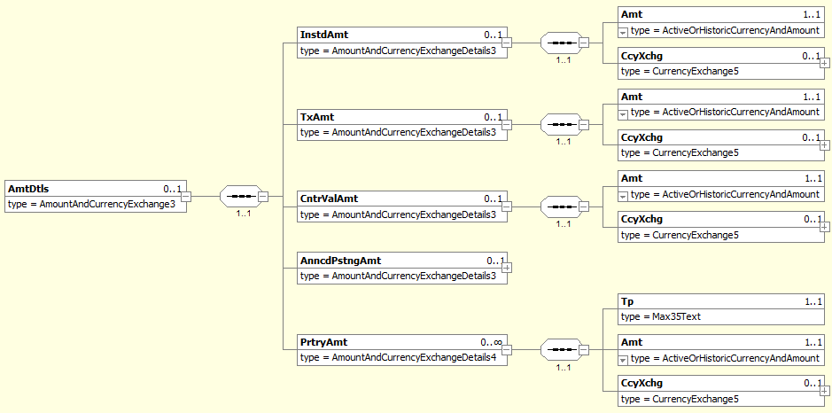
MDR Page | Item Name | XML Tag | Cardi-nality | Data type | Restrictions vs. ISO standard and additional info
123 | InstructedAmount | InstdAmt | [0..1] |  | Amount ad currency of the payment instruction.  For card transactions, this is the amount and currency entered into the ATM / POS terminal.
124 | +Amount | Amt | [1..1] | Number [18, 0..5] | Absolute instructed amount.  Cannot be negative.  This amount has the same credit/debit indicator as the entry itself.
124 | +@Currency | Ccy | [1..1] | String [3] | Instructed currency.  An attribute of the Amount element.  International currency code according to ISO 4217.
124 | +CurrencyExchange | CcyXchg | [0..1]
126 | TransactionAmount | TxAmt | [0..1] |  | Allowed only for bulk payments.
126 | +Amount | Amt | [1..1] | Number [18, 0..5] | Absolute bulk item amount.  Cannot be negative.  This amount has the same credit/debit indicator as the entry itself.
126 | +@Currency | Ccy | [1..1] | String [3] | Bulk item currency.  An attribute of the Amount element.  International currency code according to ISO 4217.
126 | +CurrencyExchange | CcyXchg | [0..1]
128 | CounterValueAmount | CntrValAmt | [0..1] |  | Present if the transaction currency differs from the account currency.
129 | +Amount | Amt | [1..1] | Number [18, 0..5] | Absolute transaction amount.  Cannot be negative.  This amount has the same credit/debit indicator as the entry itself.
129 | +@Currency | Ccy | [1..1] | String [3] | Transaction currency.  An attribute of the Amount element.  International currency code according to ISO 4217.
129 | +CurrencyExchange | CcyXchg | [0..1]
130 | ++SourceCurrency | SrcCcy | [0..1] | String [3] | The currency that enters the conversion.  International currency code according to ISO 4217.
130 | ++TargetCurrency | TrgtCcy | [0..1] | String [3] | The currency that is the result of the conversion.  International currency code according to ISO 4217.
130 | ++UnitCurrency | UnitCcy | [0..1] | String [3]
131 | ++ExchangeRate | XchgRate | [1..1] | Number [11, 0..10] | The ratio between the amounts in the target and source currency.
131 | ++ContractIdentification | CtrctId | [0..1] | String [35]
131 | ++QuotationDate | QtnDt | [0..1] | DateTime
131 | AnnouncedPostingAmount | AnncdPstngAmt | [0..1]
134 | ProprietaryAmount | PrtryAmt | [0..n]
135 | +Type | Tp | [1..1] |  | Clasifies the proprietary amount.  The value “CASHBACK” represents a card transaction cashback.  Other types of proprietary amounts are not regulated.
135 | +Amount | Amt | [1..1] | Number [18, 0..5] | Absolute cashback amount.  Cannot be negative.  This amount has the same credit/debit indicator as the entry itself.
135 | +@Currency | Ccy | [1..1] | String [3] | Cashback currency.  An attribute of the Amount element.  International currency code according to ISO 4217.
135 | +CurrencyExchange | CcyXchg | [0..1]

BankTransactionCode
Xpath | / Document / BkToCstmrStmt / Stmt / Ntry / NtryDtls [1] / TxDtls / BkTxCd

MDR Page | Item Name | XML Tag | Cardi-nality | Data type | Restrictions vs. ISO standard and additional info
142 | Domain | Domn | [0..1]
142 | Proprietary | Prtry | [1..1] |  | Always present.
142 | +Code | Cd | [1..1] | String [11] | The movement SBA transaction code.  For a list of allowed values see chapter 4.3.3.
142 | +Issuer | Issr | [1..1] | String [35] | Always “SBA”.

Charges
Xpath | / Document / BkToCstmrStmt / Stmt / Ntry / NtryDtls [1] / TxDtls / Chrgs

MDR Page | Item Name | XML Tag | Cardi-nality | Data type | Restrictions vs. ISO standard and additional info
228 | TotalChargesAndTaxAmount | TtlChrgsAndTaxAmt | [0..1]
228 | Record | Rcrd | [0..n]
230 | +Amount | Amt | [1..1] | Number [18, 0..5] | Absolute charge amount.  Cannot be negative.
230 | +@Currency | Ccy | [1..1] | String [3] | Charge currency.  An attribute of the Amount element.  International currency code according to ISO 4217
230 | +CreditDebitIndicator | CdtDbtInd | [0..1] | String Enumeration | Indicates whether the charge is being levied or returned.  Only following values are allowed:  - „CRDT“ for returned charges  - „DBIT“ for levied (and zero) charges  If omitted, it defaults to “DBIT”.
230 | +ChargeIncludedIndicator | ChrgInclInd | [0..1] | Boolean | Indicates whether the charge should be included in the amount or is added as pre-advice.  - True: Included  - False: Pre-advised
230 | +Type | Tp | [0..1]
231 | +Rate | Rate | [0..1] | Number [11, 0..10]
231 | +Bearer | Br | [0..1] | String Enumeration | Identifies the party that will bear the charge.  Only following values are allowed:  - “DEBT” – the debtor bears all charges  - “CRED” – the creditor bears all charges  - “SHAR” – each party bears the charges of its agent  - “SLEV” – the charges are distributed according to a billateral agreement between the creditor and debtor agents.
232 | + Agent | Agt | [0..1]
232 | +Tax | Tax | [0..1]

RelatedParties
Xpath | / Document / BkToCstmrStmt / Stmt / Ntry / NtryDtls [1] / TxDtls / RltdPties

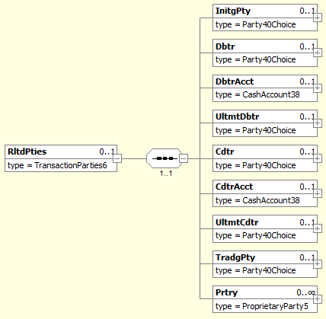
MDR Page | Item Name | XML Tag | Cardi-nality | Data type | Restrictions vs. ISO standard and additional info
201 | InitiatingParty | InitgPty | [0..1] |  | The subject who issued the payment instruction.  For card transactions, this is the card holder.  See chapter 3.3.5.3.1.5.1.
201 | Debtor | Dbtr | [0..1] |  | The owner of the debit account.  See chapter 3.3.5.3.1.5.2.
201 | DebtorAccount | DbtrAcct | [0..1] |  | See chapter 3.3.5.3.1.5.3.
202 | UltimateDebtor | UltmtDbtr | [0..1] |  | The subject on whose behalf the payment instruction was issued.  See chapter 3.3.5.3.1.5.4.
202 | Creditor | Cdtr | [0..1] |  | The owner of the credit account.  See chapter 3.3.5.3.1.5.5.
202 | CreditorAccount | CdtAcct | [0..1] |  | See chapter 3.3.5.3.1.5.6.
203 | UltimateCreditor | UltmtCdtr | [0..1] |  | The final beneficiary of the transaction.  See chapter 3.3.5.3.1.5.7.
203 | TradingParty | TradgPty | [0..1] |  | Payment initiation service provider (third party).  For card transactions, this is the merchant.  See chapter 3.3.5.3.1.5.8.
203 | Proprietary | Prtry | [0..n]

InitiatingParty
Xpath | / Document / BkToCstmrStmt / Stmt / Ntry / NtryDtls [1] / TxDtls / RltdPties / InitgPty

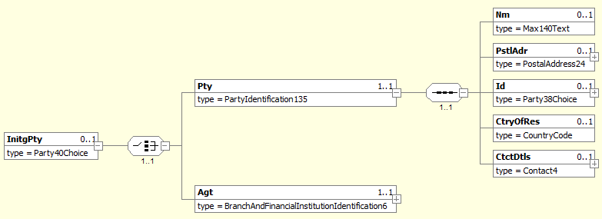
MDR Page | Item Name | XML Tag | Cardi-nality | Data type | Restrictions vs. ISO standard and additional info
286 | {Or Party | Pty | [1..1]
282 | +Name | Nm | [0..1] | String [140]
282 | +PostalAddress | PstlAdr | [0..1]
283 | +Identification | Id | [0..1]
283 | +CountryOfResidence | CtryOfRes | [0..1] | String [2]
284 | +ContactDetails | CtctDtls | [0..1]
286 | Or} Agent | Agt | [1..1]

Debtor
Xpath | / Document / BkToCstmrStmt / Stmt / Ntry / NtryDtls [1] / TxDtls / RltdPties / Dbtr

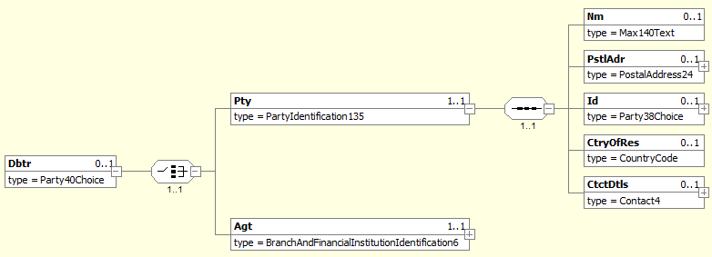
MDR Page | Item Name | XML Tag | Cardi-nality | Data type | Restrictions vs. ISO standard and additional info
286 | {Or Party | Pty | [1..1]
282 | +Name | Nm | [0..1] | String [140]
282 | +PostalAddress | PstlAdr | [0..1] |  | See chapter 3.3.5.3.1.5.2.1.
283 | +Identification | Id | [0..1] |  | See chapter 3.3.5.3.1.5.2.2
283 | +CountryOfResidence | CtryOfRes | [0..1] | String [2]
284 | +ContactDetails | CtctDtls | [0..1]
286 | Or} Agent | Agt | [1..1]

PostalAddress
Xpath | / Document / BkToCstmrStmt / Stmt / Ntry / NtryDtls [1] / TxDtls / RltdPties / Dbtr / Pty / PstlAdr

MDR Page | Item Name |  | XML Tag | Cardi-nality | Data type | Restrictions vs. ISO standard and additional info
292 | AddressType |  | AdrTp | [0..1] |  | If structured address is used, tags AddressLine are prohibited. If AddressLine is used, structured address is prohibited except Country.  Where hybrid address is allowed, the combination of structured address and 2 occurence of AddressLine may be present.
293 | +Code | Only one of these elements is present | Cd | [1..1] | String Enumeration
293 | +Proprietary |  | Prtry | [1..1]
248 | ++ Identification |  | Id | [1..1] | String [4] | Specifies an alphanumeric string with a length of 4 characters  [a-zA-Z0-9]{4}
248 | ++ Issuer |  | Issr | [1..1] | String [35]
248 | ++SchemeName |  | SchmeNm | [0..1] | String [35]
293 | Department |  | Dept | [0..1] | String [70]
293 | SubDepartment |  | SubDept | [0..1] | String [70]
294 | StreetName |  | StrtNm | [0..1] | String [70]
294 | BuildingNumber |  | BldgNb | [0..1] | String [16]
294 | BuildingName |  | BldgNm | [0..1] | String [35]
294 | Floor |  | Flr | [0..1] | String [70]
294 | PostBox |  | PstBx | [0..1] | String [16]
294 | Room |  | Room | [0..1] | String [70]
294 | PostCode |  | PstCd | [0..1] | String [16]
294 | TownName |  | TwnNm | [0..1] | String [35] | If structured address is used, at least TownName and Country is needed.
295 | TownLocationName |  | TwnLctnNm | [0..1] | String [35]
295 | DistrictName |  | DstrctNm | [0..1] | String [35]
295 | CountrySubDivision |  | CtrySubDvsn | [0..1] | String [35]
295 | Country |  | Ctry | [0..1] | String [2] | International country code according to ISO 3166-1 alpha-2.  Format [A-Z]{2,2}. In address, Country and TownName or one occurence of AddressLine is needed.
295 | AddressLine |  | AdrLine | [0..7] | String [70] | Unstructured address line. If used, structured address is prohibited except Country.  Where hybrid address is allowed, the combination of structured address and 2 occurence of AddressLine may be present.

Identification
Xpath | / Document / BkToCstmrStmt / Stmt / Ntry / NtryDtls [1] / TxDtls / RltdPties / Dbtr / Pty / Id

MDR Page | Item Name |  | XML Tag | Cardi-nality | Data type | Restrictions vs. ISO standard and additional info
284 | OrganisationIdentification | Only one of these elements is present | OrgId | [1..1] |  | Present if the debtor is a corporate subject.  See chapter 3.3.5.3.1.5.2.2.1.
285 | PrivateIdentification |  | PrvtId | [1..1] |  | Present if the debtor is a person.  See chapter 3.3.5.3.1.5.2.2.2.

OrganisationIdentification
Xpath | / Document / BkToCstmrStmt / Stmt / Ntry / NtryDtls [1] / TxDtls / RltdPties / Dbtr / Pty / Id / OrgId

MDR Page | Item Name |  | XML Tag | Cardi-nality | Data type | Restrictions vs. ISO standard and additional info
280 | AnyBIC |  | AnyBIC | [0..1] | String [11] | Recipient’s BIC according to ISO 9362.  Format [A-Z0-9]{4,4}[A-Z]{2,2}[A-Z0-9]{2,2}([A-Z0-9]{3,3}){0,1}
280 | LEI |  | LEI | [0..1] | String [20] | Legal Entity Identifier according to ISO 17442  Format [A-Z0-9]{18,18}[0-9]{2,2}
280 | Other |  | Othr | [0..n] |  | Regulated identifiers must be provided according to Table 4, other identifiers according to ISO rules.
281 | +Identification |  | Id | [1..1] | String [35] | The ID itself.
281 | +SchemeName |  | SchmeNm | [0..1]
281 | ++Code | Only one of these elements is present | Cd | [1..1] | String [4] | ID clasifier according to ISO 20022 “ExternaOrganisationIdentification” code-book.
281 | ++Proprietary |  | Prtry | [1..1] | String [35] | Proprietary ID clasifier.
281 | +Issuer |  | Issr | [0..1] | String [35] | Issuer of the ID.

PrivateIdentification
Xpath | / Document / BkToCstmrStmt / Stmt / Ntry / NtryDtls [1] / TxDtls / RltdPties / Dbtr / Pty / Id / PrvtId

MDR Page | Item Name |  | XML Tag | Cardi-nality | Data type | Restrictions vs. ISO standard and additional info
287 | DateAndPlaceOfBirth |  | DtAndPlcOfBirth | [0..1]
288 | Other |  | Othr | [0..n] |  | Regulated identifiers must be provided according to Table 5, other identifiers according to ISO rules.
288 | +Identification |  | Id | [1..1] | String [35] | The ID itself
288 | +SchemeName |  | SchmeNm | [0..1]
289 | ++Code | Only one of these elements is present | Cd | [1..1] | String [4] | ID clasifier according to ISO 20022 “ExternaPersonIdentification” code-book.
289 | ++Proprietary |  | Prtry | [1..1] | String [35] | Proprietary ID clasifier.
289 | +Issuer |  | Issr | [0..1] | String [35] | Issuer of the ID.

DebtorAccount
Xpath | / Document / BkToCstmrStmt / Stmt / Ntry / NtryDtls [1] / TxDtls / RltdPties / DbtrAcct

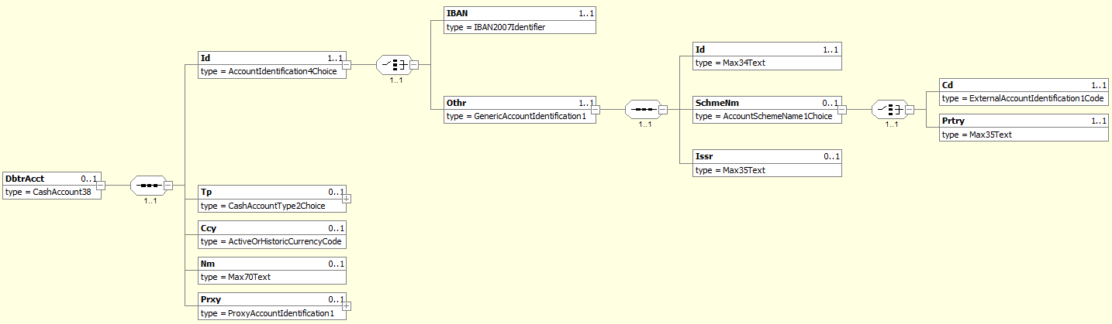
MDR Page | Item Name |  |  | XML Tag | Cardi-nality | Data type | Restrictions vs. ISO standard and additional info
118 | Identification |  |  | Id | [1..1]
120 | +IBAN | Only one of these elements is present |  | IBAN | [1..1] | String [34] | Mandatory for SEPA transactions.
120 | +Other |  |  | Othr | [1..1]
113 | ++Identification |  |  | Id | [1..1] | String [34] | Account ID in non-IBAN format.
114 | ++SchemeName |  |  | SchmeNm | [0..1]
114 | +++Code |  | Only one of these elements is present | Cd | [1..1] | String [4] | ID clasifier according to ISO 20022 “ExternalAccountIdentification” code-book.
114 | +++Proprietary |  |  | Prtry | [1..1] | String [35] | Proprietary account ID clasifier
114 | ++Issuer |  |  | Issr | [0..1] | String [35] | Issuer of the account ID.
118 | Type |  |  | Tp | [0..1]
118 | Currency |  |  | Ccy | [0..1] | String [3]
119 | Name |  |  | Nm | [0..1] | String [70]
119 | Proxy |  |  | Prxy | [0..1]

UltimateDebtor
Xpath | / Document / BkToCstmrStmt / Stmt / Ntry / NtryDtls [1] / TxDtls / RltdPties / UltmtDbtr

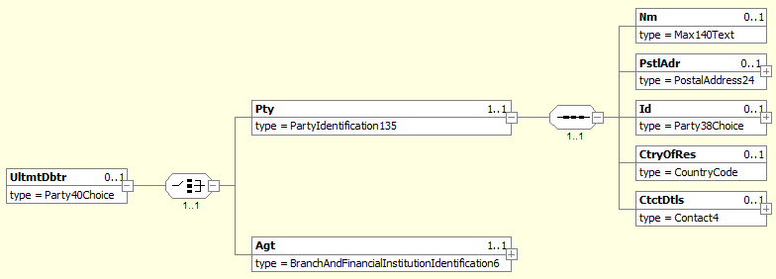
MDR Page | Item Name | XML Tag | Cardi-nality | Data type | Restrictions vs. ISO standard and additional info
286 | {Or Party | Pty | [1..1]
282 | +Name | Nm | [0..1] | String [140]
282 | +PostalAddress | PstlAdr | [0..1] |  | See chapter 3.3.5.3.1.5.4.1.
283 | +Identification | Id | [0..1] |  | See chapter 3.3.5.3.1.5.4.2.
283 | +CountryOfResidence | CtryOfRes | [0..1] | String [2]
284 | +ContactDetails | CtctDtls | [0..1]
286 | Or} Agent | Agt | [1..1]

PostalAddress
Xpath | / Document / BkToCstmrStmt / Stmt / Ntry / NtryDtls [1] / TxDtls / RltdPties / UltmtDbtr / Pty / PstlAdr

MDR Page | Item Name |  | XML Tag | Cardi-nality | Data type | Restrictions vs. ISO standard and additional info
292 | AddressType |  | AdrTp | [0..1] |  | If structured address is used, tags AddressLine are prohibited. If AddressLine is used, structured address is prohibited except Country.  Where hybrid address is allowed, the combination of structured address and 2 occurence of AddressLine may be present.
293 | +Code | Only one of these elements is present | Cd | [1..1] | String Enumeration
293 | +Proprietary |  | Prtry | [1..1]
248 | ++ Identification |  | Id | [1..1] | String [4] | Specifies an alphanumeric string with a length of 4 characters  [a-zA-Z0-9]{4}
248 | ++ Issuer |  | Issr | [1..1] | String [35]
248 | ++SchemeName |  | SchmeNm | [0..1] | String [35]
293 | Department |  | Dept | [0..1] | String [70]
293 | SubDepartment |  | SubDept | [0..1] | String [70]
294 | StreetName |  | StrtNm | [0..1] | String [70]
294 | BuildingNumber |  | BldgNb | [0..1] | String [16]
294 | BuildingName |  | BldgNm | [0..1] | String [35]
294 | Floor |  | Flr | [0..1] | String [70]
294 | PostBox |  | PstBx | [0..1] | String [16]
294 | Room |  | Room | [0..1] | String [70]
294 | PostCode |  | PstCd | [0..1] | String [16]
294 | TownName |  | TwnNm | [0..1] | String [35] | If structured address is used, at least TownName and Country is needed.
295 | TownLocationName |  | TwnLctnNm | [0..1] | String [35]
295 | DistrictName |  | DstrctNm | [0..1] | String [35]
295 | CountrySubDivision |  | CtrySubDvsn | [0..1] | String [35]
295 | Country |  | Ctry | [0..1] | String [2] | International country code according to ISO 3166-1 alpha-2.  Format [A-Z]{2,2}. In address, Country and TownName or one occurence of AddressLine is needed.
295 | AddressLine |  | AdrLine | [0..7] | String [70] | Unstructured address line. If used, structured address is prohibited except Country.  Where hybrid address is allowed, the combination of structured address and 2 occurence of AddressLine may be present.

Identification
Xpath | / Document / BkToCstmrStmt / Stmt / Ntry / NtryDtls [1] / TxDtls / RltdPties / UltmtDbtr / Pty / Id

MDR Page | Item Name |  | XML Tag | Cardi-nality | Data type | Restrictions vs. ISO standard and additional info
284 | OrganisationIdentification | Only one of these elements is present | OrgId | [1..1] |  | Present if the ultimate debtor is a corporate subject.  See chapter 3.3.5.3.1.5.4.2.1.
285 | PrivateIdentification |  | PrvtId | [1..1] |  | Present if the ultimate debtor is a person.  See chapter 3.3.5.3.1.5.4.2.2.

OrganisationIdentification
Xpath | / Document / BkToCstmrStmt / Stmt / Ntry / NtryDtls [1] / TxDtls / RltdPties / UltmtDbtr / Pty / Id / OrgId

MDR Page | Item Name |  | XML Tag | Cardi-nality | Data type | Restrictions vs. ISO standard and additional info
280 | AnyBIC |  | AnyBIC | [0..1] | String [11] | Recipient’s BIC according to ISO 9362.  Format [A-Z0-9]{4,4}[A-Z]{2,2}[A-Z0-9]{2,2}([A-Z0-9]{3,3}){0,1}
280 | LEI |  | LEI | [0..1] | String [20] | Legal Entity Identifier according to ISO 17442  Format [A-Z0-9]{18,18}[0-9]{2,2}
280 | Other |  | Othr | [0..n] |  | Regulated identifiers must be provided according to Table 4, other identifiers according to ISO rules.
281 | +Identification |  | Id | [1..1] | String [35] | The ID itself.
281 | +SchemeName |  | SchmeNm | [0..1]
281 | ++Code | Only one of these elements is present | Cd | [1..1] | String [4] | ID clasifier according to ISO 20022 “ExternaOrganisationIdentification” code-book.
281 | ++Proprietary |  | Prtry | [1..1] | String [35] | Proprietary ID clasifier.
281 | +Issuer |  | Issr | [0..1] | String [35] | Issuer of the ID.

PrivateIdentification
Xpath | / Document / BkToCstmrStmt / Stmt / Ntry / NtryDtls [1] / TxDtls / RltdPties / UltmtDbtr / Pty / Id / PrvtId

MDR Page | Item Name |  | XML Tag | Cardi-nality | Data type | Restrictions vs. ISO standard and additional info
287 | DateAndPlaceOfBirth |  | DtAndPlcOfBirth | [0..1]
288 | Other |  | Othr | [0..n] |  | Regulated identifiers must be provided according to Table 5, other identifiers according to ISO rules.
288 | +Identification |  | Id | [1..1] | String [35] | The ID itself
288 | +SchemeName |  | SchmeNm | [0..1]
289 | ++Code | Only one of these elements is present | Cd | [1..1] | String [4] | ID clasifier according to ISO 20022 “ExternaPersonIdentification” code-book.
289 | ++Proprietary |  | Prtry | [1..1] | String [35] | Proprietary ID clasifier.
289 | +Issuer |  | Issr | [0..1] | String [35] | Issuer of the ID.

Creditor
XPath | / Document / BkToCstmrStmt / Stmt / Ntry / NtryDtls [1] / TxDtls / RltdPties / Cdtr

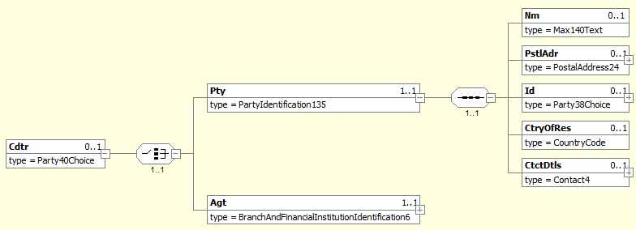
MDR Page | Item Name | XML Tag | Cardi-nality | Data type | Restrictions vs. ISO standard and additional info
286 | {Or Party | Pty | [1..1]
282 | +Name | Nm | [0..1] | String [140]
282 | +PostalAddress | PstlAdr | [0..1] |  | See chapter 3.3.5.3.1.5.5.1
283 | +Identification | Id | [0..1] |  | See chapter 3.3.5.3.1.5.5.2
283 | +CountryOfResidence | CtryOfRes | [0..1] | String [2]
284 | +ContactDetails | CtctDtls | [0..1]
286 | Or} Agent | Agt | [1..1]

PostalAddress
XPath | / Document / BkToCstmrStmt / Stmt / Ntry / NtryDtls [1] / TxDtls / RltdPties / Cdtr / Pty / PstlAdr

MDR Page | Item Name |  | XML Tag | Cardi-nality | Data type | Restrictions vs. ISO standard and additional info
292 | AddressType |  | AdrTp | [0..1] |  | If structured address is used, tags AddressLine are prohibited. If AddressLine is used, structured address is prohibited except Country.  Where hybrid address is allowed, the combination of structured address and 2 occurence of AddressLine may be present.
293 | +Code | Only one of these elements is present | Cd | [1..1] | String Enumeration
293 | +Proprietary |  | Prtry | [1..1]
248 | ++ Identification |  | Id | [1..1] | String [4] | Specifies an alphanumeric string with a length of 4 characters  [a-zA-Z0-9]{4}
248 | ++ Issuer |  | Issr | [1..1] | String [35]
248 | ++SchemeName |  | SchmeNm | [0..1] | String [35]
293 | Department |  | Dept | [0..1] | String [70]
293 | SubDepartment |  | SubDept | [0..1] | String [70]
294 | StreetName |  | StrtNm | [0..1] | String [70]
294 | BuildingNumber |  | BldgNb | [0..1] | String [16]
294 | BuildingName |  | BldgNm | [0..1] | String [35]
294 | Floor |  | Flr | [0..1] | String [70]
294 | PostBox |  | PstBx | [0..1] | String [16]
294 | Room |  | Room | [0..1] | String [70]
294 | PostCode |  | PstCd | [0..1] | String [16]
294 | TownName |  | TwnNm | [0..1] | String [35] | If structured address is used, at least TownName and Country is needed.
295 | TownLocationName |  | TwnLctnNm | [0..1] | String [35]
295 | DistrictName |  | DstrctNm | [0..1] | String [35]
295 | CountrySubDivision |  | CtrySubDvsn | [0..1] | String [35]
295 | Country |  | Ctry | [0..1] | String [2] | International country code according to ISO 3166-1 alpha-2.  Format [A-Z]{2,2}. In address, Country and TownName or one occurence of AddressLine is needed.
295 | AddressLine |  | AdrLine | [0..7] | String [70] | Unstructured address line. If used, structured address is prohibited except Country.  Where hybrid address is allowed, the combination of structured address and 2 occurence of AddressLine may be present.

Identification
XPath | / Document / BkToCstmrStmt / Stmt / Ntry / NtryDtls [1] / TxDtls / RltdPties / Cdtr / Pty / Id

MDR Page | Item Name |  | XML Tag | Cardi-nality | Data type | Restrictions vs. ISO standard and additional info
284 | OrganisationIdentification | Only one of these elements is present | OrgId | [1..1] |  | Present if the debtor is a corporate subject.  See chapter 3.3.5.3.1.5.5.2.1
285 | PrivateIdentification |  | PrvtId | [1..1] |  | Present if the debtor is a person.  See chapter 3.3.5.3.1.5.5.2.2

OrganisationIdentification
XPath | / Document / BkToCstmrStmt / Stmt / Ntry / NtryDtls [1] / TxDtls / RltdPties / Cdtr / Pty / Id / OrgId

MDR Page | Item Name |  | XML Tag | Cardi-nality | Data type | Restrictions vs. ISO standard and additional info
280 | AnyBIC |  | AnyBIC | [0..1] | String [11] | Recipient’s BIC according to ISO 9362.  Format [A-Z0-9]{4,4}[A-Z]{2,2}[A-Z0-9]{2,2}([A-Z0-9]{3,3}){0,1}
280 | LEI |  | LEI | [0..1] | String [20] | Legal Entity Identifier according to ISO 17442  Format [A-Z0-9]{18,18}[0-9]{2,2}
280 | Other |  | Othr | [0..n] |  | No more than one instance present for non-SDD transactions.  For SDD transactions, an additional instance containing the SDD CreditorID and distinguishable by SchmeNm/Prtry = “CID” may be present.
281 | +Identification |  | Id | [1..1] | String [35] | Creditor ID.  For SDD transactions, if SchmeNm/Prtry=”CID”, this is the SDD CID.
281 | +SchemeName |  | SchmeNm | [0..1]
281 | ++Code | Only one of these elements is present | Cd | [1..1] | String [4] | Creditor ID clasifier according to ISO “ExternalOrganisationIdentification” code-book.
281 | ++Proprietary |  | Prtry | [1..1] | String [35] | Proprietary creditor ID clasifier.  For SDD transactions, the value “CID” indicates an SDD CreditorID.
281 | +Issuer |  | Issr | [0..1] | String [35] | Issuer of the ID.

PrivateIdentification
Xpath | / Document / BkToCstmrStmt / Stmt / Ntry / NtryDtls [1] / TxDtls / RltdPties / Cdtr / Pty / Id / PrvtId

MDR Page | Item Name |  | XML Tag | Cardi-nality | Data type | Restrictions vs. ISO standard and additional info
287 | DateAndPlaceOfBirth |  | DtAndPlcOfBirth | [0..1]
288 | Other |  | Othr | [0..n] |  | No more than one instance present for non-SDD transactions.  For SDD transactions, an additional instance containing the SDD CreditorID and distinguishable by SchmeNm/Prtry = “CID” may be present.
288 | +Identification |  | Id | [1..1] | String [35] | Creditor ID.  For SDD transactions, if SchmeNm/Prtry=”CID”, this is the SDD CID.
288 | +SchemeName |  | SchmeNm | [0..1]
289 | ++Code | Only one of these elements is present | Cd | [1..1] | String [4] | Creditor ID clasifier according to ISO “ExternalOrganisationIdentification” code-book.
289 | ++Proprietary |  | Prtry | [1..1] | String [35] | Proprietary creditor ID clasifier.  For SDD transactions, the value “CID” indicates an SDD CreditorID.
289 | +Issuer |  | Issr | [0..1] | String [35] | Issuer of the ID.

CreditorAccount
XPath | / Document / BkToCstmrStmt / Stmt / Ntry / NtryDtls [1] / TxDtls / RltdPties / CdtrAcct

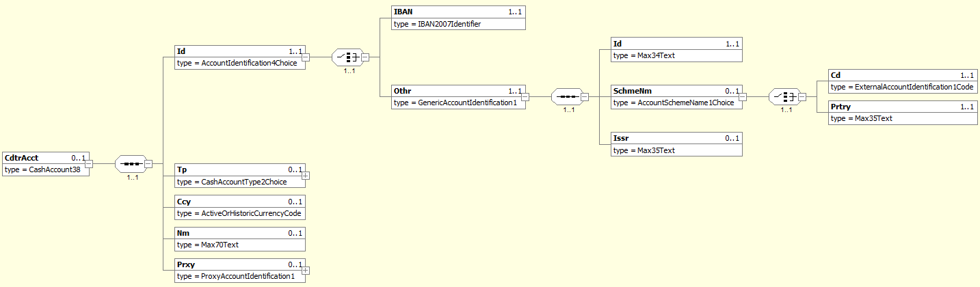
MDR Page | Item Name |  |  | XML Tag | Cardi-nality | Data type | Restrictions vs. ISO standard and additional info
118 | Identification |  |  | Id | [1..1]
120 | +IBAN | Only one of these elements is present |  | IBAN | [0..1] | String [34] | Mandatory for SEPA transactions.
120 | +Other |  |  | Othr | [0..1]
113 | ++Identification |  |  | Id | [1..1] | String [34] | Account ID in non-IBAN format.
114 | ++SchemeName |  |  | SchmeNm | [0..1]
114 | +++Code |  | Only one of these elements is present | Cd | [1..1] | String [4] | ID clasifier according to ISO 20022 “ExternalAccountIdentification” code-book.
114 | +++Proprietary |  |  | Prtry | [1..1] | String [35] | Proprietary account ID clasifier
114 | ++Issuer |  |  | Issr | [0..1] | String [35] | Issuer of the account ID.
118 | Type |  |  | Tp | [0..1]
118 | Currency |  |  | Ccy | [0..1] | String [3]
119 | Name |  |  | Nm | [0..1] | String [70]
119 | Proxy |  |  | Prxy | [0..1]

UltimateCreditor
XPath | / Document / BkToCstmrStmt / Stmt / Ntry / NtryDtls [1] / TxDtls / RltdPties / UltmtCdtr

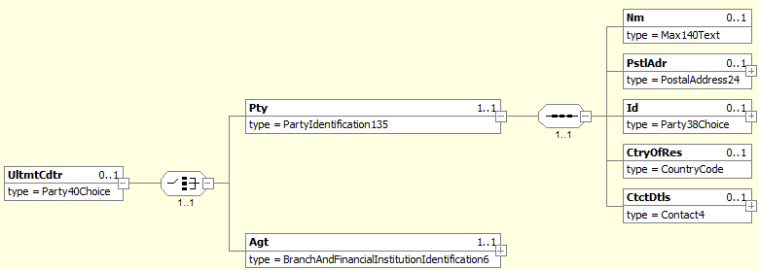
MDR Page | Item Name | XML Tag | Cardi-nality | Data type | Restrictions vs. ISO standard and additional info
286 | {Or Party | Pty | [1..1]
282 | +Name | Nm | [0..1] | String [140]
282 | +PostalAddress | PstlAdr | [0..1] |  | See chapter 3.3.5.3.1.5.7.1.
283 | +Identification | Id | [0..1] |  | See chapter 3.3.5.3.1.5.7.2.
283 | +CountryOfResidence | CtryOfRes | [0..1] | String [2]
284 | +ContactDetails | CtctDtls | [0..1]
286 | Or} Agent | Agt | [1..1] |  | Not used

PostalAddress
XPath | / Document / BkToCstmrStmt / Stmt / Ntry / NtryDtls [1] / TxDtls / RltdPties / UltmtCdtr / Pty / PstlAdr

MDR Page | Item Name |  | XML Tag | Cardi-nality | Data type | Restrictions vs. ISO standard and additional info
292 | AddressType |  | AdrTp | [0..1] |  | If structured address is used, tags AddressLine are prohibited. If AddressLine is used, structured address is prohibited except Country.  Where hybrid address is allowed, the combination of structured address and 2 occurence of AddressLine may be present.
293 | +Code | Only one of these elements is present | Cd | [1..1] | String Enumeration
293 | +Proprietary |  | Prtry | [1..1]
248 | ++ Identification |  | Id | [1..1] | String [4] | Specifies an alphanumeric string with a length of 4 characters  [a-zA-Z0-9]{4}
248 | ++ Issuer |  | Issr | [1..1] | String [35]
248 | ++SchemeName |  | SchmeNm | [0..1] | String [35]
293 | Department |  | Dept | [0..1] | String [70]
293 | SubDepartment |  | SubDept | [0..1] | String [70]
294 | StreetName |  | StrtNm | [0..1] | String [70]
294 | BuildingNumber |  | BldgNb | [0..1] | String [16]
294 | BuildingName |  | BldgNm | [0..1] | String [35]
294 | Floor |  | Flr | [0..1] | String [70]
294 | PostBox |  | PstBx | [0..1] | String [16]
294 | Room |  | Room | [0..1] | String [70]
294 | PostCode |  | PstCd | [0..1] | String [16]
294 | TownName |  | TwnNm | [0..1] | String [35] | If structured address is used, at least TownName and Country is needed.
295 | TownLocationName |  | TwnLctnNm | [0..1] | String [35]
295 | DistrictName |  | DstrctNm | [0..1] | String [35]
295 | CountrySubDivision |  | CtrySubDvsn | [0..1] | String [35]
295 | Country |  | Ctry | [0..1] | String [2] | International country code according to ISO 3166-1 alpha-2.  Format [A-Z]{2,2}. In address, Country and TownName or one occurence of AddressLine is needed.
295 | AddressLine |  | AdrLine | [0..7] | String [70] | Unstructured address line. If used, structured address is prohibited except Country.  Where hybrid address is allowed, the combination of structured address and 2 occurence of AddressLine may be present.

Identification
XPath | / Document / BkToCstmrStmt / Stmt / Ntry / NtryDtls [1] / TxDtls / RltdPties / UltmtCdtr / Pty / Id

MDR Page | Item Name |  | XML Tag | Cardi-nality | Data type | Restrictions vs. ISO standard and additional info
284 | OrganisationIdentification | Only one of these elements is present | OrgId | [1..1] |  | Present if the ultimate creditor is a corporate subject.  See chapter 3.3.5.3.1.5.7.2.1.
285 | PrivateIdentification |  | PrvtId | [1..1] |  | Present if the ultimate creditor is a person.  See chapter 3.3.5.3.1.5.7.2.2.

OrganisationIdentification
XPath | / Document / BkToCstmrStmt / Stmt / Ntry / NtryDtls [1] / TxDtls / RltdPties / UltmtCdtr / Pty / Id / OrgId

MDR Page | Item Name |  | XML Tag | Cardi-nality | Data type | Restrictions vs. ISO standard and additional info
280 | AnyBIC |  | AnyBIC | [0..1] | String [11] | Recipient’s BIC according to ISO 9362.  Format [A-Z0-9]{4,4}[A-Z]{2,2}[A-Z0-9]{2,2}([A-Z0-9]{3,3}){0,1}
280 | LEI |  | LEI | [0..1] | String [20] | Legal Entity Identifier according to ISO 17442  Format [A-Z0-9]{18,18}[0-9]{2,2}
280 | Other |  | Othr | [0..n] |  | Regulated identifiers must be provided according to Table 4, other identifiers according to ISO rules.
281 | +Identification |  | Id | [1..1] | String [35] | The ID itself.
281 | +SchemeName |  | SchmeNm | [0..1]
281 | ++Code | Only one of these elements is present | Cd | [1..1] | String [4] | ID clasifier according to ISO 20022 “ExternaOrganisationIdentification” code-book.
281 | ++Proprietary |  | Prtry | [1..1] | String [35] | Proprietary ID clasifier.
281 | +Issuer |  | Issr | [0..1] | String [35] | Issuer of the ID.

PrivateIdentification
XPath | / Document / BkToCstmrStmt / Stmt / Ntry / NtryDtls [1] / TxDtls / RltdPties / UltmtCdtr / Pty / Id / PrvtId

MDR Page | Item Name |  | XML Tag | Cardi-nality | Data type | Restrictions vs. ISO standard and additional info
287 | DateAndPlaceOfBirth |  | DtAndPlcOfBirth | [0..1]
288 | Other |  | Othr | [0..n] |  | Regulated identifiers must be provided according to Table 5, other identifiers according to ISO rules.
288 | +Identification |  | Id | [1..1] | String [35] | The ID itself
288 | +SchemeName |  | SchmeNm | [0..1]
289 | ++Code | Only one of these elements is present | Cd | [1..1] | String [4] | ID clasifier according to ISO 20022 “ExternaPersonIdentification” code-book.
289 | ++Proprietary |  | Prtry | [1..1] | String [35] | Proprietary ID clasifier.
289 | +Issuer |  | Issr | [0..1] | String [35] | Issuer of the ID.

TradingParty
XPath | / Document / BkToCstmrStmt / Stmt / Ntry / NtryDtls [1] / TxDtls / RltdPties / TradgPty

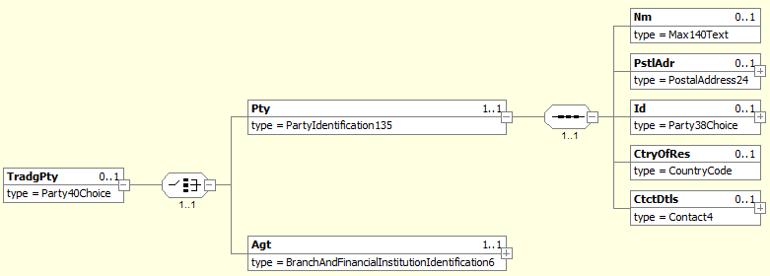
MDR Page | Item Name | XML Tag | Cardi-nality | Data type | Restrictions vs. ISO standard and additional info
286 | {Or Party | Pty | [1..1]
9.1.0 | +Name | Nm | [0..1] | String [140] | Payment initiation service provider name (third party).
9.1.1 | +PostalAddress | PstlAdr | [0..1]
9.1.12 | +Identification | Id | [0..1] |  | See chapter 3.3.5.3.1.5.8.1.
9.1.33 | +CountryOfResidence | CtryOfRes | [0..1] | String [2]
9.1.34 | +ContactDetails | CtctDtls | [0..1]
286 | Or} Agent | Agt | [1..1] |  | Not used

Identification
XPath | / Document / BkToCstmrStmt / Stmt / Ntry / NtryDtls [1] / TxDtls / RltdPties / TradgPty / Pty / Id

MDR Page | Item Name |  | XML Tag | Cardi-nality | Data type | Restrictions vs. ISO standard and additional info
284 | OrganisationIdentification | Only one of these elements is present | OrgId | [1..1] |  | Present if the PISP (third party) / merchant is a corporate subject.  See chapter 3.3.5.3.1.5.8.1.1.
285 | PrivateIdentification |  | PrvtId | [1..1] |  | Present if the PISP (third party) / merchant is a person.  See chapter 3.3.5.3.1.5.8.1.2.

OrganisationIdentification
XPath | / Document / BkToCstmrStmt / Stmt / Ntry / NtryDtls [1] / TxDtls / RltdPties / TradgPty / Pty / Id / OrgId

MDR Page | Item Name |  | XML Tag | Cardi-nality | Data type | Restrictions vs. ISO standard and additional info
280 | AnyBIC |  | AnyBIC | [0..1] | String [11] | BIC according to ISO 9362.  Format [A-Z0-9]{4,4}[A-Z]{2,2}[A-Z0-9]{2,2}([A-Z0-9]{3,3}){0,1}
280 | LEI |  | LEI | [0..1] | String [20] | Legal Entity Identifier according to ISO 17442  Format [A-Z0-9]{18,18}[0-9]{2,2}
280 | Other |  | Othr | [0..n]
281 | +Identification |  | Id | [1..1] | String [35] | ID of the Payment initiation service provider (third party).
281 | +SchemeName |  | SchmeNm | [0..1]
281 | ++Code | Only one of these elements is present | Cd | [1..1] | String [4] | For certified PISP (third party) code CBID is used.
281 | ++Proprietary |  | Prtry | [1..1] | String [35] | Proprietary ID clasifier.
281 | +Issuer |  | Issr | [0..1] | String [35] | Issuer of the ID.

PrivateIdentification
XPath | / Document / BkToCstmrStmt / Stmt / Ntry / NtryDtls [1] / TxDtls / RltdPties / TradgPty / Pty / Id / PrvtId

MDR Page | Item Name |  | XML Tag | Cardi-nality | Data type | Restrictions vs. ISO standard and additional info
287 | DateAndPlaceOfBirth |  | DtAndPlcOfBirth | [0..1]
288 | Other |  | Othr | [0..n]
288 | +Identification |  | Id | [1..1] | String [35] | ID of the Payment initiation service provider (third party).
288 | +SchemeName |  | SchmeNm | [0..1]
289 | ++Code | Only one of these elements is present | Cd | [1..1] | String [4] | For certified PISP (third party) code CBID is used.
289 | ++Proprietary |  | Prtry | [1..1] | String [35] | Proprietary ID clasifier.
289 | +Issuer |  | Issr | [0..1] | String [35] | Issuer of the ID.

RelatedAgents
XPath | / Document / BkToCstmrStmt / Stmt / Ntry / NtryDtls [1] / TxDtls / RltdAgts

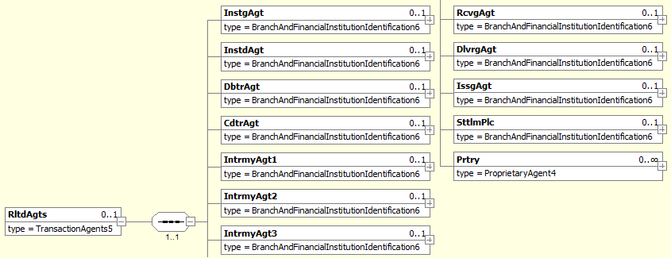
MDR Page | Item Name | XML Tag | Cardi-nality | Data type | Restrictions vs. ISO standard and additional info
205 | InstructingAgent | InstgAgt | [0..1]
205 | InstructedAgent | InstdAgt | [0..1]
206 | DebtorAgent | DbtrAgt | [0..1] |  | See chapter 3.3.5.3.1.6.1.
206 | CreditorAgent | CdtrAgt | [0..1] |  | See chapter 3.3.5.3.1.6.2.
206 | IntermediaryAgent1 | IntrmyAgt1 | [0..1] |  | May be present for SWIFT transactions.  SWIFT correspondent bank.  See chapter 3.3.5.3.1.6.3.
206 | IntermediaryAgent2 | IntrmyAgt2 | [0..1]
207 | IntermediaryAgent3 | IntrmyAgt3 | [0..1]
207 | ReceivingAgent | RcvgAgt | [0..1]
207 | DeliveringAgent | DlvrgAgt | [0..1]
208 | IssuingAgent | IssgAgt | [0..1]
208 | SettlementPlace | SttlmPlc | [0..1] |  | May be present for SEPA transactions.  SEPA clearing house.  See chapter 3.3.5.3.1.6.4.
208 | Proprietary | Prtry | [0..n] |  | May be present for card transactions.  One instance for the Issuer and one for the Acquier.  See chapter 3.3.5.3.1.6.5.

DebtorAgent
XPath | / Document / BkToCstmrStmt / Stmt / Ntry / NtryDtls [1] / TxDtls / RltdAgts / DbtrAgt

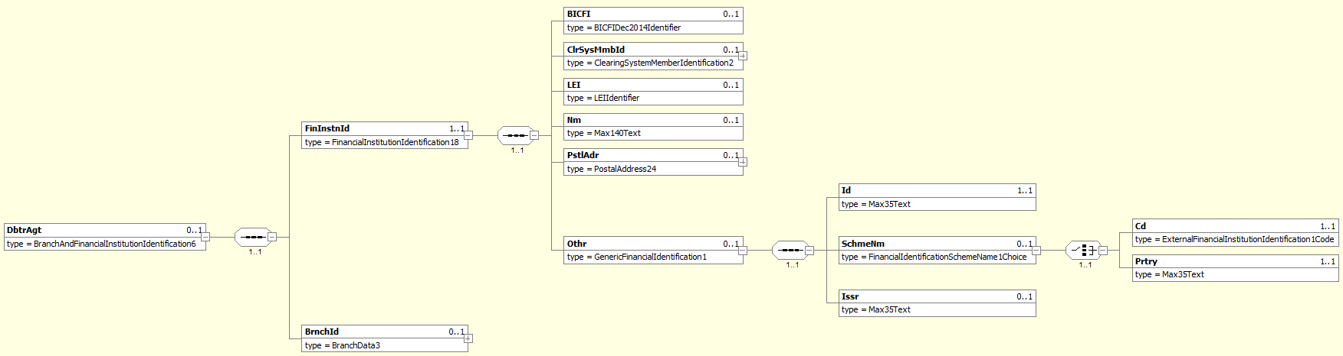
MDR Page | Item Name |  | XML Tag | Cardi-nality | Data type | Restrictions vs. ISO standard and additional info
242 | FinancialInstitutionIdentification |  | FinInstnId | [1..1]
238 | +BICFI |  | BICFI | [0..1] | String [11] | Debtor agent BIC according to ISO 9362.  Format: [A-Z0-9]{4,4}[A-Z]{2,2}[A-Z0-9]{2,2}([A-Z0-9]{3,3}){0,1}
239 | +ClearingSystemMemberIdentification |  | ClrSysMmbId | [0..1]
239 | +LEI |  | LEI | [0..1] | String [20] | Legal Entity Identifier according to ISO 17442  Format [A-Z0-9]{18,18}[0-9]{2,2}
239 | +Name |  | Nm | [0..1] | String [140]
239 | +PostalAddress |  | PstlAdr | [0..1] |  | See chapter 3.3.5.3.1.6.1.1.
240 | +Other |  | Othr | [0..1]
243 | ++Identification |  | Id | [1..1] | String [4] | EuroSIPS bank code.
244 | ++SchemeName |  | SchmeNm | [0..1]
244 | +++Code | Only one of these elements is present | Cd | [0..0] | String [4] | Prohibited.
244 | +++Proprietary |  | Prtry | [1..1] | String [35] | Always present, always equals “EuroSIPS Bank Code”.
244 | ++Issuer |  | Issr | [0..1] | String [35] | Always equals “NBS”.
243 | BranchIdentification |  | BrnchId | [0..1]

PostalAddress
XPath | / Document / BkToCstmrStmt / Stmt / Ntry / NtryDtls [1] / TxDtls / RltdAgts / DbtrAgt / FinInstnId / PstlAdr

MDR Page | Item Name |  | XML Tag | Cardi-nality | Data type | Restrictions vs. ISO standard and additional info
292 | AddressType |  | AdrTp | [0..1] |  | If structured address is used, tags AddressLine are prohibited. If AddressLine is used, structured address is prohibited except Country.  Where hybrid address is allowed, the combination of structured address and 2 occurence of AddressLine may be present.
293 | +Code | Only one of these elements is present | Cd | [1..1] | String Enumeration
293 | +Proprietary |  | Prtry | [1..1]
248 | ++ Identification |  | Id | [1..1] | String [4] | Specifies an alphanumeric string with a length of 4 characters  [a-zA-Z0-9]{4}
248 | ++ Issuer |  | Issr | [1..1] | String [35]
248 | ++SchemeName |  | SchmeNm | [0..1] | String [35]
293 | Department |  | Dept | [0..1] | String [70]
293 | SubDepartment |  | SubDept | [0..1] | String [70]
294 | StreetName |  | StrtNm | [0..1] | String [70]
294 | BuildingNumber |  | BldgNb | [0..1] | String [16]
294 | BuildingName |  | BldgNm | [0..1] | String [35]
294 | Floor |  | Flr | [0..1] | String [70]
294 | PostBox |  | PstBx | [0..1] | String [16]
294 | Room |  | Room | [0..1] | String [70]
294 | PostCode |  | PstCd | [0..1] | String [16]
294 | TownName |  | TwnNm | [0..1] | String [35] | If structured address is used, at least TownName and Country is needed.
295 | TownLocationName |  | TwnLctnNm | [0..1] | String [35]
295 | DistrictName |  | DstrctNm | [0..1] | String [35]
295 | CountrySubDivision |  | CtrySubDvsn | [0..1] | String [35]
295 | Country |  | Ctry | [0..1] | String [2] | International country code according to ISO 3166-1 alpha-2.  Format [A-Z]{2,2}. In address, Country and TownName or one occurence of AddressLine is needed.
295 | AddressLine |  | AdrLine | [0..7] | String [70] | Unstructured address line. If used, structured address is prohibited except Country.  Where hybrid address is allowed, the combination of structured address and 2 occurence of AddressLine may be present.

CreditorAgent
XPath | / Document / BkToCstmrStmt / Stmt / Ntry / NtryDtls [1] / TxDtls / RltdAgts / CdtrAgt

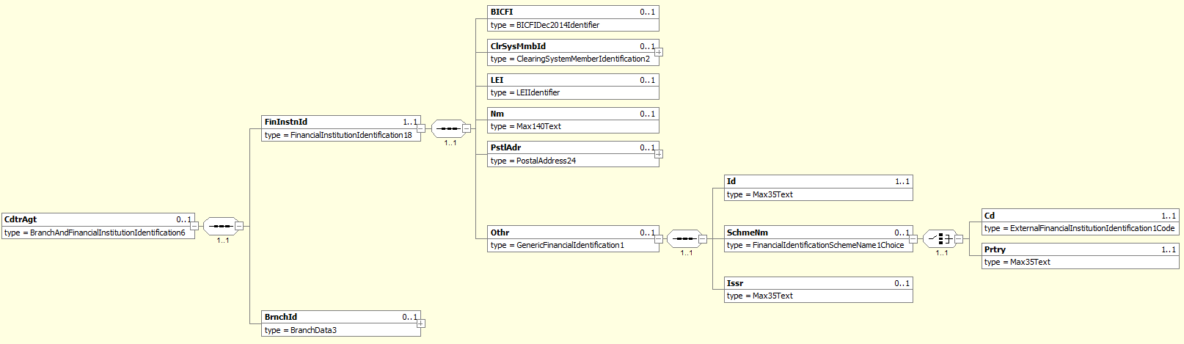
MDR Page | Item Name |  | XML Tag | Cardi-nality | Data type | Restrictions vs. ISO standard and additional info
242 | FinancialInstitutionIdentification |  | FinInstnId | [1..1]
238 | +BICFI |  | BICFI | [0..1] | String [11] | Creditor agent BIC according to ISO 9362.  Format: [A-Z0-9]{4,4}[A-Z]{2,2}[A-Z0-9]{2,2}([A-Z0-9]{3,3}){0,1}
239 | +ClearingSystemMemberIdentification |  | ClrSysMmbId | [0..1]
239 | +LEI |  | LEI | [0..1] | String [20] | Legal Entity Identifier according to ISO 17442  Format [A-Z0-9]{18,18}[0-9]{2,2}
239 | +Name |  | Nm | [0..1] | String [140]
239 | +PostalAddress |  | PstlAdr | [0..1] |  | See chapter 3.3.5.3.1.6.2.1.
240 | +Other |  | Othr | [0..1]
243 | ++Identification |  | Id | [1..1] | String [4] | EuroSIPS bank code.
244 | ++SchemeName |  | SchmeNm | [0..1]
244 | +++Code | Only one of these elements is present | Cd | [0..0] | String [4] | Prohibited.
244 | +++Proprietary |  | Prtry | [1..1] | String [35] | Always present, always equals “EuroSIPS Bank Code”.
244 | ++Issuer |  | Issr | [0..1] | String [35] | Always equals “NBS”.
243 | BranchIdentification |  | BrnchId | [0..1]

PostalAddress
XPath | / Document / BkToCstmrStmt / Stmt / Ntry / NtryDtls [1] / TxDtls / RltdAgts / CdtrAgt / FinInstnId / PstlAdr

MDR Page | Item Name |  | XML Tag | Cardi-nality | Data type | Restrictions vs. ISO standard and additional info
292 | AddressType |  | AdrTp | [0..1] |  | If structured address is used, tags AddressLine are prohibited. If AddressLine is used, structured address is prohibited except Country.  Where hybrid address is allowed, the combination of structured address and 2 occurence of AddressLine may be present.
293 | +Code | Only one of these elements is present | Cd | [1..1] | String Enumeration
293 | +Proprietary |  | Prtry | [1..1]
248 | ++ Identification |  | Id | [1..1] | String [4] | Specifies an alphanumeric string with a length of 4 characters  [a-zA-Z0-9]{4}
248 | ++ Issuer |  | Issr | [1..1] | String [35]
248 | ++SchemeName |  | SchmeNm | [0..1] | String [35]
293 | Department |  | Dept | [0..1] | String [70]
293 | SubDepartment |  | SubDept | [0..1] | String [70]
294 | StreetName |  | StrtNm | [0..1] | String [70]
294 | BuildingNumber |  | BldgNb | [0..1] | String [16]
294 | BuildingName |  | BldgNm | [0..1] | String [35]
294 | Floor |  | Flr | [0..1] | String [70]
294 | PostBox |  | PstBx | [0..1] | String [16]
294 | Room |  | Room | [0..1] | String [70]
294 | PostCode |  | PstCd | [0..1] | String [16]
294 | TownName |  | TwnNm | [0..1] | String [35] | If structured address is used, at least TownName and Country is needed.
295 | TownLocationName |  | TwnLctnNm | [0..1] | String [35]
295 | DistrictName |  | DstrctNm | [0..1] | String [35]
295 | CountrySubDivision |  | CtrySubDvsn | [0..1] | String [35]
295 | Country |  | Ctry | [0..1] | String [2] | International country code according to ISO 3166-1 alpha-2.  Format [A-Z]{2,2}. In address, Country and TownName or one occurence of AddressLine is needed.
295 | AddressLine |  | AdrLine | [0..7] | String [70] | Unstructured address line. If used, structured address is prohibited except Country.  Where hybrid address is allowed, the combination of structured address and 2 occurence of AddressLine may be present.

IntermediaryAgent1
XPath | / Document / BkToCstmrStmt / Stmt / Ntry / NtryDtls [1] / TxDtls / RltdAgts / IntrmyAgt1

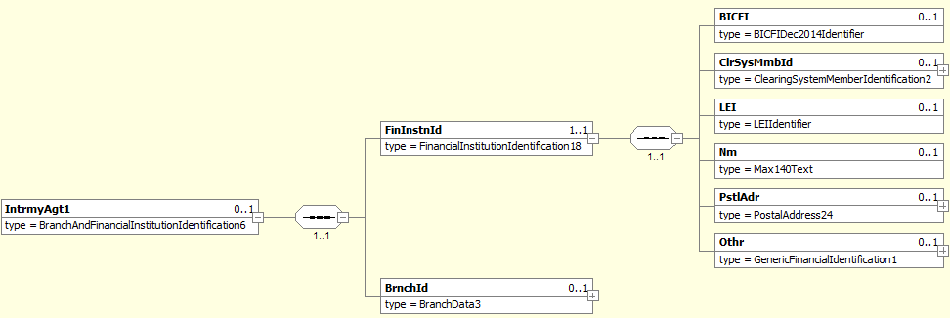
MDR Page | Item Name | XML Tag | Cardi-nality | Data type | Restrictions vs. ISO standard and additional info
242 | FinancialInstitutionIdentification | FinInstnId | [1..1]
238 | +BICFI | BICFI | [0..1] | String [11] | BIC of the SWIFT correspondent bank according to ISO 9362.  Format [A-Z0-9]{4,4}[A-Z]{2,2}[A-Z0-9]{2,2}([A-Z0-9]{3,3}){0,1}.
239 | +ClearingSystemMemberIdentification | ClrSysMmbId | [0..1]
239 | +LEI | LEI | [0..1] | String [20] | Legal Entity Identifier according to ISO 17442  Format [A-Z0-9]{18,18}[0-9]{2,2}
239 | +Name | Nm | [0..1] | String [140]
239 | +PostalAddress | PstlAdr | [0..1] |  | See chapter 3.3.5.3.1.6.3.1.
240 | +Other | Othr | [0..1]
243 | BranchIdentification | BrnchId | [0..1]

PostalAddress
XPath | / Document / BkToCstmrStmt / Stmt / Ntry / NtryDtls [1] / TxDtls / RltdAgts / IntrmyAgt1 / FinInstnId / PstlAdr

MDR Page | Item Name |  | XML Tag | Cardi-nality | Data type | Restrictions vs. ISO standard and additional info
292 | AddressType |  | AdrTp | [0..1] |  | If structured address is used, tags AddressLine are prohibited. If AddressLine is used, structured address is prohibited except Country.  Where hybrid address is allowed, the combination of structured address and 2 occurence of AddressLine may be present.
293 | +Code | Only one of these elements is present | Cd | [1..1] | String Enumeration
293 | +Proprietary |  | Prtry | [1..1]
248 | ++ Identification |  | Id | [1..1] | String [4] | Specifies an alphanumeric string with a length of 4 characters  [a-zA-Z0-9]{4}
248 | ++ Issuer |  | Issr | [1..1] | String [35]
248 | ++SchemeName |  | SchmeNm | [0..1] | String [35]
293 | Department |  | Dept | [0..1] | String [70]
293 | SubDepartment |  | SubDept | [0..1] | String [70]
294 | StreetName |  | StrtNm | [0..1] | String [70]
294 | BuildingNumber |  | BldgNb | [0..1] | String [16]
294 | BuildingName |  | BldgNm | [0..1] | String [35]
294 | Floor |  | Flr | [0..1] | String [70]
294 | PostBox |  | PstBx | [0..1] | String [16]
294 | Room |  | Room | [0..1] | String [70]
294 | PostCode |  | PstCd | [0..1] | String [16]
294 | TownName |  | TwnNm | [0..1] | String [35] | If structured address is used, at least TownName and Country is needed.
295 | TownLocationName |  | TwnLctnNm | [0..1] | String [35]
295 | DistrictName |  | DstrctNm | [0..1] | String [35]
295 | CountrySubDivision |  | CtrySubDvsn | [0..1] | String [35]
295 | Country |  | Ctry | [0..1] | String [2] | International country code according to ISO 3166-1 alpha-2.  Format [A-Z]{2,2}. In address, Country and TownName or one occurence of AddressLine is needed.
295 | AddressLine |  | AdrLine | [0..7] | String [70] | Unstructured address line. If used, structured address is prohibited except Country.  Where hybrid address is allowed, the combination of structured address and 2 occurence of AddressLine may be present.

SettlementPlace
XPath | / Document / BkToCstmrStmt / Stmt / Ntry / NtryDtls [1] / TxDtls / RltdAgts / SttlmPlc

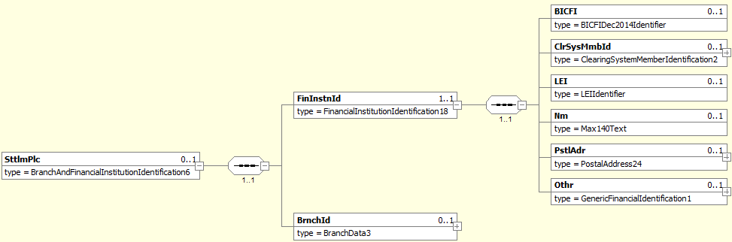
MDR Page | Item Name | XML Tag | Cardi-nality | Data type | Restrictions vs. ISO standard and additional info
242 | FinancialInstitutionIdentification | FinInstnId | [1..1]
238 | +BICFI | BICFI | [0..1] | String [11] | BIC of the SEPA clearing house according to ISO 9362.  Format [A-Z0-9]{4,4}[A-Z]{2,2}[A-Z0-9]{2,2}([A-Z0-9]{3,3}){0,1}.
239 | +ClearingSystemMemberIdentification | ClrSysMmbId | [0..1]
239 | +LEI | LEI | [0..1] | String [20] | Legal Entity Identifier according to ISO 17442  Format [A-Z0-9]{18,18}[0-9]{2,2}
239 | +Name | Nm | [0..1] | String [140]
239 | +PostalAddress | PstlAdr | [0..1] |  | See chapter 3.3.5.3.1.6.4.1.
240 | +Other | Othr | [0..1]
243 | BranchIdentification | BrnchId | [0..1]

PostalAddress
XPath | / Document / BkToCstmrStmt / Stmt / Ntry / NtryDtls [1] / TxDtls / RltdAgts / SttlmPlc / FinInstnId / PstlAdr

MDR Page | Item Name |  | XML Tag | Cardi-nality | Data type | Restrictions vs. ISO standard and additional info
292 | AddressType |  | AdrTp | [0..1] |  | If structured address is used, tags AddressLine are prohibited. If AddressLine is used, structured address is prohibited except Country.  Where hybrid address is allowed, the combination of structured address and 2 occurence of AddressLine may be present.
293 | +Code | Only one of these elements is present | Cd | [1..1] | String Enumeration
293 | +Proprietary |  | Prtry | [1..1]
248 | ++ Identification |  | Id | [1..1] | String [4] | Specifies an alphanumeric string with a length of 4 characters  [a-zA-Z0-9]{4}
248 | ++ Issuer |  | Issr | [1..1] | String [35]
248 | ++SchemeName |  | SchmeNm | [0..1] | String [35]
293 | Department |  | Dept | [0..1] | String [70]
293 | SubDepartment |  | SubDept | [0..1] | String [70]
294 | StreetName |  | StrtNm | [0..1] | String [70]
294 | BuildingNumber |  | BldgNb | [0..1] | String [16]
294 | BuildingName |  | BldgNm | [0..1] | String [35]
294 | Floor |  | Flr | [0..1] | String [70]
294 | PostBox |  | PstBx | [0..1] | String [16]
294 | Room |  | Room | [0..1] | String [70]
294 | PostCode |  | PstCd | [0..1] | String [16]
294 | TownName |  | TwnNm | [0..1] | String [35] | If structured address is used, at least TownName and Country is needed.
295 | TownLocationName |  | TwnLctnNm | [0..1] | String [35]
295 | DistrictName |  | DstrctNm | [0..1] | String [35]
295 | CountrySubDivision |  | CtrySubDvsn | [0..1] | String [35]
295 | Country |  | Ctry | [0..1] | String [2] | International country code according to ISO 3166-1 alpha-2.  Format [A-Z]{2,2}. In address, Country and TownName or one occurence of AddressLine is needed.
295 | AddressLine |  | AdrLine | [0..7] | String [70] | Unstructured address line. If used, structured address is prohibited except Country.  Where hybrid address is allowed, the combination of structured address and 2 occurence of AddressLine may be present.

Proprietary
XPath | / Document / BkToCstmrStmt / Stmt / Ntry / NtryDtls [1] / TxDtls / RltdAgts / Prtry

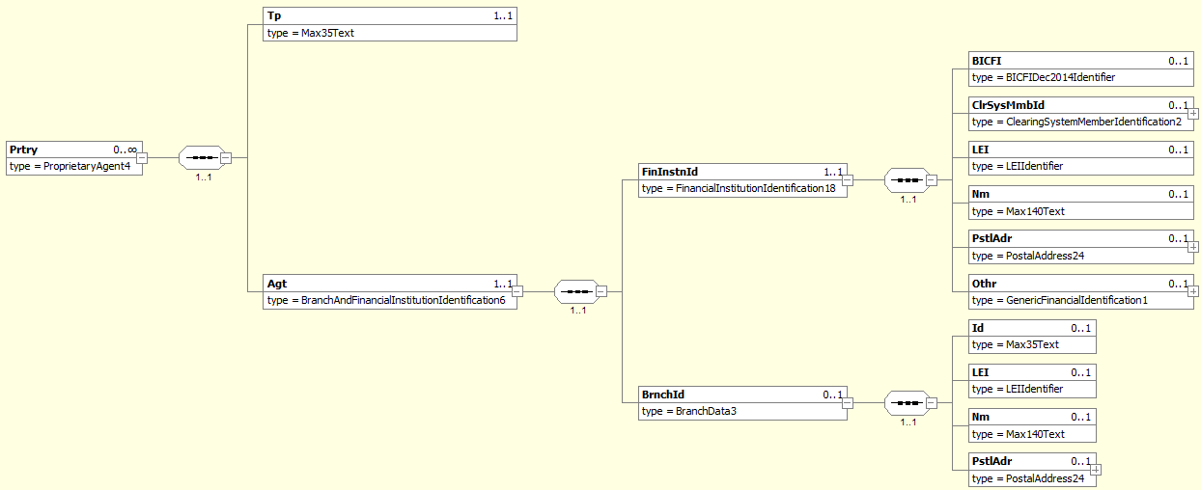
MDR Page | Item Name | XML Tag | Cardi-nality | Data type | Restrictions vs. ISO standard and additional info
208 | Type | Tp | [1..1] | String [35] | For card transactions, the values “CardIssuer” and “CardAcquier” represent the card Issuer and transaction Acquier, respectively.  Other values are not regulated.
209 | Agent | Agt | [1..1]
242 | +FinancialInstitutionIdentification | FinInstnId | [1..1]
238 | ++BICFI | BICFI | [0..1] | String [11] | For card transaction, this is the BIC of the Issuer/Acquier according to ISO 9362.  Format: [A-Z0-9]{4,4}[A-Z]{2,2}[A-Z0-9]{2,2}([A-Z0-9]{3,3}){0,1}
239 | ++ClearingSystemMemberIdentification | ClrSysMmbId | [0..1]
239 | ++LEI | LEI | [0..1] | String [20] | Legal Entity Identifier according to ISO 17442  Format [A-Z0-9]{18,18}[0-9]{2,2}
239 | ++Name | Nm | [0..1] | String [70] | For card transaction, this is the name of the Issuer/Acquier.
239 | ++PostalAddress | PstlAdr | [0..1]
240 | ++Other | Othr | [0..1]
243 | +BranchIdentification | BrnchId | [0..1] |  | For a card transaction Acquier, this represents the Point-of-Trade (ATM or POS).
242 | ++Identification | Id | [0..1] | String [25] | For a card transaction Acquier, this is the ID of the Point-of-Trade.
241 | ++LEI | LEI | [0..1] | String [20] | Legal Entity Identifier according to ISO 17442  Format [A-Z0-9]{18,18}[0-9]{2,2}
241 | ++Name | Nm | [0..1] |  | For a card transaction Acquier, this is the name of the Point-of-Trade.
241 | ++PostalAddress | PstlAdr | [0..1]

Purpose
XPath | / Document / BkToCstmrStmt / Stmt / Ntry / NtryDtls [1] / TxDtls / Purp

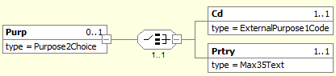
MDR Page | Item Name |  | XML Tag | Cardi-nality | Data type | Restrictions vs. ISO standard and additional info
253 | Code | Only one of these elements is present | Cd | [1..1] | String [4] | Only values from the ISO code-book „Purpose“ allowed.
253 | Proprietary |  | Prtry | [0..0] | String [35] | Prohibited.

RemittanceInfo
XPath | / Document / BkToCstmrStmt / Stmt / Ntry / NtryDtls [1] / TxDtls / RmtInf

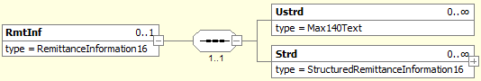
MDR Page | Item Name | XML Tag | Cardi-nality | Data type | Restrictions vs. ISO standard and additional info
323 | Unstructured | Ustrd | [0..1] | String [140] | Prohibited if <Strd> is present.
323 | Structured | Strd | [0..1] |  | Prohibited if <Ustrd> is present.  Allowed only for SEPA transactions.  See chapter 3.3.5.3.1.8.1.

Structured
XPath | / Document / BkToCstmrStmt / Stmt / Ntry / NtryDtls [1] / TxDtls / RmtInf / Strd

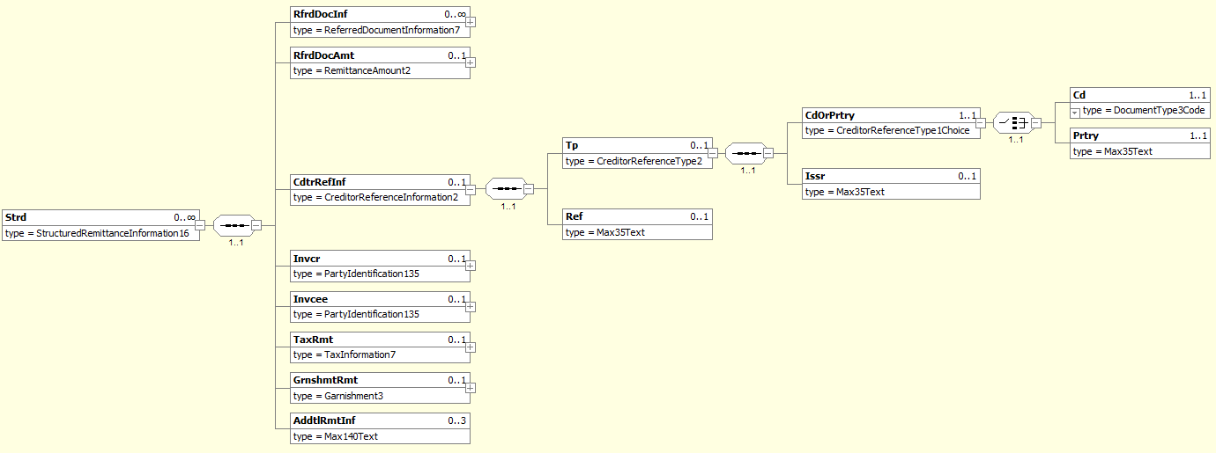
MDR Page | Item Name |  | XML Tag | Cardi-nality | Data type | Restrictions vs. ISO standard and additional info
299 | ReferredDocumentInformation |  | RfrdDocInf | [0..n]
312 | ReferredDocumentAmount |  | RfrdDocAmt | [0..1]
313 | CreditorReferenceInformation |  | CdtrRefInf | [0..1]
236 | +Type |  | Tp | [0..1]
236 | ++CodeOrProprietary |  | CdOrPrtry | [1..1]
236 | +++Code | Only one of these elements is present | Cd | [1..1] | String Enumeration | Always equals “SCOR”.
237 | +++Proprietary |  | Prtry | [0..0] | String [35] | Prohibited.
237 | ++Issuer |  | Issr | [0..1] | String [35] | Issuer of the remittance info.
237 | +Reference |  | Ref | [0..1] | String [35] | Actual remittance info.
314 | Invoicer |  | Invcr | [0..1]
314 | Invoicee |  | Invcee | [0..1]
315 | TaxRemittance |  | TaxRmt | [0..1]
315 | GarnishmentRemittance |  | GrnshmtRmt | [0..1]
316 | AdditionalRemittanceInformation |  | AddtlRmtInf | [0..3] | String [140]

RelatedDates
XPath | / Document / BkToCstmrStmt / Stmt / Ntry / NtryDtls [1] / TxDtls / RltdDts
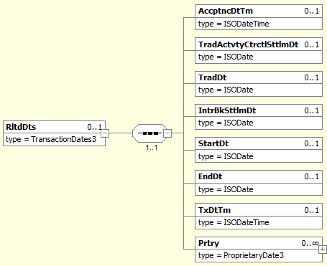
MDR Page | Item Name | XML Tag | Cardi-nality | Data type | Restrictions vs. ISO standard and additional info
211 | AcceptanceDateTime | AccptncDtTm | [0..1]
211 | TradeActivityContractualSettlementDate | TradActvtyCtrctlSttlmDt | [0..1]
211 | TradeDate | TradDt | [0..1]
211 | InterbankSettlementDate | IntrBkSttlmDt | [0..1]
211 | StartDate | StartDt | [0..1]
212 | EndDate | EndDt | [0..1]
212 | TransactionDateTime | TxDtTm | [0..1] | DateTime | Date when the amount was debited from debtor’s account.  Format [YYYY]-[MM]-[DD]Thh:mm:ss.fTZD, where:  - YYYY (4 digits), MM (2 digits) a DD (2 digits) are the year, month and day  - the time and time zone are not covered by the standard
212 | Proprietary | Prtry | [0..n]

ReturnInformation
XPath | / Document / BkToCstmrStmt / Stmt / Ntry / NtryDtls [1] / TxDtls / RtrInf

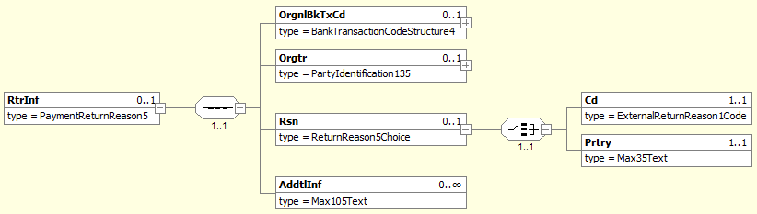
MDR Page | Item Name |  | XML Tag | Cardi-nality | Data type | Restrictions vs. ISO standard and additional info
326 | OriginalBankTransactionCode |  | OrgnlBkTxCd | [0..1] |  | See chapter 3.3.5.3.1.10.1.
327 | Originator |  | Orgtr | [0..1] |  | See chapter 3.3.5.3.1.10.2.
327 | Reason |  | Rsn | [0..1]
327 | +Code | Only one of these elements is present | Cd | [1..1] | String [4] | Return reason according to ISO „ExternalReturnReason“ code-book.
327 | +Proprietary |  | Prtry | [1..1] | String [35] | Proprietary return reason.
327 | AdditionalInformation |  | AddtlInf | [0..n] | String [105] | If present, the first instance contains the R-Message type.  Allowed values are REJECT, RETURN, RECALL, REFUND, REVERSAL, REVOCATION and REFUSAL, although only the first four are likely to appear on a client’s account.  Subsequent instances are not covered by the standard.

OriginalBankTransactionCode
XPath | / Document / BkToCstmrStmt / Stmt / Ntry / NtryDtls [1] / TxDtls / RtrInf / OrgnlBkTxCd

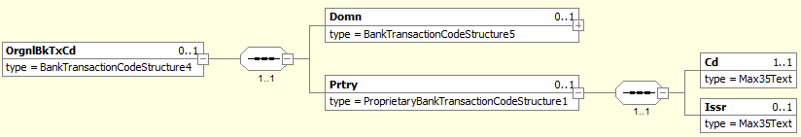
MDR Page | Item Name | XML Tag | Cardi-nality | Data type | Restrictions vs. ISO standard and additional info
142 | Domain | Domn | [0..1]
142 | Proprietary | Prtry | [1..1] |  | Always present.
142 | +Code | Cd | [1..1] | String [35] | SBA transaction code of the original transaction.  For a list of allowed values see chapter 4.3.3.
142 | +Issuer | Issr | [1..1] | String [35] | Always present, always has the value “SBA”.

Originator
XPath | / Document / BkToCstmrStmt / Stmt / Ntry / NtryDtls [1] / TxDtls / RtrInf / Orgtr

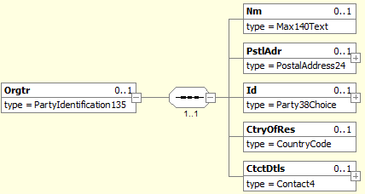
MDR Page | Item Name | XML Tag | Cardi-nality | Data type | Restrictions vs. ISO standard and additional info
282 | Name | Nm | [0..1] | String [70] | The name of the subject that initiated the R-Message.
282 | PostalAddress | PstlAdr | [0..1] |  | The address of the subject that initiated the R-Message.  See chapter 3.3.5.3.1.10.2.1.
283 | Identification | Id | [0..1]
283 | CountryOfResidence | CtryOfRes | [0..1] | String [2]
283 | ContactDetails | CtctDtls | [0..1]

PostalAddress
XPath | / Document / BkToCstmrStmt / Stmt / Ntry / NtryDtls [1] / TxDtls / RtrInf / Orgtr / PstlAdr

MDR Page | Item Name |  | XML Tag | Cardi-nality | Data type | Restrictions vs. ISO standard and additional info
292 | AddressType |  | AdrTp | [0..1] |  | If structured address is used, tags AddressLine are prohibited. If AddressLine is used, structured address is prohibited except Country.  Where hybrid address is allowed, the combination of structured address and 2 occurence of AddressLine may be present.
293 | +Code | Only one of these elements is present | Cd | [1..1] | String Enumeration
293 | +Proprietary |  | Prtry | [1..1]
248 | ++ Identification |  | Id | [1..1] | String [4] | Specifies an alphanumeric string with a length of 4 characters  [a-zA-Z0-9]{4}
248 | ++ Issuer |  | Issr | [1..1] | String [35]
248 | ++SchemeName |  | SchmeNm | [0..1] | String [35]
293 | Department |  | Dept | [0..1] | String [70]
293 | SubDepartment |  | SubDept | [0..1] | String [70]
294 | StreetName |  | StrtNm | [0..1] | String [70]
294 | BuildingNumber |  | BldgNb | [0..1] | String [16]
294 | BuildingName |  | BldgNm | [0..1] | String [35]
294 | Floor |  | Flr | [0..1] | String [70]
294 | PostBox |  | PstBx | [0..1] | String [16]
294 | Room |  | Room | [0..1] | String [70]
294 | PostCode |  | PstCd | [0..1] | String [16]
294 | TownName |  | TwnNm | [0..1] | String [35] | If structured address is used, at least TownName and Country is needed.
295 | TownLocationName |  | TwnLctnNm | [0..1] | String [35]
295 | DistrictName |  | DstrctNm | [0..1] | String [35]
295 | CountrySubDivision |  | CtrySubDvsn | [0..1] | String [35]
295 | Country |  | Ctry | [0..1] | String [2] | International country code according to ISO 3166-1 alpha-2.  Format [A-Z]{2,2}. In address, Country and TownName or one occurence of AddressLine is needed.
295 | AddressLine |  | AdrLine | [0..7] | String [70] | Unstructured address line. If used, structured address is prohibited except Country.  Where hybrid address is allowed, the combination of structured address and 2 occurence of AddressLine may be present.

CardTransaction
XPath | / Document / BkToCstmrStmt / Stmt / Ntry / NtryDtls [1] / TxDtls / CardTx

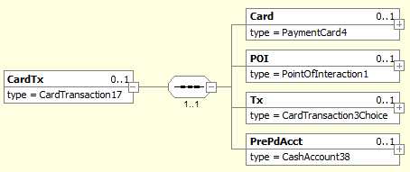
MDR Page | Item Name | XML Tag | Cardi-nality | Data type | Restrictions vs. ISO standard and additional info
161 | Card | Card | [0..1] |  | See chapter 3.3.5.3.1.11.1
165 | POI | POI | [0..1] |  | See chapter 3.3.5.3.1.11.2
171 | Transaction | Tx | [0..1] |  | See chapter 3.3.5.3.1.11.3
185 | PrePaidAccount | PrePdAcct | [0..1]

Card
XPath | / Document / BkToCstmrStmt / Stmt / Ntry / NtryDtls [1] / TxDtls / CardTx / Card

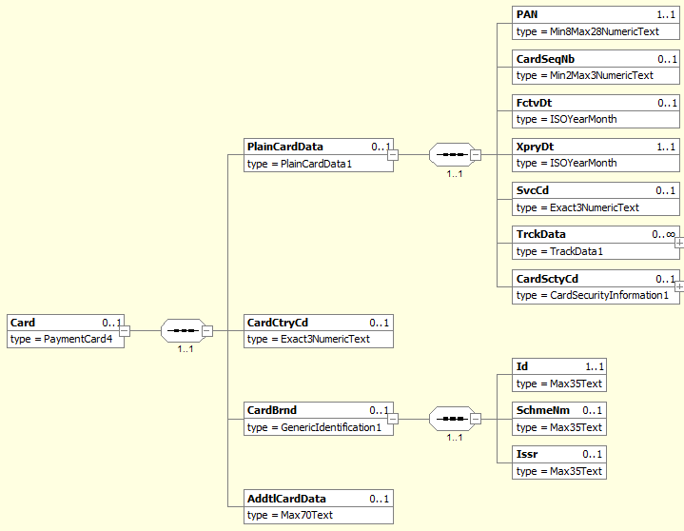

MDR Page | Item Name | XML Tag | Cardi-nality | Data type | Restrictions vs. ISO standard and additional info
162 | PlainCardData | PlainCardData | [0..1]
163 | +PAN | PAN | [1..1] | Number [28, 8..28] | Primary Account Number (PAN) of the card, or card number.  Two formats allowed when masked (original digit masked by zero ‘0’):  - Last 4 digits: 0000000000001234  - First 6 and last 4 digits: 1234560000001234
163 | +CardSequenceNumber | CardSeqNb | [0..1] | Number [3, 2..3] | Identify a card inside a set of cards with the same card number (PAN).
163 | +EffectiveDate | FctvDt | [0..1] | Date | Date as from which the card can be used.  Format: [YYYY]-[MM], where:  - YYYY (4 digits) and MM (2 digits) are the year and month (ISO 8601).
163 | +ExpiryDate | XpryDt | [1..1] | Date | Expiry date of the card.  Format: [YYYY]-[MM], where:  - YYYY (4 digits) and MM (2 digits) are the year and month (ISO 8601).  Sensitive information, will be masked as follows: 9999-12
163 | +ServiceCode | SvcCd | [0..1] | Number [3,0] | Services attached to the card, as defined in ISO 7813.
164 | +TrackData | TrckData | [0..1] |  | Magnetic track or equivalent payment card data.
164 | +CardSecurityCode | CardSctyCd | [0..1] |  | Card security code (CSC) associated with the card performing the transaction.
165 | CardCountryCode | CardCtryCd | [0..1] | Number [3,0] | Country code assigned to the card by the card issuer.
165 | CardBrand | CardBrnd | [0..1] |  | Brand name of the card.
247 | +Identification | Id | [1..1] | String [35] | Represents a card association (VISA, MasterCard). Other values are not regulated.
247 | +SchemeName | SchmeNm | [0..1] | String [35] | Name of the identification scheme.
248 | +Issuer | Issr | [0..1] | String [35] | Entity that assigns the identification.
165 | AdditionalCardData | AddtlCardData | [0..1] | String [70] | Card holder name.

POI
XPath | / Document / BkToCstmrStmt / Stmt / Ntry / NtryDtls [1] / TxDtls / CardTx / POI
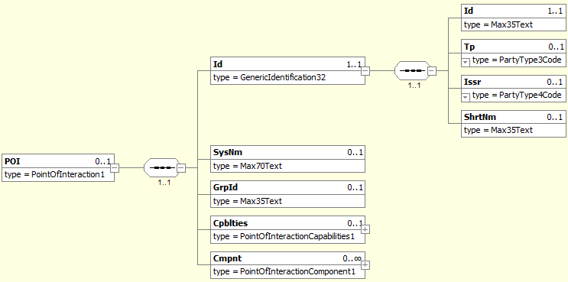

MDR Page | Item Name | XML Tag | Cardi-nality | Data type | Restrictions vs. ISO standard and additional info
166 | Identification | Id | [1..1] |  | Identification of the POI (Point Of Interaction).
249 | +Identification | Id | [1..1] | String [35] | Identification of the entity.
249 | +Type | Tp | [0..1] | String Enumeration | Type of identified entity. Only following codes are used:  - MERC - Merchant Merchant providing goods and service in the card payment transaction.
250 | +Issuer | Issr | [0..1] | String Enumeration | Entity assigning the identification  - MERC - Merchant Merchant providing goods and service in the card payment transaction.  - ACCP - Acceptor Card acceptor, party accepting the card and presenting transaction data to the acquirer.  - ITAG - IntermediaryAgent Party acting on behalf of other parties to process or forward data to other parties.  - ACQR – Acquirer Entity acquiring card transactions.  - CISS - CardIssuer Party that issues cards.  - TAXH - TaxAuthority Tax authority.
250 | +ShortName | ShrtNm | [0..1] | String [35] | Name of the entity.  Eg. SHOP A.S. TRNAVSKA C. BRATISLAVA SK
167 | SystemName | SysNm | [0..1] | String [70] | Common name assigned by the acquirer to the POI system.
167 | GroupIdentification | GrpId | [0..1] | String [35] | Identifier assigned by the merchant identifying a set of POI terminals performing some categories of transactions.
167 | Capabilities | Cpblties | [0..1] |  | Capabilities of the POI performing the transaction.
169 | Component | Cmpnt | [0..n] |  | Data related to a component of the POI performing the transaction.

Transaction
XPath | / Document / BkToCstmrStmt / Stmt / Ntry / NtryDtls [1] / TxDtls / CardTx / Tx
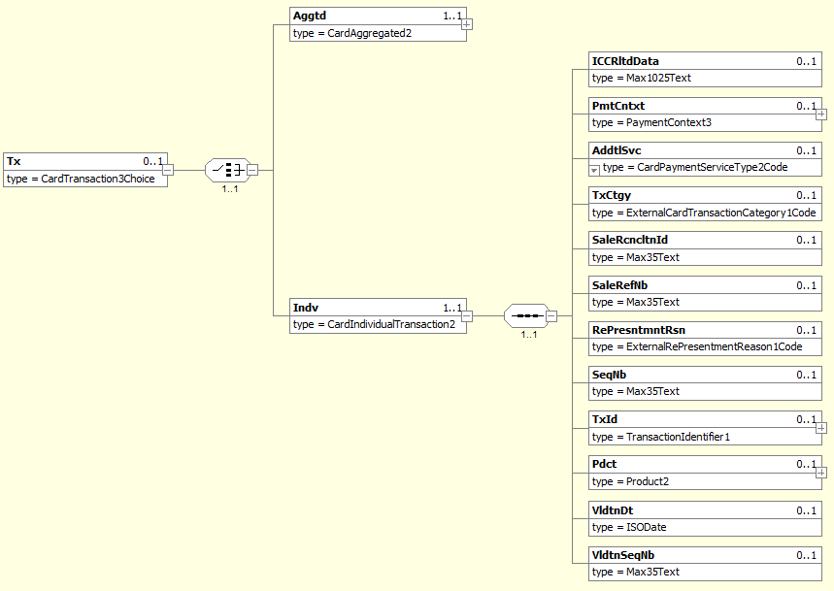

MDR Page | Item Name | XML Tag | Cardi-nality | Data type | Restrictions vs. ISO standard and additional info
173 | {Or Aggregated | Aggtd | [1..1] |  | Not used.
175 | Or} Individual | Indv | [1..1]
177 | +ICCRelatedData | ICCRltdData | [0..1] | String[1025]
177 | +PaymentContext | PmtCntxt | [0..1]
181 | +AdditionalService | AddtlSvc | [0..1] | String Enum
181 | +TransactionCategory | TxCtgy | [0..1] | String Enum | Category code conform to ISO 18245, related to the type of services or goods the merchant provides for the transaction. Merchant category code (MCC)
181 | + SaleReconciliationIdentification | SaleRcncltnId | [0..1] | String[35]
182 | +SaleReferenceNumber | SaleRefNb | [0..1] | String[35]
182 | +RePresentmentReason | RePresntmntRsn | [0..1] | String Enum
182 | +SequenceNumber | SeqNb | [0..1] | String[35]
182 | +TransactionIdentification | TxId | [0..1]
182 | +Product | Pdct | [0..1]
185 | +ValidationDate | VldtnDt | [0..1] | Date
185 | +ValidationSequenceNumber | VldtnSeqNb | [0..1] | String[35]

External sources and appendices

ISO 20022

camt.053
https://www.iso20022.org/message/12736/download
https://www.iso20022.org/message/mdr/12736/download/866

Code lists
https://www.iso20022.org/catalogue-messages/additional-content-messages/external-code-sets

SEPA

SCT
https://www.europeanpaymentscouncil.eu/what-we-do/epc-payment-schemes/sepa-credit-transfer/sepa-credit-transfer-rulebook-and

SDD
https://www.europeanpaymentscouncil.eu/what-we-do/epc-payment-schemes/sepa-direct-debit/sepa-direct-debit-core-rulebook-and-implementation

SK code-books

Regulated subject identifiers
Identifier description | SchmeNm |  | Issr | Id format restrictions
 | Tag | Value
IČO | Prtry | ICO | ORSR | [0-9]{6,8}
DIČ | Cd | TXID | DUSR
Client ID | Cd | BANK | bank’s BIC-11
Table 4: Regulated identifiers of corporate subjects.
Identifier description | SchmeNm |  | Issr | Id format restrictions
 | Tag | Value
IČO | Prtry | ICO | ORSR | [0-9]{6,8}
OP | Cd | NIDN | MVSR
RČ | Prtry | RC | MVSR | [0-9]{6,6}/[0-9]{1,4}
Passport | Cd | CCPT | MVSR
Driving Licence | Cd | DRLC | MVSR
Client ID | Cd | BANK | bank’s BIC-11
Table 5: Regulated personal identifiers.

Balance types
Type | Description
OPBD | Ledger balance at the beginning of the specified bank date.
OPAV | Available balance at the beginning of the specified bank date.
CLBD | Ledger balance at the end of the specified bank date.
CLAV | Available balance at the end of the specified bank date.
PRCD | Closing balance at COB preceding the specified date by one reporting period (e.g. if the balance date is 30.4. and the statement reporting period is two weeks, the balance refers to COB on 15.4.).
ITBD | Intermediate intra-day balance on the date and time specified. Could not be used with SubType INTM.
Table 6: Balance types.
If code INTM in <SubTp> tag is present, balance types are defined as intermediate balances in multi-page satatement (in this case is ITBD prohibited).

Transaction codes

Sample statements

A statement without pagination

A statement divided into three parts using pagination

No.284/2002 of the Laws, as amended

