

Cash Account XML Statement

SK Format Specification

Version 2.5

| **Company** | **Name** | **Role** |
| --- | --- | --- |
| Czech Banking Association |  | Author of the czech standard, on which the slovak standard is based. |
| Management Data Praha spol. s r.o. |  | Consultant |
| Slovak Banking Association Work Group |  |  |

Table 1: Document Authors.

Revision History

| **Version** | **Date** | **Author** | **Description** |
| --- | --- | --- | --- |
| 2.3  Rev.1 | 9/27/2012 | Czech Banking Association | Final version of the czech standard, background document for the slovak standard. |
| 2.3  Rev.2 | 5/13/2012 | Vršanský Ondrej | * In-depth review of the document, creation of the IssueLog. * Inclusion of XML elements that weren’t covered by the original document. * Enriched the information about individual elements with their exact interpretation within the SK standard (cardinality, type and content constraints) * Concentration of the whole SK standard into one document. * Replacement of the “sample” Excel with a sample XML. * Enhanced the document design (header, footer, logo, …) |
| 2.3  Rev. 3 | 6/6/2013 | Vršanský Ondrej | * Revision of the document according to the final SK standard.. |
| 2.3  Rev. 4 | 9/27/2014 | Vršanský Ondrej | * A complete redesign of the document. * Translation of the document into english language. * Reformulated the “character set” rule in chapter 1.2 (originally chapter 6, page 11). * Removed the “XML header” sample (chapter 6, page 11); a complete XML sample in chapter 4.4 is provided instead. * Included the Legend chapter 1.3 and Glossary chapter 1.4. * Changed the rules for publishing a new version of the standard (chapter 1.5). * Included a statement type clasifier into the <GrpHdr>/<MsgId> element. * Reformulated the description of the <GrpHdr>/<AddtlInf> element and removed it from the sample file. * Included a statement definition ID into the <Stmt>/<Id> element. * Changed the <Stmt>/<FrToDt> element to mandatory. * Removed the time portion of the <Stmt>/<FrToDt> subelements from the standard. * Set the <Acct>/<IBAN> as mandatory (and thus prohibited the <Othr> branch). * Introduced a set of standardized subject identifiers (chapter 4.3.1) to be used to identify the account owner (and, if necessary, any other party). * Included the <SchmeNm> and <Issr> subelements of the account servicer and related agent’s <Othr> IDs into the standard. * Included the <SchmeNm> and <Issr> subelements of an <Othr> identifier of <MsgRcpt>/<Id> and <Acct>/<Ownr>/<Id> into the standard. * Included the “ITBD”, “OPBD” and “OPAV” balance types into the standard. * Allowed the <DtTm> option of the <Ntry>/<BookDt> choice. * Set the <Prtry> subelement of the <BkTxCd> element (both on the <Ntry> and <TxDtls> level and in the <RtrInf>) as mandatory. Its <Issr> subelement was also set as mandatory with a constant value. * Removed the <Ntry>/<AmtDtls> branch from the standard. * Reformulated the descriptions of the <MsgId> and <PmtInfId> subelements of the <Ntry>/<NtryDtls>[1]/<Btch> element. * Constrained the cardinality of the <TxDtls> element. * Reformulated the descriptions of the <MsgId>, <PmtInfId>, <InstrId>, <EndToEndId>, <TxId> and <ClrSysRef> subelements of the <TxDtls>/<Refs> element. * Restored the cardinality of the <RltdPties>/<Prtry> element to [0..n]. * Constrained the cardinality of the number of <Othr> identifiers of any “related” party to 1. * Allowed the <Prtry> option of the <SchmeNm> choice of an <Othr> identifier of a “related” party and included the <Issr> element into the standard. * Reformulated the descriptions of the <Othr> identifiers of <CdtrAcct> and <DbtrAcct>. * Corrected the description of the ultimate creditor <Othr> identifier. * Removed the <RcvgAgt> from the standard. Instead, the <IntrmyAgt1> and <SttlmPlc> were included. * Aligned the specification of structured remittance info with SEPA rules. * Introduced the R-Message type into the <RtrInf>/<AddtlInf> element. * Redefined the placement of card transaction details as follows:   + CardAssociation: RelatedParties / Proprietary [Tp = "CardAssociation"]   + Issuer RelatedAgents / Proprietary [Tp = "CardIssuer"]   + CardHolder RelatedParties / InitiatingParty   + Merchant RelatedParties / TradingParty   + PointOfTrade RelatedAgents / Proprietary [Tp = "CardAcquier"] / Branch   + Acquier RelatedAgents / Proprietary [Tp = "CardAcquier"] * Unified the formatting of all Date and DateTime elements. * Added the “Call Center” channel into the specification of the transaction codes. * Introduced new transaction codes regarding interest and taxes. |
| 2.3  Rev. 5 | 21.11.2014 | Vršanský Ondrej | * Corrected a few minor typo-errors and replaced the term “Current account” in the document title (and on a few other places in the document) with the term “Cash account”. |
| 2.4  Rev. 1 | 20.1.2016 | Ľubomír Ďuran | * Fixed date in <MsgId> element in Sample files * Added new optional element <TxDtls><RltdDts><TxDtTm> * Fixed length for <Ustrd> element * Changed the < AddtlInf> element to optional * Fixed description of elements <PmtInfId> and <InstrId> * Fixed description of <CdtDbtInd> under <Chrgs> elements * Added version of the document * Fixed date in <Stmt><Id> element * Fixed length of <AdrLine> element * Fixed cardinality of <AdrLine> element * Fixed transaction codes for interests * Fixed values in RelatedAgents / Proprietary to [TP=”CardIssuer”] and [TP=”CardAcquier”] for Card transaction * Time zone is set as not covered by the standard * For details see external file “Zmeny vo verzii 2.4” |
| 2.5  Rev. 1 | 18.1.2018 | Ľubomír Ďuran | * Added elements Name and Identification of Payment initiation service providers. * Added new optional element <SubTp><Cd> * Added new sample of statement pagination * For details see external file “Zmeny vo verzii 2.5” |

Table 2: Revision History.

Contents

1. Introduction 7

1.1. Document Structure 7

1.2. Character set 8

1.3. Legend 8

1.4. Glossary 8

1.5. Further maintenance of the standard 9

2. Statement attributes description 10

2.1. Logical attributes hierarchy 10

2.2. Mapping of the attributes into XML 13

3. Statement XML structure 21

3.1. Root element 21

3.2. GroupHeader 22

3.2.1. MessageRecipient 24

3.2.1.1. PostalAddress 25

3.2.1.2. Identification 26

3.2.1.2.1. OrganisationIdentification 27

3.2.1.2.2. PrivateIdentification 28

3.3. Statement 29

3.3.1. Account 32

3.3.1.1. Owner 33

3.3.1.1.1. PostalAddress 34

3.3.1.1.2. Identification 35

3.3.1.1.2.1. OrganisationIdentification 36

3.3.1.1.2.2. PrivateIdentification 37

3.3.1.2. Servicer 39

3.3.1.2.1. PostalAddress 41

3.3.2. Interest 42

3.3.3. Balance 44

3.3.4. TransactionsSummary 47

3.3.5. Entry 49

3.3.5.1. BankTransactionCode 52

3.3.5.2. Charges 53

3.3.5.3. EntryDetails – Instance 1 55

3.3.5.3.1. TransactionDetails 56

3.3.5.3.1.1. References 58

3.3.5.3.1.2. AmountDetails 61

3.3.5.3.1.3. BankTransactionCode 64

3.3.5.3.1.4. Charges 65

3.3.5.3.1.5. RelatedParties 67

3.3.5.3.1.5.1. InitiatingParty 68

3.3.5.3.1.5.2. Debtor 69

3.3.5.3.1.5.2.1. PostalAddress 70

3.3.5.3.1.5.2.2. Identification 71

3.3.5.3.1.5.2.2.1. OrganisationIdentification 72

3.3.5.3.1.5.2.2.2. PrivateIdentification 73

3.3.5.3.1.5.3. DebtorAccount 74

3.3.5.3.1.5.4. UltimateDebtor 75

3.3.5.3.1.5.4.1. PostalAddress 76

3.3.5.3.1.5.4.2. Identification 77

3.3.5.3.1.5.4.2.1. OrganisationIdentification 78

3.3.5.3.1.5.4.2.2. PrivateIdentification 79

3.3.5.3.1.5.5. Creditor 80

3.3.5.3.1.5.5.1. PostalAddress 81

3.3.5.3.1.5.5.2. Identification 82

3.3.5.3.1.5.5.2.1. OrganisationIdentification 83

3.3.5.3.1.5.5.2.2. PrivateIdentification 85

3.3.5.3.1.5.6. CreditorAccount 87

3.3.5.3.1.5.7. UltimateCreditor 88

3.3.5.3.1.5.7.1. PostalAddress 89

3.3.5.3.1.5.7.2. Identification 90

3.3.5.3.1.5.7.2.1. OrganisationIdentification 91

3.3.5.3.1.5.7.2.2. PrivateIdentification 92

3.3.5.3.1.5.8. TradingParty 93

3.3.5.3.1.5.8.1. Identification 94

3.3.5.3.1.5.8.1.1. OrganisationIdentification 95

3.3.5.3.1.5.8.1.2. PrivateIdentification 96

3.3.5.3.1.5.9. ProprietaryParty 97

3.3.5.3.1.6. RelatedAgents 98

3.3.5.3.1.6.1. DebtorAgent 100

3.3.5.3.1.6.1.1. PostalAddress 102

3.3.5.3.1.6.2. CreditorAgent 104

3.3.5.3.1.6.2.1. PostalAddress 106

3.3.5.3.1.6.3. IntermediaryAgent1 107

3.3.5.3.1.6.3.1. PostalAddress 108

3.3.5.3.1.6.4. SettlementPlace 110

3.3.5.3.1.6.4.1. PostalAddress 111

3.3.5.3.1.6.5. Proprietary 113

3.3.5.3.1.7. Purpose 114

3.3.5.3.1.8. RemittanceInfo 115

3.3.5.3.1.8.1. Structured 116

3.3.5.3.1.9. RelatedDates 118

3.3.5.3.1.10. ReturnInformation 119

3.3.5.3.1.10.1. OriginalBankTransactionCode 120

3.3.5.3.1.10.2. Originator 121

3.3.5.3.1.10.2.1. PostalAddress 122

4. External sources and appendices 123

4.1. ISO 20022 123

4.1.1. camt.053 123

4.1.2. Code lists 123

4.2. SEPA 123

4.2.1. SCT 123

4.2.2. SDD 123

4.3. SK code-books 124

4.3.1. Regulated subject identifiers 124

4.3.2. Balance types 124

4.3.3. Transaction codes 125

4.4. Sample statements 125

4.4.1. A statement without pagination 125

4.4.2. A statement divided into two parts using pagination 125

# Introduction

The Slovak Payments legislation[1] obliges the payment service providers to notify their payment services consumers about transactions realised on their accounts and defines the minimal mandatory set of attributes to be included in these notifications. The most typical way to comply with this legislation is to provide the client with a transaction statement that covers all required information for a given time period. These statements are being generated either periodically (forming a continuous sequence) or ad-hoc on a customer’s request.

While the legislation defines the “minimal information content” of a statement, it lacks any further instructions regarding internal statements structure and/or format. As a result, a wide range of proprietary implementations emerged on the market, varying both in the internal content and format and in the delivery logistics. While this variety poses no problems for a retail customer, it complicates the statements processing and reconciliation within corporations that typically have to deal with statements from a multitude of accounts in different banks.

On a global scale, the need for standardization of bank statements increased with the growing use of electronic statements and the related prospect of their automated processing. Since 2004, the ISO 20022 standard – in particular the camt.053 schema – defines an international standard for cash account statements structure. All information relevant can be found at [www.iso20022.org](http://www.iso20022.org/).

Since 2002, the European Payments Council (further referred as “EPC”) defines rulebooks and standards that constitute the Single European Payment Area (further referred as “SEPA”). All SEPA interbank and bank-to-customer messages were based on the ISO 20022 standard. In October 2009, SEPA issued a [“recommendation”](http://www.europeanpaymentscouncil.eu/documents/EPC188-09%20Recommendation%20on%20Customer%20Reporting%20SCT%20and%20SDD.pdf) to use the camt.053 schema for bank-to-customer currenct account transaction statements. All information regarding EPC and SEPA can be found at <http://www.europeanpaymentscouncil.eu/index.cfm>.

As in many other countries, the final specification of the national standard for cash account electronic statements was developed under the supervision of the Slovak Banking Association. A close cooperation with the Czech Banking Association in specifying the czech national standard, on which the slovak standard is based, ensured further harmonization of both standards to the benefit of all legal or corporate entities with organisational units in both countries. On top of that, the specification was repeatedly being consulted with experts that were participating on equivatent projects in other countries. This document is the result of this process.

The use of this standard is not obligatory by any part of the Slovak legislation; however, it is highly recommended due to its cost-reduction effects for all parties involved.

## Document Structure

The document is divided into three sections:

1. Description of logical attributes that make up a statement (Chapter 2.1). An XPath for the attribiute “location” within the XML file is provided for each logical attribute.
2. Structure of the XML file (Chapter 2.2). The structure of this chapter reflects the structure of the camt.053 schema; on each level, following information is provided:

* an XPath to the described node
* a picture of the node structure
* a table with information about the node attributes and sub-elements with following columns:
* ISO index: the ISO ID of the node according to the ISO 20022 camt.053 MDR (see chapter 4.1.1).
* ISO name: the ISO name of the node according to the ISO 20022 camt.053 MDR (see chapter 4.1.1).
  + one or more “+” signs before the node name signalize that the node is a sub-node of the first preceding node with one-less “+” signs”. The number of „+“ signs denotes the level of node „indentation“ compared to the node decribed by the particular chapter.
* XML Tag : the name of the XML tag according to the ISO 20022 camt.053 MDR (see chapter 4.1.1).
  + the XML tag name is stated withouth the „<“ and „>“ characters.
* Cardinality describes the allowed node cardinality:
  + [*x*..*y*] states that the node is present a minimum of *x* and a maximum of *y* times, e.g.:
    - [0..0] means that the node is forbidden
    - [0..1] means that the node is optional
    - [0..n] means that the node can be present any number of times
    - [1..1] means that the node is mandatory
    - [1..n] means that the node is mandatory but can be repeated any number of times
    - [3..3] means that the node is present exactly three times
* Data type describes the node data type
  + If the data type field is striked-through with two diagonal lines, the node data type is complex and its individual parts are further described either on the next table rows (in which case they are indented by an additional „+“ sign) or in a separate chapter (referenced in the last table column).
* Rules Lists rules and constraints on top of the ISO 20022 camt.053 MDR. The rules can constrain:
  + cardinality (e.g. [0..n] -> [0..1])
  + data type (e.g. String [35] -> String [5])
  + value (e.g. „only „Yes“ a „No“ values allowed“)
  + semantics (e.g. „for card transactions, this is the card number“)

1. External Sources and Appendices (Chapter 4).

## Character set

Following characters are ensured to be correctly recognised and passed on, unchanged, throughout the entire end-to-end chain:

a b c d e f g h i j k l m n o p q r s t u v w x y z

A B C D E F G H I J K L M N O P Q R S T U V W X Y Z

0 1 2 3 4 5 6 7 8 9

/ - ? : ( ) . , ' +

Space

Other characters might be removed or replaced if not recognised by the system.

## Legend

The national standard regulates only a subset of the elements available within the ISO schema. To clearly distinguish the elements that the standard defines as mandatry from the optional (but still regulated) ones and finally from those it prohibits, following colors are used for the apropriate document sections:

* elements prohibited by the national standard
* elements that the standard allows but somehow regulates
* elements that the standard doesn’t regulate

## Glossary

|  |  |
| --- | --- |
| Term | Description |
| ISO | International Organisation for Standardisation or one of its products. In the context of this document, this refers to the ISO 20022 standard. |
| camt.053 | An ISO 20022 standard for bank-to-customer cash account statements. |
| MDR | „Message Definition Report“ – an ISO document containing the interpretation rules of an ISO standard (such as the camt.053 XSD schema). |
| EU | European Union |
| EPC | „European Payments Council“ – an EU body that defines SEPA rulebooks and standards. |
| SEPA | „Single Euro Payment Area“. |
| SCT | SEPA Credit Transfer. SEPA standard for payments initiated by the debtor. |
| SDD | SEPA Direct Debit. SEPA standard for payments initiated by the creditor. |
| SDD Core | SEPA scheme for debiting retail customers. |
| SDD B2B | SEPA scheme for debiting corporate customers. |
| CID | SDD Creditor ID. |
| SBA | Slovak Banking Association. |
| XML | „Extensible markup Language“ – a wide-spread standard for structured data transfer. |
| XSD | XML Schema Definition – an XML standard for XML structure specification. |
| XPath | Standard language used to reference information stored in an XML structure. |
| Bulk payment | A group of payments that are booked on the debtor account as a single debit. |
| Indirect debit | Pre-SEPA national standard for payments initiated by the creditor. |
| SIPO | „Sústredené inkaso platieb obyvateľstva“ - a special type of indirect debit commonly used in CZ and SK. |
| TPS, SIPS, EuroSIPS | Pre-SEPA Domestic Payments. |
| ZPS | Foreign Payments |
| Card Association | The card „trademark holder“ (VISA, MasterCard, ...). |
| Card Issuer | The bank that issued the card to a customer |
| Card Holder | The customer to which the card was „issued“ |
| Card Merchant | The company that accepts card transactions as payments for its services. |
| Card Acquier | The bank that provides the merchant with the POS machines. |
| ATM | Automatic Teller Machine. A standalone machine belonging to the card issuer that provides cash withdrawals and other card services. |
| POS | Point-of-Sale. A machine belonging to the card acquier and installed by the merchant that provides carrd payments, cashbacks and other card services. |
| Cash Advance | A cash withdrawal service with a payment card as the authentification tool provided by the card issuer. |
| Cashback | A cash withdrawal service with a payment card as the authentification tool provided by the card acquier. |
| PISP | Payment initiation service provider. Third party which allows users to initiate payments via its own system. |

Table 3: Glossary.

## Further maintenance of the standard

The national standard for cash account electronic statements was developed and will be further maintained under the auspices of the Slovak Banking Association and its specification will be published on its website ([www.sbaonline.sk](http://www.sbaonline.sk)). The standard will be reviewed once in a year; all necessary changes will become valid 8 months after their publication.

# Statement attributes description

## Logical attributes hierarchy

Following pictograms are used to describe the attributes logical hierarchy:

|  |  |  |
| --- | --- | --- |
| Pictogram | Meaning | Examples |
|  | Depicts a Generalization/Specialization relation. | * Person and Corporation entities are specializations of the Owner entity. * SEPATransaction and CardTransaction entities are specializations of the Transaction entity. |
|  | Depicts an „exactly one“ cardinality of an entity within a relation. In other words, the entity is „mandatory“ and „singular“ within the relation. | * There is always exactly one Account related to a Statement. * There is always exactly one Statement related to an Account. * A ReturnInformation is always related to exactly one SEPATransaction. |
|  | Depicts a „zero or one“ cardinality of an entity within a relation. In other words, the entity is „optional“ and „singular“ within the relation. | * The Account information may include information about its Owner. * The message Recipient may have a StructuredAddress. * A Transaction information may include a RemittanceInfo. |
|  | Depicts a „one or more“ cardinality of an entity within a relation. In other words, the entity is „mandatory“ and „plural“ within the relation. | * A Message consists of one or more Statements. |
|  | Depicts a „zero or more“ cardinality of an entity within a relation. In other words, the entity is „optional“ and „plural“ within the relation. | * A Statement may include any number of Entries. * A BulkEntry may include any number of Transactions. * A Transaction may include any number of Charges. |



Figure 1: Statement attributes logical hierarchy up to the Entry level.



Figure 2: Statement Entry attributes logical hierarchy.

## Mapping of the attributes into XML

|  |  |  |  |  |
| --- | --- | --- | --- | --- |
| Class | Attribute | | | XPath |
| Message | ID | | | / Document / BkToCstmrStmt / GrpHdr / MsgId |
| CreationDateTime | | | / Document / BkToCstmrStmt / GrpHdr / CreDtTm |
| PageNo | | | / Document / BkToCstmrStmt / GrpHdr / MsgPgntn / PgNb |
| IsLastPage | | | / Document / BkToCstmrStmt / GrpHdr / MsgPgntn / LastPgInd |
| AdditionalInfo | | | / Document / BkToCstmrStmt / GrpHdr / AddtlInf |
| Reci-pient | Name | | | / Document / BkToCstmrStmt / GrpHdr / MsgRcpt / Nm |
| BIC | | | / Document / BkToCstmrStmt / GrpHdr / MsgRcpt / Id / OrgId / BICOrBEI |
| UnstructuredAddress | | | / Document / BkToCstmrStmt / GrpHdr / MsgRcpt / PstlAdr / AdrLine |
| Recipient Structured Address | StreetName | | | / Document / BkToCstmrStmt / GrpHdr / MsgRcpt / PstlAdr / StrtNm |
| BuildingNo | | | / Document / BkToCstmrStmt / GrpHdr / MsgRcpt / PstlAdr / BldgNb |
| PostCode | | | / Document / BkToCstmrStmt / GrpHdr / MsgRcpt / PstlAdr / PstCd |
| TownName | | | / Document / BkToCstmrStmt / GrpHdr / MsgRcpt / PstlAdr / TwnNm |
| Country | | | / Document / BkToCstmrStmt / GrpHdr / MsgRcpt / PstlAdr / Ctry |
| RecipientOtherID | ID | Corporate subjects | | / Document / BkToCstmrStmt / GrpHdr / MsgRcpt / Id / OrgId / Othr / Id |
| Persona | | / Document / BkToCstmrStmt / GrpHdr / MsgRcpt / Id / PrvtId / Othr / Id |
| SchemeType | | | Represents the choice between the <Cd> and <Prtry> elements |
| Scheme Name | Corporate subjects | Cd | / Document / BkToCstmrStmt / GrpHdr / MsgRcpt / Id / OrgId / Othr / SchmeNm / Cd |
| Prtry | / Document / BkToCstmrStmt / GrpHdr / MsgRcpt / Id / OrgId / Othr / SchmeNm / Prtry |
| Persona | Cd | / Document / BkToCstmrStmt / GrpHdr / MsgRcpt / Id / PrvtId / Othr / SchmeNm / Cd |
| Prtry | / Document / BkToCstmrStmt / GrpHdr / MsgRcpt / Id / PrvtId / Othr / SchmeNm / Prtry |
| Issuer | Corporate subjects | | / Document / BkToCstmrStmt / GrpHdr / MsgRcpt / Id / OrgId / Othr / Issr |
| Persona | | / Document / BkToCstmrStmt / GrpHdr / MsgRcpt / Id / PrvtId / Othr / Issr |
| Statement | ID | | | / Document / BkToCstmrStmt / Stmt / Id |
| ElectronicSeqNo | | | / Document / BkToCstmrStmt / Stmt / ElectrncSeqNb |
| LegalSeqNo | | | / Document / BkToCstmrStmt / Stmt / LglSeqNb |
| CreationDateTime | | | / Document / BkToCstmrStmt / Stmt / CreDtTm |
| FromDate | | | / Document / BkToCstmrStmt / Stmt / FrToDt / FrDtTm |
| ToDate | | | / Document / BkToCstmrStmt / Stmt / FrToDt / ToDtTm |
| EntriesCount | | | / Document / BkToCstmrStmt / Stmt / TxsSummry / TtlNtries / NbOfNtries |
| EntriesSum | | | / Document / BkToCstmrStmt / Stmt / TxsSummry / TtlNtries / TtlNetNtryAmt |
| EntriesSumCRDBIndicator | | | / Document / BkToCstmrStmt / Stmt / TxsSummry / TtlNtries / CdtDbtInd |
| EntriesAbsoluteSum | | | / Document / BkToCstmrStmt / Stmt / TxsSummry / TtlNtries / Sum |
| CreditsCount | | | / Document / BkToCstmrStmt / Stmt / TxsSummry / TtlCdtNtries / NbOfNtries |
| CreditsSum | | | / Document / BkToCstmrStmt / Stmt / TxsSummry / TtlCdtNtries / Sum |
| DebitsCount | | | / Document / BkToCstmrStmt / Stmt / TxsSummry / TtlDbtNtries / NbOfNtries |
| DebitsSum | | | / Document / BkToCstmrStmt / Stmt / TxsSummry / TtlDbtNtries / Sum |
| Account | IBAN | | | / Document / BkToCstmrStmt / Stmt / Acct / Id / IBAN |
| ISOType | | | / Document / BkToCstmrStmt / Stmt / Acct / Tp / Cd |
| ProprietaryType | | | / Document / BkToCstmrStmt / Stmt / Acct / Tp / Prtry |
| Currency | | | / Document / BkToCstmrStmt / Stmt / Acct / Ccy |
| Name | | | / Document / BkToCstmrStmt / Stmt / Acct / Nm |
| Owner | Name | | | / Document / BkToCstmrStmt / Stmt / Acct / Ownr / Nm |
| ClientID | Corporate subjects | | / Document / BkToCstmrStmt / Stmt / Acct / Ownr / Id / OrgId / Othr [SchmeNm / Cd = ‘BANK’] / Id |
| Persona | | / Document / BkToCstmrStmt / Stmt / Acct / Ownr / Id / PrvtId / Othr [SchmeNm / Cd = ‘BANK’] / Id |
| ICO | Corporate subjects | | / Document / BkToCstmrStmt / Stmt / Acct / Ownr / Id / OrgId / Othr [SchmeNm / Prtry = ‘ICO’] / Id |
| Persona | | / Document / BkToCstmrStmt / Stmt / Acct / Ownr / Id / PrvtId / Othr [SchmeNm / Prtry = ‘ICO’] / Id |
| UnstructuredAddress | | | / Document / BkToCstmrStmt / Stmt / Acct / Ownr / PstlAdr / AdrLine |
| Owner Structured Address | StreetName | | | / Document / BkToCstmrStmt / Stmt / Acct / Ownr / PstlAdr / StrtNm |
| BuildingNo | | | / Document / BkToCstmrStmt / Stmt / Acct / Ownr / PstlAdr / BldgNb |
| PostCode | | | / Document / BkToCstmrStmt / Stmt / Acct / Ownr / PstlAdr / PstCd |
| TownName | | | / Document / BkToCstmrStmt / Stmt / Acct / Ownr / PstlAdr / TwnNm |
| Country | | | / Document / BkToCstmrStmt / Stmt / Acct / Ownr / PstlAdr / Ctry |
| Owner OtherID | ID | Corporate subjects | | / Document / BkToCstmrStmt / Stmt / Acct / Ownr / Id / OrgId / Othr / Id |
| Persona | | / Document / BkToCstmrStmt / Stmt / Acct / Ownr / Id / PrvtId / Othr / Id |
| SchemeType | | | Represents the choice between the <Cd> and <Prtry> elements |
| Scheme Name | Corporate subjects | Cd | / Document / BkToCstmrStmt / Stmt / Acct / Ownr / Id / OrgId / Othr / SchmeNm / Cd |
| Prtry | / Document / BkToCstmrStmt / Stmt / Acct / Ownr / Id / OrgId / Othr / SchmeNm / Prtry |
| Persona | Cd | / Document / BkToCstmrStmt / Stmt / Acct / Ownr / Id / PrvtId / Othr / SchmeNm / Cd |
| Prtry | / Document / BkToCstmrStmt / Stmt / Acct / Ownr / Id / PrvtId / Othr / SchmeNm / Prtry |
| Issuer | Corporate subjects | | / Document / BkToCstmrStmt / Stmt / Acct / Ownr / Id / OrgId / Othr / Issr |
| Persona | | / Document / BkToCstmrStmt / Stmt / Acct / Ownr / Id / PrvtId / Othr / Issr |
| Corpo-ration | DIČ | | | / Document / BkToCstmrStmt / Stmt / Acct / Ownr / Id / OrgId / Othr [SchmeNm / Cd = ‘TXID’] / Id |
| BIC | | | / Document / BkToCstmrStmt / Stmt / Acct / Ownr / Id / OrgId / BICorBEI |
| Person | RC | | | / Document / BkToCstmrStmt / Stmt / Acct / Ownr / Id / PrvtId / Othr [SchmeNm / Prtry = ‘RC’] / Id |
| OP | | | / Document / BkToCstmrStmt / Stmt / Acct / Ownr / Id / PrvtId / Othr [SchmeNm / Cd = ‘NIDN’] / Id |
| Password | | | / Document / BkToCstmrStmt / Stmt / Acct / Ownr / Id / PrvtId / Othr [SchmeNm / Cd = ‘CCPT’] / Id |
| DrivingLicence | | | / Document / BkToCstmrStmt / Stmt / Acct / Ownr / Id / PrvtId / Othr [SchmeNm / Cd = ‘DRLC’] / Id |
| Servicer | Name | | | / Document / BkToCstmrStmt / Stmt / Acct / Svcr / FinInstnId / Nm |
| BIC | | | / Document / BkToCstmrStmt / Stmt / Acct / Svcr / FinInstnId / BIC |
| UnstructuredAddress | | | / Document / BkToCstmrStmt / Stmt / Acct / Svcr / FinInstnId / PstlAdr / AdrLine |
| Servicer Structured Address | StreetName | | | / Document / BkToCstmrStmt / Stmt / Acct / Svcr / FinInstnId / PstlAdr / StrtNm |
| BuildingNo | | | / Document / BkToCstmrStmt / Stmt / Acct / Svcr / FinInstnId / PstlAdr / BldgNb |
| PostCode | | | / Document / BkToCstmrStmt / Stmt / Acct / Svcr / FinInstnId / PstlAdr / PstCd |
| TownName | | | / Document / BkToCstmrStmt / Stmt / Acct / Svcr / FinInstnId / PstlAdr / TwnNm |
| Country | | | / Document / BkToCstmrStmt / Stmt / Acct / Svcr / FinInstnId / PstlAdr / Ctry |
| Servicer OtherID | ID | | | / Document / BkToCstmrStmt / Stmt / Acct / Svcr / FinInstnId / Othr / Id |
| SchemeType | | | Represents the choice between the <Cd> and <Prtry> elements |
| SchemeName | | Cd | / Document / BkToCstmrStmt / Stmt / Acct / Svcr / FinInstnId / Othr / SchmeNm / Cd |
| Prtry | / Document / BkToCstmrStmt / Stmt / Acct / Svcr / FinInstnId / Othr / SchmeNm / Prtry |
| Issuer | | | / Document / BkToCstmrStmt / Stmt / Acct / Svcr / FinInstnId / Othr / Issr |
| Interest | Rate | | | / Document / BkToCstmrStmt / Stmt / Intrst / Rate / Tp / Pctg |
| ValidFrom | | | / Document / BkToCstmrStmt / Stmt / Intrst / FrToDt / FrDtTm |
| ValidTo | | | / Document / BkToCstmrStmt / Stmt / Intrst / FrToDt / ToDtTm |
| Balance | Type | | | / Document / BkToCstmrStmt / Stmt / Bal / Tp / CdOrPrtry / Cd |
| SubType | | | / Document / BkToCstmrStmt / Stmt / Bal / Tp / SubTp / Cd |
| Amount | | | / Document / BkToCstmrStmt / Stmt / Bal / Amt |
| Currency | | | / Document / BkToCstmrStmt / Stmt / Bal / Amt / @Ccy |
| CRDBIndicator | | | / Document / BkToCstmrStmt / Stmt / Bal / CdtDbtInd |
| Date | | | / Document / BkToCstmrStmt / Stmt / Bal / Dt / Dt |
| Timestamp | | | / Document / BkToCstmrStmt / Stmt / Bal / Dt / DtTm |
| Credit Line | Amount | | | / Document / BkToCstmrStmt / Stmt / Bal / CdtLine / Amt |
| Currency | | | / Document / BkToCstmrStmt / Stmt / Bal / CdtLine / Amt / @Ccy |
| Included | | | / Document / BkToCstmrStmt / Stmt / Bal / CdtLine / Incl |
| Entry | MovementID | | | / Document / BkToCstmrStmt / Stmt / Ntry / NtryRef |
| Amount | | | / Document / BkToCstmrStmt / Stmt / Ntry / Amt |
| Currency | | | / Document / BkToCstmrStmt / Stmt / Ntry / Amt / @Ccy |
| CRDBIndicator | | | / Document / BkToCstmrStmt / Stmt / Ntry / CdtDbtInd |
| ReversalIndicator | | | / Document / BkToCstmrStmt / Stmt / Ntry / RvslInd |
| Status | | | / Document / BkToCstmrStmt / Stmt / Ntry / Sts |
| BookingDate | | | / Document / BkToCstmrStmt / Stmt / Ntry / BookDt / Dt |
| ValueDate | | | / Document / BkToCstmrStmt / Stmt / Ntry / ValDt / Dt |
| ValueTimestamp | | | / Document / BkToCstmrStmt / Stmt / Ntry / ValDt / DtTm |
| TransactionCode | | | / Document / BkToCstmrStmt / Stmt / Ntry / BkTxCd / Prtry / Cd |
| Bulk Entry | Reference | | | / Document / BkToCstmrStmt / Stmt / Ntry / AcctSvcRef |
| InstructionMsgID | | | / Document / BkToCstmrStmt / Stmt / Ntry / NtryDtls [1] / Btch / MsgId |
| InstructionID | | | / Document / BkToCstmrStmt / Stmt / Ntry / NtryDtls [1] / Btch / PmtInfId |
| TransactionsCount | | | / Document / BkToCstmrStmt / Stmt / Ntry / NtryDtls [1] / Btch / NbOfTxs |
| Bulk Charge | Amount | | | / Document / BkToCstmrStmt / Stmt / Ntry / Chrgs / Amt |
| Currency | | | / Document / BkToCstmrStmt / Stmt / Ntry / Chrgs / Amt / @Ccy |
| CRDBIndicator | | | / Document / BkToCstmrStmt / Stmt / Ntry / Chrgs / CdtDbtInd |
| Bearer | | | / Document / BkToCstmrStmt / Stmt / Ntry / Chrgs / Br |
| Transaction | InstructionMsgID | | | / Document / BkToCstmrStmt / Stmt / Ntry / NtryDtls [1] / TxDtls / Refs / MsgId |
| InstructionID | | | / Document / BkToCstmrStmt / Stmt / Ntry / NtryDtls [1] / TxDtls / Refs / PmtInfId |
| InstructionSystemID | | | / Document / BkToCstmrStmt / Stmt / Ntry / NtryDtls [1] / TxDtls / Refs / InstrId |
| ServicerReference | | | / Document / BkToCstmrStmt / Stmt / Ntry / NtryDtls [1] / TxDtls / Refs / AcctSvcrRef |
| EndToEndID | | | / Document / BkToCstmrStmt / Stmt / Ntry / NtryDtls [1] / TxDtls / Refs / EndToEndId |
| InstructorReference | | | / Document / BkToCstmrStmt / Stmt / Ntry / NtryDtls [1] / TxDtls / Refs / TxId |
| ChequeNumber | | | / Document / BkToCstmrStmt / Stmt / Ntry / NtryDtls [1] / TxDtls / Refs / ChqNb |
| ClearingSystemReference | | | / Document / BkToCstmrStmt / Stmt / Ntry / NtryDtls [1] / TxDtls / Refs / ClrSysRef |
| InstructedAmount | | | / Document / BkToCstmrStmt / Stmt / Ntry / NtryDtls [1] / TxDtls / AmtDtls / InstdAmt / Amt |
| InstructedCurrency | | | / Document / BkToCstmrStmt / Stmt / Ntry / NtryDtls [1] / TxDtls / AmtDtls / InstdAmt / Amt / @Ccy |
| TransactionAmount | | | / Document / BkToCstmrStmt / Stmt / Ntry / NtryDtls [1] / TxDtls / AmtDtls / TxAmt / Amt |
| TransactionCurrency | | | / Document / BkToCstmrStmt / Stmt / Ntry / NtryDtls [1] / TxDtls / AmtDtls / TxAmt / Amt / @Ccy |
| CounterValueAmount | | | / Document / BkToCstmrStmt / Stmt / Ntry / NtryDtls [1] / TxDtls / AmtDtls / CntrValAmt / Amt |
| CounterValueCurrency | | | / Document / BkToCstmrStmt / Stmt / Ntry / NtryDtls [1] / TxDtls / AmtDtls / CntrValAmt / Amt / @Ccy |
| ExchangeRate | | | / Document / BkToCstmrStmt / Stmt / Ntry / NtryDtls [1] / TxDtls / AmtDtls / CntrValAmt / CcyXchg / XchgRate |
| ExchangeRateSourceCurrency | | | / Document / BkToCstmrStmt / Stmt / Ntry / NtryDtls [1] / TxDtls / AmtDtls / CntrValAmt / CcyXchg / ScrCcy |
| ExchangeRateTargetCurrency | | | / Document / BkToCstmrStmt / Stmt / Ntry / NtryDtls [1] / TxDtls / AmtDtls / CntrValAmt / CcyXchg / TrgtCcy |
| TransactionCode | | | / Document / BkToCstmrStmt / Stmt / Ntry / NtryDtls [1] / TxDtls / BkTxCd / Prtry / Cd |
| AdditionalInfo | | | / Document / BkToCstmrStmt / Stmt / Ntry / NtryDtls [1] / TxDtls / AddtlTxInf |
| Charge | Amount | | | / Document / BkToCstmrStmt / Stmt / Ntry / NtryDtls [1] / TxDtls / Chrgs / Amt |
| Currency | | | / Document / BkToCstmrStmt / Stmt / Ntry / NtryDtls [1] / TxDtls / Chrgs / Amt / @Ccy |
| CRDBIndicator | | | / Document / BkToCstmrStmt / Stmt / Ntry / NtryDtls [1] / TxDtls / Chrgs / CdtDbtInd |
| Bearer | | | / Document / BkToCstmrStmt / Stmt / Ntry / NtryDtls [1] / TxDtls / Chrgs / Br |
| Debtor | Name | | | / Document / BkToCstmrStmt / Stmt / Ntry / NtryDtls [1] / TxDtls / RltdPties / Dbtr / Nm |
| BIC | | | / Document / BkToCstmrStmt / Stmt / Ntry / NtryDtls [1] / TxDtls / RltdPties / Dbtr / Id / OrgId / BICOrBEI |
| UnstructuredAddress | | | / Document / BkToCstmrStmt / Stmt / Ntry / NtryDtls [1] / TxDtls / RltdPties / Dbtr / PstlAdr / AdrLine |
| Debtor Structured Address | StreetName | | | / Document / BkToCstmrStmt / Stmt / Ntry / NtryDtls [1] / TxDtls / RltdPties / Dbtr / PstlAdr / StrtNm |
| BuildingNo | | | / Document / BkToCstmrStmt / Stmt / Ntry / NtryDtls [1] / TxDtls / RltdPties / Dbtr / PstlAdr / BldgNb |
| PostCode | | | / Document / BkToCstmrStmt / Stmt / Ntry / NtryDtls [1] / TxDtls / RltdPties / Dbtr / PstlAdr / PstCd |
| TownName | | | / Document / BkToCstmrStmt / Stmt / Ntry / NtryDtls [1] / TxDtls / RltdPties / Dbtr / PstlAdr / TwnNm |
| Country | | | / Document / BkToCstmrStmt / Stmt / Ntry / NtryDtls [1] / TxDtls / RltdPties / Dbtr / PstlAdr / Ctry |
| Debtor OtherID | ID | Corporate subjects | | / Document / BkToCstmrStmt / Stmt / Ntry / NtryDtls [1] / TxDtls / RltdPties / Dbtr / Id / OrgId / Othr / Id |
| Persona | | / Document / BkToCstmrStmt / Stmt / Ntry / NtryDtls [1] / TxDtls / RltdPties / Dbtr / Id / PrvtId / Othr / Id |
| SchemeType | | | Represents the choice between the <Cd> and <Prtry> elements |
| Scheme Name | Corporate subjects | Cd | / Document / BkToCstmrStmt / Stmt / Ntry / NtryDtls [1] / TxDtls / RltdPties / Dbtr / Id / OrgId / Othr / SchmeNm / Cd |
| Prtry | / Document / BkToCstmrStmt / Stmt / Ntry / NtryDtls [1] / TxDtls / RltdPties / Dbtr / Id / OrgId / Othr / SchmeNm / Prtry |
| Persona | Cd | / Document / BkToCstmrStmt / Stmt / Ntry / NtryDtls [1] / TxDtls / RltdPties / Dbtr / Id / PrvtId / Othr / SchmeNm / Cd |
| Prtry | / Document / BkToCstmrStmt / Stmt / Ntry / NtryDtls [1] / TxDtls / RltdPties / Dbtr / Id / PrvtId / Othr / SchmeNm / Prtry |
| Issuer | Corporate subjects | | / Document / BkToCstmrStmt / Stmt / Ntry / NtryDtls [1] / TxDtls / RltdPties / Dbtr / Id / OrgId / Othr / Issr |
| Persona | | / Document / BkToCstmrStmt / Stmt / Ntry / NtryDtls [1] / TxDtls / RltdPties / Dbtr / Id / PrvtId / Othr / Issr |
| Debtor Account | IBAN | | | / Document / BkToCstmrStmt / Stmt / Ntry / NtryDtls [1] / TxDtls / RltdPties / DbtrAcct / Id / IBAN |
| Name | | | / Document / BkToCstmrStmt / Stmt / Ntry / NtryDtls [1] / TxDtls / RltdPties / DbtrAcct / Nm |
| Debtor Account OtherID | ID | | | / Document / BkToCstmrStmt / Stmt / Ntry / NtryDtls [1] / TxDtls / RltdPties / DbtrAcct / Id / Othr / Id |
| SchemeType | | | Represents the choice between the <Cd> and <Prtry> elements |
| Scheme Name | | Cd | / Document / BkToCstmrStmt / Stmt / Ntry / NtryDtls [1] / TxDtls / RltdPties / DbtrAcct / Id / Othr / SchmeNm / Cd |
| Prtry | / Document / BkToCstmrStmt / Stmt / Ntry / NtryDtls [1] / TxDtls / RltdPties / DbtrAcct / Id / Othr / SchmeNm / Prtry |
| Issuer | | | / Document / BkToCstmrStmt / Stmt / Ntry / NtryDtls [1] / TxDtls / RltdPties / DbtrAcct / Id / Othr / Issr |
| Ultimate Debtor | Name | | | / Document / BkToCstmrStmt / Stmt / Ntry / NtryDtls [1] / TxDtls / RltdPties / UltmtDbtr / Nm |
| BIC | | | / Document / BkToCstmrStmt / Stmt / Ntry / NtryDtls [1] / TxDtls / RltdPties / UltmtDbtr / Id / OrgId / BICOrBEI |
| UnstructuredAddress | | | / Document / BkToCstmrStmt / Stmt / Ntry / NtryDtls [1] / TxDtls / RltdPties / UltmtDbtr / PstlAdr / AdrLine |
| Ultimate Debtor Structured Address | StreetName | | | / Document / BkToCstmrStmt / Stmt / Ntry / NtryDtls [1] / TxDtls / RltdPties / UltmtDbtr / PstlAdr / StrtNm |
| BuildingNo | | | / Document / BkToCstmrStmt / Stmt / Ntry / NtryDtls [1] / TxDtls / RltdPties / UltmtDbtr / PstlAdr / BldgNb |
| PostCode | | | / Document / BkToCstmrStmt / Stmt / Ntry / NtryDtls [1] / TxDtls / RltdPties / UltmtDbtr / PstlAdr / PstCd |
| TownName | | | / Document / BkToCstmrStmt / Stmt / Ntry / NtryDtls [1] / TxDtls / RltdPties / UltmtDbtr / PstlAdr / TwnNm |
| Country | | | / Document / BkToCstmrStmt / Stmt / Ntry / NtryDtls [1] / TxDtls / RltdPties / UltmtDbtr / PstlAdr / Ctry |
| Ultimate Debtor OtherID | ID | Corporate subjects | | / Document / BkToCstmrStmt / Stmt / Ntry / NtryDtls [1] / TxDtls / RltdPties / UltmtDbtr / Id / OrgId / Othr / Id |
| Persona | | / Document / BkToCstmrStmt / Stmt / Ntry / NtryDtls [1] / TxDtls / RltdPties / UltmtDbtr / Id / PrvtId / Othr / Id |
| SchemeType | | | Represents the choice between the <Cd> and <Prtry> elements |
| Scheme Name | Corporate subjects | Cd | / Document / BkToCstmrStmt / Stmt / Ntry / NtryDtls [1] / TxDtls / RltdPties / UltmtDbtr / Id / OrgId / Othr / SchmeNm / Cd |
| Prtry | / Document / BkToCstmrStmt / Stmt / Ntry / NtryDtls [1] / TxDtls / RltdPties / UltmtDbtr / Id / OrgId / Othr / SchmeNm / Prtry |
| Persona | Cd | / Document / BkToCstmrStmt / Stmt / Ntry / NtryDtls [1] / TxDtls / RltdPties / UltmtDbtr / Id / PrvtId / Othr / SchmeNm / Cd |
| Prtry | / Document / BkToCstmrStmt / Stmt / Ntry / NtryDtls [1] / TxDtls / RltdPties / UltmtDbtr / Id / PrvtId / Othr / SchmeNm / Prtry |
| Issuer | Corporate subjects | | / Document / BkToCstmrStmt / Stmt / Ntry / NtryDtls [1] / TxDtls / RltdPties / UltmtDbtr / Id / OrgId / Othr / Issr |
| Persona | | / Document / BkToCstmrStmt / Stmt / Ntry / NtryDtls [1] / TxDtls / RltdPties / UltmtDbtr / Id / PrvtId / Othr / Issr |
| Creditor | Name | | | / Document / BkToCstmrStmt / Stmt / Ntry / NtryDtls [1] / TxDtls / RltdPties / Cdtr / Nm |
| BIC | | | / Document / BkToCstmrStmt / Stmt / Ntry / NtryDtls [1] / TxDtls / RltdPties / Cdtr / Id / OrgId / BICOrBEI |
| UnstructuredAddress | | | / Document / BkToCstmrStmt / Stmt / Ntry / NtryDtls [1] / TxDtls / RltdPties / Cdtr / PstlAdr / AdrLine |
| Creditor Structured Address | StreetName | | | / Document / BkToCstmrStmt / Stmt / Ntry / NtryDtls [1] / TxDtls / RltdPties / Cdtr / PstlAdr / StrtNm |
| BuildingNo | | | / Document / BkToCstmrStmt / Stmt / Ntry / NtryDtls [1] / TxDtls / RltdPties / Cdtr / PstlAdr / BldgNb |
| PostCode | | | / Document / BkToCstmrStmt / Stmt / Ntry / NtryDtls [1] / TxDtls / RltdPties / Cdtr / PstlAdr / PstCd |
| TownName | | | / Document / BkToCstmrStmt / Stmt / Ntry / NtryDtls [1] / TxDtls / RltdPties / Cdtr / PstlAdr / TwnNm |
| Country | | | / Document / BkToCstmrStmt / Stmt / Ntry / NtryDtls [1] / TxDtls / RltdPties / Cdtr / PstlAdr / Ctry |
| Creditor OtherID | ID | Corporate subjects | | / Document / BkToCstmrStmt / Stmt / Ntry / NtryDtls [1] / TxDtls / RltdPties / Cdtr / Id / OrgId / Othr / Id |
| Persona | | / Document / BkToCstmrStmt / Stmt / Ntry / NtryDtls [1] / TxDtls / RltdPties / Cdtr / Id / PrvtId / Othr / Id |
| SchemeType | | | Represents the choice between the <Cd> and <Prtry> elements |
| Scheme Name | Corporate subjects | Cd | / Document / BkToCstmrStmt / Stmt / Ntry / NtryDtls [1] / TxDtls / RltdPties / Dbtr / Id / OrgId / Othr / SchmeNm / Cd |
| Prtry | / Document / BkToCstmrStmt / Stmt / Ntry / NtryDtls [1] / TxDtls / RltdPties / Dbtr / Id / OrgId / Othr / SchmeNm / Prtry |
| Persona | Cd | / Document / BkToCstmrStmt / Stmt / Ntry / NtryDtls [1] / TxDtls / RltdPties / Dbtr / Id / PrvtId / Othr / SchmeNm / Cd |
| Prtry | / Document / BkToCstmrStmt / Stmt / Ntry / NtryDtls [1] / TxDtls / RltdPties / Dbtr / Id / PrvtId / Othr / SchmeNm / Prtry |
| Issuer | Corporate subjects | | / Document / BkToCstmrStmt / Stmt / Ntry / NtryDtls [1] / TxDtls / RltdPties / Cdtr / Id / OrgId / Othr / Issr |
| Persona | | / Document / BkToCstmrStmt / Stmt / Ntry / NtryDtls [1] / TxDtls / RltdPties / Cdtr / Id / PrvtId / Othr / Issr |
| Creditor Account | IBAN | | | / Document / BkToCstmrStmt / Stmt / Ntry / NtryDtls [1] / TxDtls / RltdPties / CdtrAcct / Id / IBAN |
| Name | | | / Document / BkToCstmrStmt / Stmt / Ntry / NtryDtls [1] / TxDtls / RltdPties / CdtrAcct / Nm |
| Creditor Account OtherID | ID | | | / Document / BkToCstmrStmt / Stmt / Ntry / NtryDtls [1] / TxDtls / RltdPties / CdtrAcct / Id / Othr / Id |
| SchemeType | | | Represents the choice between the <Cd> and <Prtry> elements |
| Scheme Name | | Cd | / Document / BkToCstmrStmt / Stmt / Ntry / NtryDtls [1] / TxDtls / RltdPties / CdtrAcct / Id / Othr / SchmeNm / Cd |
| Prtry | / Document / BkToCstmrStmt / Stmt / Ntry / NtryDtls [1] / TxDtls / RltdPties / CdtrAcct / Id / Othr / SchmeNm / Prtry |
| Issuer | | | / Document / BkToCstmrStmt / Stmt / Ntry / NtryDtls [1] / TxDtls / RltdPties / CdtrAcct / Id / Othr / Issr |
| Ultimate Creditor | Name | | | / Document / BkToCstmrStmt / Stmt / Ntry / NtryDtls [1] / TxDtls / RltdPties / UltmtCdtr / Nm |
| BIC | | | / Document / BkToCstmrStmt / Stmt / Ntry / NtryDtls [1] / TxDtls / RltdPties / UltmtCdtr / Id / OrgId / BICOrBEI |
| UnstructuredAddress | | | / Document / BkToCstmrStmt / Stmt / Ntry / NtryDtls [1] / TxDtls / RltdPties / UltmtCdtr / PstlAdr / AdrLine |
| Ultimate Creditor Structured Address | StreetName | | | / Document / BkToCstmrStmt / Stmt / Ntry / NtryDtls [1] / TxDtls / RltdPties / UltmtCdtr / PstlAdr / StrtNm |
| BuildingNo | | | / Document / BkToCstmrStmt / Stmt / Ntry / NtryDtls [1] / TxDtls / RltdPties / UltmtCdtr / PstlAdr / BldgNb |
| PostCode | | | / Document / BkToCstmrStmt / Stmt / Ntry / NtryDtls [1] / TxDtls / RltdPties / UltmtCdtr / PstlAdr / PstCd |
| TownName | | | / Document / BkToCstmrStmt / Stmt / Ntry / NtryDtls [1] / TxDtls / RltdPties / UltmtCdtr / PstlAdr / TwnNm |
| Country | | | / Document / BkToCstmrStmt / Stmt / Ntry / NtryDtls [1] / TxDtls / RltdPties / UltmtCdtr / PstlAdr / Ctry |
| Ultimate Creditor OtherID | ID | Corporate subjects | | / Document / BkToCstmrStmt / Stmt / Ntry / NtryDtls [1] / TxDtls / RltdPties / UltmtCdtr / Id / OrgId / Othr / Id |
| Persona | | / Document / BkToCstmrStmt / Stmt / Ntry / NtryDtls [1] / TxDtls / RltdPties / UltmtCdtr / Id / PrvtId / Othr / Id |
| SchemeType | | | Represents the choice between the <Cd> and <Prtry> elements |
| Scheme Name | Corporate subjects | Cd | / Document / BkToCstmrStmt / Stmt / Ntry / NtryDtls [1] / TxDtls / RltdPties / UltmtCdtr / Id / OrgId / Othr / SchmeNm / Cd |
| Prtry | / Document / BkToCstmrStmt / Stmt / Ntry / NtryDtls [1] / TxDtls / RltdPties / UltmtCdtr / Id / OrgId / Othr / SchmeNm / Prtry |
| Persona | Cd | / Document / BkToCstmrStmt / Stmt / Ntry / NtryDtls [1] / TxDtls / RltdPties / UltmtCdtr / Id / PrvtId / Othr / SchmeNm / Cd |
| Prtry | / Document / BkToCstmrStmt / Stmt / Ntry / NtryDtls [1] / TxDtls / RltdPties / UltmtCdtr / Id / PrvtId / Othr / SchmeNm / Prtry |
| Issuer | Corporate subjects | | / Document / BkToCstmrStmt / Stmt / Ntry / NtryDtls [1] / TxDtls / RltdPties / UltmtCdtr / Id / OrgId / Othr / Issr |
| Persona | | / Document / BkToCstmrStmt / Stmt / Ntry / NtryDtls [1] / TxDtls / RltdPties / UltmtCdtr / Id / PrvtId / Othr / Issr |
| ProprietaryParty | Type | | | / Document / BkToCstmrStmt / Stmt / Ntry / NtryDtls [1] / TxDtls / RltdPties / Prtry / Tp |
| Name | | | / Document / BkToCstmrStmt / Stmt / Ntry / NtryDtls [1] / TxDtls / RltdPties / Prtry / Pty / Nm |
| Debtor Agent | Name | | | / Document / BkToCstmrStmt / Stmt / Ntry / NtryDtls [1] / TxDtls / RltdAgts / DbtrAgt / FinInstnId / Nm |
| BIC | | | / Document / BkToCstmrStmt / Stmt / Ntry / NtryDtls [1] / TxDtls / RltdAgts / DbtrAgt / FinInstnId / BIC |
| UnstructuredAddress | | | / Document / BkToCstmrStmt / Stmt / Ntry / NtryDtls [1] / TxDtls / RltdAgts / DbtrAgt / FinInstnId / PstlAdr / AdrLine |
| Debtor Agent Structured Address | StreetName | | | / Document / BkToCstmrStmt / Stmt / Ntry / NtryDtls [1] / TxDtls / RltdAgts / DbtrAgt / FinInstnId / PstlAdr / StrtNm |
| BuildingNo | | | / Document / BkToCstmrStmt / Stmt / Ntry / NtryDtls [1] / TxDtls / RltdAgts / DbtrAgt / FinInstnId / PstlAdr / BldgNb |
| PostCode | | | / Document / BkToCstmrStmt / Stmt / Ntry / NtryDtls [1] / TxDtls / RltdAgts / DbtrAgt / FinInstnId / PstlAdr / PstCd |
| TownName | | | / Document / BkToCstmrStmt / Stmt / Ntry / NtryDtls [1] / TxDtls / RltdAgts / DbtrAgt / FinInstnId / PstlAdr / TwnNm |
| Country | | | / Document / BkToCstmrStmt / Stmt / Ntry / NtryDtls [1] / TxDtls / RltdAgts / DbtrAgt / FinInstnId / PstlAdr / Ctry |
| Debtor Agent OtherID | ID | | | / Document / BkToCstmrStmt / Stmt / Ntry / NtryDtls [1] / TxDtls / RltdAgts / DbtrAgt / FinInstnId / Othr / Id |
| SchemeType | | | Represents the choice between the <Cd> and <Prtry> elements |
| Scheme Name | | Cd | / Document / BkToCstmrStmt / Stmt / Ntry / NtryDtls [1] / TxDtls / RltdAgts / DbtrAgt / FinInstnId / Othr / SchmeNm / Cd |
| Prtry | / Document / BkToCstmrStmt / Stmt / Ntry / NtryDtls [1] / TxDtls / RltdAgts / DbtrAgt / FinInstnId / Othr / SchmeNm / Prtry |
| Issuer | | | / Document / BkToCstmrStmt / Stmt / Ntry / NtryDtls [1] / TxDtls / RltdAgts / DbtrAgt / FinInstnId / Othr / Issr |
| Creditor Agent | Name | | | / Document / BkToCstmrStmt / Stmt / Ntry / NtryDtls [1] / TxDtls / RltdAgts / CdtrAgt / FinInstnId / Nm |
| BIC | | | / Document / BkToCstmrStmt / Stmt / Ntry / NtryDtls [1] / TxDtls / RltdAgts / CdtrAgt / FinInstnId / BIC |
| UnstructuredAddress | | | / Document / BkToCstmrStmt / Stmt / Ntry / NtryDtls [1] / TxDtls / RltdAgts / CdtrAgt / FinInstnId / PstlAdr / AdrLine |
| Creditor Agent Structured Address | StreetName | | | / Document / BkToCstmrStmt / Stmt / Ntry / NtryDtls [1] / TxDtls / RltdAgts / CdtrAgt / FinInstnId / PstlAdr / StrtNm |
| BuildingNo | | | / Document / BkToCstmrStmt / Stmt / Ntry / NtryDtls [1] / TxDtls / RltdAgts / CdtrAgt / FinInstnId / PstlAdr / BldgNb |
| PostCode | | | / Document / BkToCstmrStmt / Stmt / Ntry / NtryDtls [1] / TxDtls / RltdAgts / CdtrAgt / FinInstnId / PstlAdr / PstCd |
| TownName | | | / Document / BkToCstmrStmt / Stmt / Ntry / NtryDtls [1] / TxDtls / RltdAgts / CdtrAgt / FinInstnId / PstlAdr / TwnNm |
| Country | | | / Document / BkToCstmrStmt / Stmt / Ntry / NtryDtls [1] / TxDtls / RltdAgts / CdtrAgt / FinInstnId / PstlAdr / Ctry |
| Creditor Agent OtherID | ID | | | / Document / BkToCstmrStmt / Stmt / Ntry / NtryDtls [1] / TxDtls / RltdAgts / CdtrAgt / FinInstnId / Othr / Id |
| SchemeType | | | Represents the choice between the <Cd> and <Prtry> elements |
| Scheme Name | | Cd | / Document / BkToCstmrStmt / Stmt / Ntry / NtryDtls [1] / TxDtls / RltdAgts / CdtrAgt / FinInstnId / Othr / SchmeNm / Cd |
| Prtry | / Document / BkToCstmrStmt / Stmt / Ntry / NtryDtls [1] / TxDtls / RltdAgts / CdtrAgt / FinInstnId / Othr / SchmeNm / Prtry |
| Issuer | | | / Document / BkToCstmrStmt / Stmt / Ntry / NtryDtls [1] / TxDtls / RltdAgts / CdtrAgt / FinInstnId / Othr / Issr |
| Intermediary Agent1 | Name | | | / Document / BkToCstmrStmt / Stmt / Ntry / NtryDtls [1] / TxDtls / RltdAgts / IntrmyAgt1 / FinInstnId / Nm |
| BIC | | | / Document / BkToCstmrStmt / Stmt / Ntry / NtryDtls [1] / TxDtls / RltdAgts / IntrmyAgt1 / FinInstnId / BIC |
| UnstructuredAddress | | | / Document / BkToCstmrStmt / Stmt / Ntry / NtryDtls [1] / TxDtls / RltdAgts / IntrmyAgt1 / FinInstnId / PstlAdr / AdrLine |
| Intermed. Agent1 Structured Address | StreetName | | | / Document / BkToCstmrStmt / Stmt / Ntry / NtryDtls [1] / TxDtls / RltdAgts / IntrmyAgt1 / FinInstnId / PstlAdr / StrtNm |
| BuildingNo | | | / Document / BkToCstmrStmt / Stmt / Ntry / NtryDtls [1] / TxDtls / RltdAgts / IntrmyAgt1 / FinInstnId / PstlAdr / BldgNb |
| PostCode | | | / Document / BkToCstmrStmt / Stmt / Ntry / NtryDtls [1] / TxDtls / RltdAgts / IntrmyAgt1 / FinInstnId / PstlAdr / PstCd |
| TownName | | | / Document / BkToCstmrStmt / Stmt / Ntry / NtryDtls [1] / TxDtls / RltdAgts / IntrmyAgt1 / FinInstnId / PstlAdr / TwnNm |
| Country | | | / Document / BkToCstmrStmt / Stmt / Ntry / NtryDtls [1] / TxDtls / RltdAgts / IntrmyAgt1 / FinInstnId / PstlAdr / Ctry |
| Intermediary Agent1 OtherID | ID | | | / Document / BkToCstmrStmt / Stmt / Ntry / NtryDtls [1] / TxDtls / RltdAgts / IntrmyAgt1 / FinInstnId / Othr / Id |
| SchemeType | | | Represents the choice between the <Cd> and <Prtry> elements |
| Scheme Name | | Cd | / Document / BkToCstmrStmt / Stmt / Ntry / NtryDtls [1] / TxDtls / RltdAgts / IntrmyAgt1 / FinInstnId / Othr / SchmeNm / Cd |
| Prtry | / Document / BkToCstmrStmt / Stmt / Ntry / NtryDtls [1] / TxDtls / RltdAgts / IntrmyAgt1 / FinInstnId / Othr / SchmeNm / Prtry |
| Issuer | | | / Document / BkToCstmrStmt / Stmt / Ntry / NtryDtls [1] / TxDtls / RltdAgts / IntrmyAgt1 / FinInstnId / Othr / Issr |
| Settlement Place | Name | | | / Document / BkToCstmrStmt / Stmt / Ntry / NtryDtls [1] / TxDtls / RltdAgts /SttlmPlc / FinInstnId / Nm |
| BIC | | | / Document / BkToCstmrStmt / Stmt / Ntry / NtryDtls [1] / TxDtls / RltdAgts / SttlmPlc / FinInstnId / BIC |
| UnstructuredAddress | | | / Document / BkToCstmrStmt / Stmt / Ntry / NtryDtls [1] / TxDtls / RltdAgts / SttlmPlc / FinInstnId / PstlAdr / AdrLine |
| Settlement Place Structured Address | StreetName | | | / Document / BkToCstmrStmt / Stmt / Ntry / NtryDtls [1] / TxDtls / RltdAgts / SttlmPlc / FinInstnId / PstlAdr / StrtNm |
| BuildingNo | | | / Document / BkToCstmrStmt / Stmt / Ntry / NtryDtls [1] / TxDtls / RltdAgts / SttlmPlc / FinInstnId / PstlAdr / BldgNb |
| PostCode | | | / Document / BkToCstmrStmt / Stmt / Ntry / NtryDtls [1] / TxDtls / RltdAgts / SttlmPlc / FinInstnId / PstlAdr / PstCd |
| TownName | | | / Document / BkToCstmrStmt / Stmt / Ntry / NtryDtls [1] / TxDtls / RltdAgts / SttlmPlc / FinInstnId / PstlAdr / TwnNm |
| Country | | | / Document / BkToCstmrStmt / Stmt / Ntry / NtryDtls [1] / TxDtls / RltdAgts / SttlmPlc / FinInstnId / PstlAdr / Ctry |
| Settlement Place OtherID | ID | | | / Document / BkToCstmrStmt / Stmt / Ntry / NtryDtls [1] / TxDtls / RltdAgts / SttlmPlc / FinInstnId / Othr / Id |
| SchemeType | | | Represents the choice between the <Cd> and <Prtry> elements |
| Scheme Name | | Cd | / Document / BkToCstmrStmt / Stmt / Ntry / NtryDtls [1] / TxDtls / RltdAgts / SttlmPlc / FinInstnId / Othr / SchmeNm / Cd |
| Prtry | / Document / BkToCstmrStmt / Stmt / Ntry / NtryDtls [1] / TxDtls / RltdAgts / SttlmPlc / FinInstnId / Othr / SchmeNm / Prtry |
| Issuer | | | / Document / BkToCstmrStmt / Stmt / Ntry / NtryDtls [1] / TxDtls / RltdAgts / SttlmPlc / FinInstnId / Othr / Issr |
| Remittance Info | Unstructured | | | / Document / BkToCstmrStmt / Stmt / Ntry / NtryDtls [1] / TxDtls / RmtInf / Ustrd |
| StructuredReference | | | / Document / BkToCstmrStmt / Stmt / Ntry / NtryDtls [1] / TxDtls / RmtInf / Strd / CdtrRefInf / Ref |
| StructuredIssuer | | | / Document / BkToCstmrStmt / Stmt / Ntry / NtryDtls [1] / TxDtls / RmtInf / Strd / CdtrRefInf / Tp / Issr |
| Related Dates | TransactionDateTime | | | / Document / BkToCstmrStmt / Stmt / Ntry / NtryDtls [1] / TxDtls / RltdDts / TxDtTm |
| SEPA Transaction | Purpose | | | / Document / BkToCstmrStmt / Stmt / Ntry / NtryDtls [1] / TxDtls / Purp / Cd |
| Return Info | OriginalTransactionCode | | | / Document / BkToCstmrStmt / Stmt / Ntry / NtryDtls [1] / TxDtls / RtrInf / Orgnl BkTxCd / Prtry / Cd |
| Reason | | | / Document / BkToCstmrStmt / Stmt / Ntry / NtryDtls [1] / TxDtls / RtrInf / Rsn / Cd |
| Originator | Name | | | / Document / BkToCstmrStmt / Stmt / Ntry / NtryDtls [1] / TxDtls / RtrInf / Orgtr / Nm |
| UnstructuredAddress | | | / Document / BkToCstmrStmt / Stmt / Ntry / NtryDtls [1] / TxDtls / RtrInf / Orgtr / PstlAdr / AdrLine |
| Originator Structured Address | StreetName | | | / Document / BkToCstmrStmt / Stmt / Ntry / NtryDtls [1] / TxDtls / RtrInf / Orgtr / PstlAdr / StrtNm |
| BuildingNo | | | / Document / BkToCstmrStmt / Stmt / Ntry / NtryDtls [1] / TxDtls / RtrInf / Orgtr / PstlAdr / BldgNb |
| PostCode | | | / Document / BkToCstmrStmt / Stmt / Ntry / NtryDtls [1] / TxDtls / RtrInf / Orgtr / PstlAdr / PstCd |
| TownName | | | / Document / BkToCstmrStmt / Stmt / Ntry / NtryDtls [1] / TxDtls / RtrInf / Orgtr / PstlAdr / TwnNm |
| Country | | | / Document / BkToCstmrStmt / Stmt / Ntry / NtryDtls [1] / TxDtls / RtrInf / Orgtr / PstlAdr / Ctry |
| SDD Transaction | CreditorID | Corporate subjects | | / Document / BkToCstmrStmt / Stmt / Ntry / NtryDtls [1] / TxDtls / RtrInf / Orgtr / Id / OrgId / Othr / Id |
| Persona | | / Document / BkToCstmrStmt / Stmt / Ntry / NtryDtls [1] / TxDtls / RtrInf / Orgtr / Id / PrvtId / Othr / Id |
| MandateReference | | | / Document / BkToCstmrStmt / Stmt / Ntry / NtryDtls [1] / TxDtls / Refs / MndtId |
| Card Transaction | CardNumber | | | / Document / BkToCstmrStmt / Stmt / Ntry / NtryDtls [1] / TxDtls / Refs / ChqNb |
| CashbackAmount | | | / Document / BkToCstmrStmt / Stmt / Ntry / NtryDtls [1] / TxDtls / AmtDtls / PrtryAmt / Amt |
| CashbackCurrency | | | / Document / BkToCstmrStmt / Stmt / Ntry / NtryDtls [1] / TxDtls / AmtDtls / PrtryAmt / Amt / @Ccy |
| Card Association | Name | | | / Document / BkToCstmrStmt / Stmt / Ntry / NtryDtls [1] / TxDtls / RltdPties / Prtry [Tp = “CardAssociation”] / Pty / Nm |
| Card Issuer | BIC | | | / Document / BkToCstmrStmt / Stmt / Ntry / NtryDtls [1] / TxDtls / RltdAgts / Prtry [Tp = “CardIssuer”] / Agt / FinInstnId / BIC |
| Name | | | / Document / BkToCstmrStmt / Stmt / Ntry / NtryDtls [1] / TxDtls / RltdAgts / Prtry [Tp = “CardIssuer”] / Agt / FinInstnId / Nm |
| Card Holder | Name | | | / Document / BkToCstmrStmt / Stmt / Ntry / NtryDtls [1] / TxDtls / RltdPties / InitgPty / Nm |
| Card Acquier | BIC | | | / Document / BkToCstmrStmt / Stmt / Ntry / NtryDtls [1] / TxDtls / RltdAgts / Prtry [Tp = “CardAcquier”] / Agt / FinInstnId / BIC |
| Name | | | / Document / BkToCstmrStmt / Stmt / Ntry / NtryDtls [1] / TxDtls / RltdAgts / Prtry [Tp = “CardAcquier”] / Agt / FinInstnId / Nm |
| PointOfTrade | ID | | | / Document / BkToCstmrStmt / Stmt / Ntry / NtryDtls [1] / TxDtls / RltdAgts / Prtry [Tp = “CardAcquier”] / Agt / BrnchId / Id |
| Name | | | / Document / BkToCstmrStmt / Stmt / Ntry / NtryDtls [1] / TxDtls / RltdAgts / Prtry [Tp = “CardAcquier”] / Agt / BrnchId / Nm |
| PISP (third party) / Merchant | BIC | | | / Document / BkToCstmrStmt / Stmt / Ntry / NtryDtls [1] / TxDtls / RltdPties / TradgPty / Id / OrgId / BICOrBEI |
| OtherID | Corporate subjects | | / Document / BkToCstmrStmt / Stmt / Ntry / NtryDtls [1] / TxDtls / RltdPties / TradgPty / Id / OrgId / Othr / Id |
| Persona | | / Document / BkToCstmrStmt / Stmt / Ntry / NtryDtls [1] / TxDtls / RltdPties / TradgPty / Id / PrvtId / Othr / Id |
| Name | | | / Document / BkToCstmrStmt / Stmt / Ntry / NtryDtls [1] / TxDtls / RltdPties / TradgPty / Nm |

# Statement XML structure

## Root element

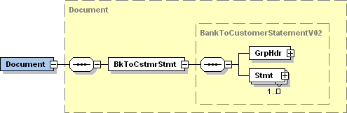

| **ISO Index** | **Item Name** | **XML Tag** | **Cardi-nality** | **Data type** | **Restrictions vs. ISO standard and additional info** |
| --- | --- | --- | --- | --- | --- |
|  | Document root | Document | [1..1] |  |  |
|  | +Message root | BkToCstmrStmt | [1..1] |  |  |
| **1.0** | ++GroupHeader | GrpHdr | [1..1] |  | See chapter 3.2. |
| **2.0** | ++Statement | Stmt | [1..n] |  | See chapter 3.3. |

## GroupHeader

|  |  |
| --- | --- |
| **XPath** | / Document / BkToCstmrStmt / GrpHdr |

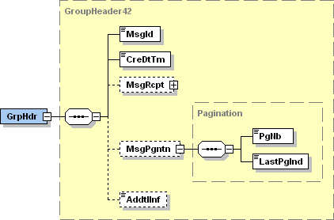

| **ISO Index** | **Item Name** | **XML Tag** | **Cardi-nality** | **Data type** | **Restrictions vs. ISO standard and additional info** |
| --- | --- | --- | --- | --- | --- |
| **1.1** | MessageIdentification | MsgId | [1..1] | String [35] | A unique identifier of the message. A message consists of one or more XML files in the camt.053 format (see MessagePagination) that share the same message ID.  Format: [BIC]-[Product]-[RRMMDD]-[ID], where:   * [BIC] (11 characters) is the BIC-11 identifier of the bank that generated the message. * [Product] (3 characters) can be used to distinguish different “types” of XML statements that may differ in some aspects of their internal structure and/or semantics (still within the boundaries of the national standard). Three asterics (***) represent a “NULL” value. * [RRMMDD] (6 digits) is the date the message was generated. * ID (1 to 12 characters) is a unique message identifier within the day. |
| **1.2** | CreationDateTime | CreDtTm | [1..1] | DateTime | Date and time at which the message creation was finished.  Format: [YYYY]-[MM]-[DD]T[hh]:[mm]:[ss].[f]TZD, where:   * YYYY (4 digits), MM (2 digits) and DD (2 digits) are the year, month and day * hh (two digits), mm (two digits), ss (2 digits) and f (1 digit) are the hour, minute, second and fraction of second * TZD – Time zone is not covered by the standard |
| **1.3** | MessageRecipient | MsgRcpt | [0..1] |  | Information about the message recipient (may differ from the account owner).  See chapter 3.2.1. |
| **1.4** | MessagePagination | MsgPgntn | [0..1] |  | Mandatory if the message is split into several files.  If present on an unpaginated message, The <PgNo> must be set to 1 and the <LastPgInd> must be *true*. |
| **8.1.0** | +PageNumber | PgNb | [1..1] | String [5] | Only digits allowed.  Sequence number of the message “part”. |
| **8.1.1** | +LastPageIndicator | LastPgInd | [1..1] | Boolean | *true* if this is the last part of the message. |
| **1.5** | AdditionalInformation | AddtInf | [0..1] | String [500] | For periodically generated statements, this can contain the statement generation frequency (period length). The format and internal structure of this element is not covered by the standard. |

### MessageRecipient

|  |  |
| --- | --- |
| **XPath** | / Document / BkToCstmrStmt / GrpHdr / MsgRcpt |

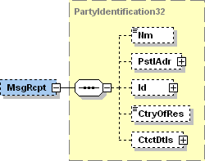

| **ISO Index** | **Item Name** | **XML Tag** | **Cardi-nality** | **Data type** | **Restrictions vs. ISO standard and additional info** |
| --- | --- | --- | --- | --- | --- |
| **9.1.0** | Name | Nm | [0..1] | String [140] |  |
| **9.1.1** | PostalAddress | PstlAdr | [0..1] |  | See chapter 3.2.1.1. |
| **9.1.12** | Identification | Id | [0..1] |  | See chapter 3.2.1.2. |
| **9.1.33** | CountryOfResidence | CtryOfRes | [0..1] | String [2] |  |
| **9.1.34** | ContactDetails | CtctDtls | [0..1] |  |  |

#### PostalAddress

|  |  |
| --- | --- |
| **XPath** | / Document / BkToCstmrStmt / GrpHdr / MsgRcpt / PstlAdr |

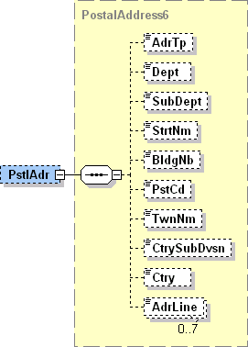

| **ISO Index** | **Item Name** | **XML Tag** | **Cardi-nality** | **Data type** | **Restrictions vs. ISO standard and additional info** |
| --- | --- | --- | --- | --- | --- |
| **9.1.2** | AddressType | AdrTp | [0..1] | String Enumeration |  |
| **9.1.3** | Department | Dept | [0..1] | String [70] |  |
| **9.1.4** | SubDepartment | SubDept | [0..1] | String [70] |  |
| **9.1.5** | StreetName | StrtNm | [0..1] | String [70] |  |
| **9.1.6** | BuildingNumber | BldgNb | [0..1] | String [16] |  |
| **9.1.7** | PostCode | PstCd | [0..1] | String [16] |  |
| **9.1.8** | TownName | TwnNm | [0..1] | String [35] |  |
| **9.1.9** | CountrySubDivision | CtrySubDvsn | [0..1] | String [35] |  |
| **9.1.10** | Country | Ctry | [0..1] | String [2] | International country code according to ISO 3166-1 alpha-2.  Format [A-Z]{2,2} |
| **9.1.11** | AddressLine | AdrLine | [0..7] | String [70] | Unstructured address line. |

#### Identification

|  |  |
| --- | --- |
| **XPath** | / Document / BkToCstmrStmt / GrpHdr / MsgRcpt / Id |

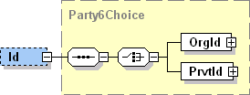

| **ISO Index** | **Item Name** | | **XML Tag** | **Cardi-nality** | **Data type** | **Restrictions vs. ISO standard and additional info** |
| --- | --- | --- | --- | --- | --- | --- |
| **9.1.13** | OrganisationIdentification | Only one of these elements is present | OrgId | [1..1] |  | Identifies a corporate subject.  See chapter 3.2.1.2.1. |
| **9.1.21** | PrivateIdentification | PrvtId | [1..1] |  | Identifies a person.  See chapter 3.2.1.2.2. |

##### OrganisationIdentification

|  |  |
| --- | --- |
| **XPath** | / Document / BkToCstmrStmt / GrpHdr / MsgRcpt / Id / OrgId |

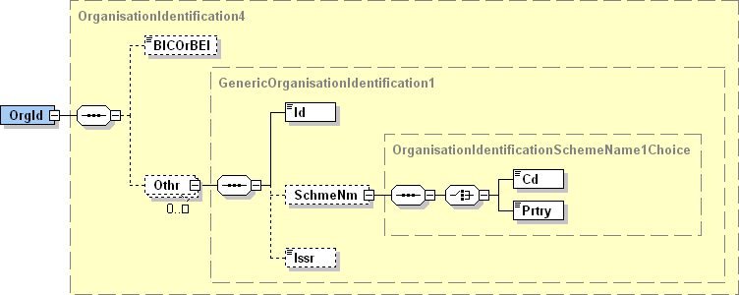

| **ISO Index** | **Item Name** | | **XML Tag** | **Cardi-nality** | **Data type** | **Restrictions vs. ISO standard and additional info** |
| --- | --- | --- | --- | --- | --- | --- |
| **9.1.14** | BICOrBEI | | BICOrBEI | [0..1] | String [11] | Recipient’s BIC according to ISO 9362.  Format [A-Z]{6,6}[A-Z2-9][A-NP-Z0-9]([A-Z0-9]{3,3}){0,1} |
| **9.1.15** | Other | | Othr | [0..n] |  | Regulated identifiers must be provided according to Table 4, other identifiers according to ISO rules. |
| **9.1.16** | +Identification | | Id | [1..1] | String [35] | The ID itself. |
| **9.1.17** | +SchemeName | | SchmeNm | [0..1] |  |  |
| **9.1.18** | ++Code | Only one of these elements is present | Cd | [1..1] | String [4] | ID clasifier according to ISO 20022 “ExternaOrganisationIdentification” code-book. |
| **9.1.19** | ++Proprietary | Prtry | [1..1] | String Enumeration | Proprietary ID clasifier. |
| **9.1.20** | +Issuer | | Issr | [0..1] | String [35] | Issuer of the ID. |

##### PrivateIdentification

|  |  |
| --- | --- |
| **XPath** | / Document / BkToCstmrStmt / GrpHdr / MsgRcpt / Id / PrvId |

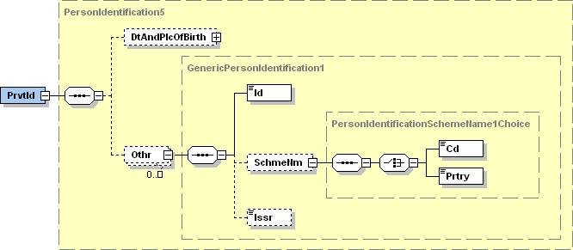

| **ISO Index** | **Item Name** | | **XML Tag** | **Cardi-nality** | **Data type** | **Restrictions vs. ISO standard and additional info** |
| --- | --- | --- | --- | --- | --- | --- |
| **9.1.22** | DateAndPlaceOfBirth | | DtAndPlcOfBirth | [0..1] |  |  |
| **9.1.27** | Other | | Othr | [0..n] |  | Regulated identifiers must be provided according to Table 4, other identifiers according to ISO rules. |
| **9.1.28** | +Identification | | Id | [1..1] | String [35] | The ID itself |
| **9.1.29** | +SchemeName | | SchmeNm | [0..1] |  |  |
| **9.1.30** | ++Code | Only one of these elements is present | Cd | [1..1] | String [4] | ID clasifier according to ISO 20022 “ExternaPersonIdentification” code-book. |
| **9.1.31** | ++Proprietary | Prtry | [1..1] | String Enumeration | Proprietary ID clasifier. |
| **9.1.32** | +Issuer | | Issr | [0..1] | String [35] | Issuer of the ID. |

## Statement

|  |  |
| --- | --- |
| **XPath** | / Document / BkToCstmrStmt / Stmt |

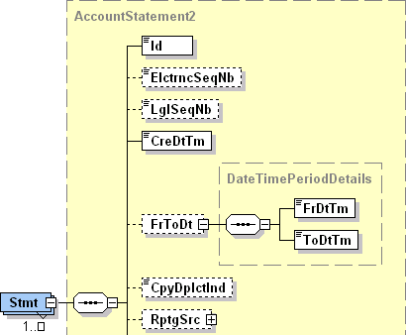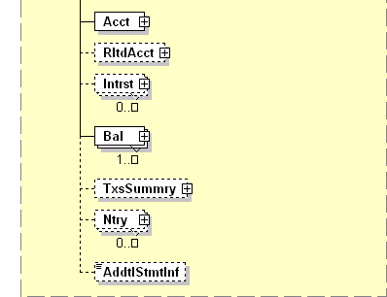

| **ISO Index** | **Item Name** | **XML Tag** | **Cardi-nality** | **Data type** | **Restrictions vs. ISO standard and additional info** |
| --- | --- | --- | --- | --- | --- |
| **2.1** | Identification | Id | [1..1] | String [35] | A unique statement identifier.  Format [IBAN]-[Seq]-[YYMMDD], where:   * IBAN (24 characters) is the account number in SK IBAN format * [Seq] identifies the sequence to which the statement belongs. If the statement was produced out-of-sequemce, this parameter will have the value of “***” (three asterisks). * YY (2 digits), MM (2 digits) a DD (2 digits) are the year, month and day of the last business day covered by the statement. |
| **2.2** | ElectronicSequenceNumber | ElctrncSeqNb | [0..1] | Number [18,0] |  |
| **2.3** | LegalSequenceNumber | LglSeqNb | [0..1] | Number [18,0] | A sequential statement order number within a given statement sequence and a year.  Mandatory for sequential statements, optional for on-demand statements. |
| **2.4** | CreationDateTime | CreDtTm | [1..1] | DateTime | Date and time at which the statement creation finished.  Format [YYYY]-[MM]-[DD]T[hh]:[mm]:[ss].[f]TZD, where:   * YYYY (4 digits), MM (2 digits) a DD (2 digits) are the year, month and day * hh (2 digits), mm (2 digits), ss (2 digits) a f (1 digit) are the hour, minute, second and fraction of a second * TZD – Time zone is not covered by the standard |
| **2.5** | FromToDate | FrToDt | [1..1] |  | Always present.  Specifies the interval of business dates covered by the statement. |
| **5.1.0** | +FromDateTime | FrDtTm | [1..1] | DateTime | First business date covered by the statement.  Format [YYYY]-[MM]-[DD]Thh:mm:ss.fTZD, where:   * YYYY (4 digits), MM (2 digits) a DD (2 digits) are the year, month and day * the time and time zone are not covered by the standard |
| **5.1.1** | +ToDateTime | ToDtTm | [1..1] | DateTime | Last business date coverd by the statement.  Format [YYYY]-[MM]-[DD]Thh:mm:ss.fTZD, where:   * YYYY (4 digits), MM (2 digits) a DD (2 digits) are the year, month and day * the time and time zone are not covered by the standard |
| **2.6** | CopyDuplicateIndicator | CpyDplctInd | [0..1] | String Enumeration |  |
| **2.7** | ReportingSource | RptgSrc | [0..1] |  |  |
| **2.10** | Account | Acct | [1..1] |  | See chapter 3.3.1. |
| **2.11** | RelatedAccount | RltdAcct | [0..1] |  |  |
| **2.12** | Interest | Intrst | [0..1] |  | See chapter 3.3.2. |
| **2.23** | Balance | Bal | [1..n] |  | See chapter 3.3.3. |
| **2.43** | TransactionsSummary | TxsSummry | [0..1] |  | If the message is split into several files, this element may be present only on the last “page”.  See chapter 3.3.4. |
| **2.76** | Entry | Ntry | [0..n] |  | See chapter 3.3.5. |
| **2.315** | AdditionalStatementInformation | AddtlStmtInf | [0..1] | String [500] | Statement frequency. |

### Account

|  |  |
| --- | --- |
| **XPath** | / Document / BkToCstmrStmt / Stmt / Acct |

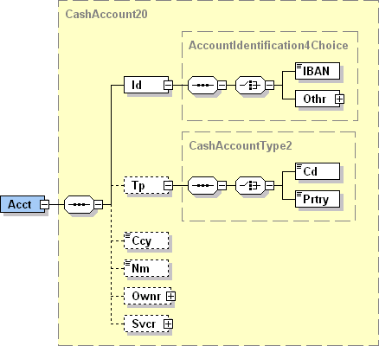

| **ISO Index** | **Item Name** | | **XML Tag** | **Cardi-nality** | **Data type** | **Restrictions vs. ISO standard and additional info** |
| --- | --- | --- | --- | --- | --- | --- |
| **1.2.0** | Identification | | Id | [1..1] |  |  |
| **1.2.1** | +IBAN | Only one of these elements is present | IBAN | [1..1] | String [34] | Always present. |
| **1.2.2** | +Other | Othr | [0..0] |  | Prohibited. |
| **1.2.8** | Type | | Tp | [0..1] |  |  |
| **1.2.9** | +Code | Only one of these elements is present | Code | [1..1] | String [4] | ISO account clasifier.  Only values from ISO code-book “ExternalCashAccountType” are allowed. |
| **1.2.10** | +Proprietary | Prtry | [1..1] | String Enumeration | Proprietary account clasifier. |
| **1.2.11** | Currency | | Ccy | [0..1] | String [3] | International currency code according to ISO 4217. |
| **1.2.12** | Name | | Nm | [0..1] | String [70] |  |
| **1.2.13** | Owner | | Ownr | [0..1] |  | See chapter 3.3.1.1. |
| **1.2.56** | Servicer | | Svcr | [0..1] |  | See chapter 3.3.1.2. |

#### Owner

|  |  |
| --- | --- |
| **XPath** | / Document / BkToCstmrStmt / Stmt / Acct / Ownr |

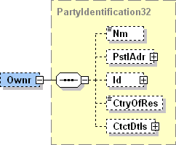

| **ISO Index** | **Item Name** | **XML Tag** | **Cardi-nality** | **Data type** | **Restrictions vs. ISO standard and additional info** |
| --- | --- | --- | --- | --- | --- |
| **9.1.0** | Name | Nm | [0..1] | String [140] |  |
| **9.1.1** | PostalAddress | PstlAdr | [0..1] |  | See chapter 3.3.1.1.1. |
| **9.1.12** | Identification | Id | [0..1] |  | See chapter 3.3.1.1.2. |
| **9.1.33** | CountryOfResidence | CtryOfRes | [0..1] | String [2] |  |
| **9.1.34** | ContactDetails | CtctDtls | [0..1] |  |  |

##### PostalAddress

|  |  |
| --- | --- |
| **XPath** | / Document / BkToCstmrStmt / Stmt / Acct / Ownr / PstlAdr |



| **ISO Index** | **Item Name** | **XML Tag** | **Cardi-nality** | **Data type** | **Restrictions vs. ISO standard and additional info** |
| --- | --- | --- | --- | --- | --- |
| **9.1.2** | AddressType | AdrTp | [0..1] | String Enumeration |  |
| **9.1.3** | Department | Dept | [0..1] | String [70] |  |
| **9.1.4** | SubDepartment | SubDept | [0..1] | String [70] |  |
| **9.1.5** | StreetName | StrtNm | [0..1] | String [70] |  |
| **9.1.6** | BuildingNumber | BldgNb | [0..1] | String [16] |  |
| **9.1.7** | PostCode | PstCd | [0..1] | String [16] |  |
| **9.1.8** | TownName | TwnNm | [0..1] | String [35] |  |
| **9.1.9** | CountrySubDivision | CtrySubDvsn | [0..1] | String [35] |  |
| **9.1.10** | Country | Ctry | [0..1] | String [2] | International country code according to ISO 3166-1 alpha-2.  Format [A-Z]{2,2} |
| **9.1.11** | AddressLine | AdrLine | [0..7] | String [70] | Unstructured address line. |

##### Identification

|  |  |
| --- | --- |
| **XPath** | / Document / BkToCstmrStmt / Stmt / Acct / Ownr / Id |



| **ISO Index** | **Item Name** | | **XML Tag** | **Cardi-nality** | **Data type** | **Restrictions vs. ISO standard and additional info** |
| --- | --- | --- | --- | --- | --- | --- |
| **9.1.13** | OrganisationIdentification | Only one of these elements is present | OrgId | [1..1] |  | Identifies a corporate subject.  See chapter 3.3.1.1.2.1. |
| **9.1.21** | PrivateIdentification | PrvtId | [1..1] |  | Identifies a person.  See chapter 3.3.1.1.2.2. |

###### OrganisationIdentification

|  |  |
| --- | --- |
| **XPath** | / Document / BkToCstmrStmt / Stmt / Acct / Ownr / Id / OrgId |



| **ISO Index** | **Item Name** | | **XML Tag** | **Cardi-nality** | **Data type** | **Restrictions vs. ISO standard and additional info** |
| --- | --- | --- | --- | --- | --- | --- |
| **9.1.14** | BICOrBEI | | BICOrBEI | [0..1] | String [11] | Account owner BIC according to ISO 9362.  Format [A-Z]{6,6}[A-Z2-9][A-NP-Z0-9]([A-Z0-9]{3,3}){0,1} |
| **9.1.15** | Other | | Othr | [0..n] |  | Regulated identifiers must be provided according to Table 4, other identifiers according to ISO rules. |
| **9.1.16** | +Identification | | Id | [1..1] | String [35] | The ID itself. |
| **9.1.17** | +SchemeName | | SchmeNm | [0..1] |  |  |
| **9.1.18** | ++Code | Only one of these elements is present | Cd | [1..1] | String [4] | ID clasifier according to ISO 20022 “ExternaOrganisationIdentification” code-book. |
| **9.1.19** | ++Proprietary | Prtry | [1..1] | String Enumeration | Proprietary ID clasifier. |
| **9.1.20** | +Issuer | | Issr | [0..1] | String [35] | Issuer of the ID. |

###### PrivateIdentification

|  |  |
| --- | --- |
| **XPath** | / Document / BkToCstmrStmt / Stmt / Acct / Ownr / Id / PrvId |

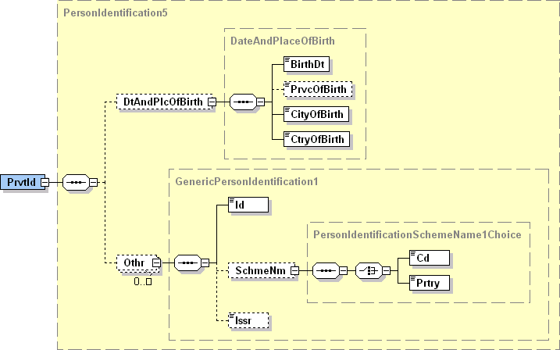

| **ISO Index** | **Item Name** | | **XML Tag** | **Cardi-nality** | **Data type** | **Restrictions vs. ISO standard and additional info** |
| --- | --- | --- | --- | --- | --- | --- |
| **9.1.22** | DateAndPlaceOfBirth | | DtAndPlcOfBirth | [0..1] |  |  |
| **9.1.27** | Other | | Othr | [0..n] |  | Regulated identifiers must be provided according to Table 5, other identifiers according to ISO rules. |
| **9.1.28** | +Identification | | Id | [1..1] | String [35] | The ID itself. |
| **9.1.29** | +SchemeName | | SchmeNm | [1..1] |  |  |
| **9.1.30** | ++Code | Only one of these elements is present | Cd | [0..1] | String [4] | ID clasifier according to ISO 20022 “ExternaPersonIdentification” code-book. |
| **9.1.31** | ++Proprietary | Prtry | [1..1] | String Enumeration | Proprietary ID clasifier. |
| **9.1.32** | +Issuer | | Issr | [0..1] | String [35] | Issuer of the ID. |

#### Servicer

|  |  |
| --- | --- |
| **XPath** | / Document / BkToCstmrStmt / Stmt / Acct / Svcr |

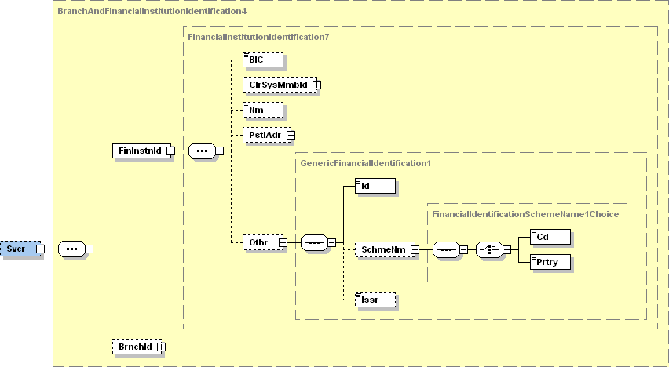

| **ISO Index** | **Item Name** | | **XML Tag** | **Cardi-nality** | **Data type** | **Restrictions vs. ISO standard and additional info** |
| --- | --- | --- | --- | --- | --- | --- |
| **6.1.0** | FinancialInstitutionIdentification | | FinInstnId | [1..1] |  |  |
| **6.1.1** | +BIC | | BIC | [0..1] | String [11] | Account Servicer BIC according to ISO 9362.  Format: [A-Z]{6,6}[A-Z2-9][A-NP-Z0-9]([A-Z0-9]{3,3}){0,1} |
| **6.1.2** | +ClearingSystemMemberIdentification | | ClrSysMmbId | [0..1] |  |  |
| **6.1.7** | +Name | | Nm | [0..1] | String [140] | Account Servicer Name. |
| **6.1.8** | +PostalAddress | | PstlAdr | [0..1] |  | See chapter 3.3.1.2.1. |
| **6.1.19** | +Other | | Othr | [0..1] |  |  |
| **1.2.77** | ++Identification | | Id | [1..1] | String [35] | Account Servicer EuroSIPS code. |
| **1.2.78** | ++SchemeName | | SchmeNm | [0..1] |  |  |
| **1.2.79** | +++Code | Only one of these elements is present | Cd | [0..0] | String [4] | Prohibited. |
| **1.2.80** | +++Proprietary | Prtry | [1..1] | String [35] | Always present, always equals “EuroSIPS Bank Code”. |
| **1.2.81** | ++Issuer | | Issr | [0..1] | String [35] | Always equals “NBS”. |
| **6.1.25** | BranchIdentification | | BrnchId | [0..1] |  |  |

##### PostalAddress

|  |  |
| --- | --- |
| **XPath** | / Document / BkToCstmrStmt / Stmt / Acct / Svcr / PstlAdr |



| **ISO Index** | **Item Name** | **XML Tag** | **Cardi-nality** | **Data type** | **Restrictions vs. ISO standard and additional info** |
| --- | --- | --- | --- | --- | --- |
| **9.1.2** | AddressType | AdrTp | [0..1] | String Enumeration |  |
| **9.1.3** | Department | Dept | [0..1] | String [70] |  |
| **9.1.4** | SubDepartment | SubDept | [0..1] | String [70] |  |
| **9.1.5** | StreetName | StrtNm | [0..1] | String [70] |  |
| **9.1.6** | BuildingNumber | BldgNb | [0..1] | String [16] |  |
| **9.1.7** | PostCode | PstCd | [0..1] | String [16] |  |
| **9.1.8** | TownName | TwnNm | [0..1] | String [35] |  |
| **9.1.9** | CountrySubDivision | CtrySubDvsn | [0..1] | String [35] |  |
| **9.1.10** | Country | Ctry | [0..1] | String [2] | International country code according to ISO 3166-1 alpha-2.  Format [A-Z]{2,2} |
| **9.1.11** | AddressLine | AdrLine | [0..7] | String [70] | Unstructured address line. |

### Interest

|  |  |
| --- | --- |
| **XPath** | / Document / BkToCstmrStmt / Stmt / Intrst |

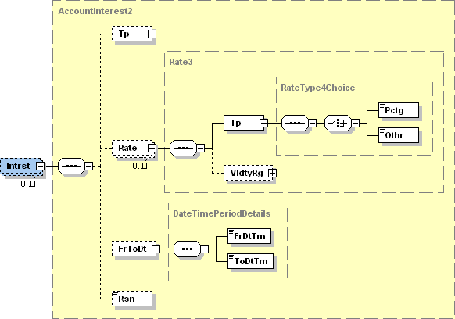

| **ISO Index** | **Item Name** | **XML Tag** | **Cardi-nality** | **Data type** | **Restrictions vs. ISO standard and additional info** |
| --- | --- | --- | --- | --- | --- |
| **2.13** | Type | Tp | [0..1] |  |  |
| **2.16** | Rate | Rate | [0..n] |  |  |
| **2.17** | +Type | Tp | [1..1] |  |  |
| **2.18** | ++Percentage | Pctg | [1..1] | Number [11, 0..10] | Always present. |
| **2.19** | ++Other | Othr | [0..0] | String [35] | Prohibited. |
| **2.20** | +ValidityRange | VldtyRg | [0..1] |  |  |
| **2.21** | FromToDate | FrToDt | [0..1] |  | Interest rate validity range. |
| **5.1.0** | +FromDateTime | FrDtTm | [1..1] | DateTime | First business date on which the interest was applied.  Format [YYYY]-[MM]-[DD]Thh:mm:ss.fTZD, where:   * YYYY (4 digits), MM (2 digits) a DD (2 digits) are the year, month and day * the time and time zone are not covered by the standard |
| **5.1.1** | +ToDateTime | ToDtTm | [1..1] | DateTime | Last business date on which the interest was applied.  Format [YYYY]-[MM]-[DD]Thh:mm:ss.fTZD, where:   * YYYY (4 digits), MM (2 digits) a DD (2 digits) are the year, month and day * the time and time zone are not covered by the standard |
| **2.22** | Reason | Rsn | [0..1] | String [35] |  |

### Balance

|  |  |
| --- | --- |
| **XPath** | / Document / BkToCstmrStmt / Stmt / Bal |

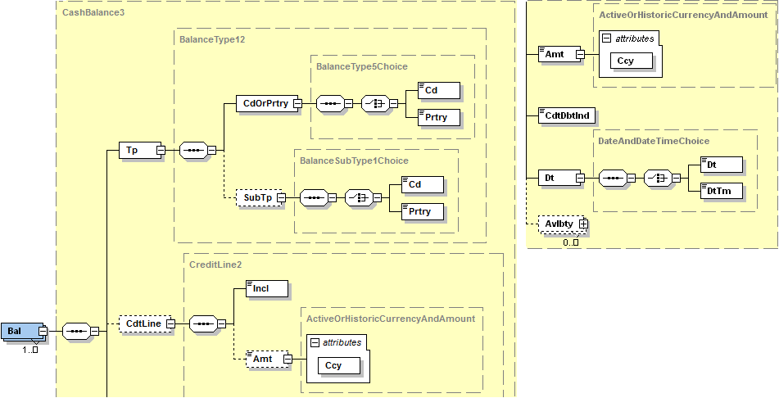

| **ISO Index** | **Item Name** | | **XML Tag** | **Cardi-nality** | **Data type** | **Restrictions vs. ISO standard and additional info** |
| --- | --- | --- | --- | --- | --- | --- |
| **2.24** | Type | | Tp | [1..1] |  |  |
| **2.25** | +CodeOrProprietary | | CdOrPrtry | [1..1] |  |  |
| **2.26** | ++Code | | Cd | [1..1] | String Enumeration | Identifies the balance type.  Only values from Table 6 allowed.. |
| **2.27** | ++Proprietary | | Prtry | [0..0] | String [35] | Prohibited. |
| **2.28** | +SubType | | SubTp | [0..1] |  |  |
| **2.29** | ++Code | | Cd | [1..1] | String [4] | Identifies the balance subtype. Only code INTM is allowed and defines the balance as an intermediate balance in multi-page statement.  Can be used as a more detailed alternative to intermediate balance type ITBD used in tag CdOrPrtry / Cd. When the code ITBD is present in tag CdOrPrtry / Cd, tag SubType is prohibited.  For other codes from CdOrPrtry / Cd, the SubType defines the certain balance as an intermediate balance. |
| **2.30** | ++Proprietary | | Prtry | [0..0] | String [35] | Prohibited. |
| **2.31** | CreditLine | | CdtLine | [0..1] |  |  |
| **2.32** | +Included | | Incl | [1..1] | Boolean | Indicates whether the credit line is included in the balance or not. |
| **2.33** | +Amount | | Amt | [0..1] | Number [18,0..5] |  |
|  | +@Currency | | Ccy | [1..1] | String [3] | International currency code according to ISO 4217. |
| **2.34** | Amount | | Amt | [1..1] | Number [18, 0..5] | Absolute balance amount.  Cannot be negative. |
|  | @Currency | | Ccy | [1..1] | String [3] | Balance currency.  An attribute of the Amount element.  International currency code according to ISO 4217. |
| **2.35** | CreditDebitIndicator | | CdtDbtInd | [1..1] | String Enumeration | Indicates, whether the balance is positive or negative.  Only following values are allowed:   * „CRDT“ for positive (and zero) balances * „DBIT“ for negative balances |
| **2.36** | Date | | Dt | [1..1] |  |  |
| **4.1.0** | +Date | Only one of these elements is present | Dt | [1..1] | Date | The balance reference date.  For CLBD and CLAV balances, this is the actual balance validity date; valid values are dates between Stmt / FrToDt / FrDtTm and Stmt / FrToDt / ToDtTm (inclusive).  For PRCD balances, the value must be equal to Stmt / FrToDt / FrDtTm; the balance validity date is one business day before Stmt / FrToDt / FrDtTm  Format [YYYY]-[MM]-[DD], where:   * YYYY (4 digits), MM (2 digits) a DD (2 digits) are the year, month and day. |
| **4.1.1** | +DateTime | DtTm | [1..1] | DateTime | The balance validity timestamp, usually used with ITBD balances.  Format: [YYYY]-[MM]-[DD]T[hh]:[mm]:[ss].[f]TZD, where:   * YYYY (4 digits), MM (2 digits) and DD (2 digits) are the year, month and day * hh (two digits), mm (two digits), ss (2 digits) and f (1 digit) are the hour, minute, second and fraction of second * TZD – Time zone is not covered by the standard |
| **2.37** | Availability | | Avlbty | [0..n] |  |  |

### TransactionsSummary

|  |  |
| --- | --- |
| **XPath** | / Document / BkToCstmrStmt / Stmt / TxsSummry |

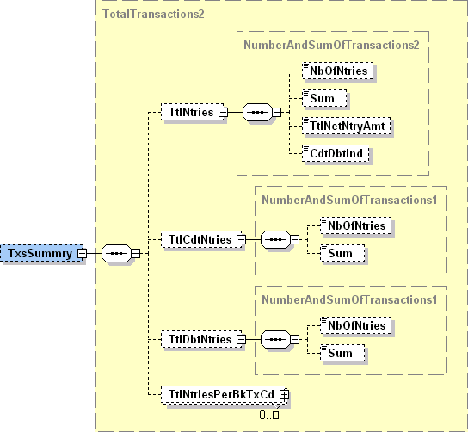

| **ISO Index** | **Item Name** | **XML Tag** | **Cardi-nality** | **Data type** | **Restrictions vs. ISO standard and additional info** |
| --- | --- | --- | --- | --- | --- |
| **2.44** | TotalEntries | TtlNtries | [0..1] |  |  |
| **2.45** | +NumberOfEntries | NbOfNtries | [0..1] | String [15] | Only digits allowed (format [0-9]{1,15}).  Total number of movements within the statement. |
| **2.46** | +Sum | Sum | [0..1] | Number [18, 0..17] | Sum of absolute values of all movements within the statement. |
| **2.47** | +TotalNetEntryAmount | TtlNetNtryAmt | [0..1] | Number [18, 0..17] | Sum of all movements within the statement. This amount should be equal to the difference between the closing and opening balance. |
| **2.48** | +CreditDebitIndicator | CdtDbtInd | [0..1] | String Enumeration | Mandatory if the <TtlNetNtryAmt> element is present.  Indicates, whether the value of <TtlNetNtryAmt> is positive or negative.  Only following values are allowed:   * „CRDT“ for positive (and zero) amounts * „DBIT“ for negative amounts |
| **2.49** | TotalCreditEntries | TtlCdtNtries | [0..1] |  |  |
| **2.50** | +NumberOfEntries | NbOfNtries | [0..1] | String [15] | Only digits allowed (format [0-9]{1,15}).  Total number of credits within the statement. |
| **2.51** | +Sum | Sum | [0..1] | Number [18, 0..17] | Sum of all credits within the statement. |
| **2.52** | TotalDebitEntries | TtlDbtNtries | [0..1] |  |  |
| **2.53** | +NumberOfEntries | NbOfNtries | [0..1] | String [15] | Only digits allowed (format [0-9]{1,15}).  Total number of debits within the statement. |
| **2.54** | +Sum | Sum | [0..1] | Number [18, 0..17] | Sum of all debits within the statement. |
| **2.55** | TotalEntriesPer-BankTransactionCode | TtlNtriesPerBkTxCd | [0..n] |  |  |

### Entry

|  |  |
| --- | --- |
| **XPath** | / Document / BkToCstmrStmt / Stmt / Ntry |

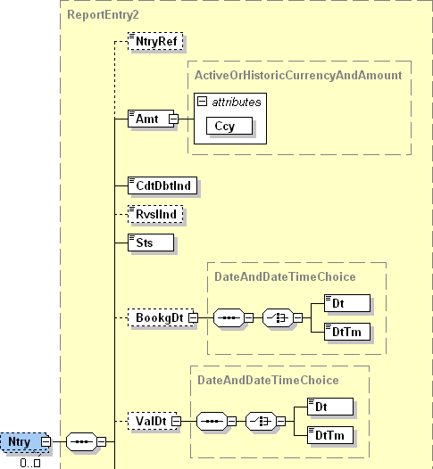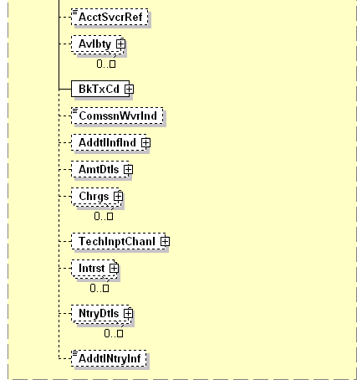

| **ISO Index** | **Item Name** | | **XML Tag** | **Cardi-nality** | **Data type** | **Restrictions vs. ISO standard and additional info** |
| --- | --- | --- | --- | --- | --- | --- |
| **2.77** | EntryReference | | NtryRef | [0..1] | String [35] | A unique movement identifier. |
| **2.78** | Amount | | Amt | [1..1] | Number [18, 0..5] | Absolute movement amount.  Cannot be negative. |
|  | @Currency | | Ccy | [1..1] | String [3] | Movement currency.  An attribute of the Amount element.  International currency code according to ISO 4217. |
| **2.79** | CreditDebitIndicator | | CdtDbtInd | [1..1] | String Enumeration | Indicates whether the movement is a credit or a debit.  Only following values are allowed:   * „CRDT“ for credits (and zero movements) * „DBIT“ for debits |
| **2.80** | ReversalIndicator | | RvslInd | [0..1] | Boolean | Indicates whether the movement is a reversal. Do not confuse this with a SEPA R-Message indicated by the <RtrInf> element on the <TxDtls> level.  Defaults to *false*. |
| **2.81** | Status | | Sts | [1..1] | String Enumeration | Always “BOOK”. |
| **2.82** | BookingDate | | BookDt | [0..1] |  |  |
| **4.1.0** | +Date | Only one of these elements is present | Dt | [1..1] | Date | Movement posting date.  Format: [YYYY]-[MM]-[DD], where:   * YYYY (4 digits), MM (2 digits) and DD (2 digits) are the year, month and day |
| **4.1.1** | +DateTime | DtTm | [1..1] | DateTime | Movement posting timestamp.  Format: [YYYY]-[MM]-[DD]T[hh]:[mm]:[ss].[f]TZD, where:   * YYYY (4 digits), MM (2 digits) and DD (2 digits) are the year, month and day * hh (two digits), mm (two digits), ss (2 digits) and f (1 digit) are the hour, minute, second and fraction of second * TZD – Time zone is not covered by the standard |
| **2.83** | ValueDate | | ValDt | [0..1] |  |  |
| **4.1.0** | +Date | Only one of these elements is present | Dt | [1..1] | Date | Movement value date.  Format: [YYYY]-[MM]-[DD], where:   * YYYY (4 digits), MM (2 digits) and DD (2 digits) are the year, month and day |
| **4.1.1** | +DateTime | DtTm | [0..0] | DateTime | Movement value timestamp.  Format: [YYYY]-[MM]-[DD]T[hh]:[mm]:[ss].[f]TZD, where:   * YYYY (4 digits), MM (2 digits) and DD (2 digits) are the year, month and day * hh (two digits), mm (two digits), ss (2 digits) and f (1 digit) are the hour, minute, second and fraction of second * TZD – Time zone is not covered by the standard |
| **2.84** | AccountServicerReference | | AcctSvcrRef | [0..1] | String [35] | Allowed only for bulk payments.  System bulk reference assigned by the debtor agent. |
| **2.85** | Availability | | Avlbty | [0..n] |  |  |
| **2.91** | BankTransactionCode | | BkTxCd | [1..1] |  | See chapter 3.3.5.1. |
| **2.100** | CommissionWaiverIndicator | | ComssnWvrInd | [0..1] | Boolean |  |
| **2.101** | AdditionalInformationIndicator | | AddtInfInd | [0..1] |  |  |
| **2.104** | AmountDetails | | AmtDtls | [0..1] |  | Allowed only for bulk payments.  The contents of this element is not regulated. |
| **2.105** | Charges | | Chrgs | [0..n] |  | Allowed only for bulk payments.  See chapter 3.3.5.2. |
| **2.119** | TechnicalInputChannel | | TechInptChanl | [0..1] |  |  |
| **2.122** | Interest | | Intrst | [0..n] |  |  |
| **2.135** | EntryDetails | | NtryDtls | [0..n] |  | All SBA regulations refer to the first instance of <NtryDtls> (see chapter 3.3.5.3). Subsequent instances are not regulated. |
| **2.314** | AdditionalEntryInformation | | AddtNtryInf | [0..1] | String [500] |  |

#### BankTransactionCode

|  |  |
| --- | --- |
| **XPath** | / Document / BkToCstmrStmt / Stmt / Ntry / BkTxCd |

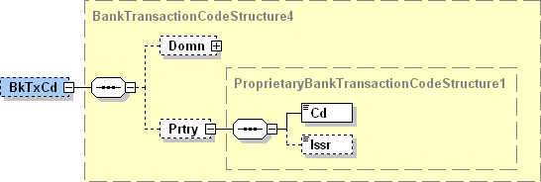

| **ISO Index** | **Item Name** | **XML Tag** | **Cardi-nality** | **Data type** | **Restrictions vs. ISO standard and additional info** |
| --- | --- | --- | --- | --- | --- |
| **2.92** | Domain | Domn | [0..1] |  |  |
| **2.97** | Proprietary | Prtry | [1..1] |  | Always present. |
| **2.98** | +Code | Cd | [1..1] | String [11] | The movement SBA transaction code.  For a list of allowed values see chapter 4.3.3. |
| **2.99** | +Issuer | Issr | [1..1] | String [35] | Always “SBA”. |

#### Charges

|  |  |
| --- | --- |
| **XPath** | / Document / BkToCstmrStmt / Stmt / Ntry / Chrgs |

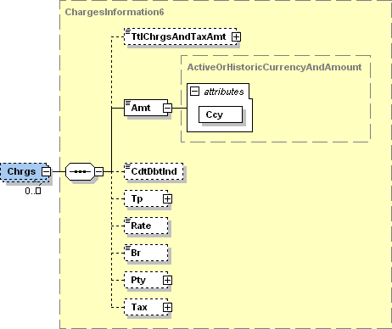

| **ISO Index** | **Item Name** | **XML Tag** | **Cardi-nality** | **Data type** | **Restrictions vs. ISO standard and additional info** |
| --- | --- | --- | --- | --- | --- |
| **2.106** | TotalChargesAndTaxAmount | TtlChrgsAndTaxAmt | [0..1] |  |  |
| **2.107** | Amount | Amt | [1..1] | Number [18, 0..5] | Absolute charge amount.  Cannot be negative. |
|  | @Currency | Ccy | [1..1] | String [3] | Charge currency.  An attribute of the Amount element.  International currency code according to ISO 4217 |
| **2.108** | CreditDebitIndicator | CdtDbtInd | [0..1] | String Enumeration | Indicates whether the charge is being levied or returned.  Only following values are allowed:   * „CRDT“ for returned charges * „DBIT“ for levied (and zero) charges   If omitted, it defaults to “DBIT”. |
| **2.109** | Type | Tp | [0..1] |  |  |
| **2.112** | Rate | Rate | [0..1] | Number [11, 0..10] |  |
| **2.113** | Bearer | Br | [0..1] | String Enumeration | Identifies the party that will bear the charge.  Only following values are allowed:   * “DEBT” – the debtor bears all charges * “CRED” – the creditor bears all charges * “SHAR” – each party bears the charges of its agent * “SLEV” – the charges are distributed according to a billateral agreement between the creditor and debtor agents. |
| **2.114** | Party | Pty | [0..1] |  |  |
| **2.115** | Tax | Tax | [0..1] |  |  |

#### EntryDetails – Instance 1

|  |  |
| --- | --- |
| **XPath** | / Document / BkToCstmrStmt / Stmt / Ntry / NtryDtls [1] |

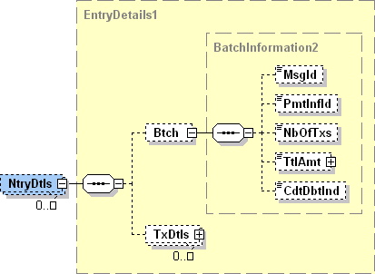

| **ISO Index** | **Item Name** | **XML Tag** | **Cardi-nality** | **Data type** | **Restrictions vs. ISO standard and additional info** |
| --- | --- | --- | --- | --- | --- |
| **2.136** | Batch | Btch | [0..1] |  | Allowed only for bulk payments. |
| **2.137** | +MessageIdentification | MsgId | [0..1] | String [35] | Payment instruction message ID. |
| **2.138** | +PaymentInformationIdentification | PmtInfId | [0..1] | String [35] | Payment instruction ID assigned by the instructing party. |
| **2.139** | +NumberOfTransactions | NbOfTxs | [0..1] | String [15] | Only digits allowed.  Number of transactions in the bulk payment. |
| **2.140** | +TotalAmount | TtlAmt | [0..1] | Number [18, 0..5] |  |
| **2.141** | +CreditDebitIndicator | CdtDbtIndTxInf | [0..1] | String Enumeration |  |
| **2.142** | TransactionDetails | TxDtls | [0..n] |  | More than one instance allowed only for bulk payments.  See chapter 3.3.5.3.1. |

##### TransactionDetails

|  |  |
| --- | --- |
| **XPath** | / Document / BkToCstmrStmt / Stmt / Ntry / NtryDtls [1] / TxDtls |

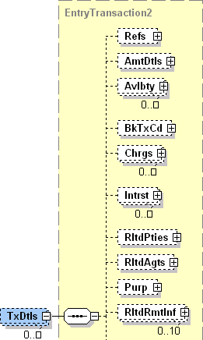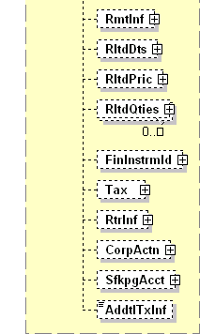

| **ISO Index** | **Item Name** | **XML Tag** | **Cardi-nality** | **Data type** | **Restrictions vs. ISO standard and additional info** |
| --- | --- | --- | --- | --- | --- |
| **2.143** | References | Refs | [0..1] |  | See chapter 3.3.5.3.1.1. |
| **2.156** | AmountDetails | AmtDtls | [0..1] |  | See chapter 3.3.5.3.1.2. |
| **2.157** | Availability | Avlbty | [0..n] |  |  |
| **2.163** | BankTransactionCode | BkTxCd | [0..1] |  | See chapter 3.3.5.3.1.3. |
| **2.172** | Charges | Chrgs | [0..n] |  | See chapter 3.3.5.3.1.4. |
| **2.186** | Interest | Intrst | [0..n] |  |  |
| **2.199** | RelatedParties | RltdPties | [0..1] |  | See chapter 3.3.5.3.1.5. |
| **2.211** | RelatedAgents | RltdAgts | [0..1] |  | See chapter 3.3.5.3.1.6. |
| **2.224** | Purpose | Purp | [0..1] |  | Allowed only for SEPA payments.  See chapter 3.3.5.3.1.7. |
| **2.227** | RelatedRemittanceInformation | RltdRmtInf | [0..n] |  |  |
| **2.234** | RemittanceInformation | RmtInf | [0..1] |  | See chapter 3.3.5.3.1.8. |
| **2.266** | RelatedDates | RltdDts | [0..1] |  | See chapter 3.3.5.3.1.9 |
| **2.277** | RelatedPrice | RltdPric | [0..1] |  |  |
| **2.282** | RelatedQuantities | RltsQties | [0..n] |  |  |
| **2.287** | FinancialInstrumentIdentification | FinInstrmId | [0..1] |  |  |
| **2.292** | Tax | Tax | [0..1] |  |  |
| **2.293** | ReturnInformation | RtrInf | [0..1] |  | Allowed only for SEPA R-Messages.  See chapter 3.3.5.3.1.10 |
| **2.308** | CorporateAction | CorpActn | [0..1] |  |  |
| **2.312** | SafekeepingAccount | SfkpgAcct | [0..1] |  |  |
| **2.313** | AdditionalTransactionInformation | Addtl | [0..1] | String [500] |  |

###### References

|  |  |
| --- | --- |
| **XPath** | / Document / BkToCstmrStmt / Stmt / Ntry / NtryDtls [1] / TxDtls / Refs |

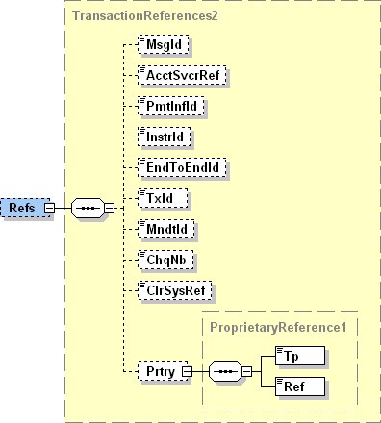

| **ISO Index** | **Item Name** | **XML Tag** | **Cardi-nality** | **Data type** | **Restrictions vs. ISO standard and additional info** |
| --- | --- | --- | --- | --- | --- |
| **2.144** | MessageIdentification | MsgId | [0..1] | String [35] | Payment instruction message ID. |
| **2.145** | AccountServicerReference | AcctSvcrRef | [0..1] | String [35] | Payment reference assigned by the account–servicing agent. |
| **2.146** | PaymentInformationIdentification | PmtInfId | [0..1] | String [35] | Payment instruction ID assigned by the instructing agent. |
| **2.147** | InstructionIdentification | InstrId | [0..1] | String [35] | Payment instruction ID assigned by the instructing party.  Value can be obtained from the client's payment order. |
| **2.148** | EndToEndIndentification | EndToEndId | [0..1] | String [35] | Payment reference assigned by the instructing party.  It may contain EuroSIPS credit-side symbols, although the conditions, under which the symbols are recognised, differ between banks.  The most rigorous formatting specification, that should be recognised by all participants, requires all three symbols to be present (event those without a value) in a strict order and no other text apart from the symbols may be present in the reference. The corresponding regular expression is:  **^/VS[0-9]{0,10}/SS[0-9]{0,10}/KS[0-9]{0,4}$**  Some more liberal specifications allow for:   * skipping the label if the symbol has no value:   + **^(/VS[0-9]{0,10})?(/SS[0-9]{0,10})?(/KS[0-9]{0,4})?$** * text around the symbols:   + **/VS[0-9]{0,10}/SS[0-9]{0,10}/KS[0-9]{0,4}** * or a combination of both:   + **(/VS[0-9]{0,10})?(/SS[0-9]{0,10})?(/KS[0-9]{0,4})?**   The most liberal specification allows any subset of the symbols to be present in any order and with free text anywhere between and around them. The corresponding regular expression is too long to be readable; instead, a free-form description of the formatting follows:  The EuroSIPS credit-side symbols are recognizable by dedicated labels. All labels are case-sensitive. If a label does not exist or exists more than once within the reference or if the first character after the label is not a digit, the related symbol is considered non-existent. The symbol starts with the first digit after the label and ends before the first non-digit character or by reaching the maximal symbol length. The labels and maximal lengths for individual symbols are as follows:  **Symbol Label Maximal length**  Variable /VS 10  Specific /SS 10  Constant /KS 4 |
| **2.149** | TransactionIdentification | TxId | [0..1] | String [35] | Transaction reference assigned by the instructing application. For incoming transactions, this is the instructing agent; for outgoing transactions, this is the instructing “front-end” application. For card transactions, this is the Point-of-Trade (ATM or POS) or the Acquier’s transactions processing system.  A system equivalent of the End-to-End ID. |
| **2.150** | MandateIdentification | MndtId | [0..1] | String [35] | Allowed only for SDD transactions.  A unique mandate identifier. |
| **2.151** | ChequeNumber | ChqNb | [0..1] | String [35] | * For card transactions, this is the card number in format **** **** **** 1111 * For cheque transactions, this is the cheque number. |
| **2.152** | ClearingSystemReference | ClrSysRef | [0..1] | String [35] | Transaction reference assigned by the clearing system. |
| **2.153** | Proprietary | Prtry | [0..1] |  |  |

###### AmountDetails

|  |  |
| --- | --- |
| **XPath** | / Document / BkToCstmrStmt / Stmt / Ntry / NtryDtls [1] / TxDtls / AmtDtls |

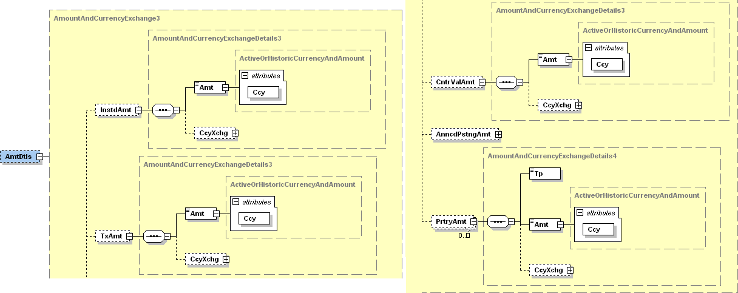

| **ISO Index** | **Item Name** | **XML Tag** | **Cardi-nality** | **Data type** | **Restrictions vs. ISO standard and additional info** |
| --- | --- | --- | --- | --- | --- |
| **2.1.0** | InstructedAmount | InstdAmt | [0..1] |  | Amount ad currency of the payment instruction.  For card transactions, this is the amount and currency entered into the ATM / POS terminal. |
| **2.1.10** | +Amount | Amt | [1..1] | Number [18, 0..5] | Absolute instructed amount.  Cannot be negative.  This amount has the same credit/debit indicator as the entry itself. |
|  | +@Currency | Ccy | [1..1] | String [3] | Instructed currency.  An attribute of the Amount element.  International currency code according to ISO 4217. |
| **2.1.11** | +CurrencyExchange | CcyXchg | [0..1] |  |  |
| **2.1.9** | TransactionAmount | TxAmt | [0..1] |  | Allowed only for bulk payments. |
| **2.1.10** | +Amount | Amt | [1..1] | Number [18, 0..5] | Absolute bulk item amount.  Cannot be negative.  This amount has the same credit/debit indicator as the entry itself. |
|  | +@Currency | Ccy | [1..1] | String [3] | Bulk item currency.  An attribute of the Amount element.  International currency code according to ISO 4217. |
| **2.1.11** | +CurrencyExchange | CcyXchg | [0..1] |  |  |
| **2.1.18** | CounterValueAmount | CntrValAmt | [0..1] |  | Present if the transaction currency differs from the account currency. |
| **2.1.10** | +Amount | Amt | [1..1] | Number [18, 0..5] | Absolute transaction amount.  Cannot be negative.  This amount has the same credit/debit indicator as the entry itself. |
|  | +@Currency | Ccy | [1..1] | String [3] | Transaction currency.  An attribute of the Amount element.  International currency code according to ISO 4217. |
| **2.1.11** | +CurrencyExchange | CcyXchg | [0..1] |  |  |
| **2.1.12** | ++SourceCurrency | SrcCcy | [0..1] | String [3] | The currency that enters the conversion.  International currency code according to ISO 4217. |
| **2.1.13** | ++TargetCurrency | TrgtCcy | [0..1] | String [3] | The currency that is the result of the conversion.  International currency code according to ISO 4217. |
| **2.1.14** | ++UnitCurrency | UnitCcy | [0..1] | String [3] |  |
| **2.1.15** | ++ExchangeRate | XchgRate | [1..1] | Number [11, 0..10] | The ratio between the amounts in the target and source currency. |
| **2.1.16** | ++ContractIdentification | CtrctId | [0..1] | String [35] |  |
| **2.1.17** | ++QuotationDate | QtnDt | [0..1] | DateTime |  |
| **2.1.27** | AnnouncedPostingAmount | AnncdPstngAmt | [0..1] |  |  |
| **2.1.36** | ProprietaryAmount | PrtryAmt | [0..n] |  |  |
|  | +Type | Tp | [1..1] |  | Clasifies the proprietary amount.  The value “CASHBACK” represents a card transaction cashback.  Other types of proprietary amounts are not regulated. |
| **2.1.10** | +Amount | Amt | [1..1] | Number [18, 0..5] | Absolute cashback amount.  Cannot be negative.  This amount has the same credit/debit indicator as the entry itself. |
|  | +@Currency | Ccy | [1..1] | String [3] | Cashback currency.  An attribute of the Amount element.  International currency code according to ISO 4217. |
| **2.1.11** | +CurrencyExchange | CcyXchg | [0..1] |  |  |

###### BankTransactionCode

|  |  |
| --- | --- |
| **XPath** | / Document / BkToCstmrStmt / Stmt / Ntry / NtryDtls [1] / TxDtls / BkTxCd |



| **ISO Index** | **Item Name** | **XML Tag** | **Cardi-nality** | **Data type** | **Restrictions vs. ISO standard and additional info** |
| --- | --- | --- | --- | --- | --- |
| **2.92** | Domain | Domn | [0..1] |  |  |
| **2.97** | Proprietary | Prtry | [1..1] |  | Always present. |
| **2.98** | +Code | Cd | [1..1] | String [11] | The movement SBA transaction code.  For a list of allowed values see chapter 4.3.3. |
| **2.99** | +Issuer | Issr | [1..1] | String [35] | Always “SBA”. |

###### Charges

|  |  |
| --- | --- |
| **XPath** | / Document / BkToCstmrStmt / Stmt / Ntry / NtryDtls [1] / TxDtls / Chrgs |



| **ISO Index** | **Item Name** | **XML Tag** | **Cardi-nality** | **Data type** | **Restrictions vs. ISO standard and additional info** |
| --- | --- | --- | --- | --- | --- |
| **2.173** | TotalChargesAndTaxAmount | TtlChrgsAndTaxAmt | [0..1] |  |  |
| **2.174** | Amount | Amt | [1..1] | Number [18, 0..5] | Absolute charge amount.  Cannot be negative. |
|  | @Currency | Ccy | [1..1] | String [3] | Charge currency.  An attribute of the Amount element.  International currency code according to ISO 4217 |
| **2.175** | CreditDebitIndicator | CdtDbtInd | [0..1] | String Enumeration | Indicates whether the charge is being levied or returned.  Only following values are allowed:   * „CRDT“ for returned charges * „DBIT“ for levied (and zero) charges   If omitted, it defaults to “DBIT”. |
| **2.176** | Type | Tp | [0..1] |  |  |
| **2.179** | Rate | Rate | [0..1] | Number [11, 0..10] |  |
| **2.180** | Bearer | Br | [0..1] | String Enumeration | Identifies the party that will bear the charge.  Only following values are allowed:   * “DEBT” – the debtor bears all charges * “CRED” – the creditor bears all charges * “SHAR” – each party bears the charges of its agent * “SLEV” – the charges are distributed according to a billateral agreement between the creditor and debtor agents. |
| **2.181** | Party | Pty | [0..1] |  |  |
| **2.182** | Tax | Tax | [0..1] |  |  |

###### RelatedParties

|  |  |
| --- | --- |
| **XPath** | / Document / BkToCstmrStmt / Stmt / Ntry / NtryDtls [1] / TxDtls / RltdPties |

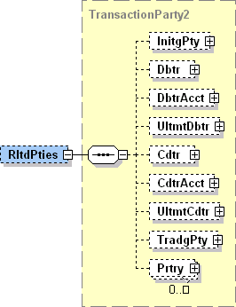

| **ISO Index** | **Item Name** | **XML Tag** | **Cardi-nality** | **Data type** | **Restrictions vs. ISO standard and additional info** |
| --- | --- | --- | --- | --- | --- |
| **2.200** | InitiatingParty | InitgPty | [0..1] |  | The subject who issued the payment instruction.  For card transactions, this is the card holder.  See chapter 3.3.5.3.1.5.1. |
| **2.201** | Debtor | Dbtr | [0..1] |  | The owner of the debit account.  See chapter 3.3.5.3.1.5.2. |
| **2.202** | DebtorAccount | DbtrAcct | [0..1] |  | See chapter 3.3.5.3.1.5.3. |
| **2.203** | UltimateDebtor | UltmtDbtr | [0..1] |  | The subject on whose behalf the payment instruction was issued.  See chapter 3.3.5.3.1.5.4. |
| **2.204** | Creditor | Cdtr | [0..1] |  | The owner of the credit account.  See chapter 3.3.5.3.1.5.5. |
| **2.205** | CreditorAccount | CdtAcct | [0..1] |  | See chapter 3.3.5.3.1.5.6. |
| **2.206** | UltimateCreditor | UltmtCdtr | [0..1] |  | The final beneficiary of the transaction.  See chapter 3.3.5.3.1.5.7. |
| **2.207** | TradingParty | TradgPty | [0..1] |  | Payment initiation service provider (third party).  For card transactions, this is the merchant.  See chapter 3.3.5.3.1.5.8. |
| **2.208** | Proprietary | Prtry | [0..n] |  | See chapter 3.3.5.3.1.5.9. |

InitiatingParty

|  |  |
| --- | --- |
| **XPath** | / Document / BkToCstmrStmt / Stmt / Ntry / NtryDtls [1] / TxDtls / RltdPties / InitgPty |

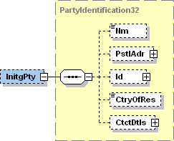

| **ISO Index** | **Item Name** | **XML Tag** | **Cardi-nality** | **Data type** | **Restrictions vs. ISO standard and additional info** |
| --- | --- | --- | --- | --- | --- |
| **9.1.0** | Name | Nm | [0..1] | String [140] | For card transactions, this is the card holder name. |
| **9.1.1** | PostalAddress | PstlAdr | [0..1] |  |  |
| **9.1.12** | Identification | Id | [0..1] |  |  |
| **9.1.33** | CountryOfResidence | CtryOfRes | [0..1] | String [2] |  |
| **9.1.34** | ContactDetails | CtctDtls | [0..1] |  |  |

Debtor

|  |  |
| --- | --- |
| **XPath** | / Document / BkToCstmrStmt / Stmt / Ntry / NtryDtls [1] / TxDtls / RltdPties / Dbtr |

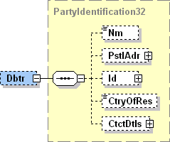

| **ISO Index** | **Item Name** | **XML Tag** | **Cardi-nality** | **Data type** | **Restrictions vs. ISO standard and additional info** |
| --- | --- | --- | --- | --- | --- |
| **9.1.0** | Name | Nm | [0..1] | String [140] |  |
| **9.1.1** | PostalAddress | PstlAdr | [0..1] |  | See chapter 3.3.5.3.1.5.2.1. |
| **9.1.12** | Identification | Id | [0..1] |  | See chapter 3.3.5.3.1.5.2.2. |
| **9.1.33** | CountryOfResidence | CtryOfRes | [0..1] | String [2] |  |
| **9.1.34** | ContactDetails | CtctDtls | [0..1] |  |  |

PostalAddress

|  |  |
| --- | --- |
| **XPath** | / Document / BkToCstmrStmt / Stmt / Ntry / NtryDtls [1] / TxDtls / RltdPties / Dbtr / PstlAdr |



| **ISO Index** | **Item Name** | **XML Tag** | **Cardi-nality** | **Data type** | **Restrictions vs. ISO standard and additional info** |
| --- | --- | --- | --- | --- | --- |
| **9.1.2** | AddressType | AdrTp | [0..1] | String Enumeration |  |
| **9.1.3** | Department | Dept | [0..1] | String [70] |  |
| **9.1.4** | SubDepartment | SubDept | [0..1] | String [70] |  |
| **9.1.5** | StreetName | StrtNm | [0..1] | String [70] |  |
| **9.1.6** | BuildingNumber | BldgNb | [0..1] | String [16] |  |
| **9.1.7** | PostCode | PstCd | [0..1] | String [16] |  |
| **9.1.8** | TownName | TwnNm | [0..1] | String [35] |  |
| **9.1.9** | CountrySubDivision | CtrySubDvsn | [0..1] | String [35] |  |
| **9.1.10** | Country | Ctry | [0..1] | String [2] | International country code according to ISO 3166-1 alpha-2.  Format [A-Z]{2,2} |
| **9.1.11** | AddressLine | AdrLine | [0..7] | String [70] | Unstructured address line. |

Identification

|  |  |
| --- | --- |
| **XPath** | / Document / BkToCstmrStmt / Stmt / Ntry / NtryDtls [1] / TxDtls / RltdPties / Dbtr / Id |



| **ISO Index** | **Item Name** | | **XML Tag** | **Cardi-nality** | **Data type** | **Restrictions vs. ISO standard and additional info** |
| --- | --- | --- | --- | --- | --- | --- |
| **9.1.13** | OrganisationIdentification | Only one of these elements is present | OrgId | [1..1] |  | Present if the debtor is a corporate subject.  See chapter 3.3.5.3.1.5.2.2.1. |
| **9.1.21** | PrivateIdentification | PrvtId | [1..1] |  | Present if the debtor is a person.  See chapter 3.3.5.3.1.5.2.2.2. |

OrganisationIdentification

|  |  |
| --- | --- |
| **XPath** | / Document / BkToCstmrStmt / Stmt / Ntry / NtryDtls [1] / TxDtls / RltdPties / Dbtr / Id / OrgId |



| **ISO Index** | **Item Name** | | **XML Tag** | **Cardi-nality** | **Data type** | **Restrictions vs. ISO standard and additional info** |
| --- | --- | --- | --- | --- | --- | --- |
| **9.1.14** | BICOrBEI | | BICOrBEI | [0..1] | String [11] | Debtor BIC according to ISO 9362.  Format [A-Z]{6,6}[A-Z2-9][A-NP-Z0-9]([A-Z0-9]{3,3}){0,1} |
| **9.1.15** | Other | | Othr | [0..1] |  | No more than one instance present. |
| **9.1.16** | +Identification | | Id | [1..1] | String [35] | Debtor ID. |
| **9.1.17** | +SchemeName | | SchmeNm | [0..1] |  |  |
| **9.1.18** | ++Code | Only one of these elements is present | Cd | [1..1] | String [4] | Debtor ID clasifier according to ISO “ExternalOrganisationIdentification” code-book. |
| **9.1.19** | ++Proprietary | Prtry | [1..1] | String [35] | Proprietary debtor ID clasifier. |
| **9.1.20** | +Issuer | | Issr | [0..1] | String [35] | Issuer of the debtor ID. |

PrivateIdentification

|  |  |
| --- | --- |
| **XPath** | / Document / BkToCstmrStmt / Stmt / Ntry / NtryDtls [1] / TxDtls / RltdPties / Dbtr / Id / PrvtId |



| **ISO Index** | **Item Name** | | **XML Tag** | **Cardi-nality** | **Data type** | **Restrictions vs. ISO standard and additional info** |
| --- | --- | --- | --- | --- | --- | --- |
| **9.1.22** | DateAndPlaceOfBirth | | DtAndPlcOfBirth | [0..1] |  |  |
| **9.1.27** | Other | | Othr | [0..1] |  | No more than one instance present. |
| **9.1.28** | +Identification | | Id | [1..1] | String [35] | Debtor ID. |
| **9.1.29** | +SchemeName | | SchmeNm | [0..1] |  |  |
| **9.1.30** | ++Code | Only one of these elements is present | Cd | [1..1] | String [4] | Debtor ID clasifier according to ISO “ExternalPersonIdentification” code-book. |
| **9.1.31** | ++Proprietary | Prtry | [1..1] | String [35] | Proprietary debtor ID clasifier. |
| **9.1.32** | +Issuer | | Issr | [0..1] | String [35] | Issuer of the debtor ID. |

DebtorAccount

|  |  |
| --- | --- |
| **XPath** | / Document / BkToCstmrStmt / Stmt / Ntry / NtryDtls [1] / TxDtls / RltdPties / DbtrAcct |

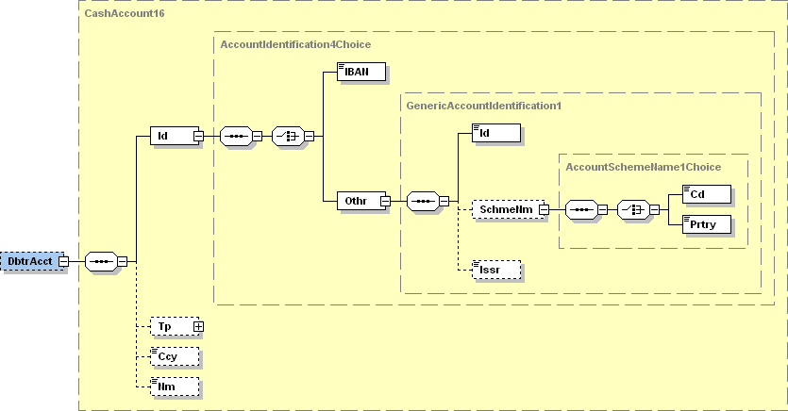

| **ISO Index** | **Item Name** | | | **XML Tag** | **Cardi-nality** | **Data type** | **Restrictions vs. ISO standard and additional info** |
| --- | --- | --- | --- | --- | --- | --- | --- |
| **1.1.0** | Identification | | | Id | [1..1] |  |  |
| **1.1.1** | +IBAN | Only one of these elements is present | | IBAN | [1..1] | String [34] | Mandatory for SEPA transactions. |
| **1.1.2** | +Other | Othr | [1..1] |  |  |
| **1.1.3** | ++Identification | | | Id | [1..1] | String [34] | Account ID in non-IBAN format. |
| **1.1.4** | ++SchemeName | | | SchmeNm | [0..1] |  |  |
| **1.1.5** | +++Code | | Only one of these elements is present | Cd | [1..1] | String [4] | ID clasifier according to ISO 20022 “ExternalAccountIdentification” code-book. |
| **1.1.6** | +++Proprietary | | Prtry | [1..1] | String [35] | Proprietary account ID clasifier |
| **1.1.7** | ++Issuer | | | Issr | [0..1] | String [35] | Issuer of the account ID. |
| **1.1.8** | Type | | | Tp | [0..1] |  |  |
| **1.1.11** | Currency | | | Ccy | [0..1] | String [3] |  |
| **1.1.12** | Name | | | Nm | [0..1] | String [70] |  |

UltimateDebtor

|  |  |
| --- | --- |
| **XPath** | / Document / BkToCstmrStmt / Stmt / Ntry / NtryDtls [1] / TxDtls / RltdPties / UltmtDbtr |

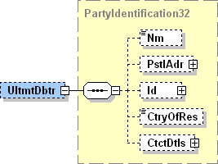

| **ISO Index** | **Item Name** | **XML Tag** | **Cardi-nality** | **Data type** | **Restrictions vs. ISO standard and additional info** |
| --- | --- | --- | --- | --- | --- |
| **9.1.0** | Name | Nm | [0..1] | String [140] |  |
| **9.1.1** | PostalAddress | PstlAdr | [0..1] |  | See chapter 3.3.5.3.1.5.4.1. |
| **9.1.12** | Identification | Id | [0..1] |  | See chapter 3.3.5.3.1.5.4.2. |
| **9.1.33** | CountryOfResidence | CtryOfRes | [0..1] | String [2] |  |
| **9.1.34** | ContactDetails | CtctDtls | [0..1] |  |  |

PostalAddress

|  |  |
| --- | --- |
| **XPath** | / Document / BkToCstmrStmt / Stmt / Ntry / NtryDtls [1] / TxDtls / RltdPties / UltmtDbtr / PstlAdr |



| **ISO Index** | **Item Name** | **XML Tag** | **Cardi-nality** | **Data type** | **Restrictions vs. ISO standard and additional info** |
| --- | --- | --- | --- | --- | --- |
| **9.1.2** | AddressType | AdrTp | [0..1] | String Enumeration |  |
| **9.1.3** | Department | Dept | [0..1] | String [70] |  |
| **9.1.4** | SubDepartment | SubDept | [0..1] | String [70] |  |
| **9.1.5** | StreetName | StrtNm | [0..1] | String [70] |  |
| **9.1.6** | BuildingNumber | BldgNb | [0..1] | String [16] |  |
| **9.1.7** | PostCode | PstCd | [0..1] | String [16] |  |
| **9.1.8** | TownName | TwnNm | [0..1] | String [35] |  |
| **9.1.9** | CountrySubDivision | CtrySubDvsn | [0..1] | String [35] |  |
| **9.1.10** | Country | Ctry | [0..1] | String [2] | International country code according to ISO 3166-1 alpha-2.  Format [A-Z]{2,2} |
| **9.1.11** | AddressLine | AdrLine | [0..7] | String [70] | Unstructured address line. |

Identification

|  |  |
| --- | --- |
| **XPath** | / Document / BkToCstmrStmt / Stmt / Ntry / NtryDtls [1] / TxDtls / RltdPties / UltmtDbtr / Id |



| **ISO Index** | **Item Name** | | **XML Tag** | **Cardi-nality** | **Data type** | **Restrictions vs. ISO standard and additional info** |
| --- | --- | --- | --- | --- | --- | --- |
| **9.1.13** | OrganisationIdentification | Only one of these elements is present | OrgId | [1..1] |  | Present if the ultimate debtor is a corporate subject.  See chapter 3.3.5.3.1.5.4.2.1. |
| **9.1.21** | PrivateIdentification | PrvtId | [1..1] |  | Present if the ultimate debtor is a person.  See chapter 3.3.5.3.1.5.4.2.2. |

OrganisationIdentification

|  |  |
| --- | --- |
| **XPath** | / Document / BkToCstmrStmt / Stmt / Ntry / NtryDtls [1] / TxDtls / RltdPties / UltmtDbtr / Id / OrgId |



| **ISO Index** | **Item Name** | | **XML Tag** | **Cardi-nality** | **Data type** | **Restrictions vs. ISO standard and additional info** |
| --- | --- | --- | --- | --- | --- | --- |
| **9.1.14** | BICOrBEI | | BICOrBEI | [0..1] | String [11] | Ultimate debtor BIC according to ISO 9362.  Format [A-Z]{6,6}[A-Z2-9][A-NP-Z0-9]([A-Z0-9]{3,3}){0,1} |
| **9.1.15** | Other | | Othr | [0..1] |  | No more than one instance present. |
| **9.1.16** | +Identification | | Id | [1..1] | String [35] | Ultimate debtor ID. |
| **9.1.17** | +SchemeName | | SchmeNm | [0..1] |  |  |
| **9.1.18** | ++Code | Only one of these elements is present | Cd | [1..1] | String [4] | Ultimate debtor ID clasifier according to ISO “ExternalOrganisationIdentification” code-book. |
| **9.1.19** | ++Proprietary | Prtry | [1..1] | String [35] | Proprietary ultimate debtor ID clasifier. |
| **9.1.20** | +Issuer | | Issr | [0..1] | String [35] | Issuer of the ultimate debtor ID. |

PrivateIdentification

|  |  |
| --- | --- |
| **XPath** | / Document / BkToCstmrStmt / Stmt / Ntry / NtryDtls [1] / TxDtls / RltdPties / UltmtDbtr / Id / PrvtId |



| **ISO Index** | **Item Name** | | **XML Tag** | **Cardi-nality** | **Data type** | **Restrictions vs. ISO standard and additional info** |
| --- | --- | --- | --- | --- | --- | --- |
| **9.1.22** | DateAndPlaceOfBirth | | DtAndPlcOfBirth | [0..1] |  |  |
| **9.1.27** | Other | | Othr | [0..1] |  | No more than one instance present. |
| **9.1.28** | +Identification | | Id | [1..1] | String [35] | Ultimate debtor ID. |
| **9.1.29** | +SchemeName | | SchmeNm | [0..1] |  |  |
| **9.1.30** | ++Code | Only one of these elements is present | Cd | [1..1] | String [4] | Ultimate debtor ID clasifier according to ISO “ExternalPersonIdentification” code-book. |
| **9.1.31** | ++Proprietary | Prtry | [1..1] | String [35] | Proprietary ultimate debtor ID clasifier. |
| **9.1.32** | +Issuer | | Issr | [0..1] | String [35] | Issuer of the ultimate debtor ID. |

Creditor

|  |  |
| --- | --- |
| **XPath** | / Document / BkToCstmrStmt / Stmt / Ntry / NtryDtls [1] / TxDtls / RltdPties / Cdtr |

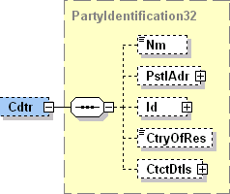

| **ISO Index** | **Item Name** | **XML Tag** | **Cardi-nality** | **Data type** | **Restrictions vs. ISO standard and additional info** |
| --- | --- | --- | --- | --- | --- |
| **9.1.0** | Name | Nm | [0..1] | String [140] |  |
| **9.1.1** | PostalAddress | PstlAdr | [0..1] |  | See chapter 3.3.5.3.1.5.2.1. |
| **9.1.12** | Identification | Id | [0..1] |  | See chapter 3.3.5.3.1.5.2.2. |
| **9.1.33** | CountryOfResidence | CtryOfRes | [0..1] | String [2] |  |
| **9.1.34** | ContactDetails | CtctDtls | [0..1] |  |  |

PostalAddress

|  |  |
| --- | --- |
| **XPath** | / Document / BkToCstmrStmt / Stmt / Ntry / NtryDtls [1] / TxDtls / RltdPties / Cdtr / PstlAdr |



| **ISO Index** | **Item Name** | **XML Tag** | **Cardi-nality** | **Data type** | **Restrictions vs. ISO standard and additional info** |
| --- | --- | --- | --- | --- | --- |
| **9.1.2** | AddressType | AdrTp | [0..1] | String Enumeration |  |
| **9.1.3** | Department | Dept | [0..1] | String [70] |  |
| **9.1.4** | SubDepartment | SubDept | [0..1] | String [70] |  |
| **9.1.5** | StreetName | StrtNm | [0..1] | String [70] |  |
| **9.1.6** | BuildingNumber | BldgNb | [0..1] | String [16] |  |
| **9.1.7** | PostCode | PstCd | [0..1] | String [16] |  |
| **9.1.8** | TownName | TwnNm | [0..1] | String [35] |  |
| **9.1.9** | CountrySubDivision | CtrySubDvsn | [0..1] | String [35] |  |
| **9.1.10** | Country | Ctry | [0..1] | String [2] | International country code according to ISO 3166-1 alpha-2.  Format [A-Z]{2,2} |
| **9.1.11** | AddressLine | AdrLine | [0..7] | String [70] | Unstructured address line. |

Identification

|  |  |
| --- | --- |
| **XPath** | / Document / BkToCstmrStmt / Stmt / Ntry / NtryDtls [1] / TxDtls / RltdPties / Cdtr / Id |



| **ISO Index** | **Item Name** | | **XML Tag** | **Cardi-nality** | **Data type** | **Restrictions vs. ISO standard and additional info** |
| --- | --- | --- | --- | --- | --- | --- |
| **9.1.13** | OrganisationIdentification | Only one of these elements is present | OrgId | [1..1] |  | Present if the creditor is a corporate subject.  See chapter 3.3.5.3.1.5.2.2.1. |
| **9.1.21** | PrivateIdentification | PrvtId | [1..1] |  | Present if the creditor is a person.  See chapter 3.3.5.3.1.5.2.2.2. |

OrganisationIdentification

|  |  |
| --- | --- |
| **XPath** | / Document / BkToCstmrStmt / Stmt / Ntry / NtryDtls [1] / TxDtls / RltdPties / Cdtr / Id / OrgId |



| **ISO Index** | **Item Name** | | **XML Tag** | **Cardi-nality** | **Data type** | **Restrictions vs. ISO standard and additional info** |
| --- | --- | --- | --- | --- | --- | --- |
| **9.1.14** | BICOrBEI | | BICOrBEI | [0..1] | String [11] | Creditor BIC according to ISO 9362.  Format [A-Z]{6,6}[A-Z2-9][A-NP-Z0-9]([A-Z0-9]{3,3}){0,1} |
| **9.1.15** | Other | | Othr | [0..2] |  | No more than one instance present for non-SDD transactions.  For SDD transactions, an additional instance containing the SDD CreditorID and distinguishable by SchmeNm/Prtry = “CID” may be present. |
| **9.1.16** | +Identification | | Id | [1..1] | String [35] | Creditor ID.  For SDD transactions, if SchmeNm/Prtry=”CID”, this is the SDD CID. |
| **9.1.17** | +SchemeName | | SchmeNm | [0..1] |  |  |
| **9.1.18** | ++Code | Only one of these elements is present | Cd | [1..1] | String [4] | Creditor ID clasifier according to ISO “ExternalOrganisationIdentification” code-book. |
| **9.1.19** | ++Proprietary | Prtry | [1..1] | String [35] | Proprietary creditor ID clasifier.  For SDD transactions, the value “CID” indicates an SDD CreditorID. |
| **9.1.20** | +Issuer | | Issr | [0..1] | String [35] | Issuer of the creditor ID. |

PrivateIdentification

|  |  |
| --- | --- |
| **XPath** | / Document / BkToCstmrStmt / Stmt / Ntry / NtryDtls [1] / TxDtls / RltdPties / Cdtr / Id / PrvtId |



| **ISO Index** | **Item Name** | | **XML Tag** | **Cardi-nality** | **Data type** | **Restrictions vs. ISO standard and additional info** |
| --- | --- | --- | --- | --- | --- | --- |
| **9.1.22** | DateAndPlaceOfBirth | | DtAndPlcOfBirth | [0..1] |  |  |
| **9.1.27** | Other | | Othr | [0..2] |  | No more than one instance present for non-SDD transactions.  For SDD transactions, an additional instance containing the SDD CreditorID and distinguishable by SchmeNm/Prtry = “CID” may be present. |
| **9.1.28** | +Identification | | Id | [1..1] | String [35] | Creditor ID.  For SDD transactions, if SchmeNm/Prtry=”CID”, this is the SDD CID. |
| **9.1.29** | +SchemeName | | SchmeNm | [0..1] |  |  |
| **9.1.30** | ++Code | Only one of these elements is present | Cd | [1..1] | String [4] | Creditor ID clasifier according to ISO “ExternalOrganisationIdentification” code-book. |
| **9.1.31** | ++Proprietary | Prtry | [1..1] | String [35] | Proprietary creditor ID clasifier.  For SDD transactions, the value “CID” indicates an SDD CreditorID. |
| **9.1.32** | +Issuer | | Issr | [0..1] | String [35] | Issuer of the creditor ID. |

CreditorAccount

|  |  |
| --- | --- |
| **XPath** | / Document / BkToCstmrStmt / Stmt / Ntry / NtryDtls [1] / TxDtls / RltdPties / CdtrAcct |

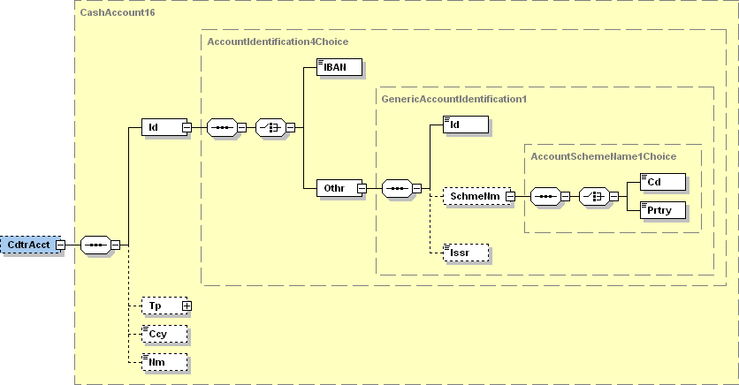

| **ISO Index** | **Item Name** | | | **XML Tag** | **Cardi-nality** | **Data type** | **Restrictions vs. ISO standard and additional info** |
| --- | --- | --- | --- | --- | --- | --- | --- |
| **1.1.0** | Identification | | | Id | [1..1] |  |  |
| **1.1.1** | +IBAN | Only one of these elements is present | | IBAN | [0..1] | String [34] | Mandatory for SEPA transactions. |
| **1.1.2** | +Other | Othr | [0..1] |  |  |
| **1.1.3** | ++Identification | | | Id | [1..1] | String [34] | Account ID in non-IBAN format. |
| **1.1.4** | ++SchemeName | | | SchmeNm | [0..1] |  |  |
| **1.1.5** | +++Code | | Only one of these elements is present | Cd | [1..1] | String [4] | ID clasifier according to ISO 20022 “ExternalAccountIdentification” code-book. |
| **1.1.6** | +++Proprietary | | Prtry | [1..1] | String [35] | Proprietary account ID clasifier |
| **1.1.7** | ++Issuer | | | Issr | [0..1] | String [35] | Issuer of the account ID. |
| **1.1.8** | Type | | | Tp | [0..1] |  |  |
| **1.1.11** | Currency | | | Ccy | [0..1] | String [3] |  |
| **1.1.12** | Name | | | Nm | [0..1] | String [70] |  |

UltimateCreditor

|  |  |
| --- | --- |
| **XPath** | / Document / BkToCstmrStmt / Stmt / Ntry / NtryDtls [1] / TxDtls / RltdPties / UltmtCdtr |

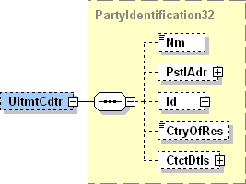

| **ISO Index** | **Item Name** | **XML Tag** | **Cardi-nality** | **Data type** | **Restrictions vs. ISO standard and additional info** |
| --- | --- | --- | --- | --- | --- |
| **9.1.0** | Name | Nm | [0..1] | String [140] |  |
| **9.1.1** | PostalAddress | PstlAdr | [0..1] |  | See chapter 3.3.5.3.1.5.7.1. |
| **9.1.12** | Identification | Id | [0..1] |  | See chapter 3.3.5.3.1.5.7.2. |
| **9.1.33** | CountryOfResidence | CtryOfRes | [0..1] | String [2] |  |
| **9.1.34** | ContactDetails | CtctDtls | [0..1] |  |  |

PostalAddress

|  |  |
| --- | --- |
| **XPath** | / Document / BkToCstmrStmt / Stmt / Ntry / NtryDtls [1] / TxDtls / RltdPties / UltmtCdtr / PstlAdr |



| **ISO Index** | **Item Name** | **XML Tag** | **Cardi-nality** | **Data type** | **Restrictions vs. ISO standard and additional info** |
| --- | --- | --- | --- | --- | --- |
| **9.1.2** | AddressType | AdrTp | [0..1] | String Enumeration |  |
| **9.1.3** | Department | Dept | [0..1] | String [70] |  |
| **9.1.4** | SubDepartment | SubDept | [0..1] | String [70] |  |
| **9.1.5** | StreetName | StrtNm | [0..1] | String [70] |  |
| **9.1.6** | BuildingNumber | BldgNb | [0..1] | String [16] |  |
| **9.1.7** | PostCode | PstCd | [0..1] | String [16] |  |
| **9.1.8** | TownName | TwnNm | [0..1] | String [35] |  |
| **9.1.9** | CountrySubDivision | CtrySubDvsn | [0..1] | String [35] |  |
| **9.1.10** | Country | Ctry | [0..1] | String [2] | International country code according to ISO 3166-1 alpha-2.  Format [A-Z]{2,2} |
| **9.1.11** | AddressLine | AdrLine | [0..7] | String [70] | Unstructured address line. |

Identification

|  |  |
| --- | --- |
| **XPath** | / Document / BkToCstmrStmt / Stmt / Ntry / NtryDtls [1] / TxDtls / RltdPties / UltmtCdtr / Id |



| **ISO Index** | **Item Name** | | **XML Tag** | **Cardi-nality** | **Data type** | **Restrictions vs. ISO standard and additional info** |
| --- | --- | --- | --- | --- | --- | --- |
| **9.1.13** | OrganisationIdentification | Only one of these elements is present | OrgId | [1..1] |  | Present if the ultimate creditor is a corporate subject.  See chapter 3.3.5.3.1.5.7.2.1. |
| **9.1.21** | PrivateIdentification | PrvtId | [1..1] |  | Present if the ultimate creditor is a person.  See chapter 3.3.5.3.1.5.7.2.2. |

OrganisationIdentification

|  |  |
| --- | --- |
| **XPath** | / Document / BkToCstmrStmt / Stmt / Ntry / NtryDtls [1] / TxDtls / RltdPties / UltmtCdtr / Id / OrgId |



| **ISO Index** | **Item Name** | | **XML Tag** | **Cardi-nality** | **Data type** | **Restrictions vs. ISO standard and additional info** |
| --- | --- | --- | --- | --- | --- | --- |
| **9.1.14** | BICOrBEI | | BICOrBEI | [0..1] | String [11] | Ultimate creditor BIC according to ISO 9362.  Format [A-Z]{6,6}[A-Z2-9][A-NP-Z0-9]([A-Z0-9]{3,3}){0,1} |
| **9.1.15** | Other | | Othr | [0..1] |  | No more than one instance present. |
| **9.1.16** | +Identification | | Id | [1..1] | String [35] | Ultimate creditor ID. |
| **9.1.17** | +SchemeName | | SchmeNm | [0..1] |  |  |
| **9.1.18** | ++Code | Only one of these elements is present | Cd | [1..1] | String [4] | Ultimate creditor ID clasifier according to ISO “ExternalOrganisationIdentification” code-book. |
| **9.1.19** | ++Proprietary | Prtry | [1..1] | String [35] | Proprietary ultimate creditor ID clasifier. |
| **9.1.20** | +Issuer | | Issr | [0..1] | String [35] | Issuer of the ultimate creditor ID. |

PrivateIdentification

|  |  |
| --- | --- |
| **XPath** | / Document / BkToCstmrStmt / Stmt / Ntry / NtryDtls [1] / TxDtls / RltdPties / UltmtCdtr / Id / PrvtId |



| **ISO Index** | **Item Name** | | **XML Tag** | **Cardi-nality** | **Data type** | **Restrictions vs. ISO standard and additional info** |
| --- | --- | --- | --- | --- | --- | --- |
| **9.1.22** | DateAndPlaceOfBirth | | DtAndPlcOfBirth | [0..1] |  |  |
| **9.1.27** | Other | | Othr | [0..1] |  | No more than one instance present. |
| **9.1.28** | +Identification | | Id | [1..1] | String [35] | Ultimate creditor ID. |
| **9.1.29** | +SchemeName | | SchmeNm | [0..1] |  |  |
| **9.1.30** | ++Code | Only one of these elements is present | Cd | [1..1] | String [4] | Ultimate creditor ID clasifier according to ISO “ExternalPersonIdentification” code-book. |
| **9.1.31** | ++Proprietary | Prtry | [1..1] | String [35] | Proprietary ultimate creditor ID clasifier. |
| **9.1.32** | +Issuer | | Issr | [0..1] | String [35] | Issuer of the ultimate creditor ID. |

TradingParty

|  |  |
| --- | --- |
| **XPath** | / Document / BkToCstmrStmt / Stmt / Ntry / NtryDtls [1] / TxDtls / RltdPties / TradgPty |

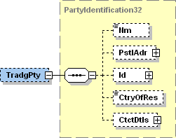

| **ISO Index** | **Item Name** | **XML Tag** | **Cardi-nality** | **Data type** | **Restrictions vs. ISO standard and additional info** |
| --- | --- | --- | --- | --- | --- |
| **9.1.0** | Name | Nm | [0..1] | String [140] | Payment initiation service provider name (third party).  For card transactions, this is the merchant name. |
| **9.1.1** | PostalAddress | PstlAdr | [0..1] |  |  |
| **9.1.12** | Identification | Id | [0..1] |  | See chapter 3.3.5.3.1.5.8.1. |
| **9.1.33** | CountryOfResidence | CtryOfRes | [0..1] | String [2] |  |
| **9.1.34** | ContactDetails | CtctDtls | [0..1] |  |  |

Identification

|  |  |
| --- | --- |
| **XPath** | / Document / BkToCstmrStmt / Stmt / Ntry / NtryDtls [1] / TxDtls / RltdPties / TradgPty / Id= |



| **ISO Index** | **Item Name** | | **XML Tag** | **Cardi-nality** | **Data type** | **Restrictions vs. ISO standard and additional info** |
| --- | --- | --- | --- | --- | --- | --- |
| **9.1.13** | OrganisationIdentification | Only one of these elements is present | OrgId | [1..1] |  | Present if the PISP (third party) / merchant is a corporate subject.  See chapter 3.3.5.3.1.5.8.1.1. |
| **9.1.21** | PrivateIdentification | PrvtId | [1..1] |  | Present if the PISP (third party) / merchant is a person.  See chapter 3.3.5.3.1.5.8.1.2. |

OrganisationIdentification

|  |  |
| --- | --- |
| **XPath** | / Document / BkToCstmrStmt / Stmt / Ntry / NtryDtls [1] / TxDtls / RltdPties / TradgPty / Id / OrgId |



| **ISO Index** | **Item Name** | | **XML Tag** | **Cardi-nality** | **Data type** | **Restrictions vs. ISO standard and additional info** |
| --- | --- | --- | --- | --- | --- | --- |
| **9.1.14** | BICOrBEI | | BICOrBEI | [0..1] | String [11] | Merchant BIC according to ISO 9362.  Format [A-Z]{6,6}[A-Z2-9][A-NP-Z0-9]([A-Z0-9]{3,3}){0,1} |
| **9.1.15** | Other | | Othr | [0..n] |  |  |
| **9.1.16** | +Identification | | Id | [1..1] | String [35] | Merchant ID / ID of the Payment initiation service provider (third party). |
| **9.1.17** | +SchemeName | | SchmeNm | [0..1] |  |  |
| **9.1.18** | ++Code | Only one of these elements is present | Cd | [1..1] | String [4] | Merchant ID clasifier according to ISO “ExternalOrganisationIdentification” code-book.  For certified PISP (third party) code CBID is used. |
| **9.1.19** | ++Proprietary | Prtry | [1..1] | String [35] | Proprietary merchant ID clasifier. |
| **9.1.20** | +Issuer | | Issr | [0..1] | String [35] | Issuer of the merchant ID. |

PrivateIdentification

|  |  |
| --- | --- |
| **XPath** | / Document / BkToCstmrStmt / Stmt / Ntry / NtryDtls [1] / TxDtls / RltdPties / TradgPty / Id / PrvtId |



| **ISO Index** | **Item Name** | | **XML Tag** | **Cardi-nality** | **Data type** | **Restrictions vs. ISO standard and additional info** |
| --- | --- | --- | --- | --- | --- | --- |
| **9.1.22** | DateAndPlaceOfBirth | | DtAndPlcOfBirth | [0..1] |  |  |
| **9.1.27** | Other | | Othr | [0..n] |  |  |
| **9.1.28** | +Identification | | Id | [1..1] | String [35] | Merchant ID / ID of the Payment initiation service provider (third party). |
| **9.1.29** | +SchemeName | | SchmeNm | [0..1] |  |  |
| **9.1.30** | ++Code | Only one of these elements is present | Cd | [1..1] | String [4] | Merchant ID clasifier according to ISO “ExternalPersonIdentification” code-book.  For certified PISP (third party) code CBID is used. |
| **9.1.31** | ++Proprietary | Prtry | [1..1] | String [35] | Proprietary merchant ID clasifier. |
| **9.1.32** | +Issuer | | Issr | [0..1] | String [35] | Issuer of the merchant ID. |

ProprietaryParty

|  |  |
| --- | --- |
| **XPath** | / Document / BkToCstmrStmt / Stmt / Ntry / NtryDtls [1] / TxDtls / RltdPties / Prtry |

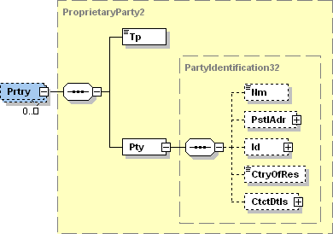

| **ISO Index** | **Item Name** | **XML Tag** | **Cardi-nality** | **Data type** | **Restrictions vs. ISO standard and additional info** |
| --- | --- | --- | --- | --- | --- |
| **2.209** | Type | Tp | [1..1] | String [35] | Clasifies the proprietary party. For card transactions, the value “CardAssociation” represents a card association (VISA, MasterCard, …). Other values are not regulated. |
| **2.210** | Party | Pty | [1..1] |  |  |
| **9.1.0** | +Name | Nm | [0..1] | String [25] | For card transactions, this is the name of the card association. |
| **9.1.1** | +PostalAddress | PstlAdr | [0..1] |  |  |
| **9.1.12** | +Identification | Id | [0..1] |  |  |
| **9.1.33** | +CountryOfResidence | CtryOfRes | [0..1] | String [2] |  |
| **9.1.34** | +ContactDetails | CtctDtls | [0..1] |  |  |

###### RelatedAgents

|  |  |
| --- | --- |
| **XPath** | / Document / BkToCstmrStmt / Stmt / Ntry / NtryDtls [1] / TxDtls / RltdAgts |

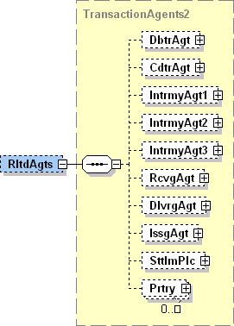

| **ISO Index** | **Item Name** | **XML Tag** | **Cardi-nality** | **Data type** | **Restrictions vs. ISO standard and additional info** |
| --- | --- | --- | --- | --- | --- |
| **2.212** | DebtorAgent | DbtrAgt | [0..1] |  | See chapter 3.3.5.3.1.6.1. |
| **2.213** | CreditorAgent | CdtrAgt | [0..1] |  | See chapter 3.3.5.3.1.6.2. |
| **2.214** | IntermediaryAgent1 | IntrmyAgt1 | [0..1] |  | May be present for SWIFT transactions.  SWIFT correspondent bank.  See chapter 3.3.5.3.1.6.3. |
| **2.215** | IntermediaryAgent2 | IntrmyAgt2 | [0..1] |  |  |
| **2.216** | IntermediaryAgent3 | IntrmyAgt3 | [0..1] |  |  |
| **2.217** | ReceivingAgent | RcvgAgt | [0..1] |  |  |
| **2.218** | DeliveringAgent | DlvrgAgt | [0..1] |  |  |
| **2.219** | IssuingAgent | IssgAgt | [0..1] |  |  |
| **2.220** | SettlementPlace | SttlmPlc | [0..1] |  | May be present for SEPA transactions.  SEPA clearing house.  See chapter 3.3.5.3.1.6.4. |
| **2.221** | Proprietary | Prtry | [0..n] |  | May be present for card transactions.  One instance for the Issuer and one for the Acquier.  See chapter 3.3.5.3.1.6.5. |

DebtorAgent

|  |  |
| --- | --- |
| **XPath** | / Document / BkToCstmrStmt / Stmt / Ntry / NtryDtls [1] / TxDtls / RltdAgts / DbtrAgt |

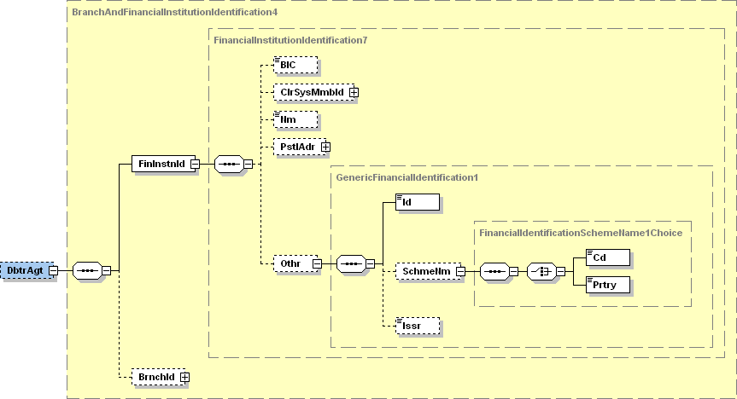

| **ISO Index** | **Item Name** | | **XML Tag** | **Cardi-nality** | **Data type** | **Restrictions vs. ISO standard and additional info** |
| --- | --- | --- | --- | --- | --- | --- |
| **6.1.0** | FinancialInstitutionIdentification | | FinInstnId | [1..1] |  |  |
| **6.1.1** | +BIC | | BIC | [0..1] | String [11] | Debtor agent BIC according to ISO 9362.  Format: [A-Z]{6,6}[A-Z2-9][A-NP-Z0-9]([A-Z0-9]{3,3}){0,1} |
| **6.1.2** | +ClearingSystemMemberIdentification | | ClrSysMmbId | [0..1] |  |  |
| **6.1.7** | +Name | | Nm | [0..1] | String [140] |  |
| **6.1.8** | +PostalAddress | | PstlAdr | [0..1] |  | See chapter 3.3.5.3.1.6.1.1. |
| **6.1.19** | +Other | | Othr | [0..1] |  |  |
| **6.1.20** | ++Identification | | Id | [1..1] | String [4] | EuroSIPS bank code. |
| **6.1.21** | ++SchemeName | | SchmeNm | [0..1] |  |  |
| **6.1.22** | +++Code | Only one of these elements is present | Cd | [0..0] | String [4] | Prohibited. |
| **6.1.23** | +++Proprietary | Prtry | [1..1] | String [35] | Always present, always equals “EuroSIPS Bank Code”. |
| **6.1.24** | ++Issuer | | Issr | [0..1] | String [35] | Always equals “NBS”. |
| **6.1.25** | BranchIdentification | | BrnchId | [0..1] |  |  |

PostalAddress

|  |  |
| --- | --- |
| **XPath** | / Document / BkToCstmrStmt / Stmt / Ntry / NtryDtls [1] / TxDtls / RltdAgts / DbtrAgt / FinInstnId / PstlAdr |



| **ISO Index** | **Item Name** | **XML Tag** | **Cardi-nality** | **Data type** | **Restrictions vs. ISO standard and additional info** |
| --- | --- | --- | --- | --- | --- |
| **9.1.2** | AddressType | AdrTp | [0..1] | String Enumeration |  |
| **9.1.3** | Department | Dept | [0..1] | String [70] |  |
| **9.1.4** | SubDepartment | SubDept | [0..1] | String [70] |  |
| **9.1.5** | StreetName | StrtNm | [0..1] | String [70] |  |
| **9.1.6** | BuildingNumber | BldgNb | [0..1] | String [16] |  |
| **9.1.7** | PostCode | PstCd | [0..1] | String [16] |  |
| **9.1.8** | TownName | TwnNm | [0..1] | String [35] |  |
| **9.1.9** | CountrySubDivision | CtrySubDvsn | [0..1] | String [35] |  |
| **9.1.10** | Country | Ctry | [0..1] | String [2] | International country code according to ISO 3166-1 alpha-2.  Format [A-Z]{2,2} |
| **9.1.11** | AddressLine | AdrLine | [0..7] | String [70] | Unstructured address line. |

CreditorAgent

|  |  |
| --- | --- |
| **XPath** | / Document / BkToCstmrStmt / Stmt / Ntry / NtryDtls [1] / TxDtls / RltdAgts / CdtrAgt |

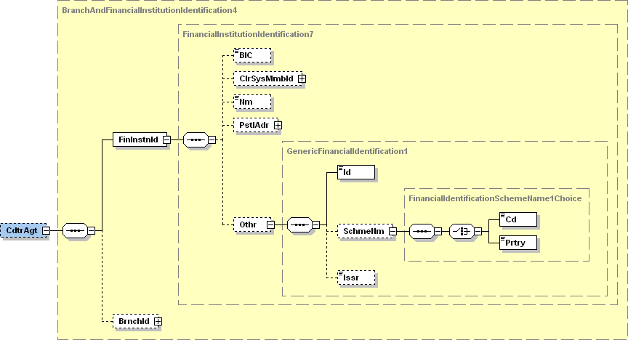

| **ISO Index** | **Item Name** | | **XML Tag** | **Cardi-nality** | **Data type** | **Restrictions vs. ISO standard and additional info** |
| --- | --- | --- | --- | --- | --- | --- |
| **6.1.0** | FinancialInstitutionIdentification | | FinInstnId | [1..1] |  |  |
| **6.1.1** | +BIC | | BIC | [0..1] | String [11] | Creditor agent BIC according to ISO 9362.  Format: [A-Z]{6,6}[A-Z2-9][A-NP-Z0-9]([A-Z0-9]{3,3}){0,1} |
| **6.1.2** | +ClearingSystemMemberIdentification | | ClrSysMmbId | [0..1] |  |  |
| **6.1.7** | +Name | | Nm | [0..1] | String [140] |  |
| **6.1.8** | +PostalAddress | | PstlAdr | [0..1] |  | See chapter 3.3.5.3.1.6.2.1. |
| **6.1.19** | +Other | | Othr | [0..1] |  |  |
| **6.1.20** | ++Identification | | Id | [1..1] | String [4] | EuroSIPS bank code. |
| **6.1.21** | ++SchemeName | | SchmeNm | [0..1] |  |  |
| **6.1.22** | +++Code | Only one of these elements is present | Cd | [0..0] | String [4] | Prohibited. |
| **6.1.23** | +++Proprietary | Prtry | [1..1] | String [35] | Always present, always equals “EuroSIPS Bank Code”. |
| **6.1.24** | ++Issuer | | Issr | [0..1] | String [35] | Always equals “NBS”. |
| **6.1.25** | BranchIdentification | | BrnchId | [0..1] |  |  |

PostalAddress

|  |  |
| --- | --- |
| **XPath** | / Document / BkToCstmrStmt / Stmt / Ntry / NtryDtls [1] / TxDtls / RltdAgts / CdtrAgt / FinInstnId / PstlAdr |



| **ISO Index** | **Item Name** | **XML Tag** | **Cardi-nality** | **Data type** | **Restrictions vs. ISO standard and additional info** |
| --- | --- | --- | --- | --- | --- |
| **9.1.2** | AddressType | AdrTp | [0..1] | String Enumeration |  |
| **9.1.3** | Department | Dept | [0..1] | String [70] |  |
| **9.1.4** | SubDepartment | SubDept | [0..1] | String [70] |  |
| **9.1.5** | StreetName | StrtNm | [0..1] | String [70] |  |
| **9.1.6** | BuildingNumber | BldgNb | [0..1] | String [16] |  |
| **9.1.7** | PostCode | PstCd | [0..1] | String [16] |  |
| **9.1.8** | TownName | TwnNm | [0..1] | String [35] |  |
| **9.1.9** | CountrySubDivision | CtrySubDvsn | [0..1] | String [35] |  |
| **9.1.10** | Country | Ctry | [0..1] | String [2] | International country code according to ISO 3166-1 alpha-2.  Format [A-Z]{2,2} |
| **9.1.11** | AddressLine | AdrLine | [0..7] | String [70] | Unstructured address line. |

IntermediaryAgent1

|  |  |
| --- | --- |
| **XPath** | / Document / BkToCstmrStmt / Stmt / Ntry / NtryDtls [1] / TxDtls / RltdAgts / IntrmyAgt1 |

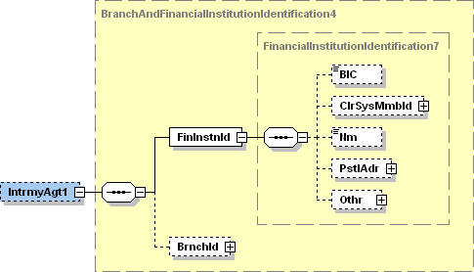

| **ISO Index** | **Item Name** | **XML Tag** | **Cardi-nality** | **Data type** | **Restrictions vs. ISO standard and additional info** |
| --- | --- | --- | --- | --- | --- |
| **6.1.0** | FinancialInstitutionIdentification | FinInstnId | [1..1] |  |  |
| **6.1.1** | +BIC | BIC | [0..1] | String [11] | BIC of the SWIFT correspondent bank according to ISO 9362.  Format [A-Z]{6,6}[A-Z2-9][A-NP-Z0-9]([A-Z0-9]{3,3}){0,1}. |
| **6.1.2** | +ClearingSystemMemberIdentification | ClrSysMmbId | [0..1] |  |  |
| **6.1.7** | +Name | Nm | [0..1] | String [140] |  |
| **6.1.8** | +PostalAddress | PstlAdr | [0..1] |  | See chapter 3.3.5.3.1.6.3.1. |
| **6.1.19** | +Other | Othr | [0..1] |  |  |
| **6.1.25** | BranchIdentification | BrnchId | [0..1] |  |  |

PostalAddress

|  |  |
| --- | --- |
| **XPath** | / Document / BkToCstmrStmt / Stmt / Ntry / NtryDtls [1] / TxDtls / RltdAgts / IntrmyAgt1 / FinInstnId / PstlAdr |



| **ISO Index** | **Item Name** | **XML Tag** | **Cardi-nality** | **Data type** | **Restrictions vs. ISO standard and additional info** |
| --- | --- | --- | --- | --- | --- |
| **9.1.2** | AddressType | AdrTp | [0..1] | String Enumeration |  |
| **9.1.3** | Department | Dept | [0..1] | String [70] |  |
| **9.1.4** | SubDepartment | SubDept | [0..1] | String [70] |  |
| **9.1.5** | StreetName | StrtNm | [0..1] | String [70] |  |
| **9.1.6** | BuildingNumber | BldgNb | [0..1] | String [16] |  |
| **9.1.7** | PostCode | PstCd | [0..1] | String [16] |  |
| **9.1.8** | TownName | TwnNm | [0..1] | String [35] |  |
| **9.1.9** | CountrySubDivision | CtrySubDvsn | [0..1] | String [35] |  |
| **9.1.10** | Country | Ctry | [0..1] | String [2] | International country code according to ISO 3166-1 alpha-2.  Format [A-Z]{2,2} |
| **9.1.11** | AddressLine | AdrLine | [0..7] | String [70] | Unstructured address line. |

SettlementPlace

|  |  |
| --- | --- |
| **XPath** | / Document / BkToCstmrStmt / Stmt / Ntry / NtryDtls [1] / TxDtls / RltdAgts / SttlmPlc |

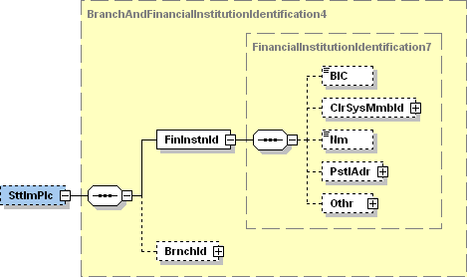

| **ISO Index** | **Item Name** | **XML Tag** | **Cardi-nality** | **Data type** | **Restrictions vs. ISO standard and additional info** |
| --- | --- | --- | --- | --- | --- |
| **6.1.0** | FinancialInstitutionIdentification | FinInstnId | [1..1] |  |  |
| **6.1.1** | +BIC | BIC | [0..1] | String [11] | BIC of the SEPA clearing house according to ISO 9362.  Format [A-Z]{6,6}[A-Z2-9][A-NP-Z0-9]([A-Z0-9]{3,3}){0,1}. |
| **6.1.2** | +ClearingSystemMemberIdentification | ClrSysMmbId | [0..1] |  |  |
| **6.1.7** | +Name | Nm | [0..1] | String [140] |  |
| **6.1.8** | +PostalAddress | PstlAdr | [0..1] |  | See chapter 3.3.5.3.1.6.4.1. |
| **6.1.19** | +Other | Othr | [0..1] |  |  |
| **6.1.25** | BranchIdentification | BrnchId | [0..1] |  |  |

PostalAddress

|  |  |
| --- | --- |
| **XPath** | / Document / BkToCstmrStmt / Stmt / Ntry / NtryDtls [1] / TxDtls / RltdAgts / SttlmPlc / FinInstnId / PstlAdr |



| **ISO Index** | **Item Name** | **XML Tag** | **Cardi-nality** | **Data type** | **Restrictions vs. ISO standard and additional info** |
| --- | --- | --- | --- | --- | --- |
| **9.1.2** | AddressType | AdrTp | [0..1] | String Enumeration |  |
| **9.1.3** | Department | Dept | [0..1] | String [70] |  |
| **9.1.4** | SubDepartment | SubDept | [0..1] | String [70] |  |
| **9.1.5** | StreetName | StrtNm | [0..1] | String [70] |  |
| **9.1.6** | BuildingNumber | BldgNb | [0..1] | String [16] |  |
| **9.1.7** | PostCode | PstCd | [0..1] | String [16] |  |
| **9.1.8** | TownName | TwnNm | [0..1] | String [35] |  |
| **9.1.9** | CountrySubDivision | CtrySubDvsn | [0..1] | String [35] |  |
| **9.1.10** | Country | Ctry | [0..1] | String [2] | International country code according to ISO 3166-1 alpha-2.  Format [A-Z]{2,2} |
| **9.1.11** | AddressLine | AdrLine | [0..7] | String [70] | Unstructured address line. |

Proprietary

|  |  |  |
| --- | --- | --- |
| **XPath** | / Document / BkToCstmrStmt / Stmt / Ntry / NtryDtls [1] / TxDtls / RltdAgts / Prtry | / Document / BkToCstmrStmt / Stmt / Ntry / NtryDtls [1] / TxDtls / RltdAgts / SttlmPlc |

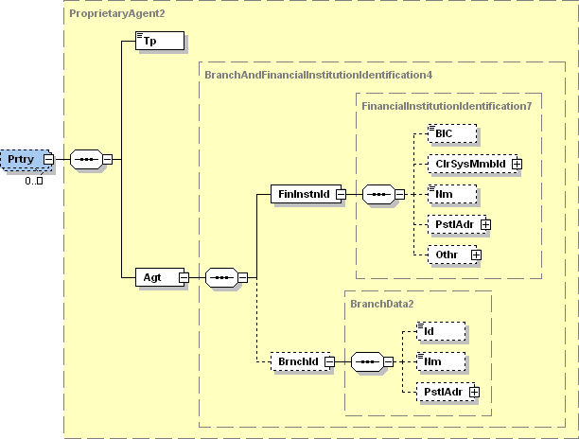

| **ISO Index** | **Item Name** | **XML Tag** | **Cardi-nality** | **Data type** | **Restrictions vs. ISO standard and additional info** |
| --- | --- | --- | --- | --- | --- |
| **2.222** | Type | Tp | [1..1] | String [35] | For card transactions, the values “CardIssuer” and “CardAcquier” represent the card Issuer and transaction Acquier, respectively.  Other values are not regulated. |
| **2.223** | Agent | Agt | [1..1] |  |  |
| **6.1.0** | +FinancialInstitutionIdentification | FinInstnId | [1..1] |  |  |
| **6.1.1** | ++BIC | BIC | [0..1] | String [11] | For card transaction, this is the BIC of the Issuer/Acquier. |
| **6.1.2** | ++ClearingSystemMemberIdentification | ClrSysMmbId | [0..1] |  |  |
| **6.1.7** | ++Name | Nm | [0..1] | String [70] | For card transaction, this is the name of the Issuer/Acquier. |
| **6.1.8** | ++PostalAddress | PstlAdr | [0..1] |  |  |
| **6.1.19** | ++Other | Othr | [0..1] |  |  |
| **6.1.25** | +BranchIdentification | BrnchId | [0..1] |  | For a card transaction Acquier, this represents the Point-of-Trade (ATM or POS). |
| **6.1.26** | ++Identification | Id | [0..1] | String [25] | For a card transaction Acquier, this is the ID of the Point-of-Trade. |
| **6.1.27** | ++Name | Nm | [0..1] |  | For a card transaction Acquier, this is the name of the Point-of-Trade. |
| **6.1.28** | ++PostalAddress | PstlAdr | [0..1] |  |  |

###### Purpose

|  |  |
| --- | --- |
| **XPath** | / Document / BkToCstmrStmt / Stmt / Ntry / NtryDtls [1] / TxDtls / Purp |

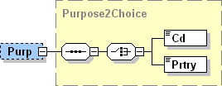

| **ISO Index** | **Item Name** | | **XML Tag** | **Cardi-nality** | **Data type** | **Restrictions vs. ISO standard and additional info** |
| --- | --- | --- | --- | --- | --- | --- |
| **2.87** | Code | Only one of these elements is present | Cd | [1..1] | String [4] | Only values from the ISO code-book „Purpose“ allowed. |
| **2.88** | Proprietary | Prtry | [0..0] | String [35] | Prohibited. |

###### RemittanceInfo

|  |  |
| --- | --- |
| **XPath** | / Document / BkToCstmrStmt / Stmt / Ntry / NtryDtls [1] / TxDtls / RmtInf |

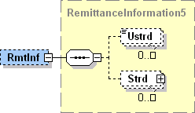

| **ISO Index** | **Item Name** | **XML Tag** | **Cardi-nality** | **Data type** | **Restrictions vs. ISO standard and additional info** |
| --- | --- | --- | --- | --- | --- |
| **2.235** | Unstructured | Ustrd | [0..1] | String [140] | Prohibited if <Strd> is present. |
| **2.236** | Structured | Strd | [0..1] |  | Prohibited if <Ustrd> is present.  Allowed only for SEPA transactions.  See chapter 3.3.5.3.1.8.1. |

Structured

|  |  |
| --- | --- |
| **XPath** | / Document / BkToCstmrStmt / Stmt / Ntry / NtryDtls [1] / TxDtls / RmtInf / Strd |

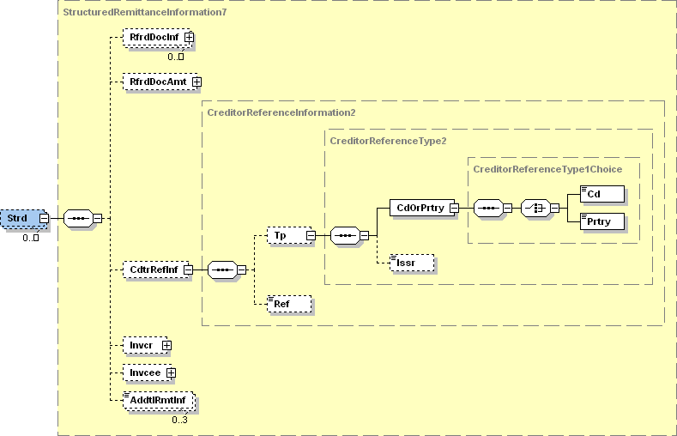

| **ISO Index** | **Item Name** | | **XML Tag** | **Cardi-nality** | **Data type** | **Restrictions vs. ISO standard and additional info** |
| --- | --- | --- | --- | --- | --- | --- |
| **2.237** | ReferredDocumentInformation | | RfrdDocInf | [0..n] |  |  |
| **2.245** | ReferredDocumentAmount | | RfrdDocAmt | [0..1] |  |  |
| **2.256** | CreditorReferenceInformation | | CdtrRefInf | [0..1] |  |  |
| **2.257** | +Type | | Tp | [0..1] |  |  |
| **2.258** | ++CodeOrProprietary | | CdOrPrtry | [1..1] |  |  |
| **2.259** | +++Code | Only one of these elements is present | Cd | [1..1] | String Enumeration | Always equals “SCOR”. |
| **2.260** | +++Proprietary | Prtry | [0..0] | String [35] | Prohibited. |
| **2.261** | ++Issuer | | Issr | [0..1] | String [35] | Issuer of the remittance info. |
| **2.262** | +Reference | | Ref | [0..1] | String [35] | Actual remittance info. |
| **2.263** | Invoicer | | Invcr | [0..1] |  |  |
| **2.264** | Invoicee | | Invcee | [0..1] |  |  |
| **2.265** | AdditionalRemittanceInformation | | AddtlRmtInf | [0..3] | String [140] |  |

###### 

###### RelatedDates

|  |  |
| --- | --- |
| **XPath** | / Document / BkToCstmrStmt / Stmt / Ntry / NtryDtls [1] / TxDtls / RltdDts |

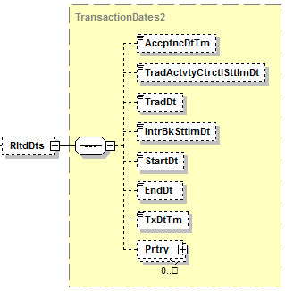

| **ISO Index** | **Item Name** | **XML Tag** | **Cardi-nality** | **Data type** | **Restrictions vs. ISO standard and additional info** |
| --- | --- | --- | --- | --- | --- |
| **2.267** | AcceptanceDateTime | AccptncDtTm | [0..1] |  |  |
| **2.268** | TradeActivityContractualSettlementDate | TradActvtyCtrctlSttlmDt | [0..1] |  |  |
| **2.269** | TradeDate | TradDt | [0..1] |  |  |
| **2.270** | InterbankSettlementDate | IntrBkSttlmDt | [0..1] |  |  |
| **2.271** | StartDate | StartDt | [0..1] |  |  |
| **2.272** | EndDate | EndDt | [0..1] |  |  |
| **2.273** | TransactionDateTime | TxDtTm | [0..1] | DateTime | Date when the amount was debited from debtor’s account.  Format [YYYY]-[MM]-[DD]Thh:mm:ss.fTZD, where:   * YYYY (4 digits), MM (2 digits) a DD (2 digits) are the year, month and day * the time and time zone are not covered by the standard |
| **2.274** | Proprietary | Prtry | [0..n] |  |  |

###### ReturnInformation

|  |  |
| --- | --- |
| **XPath** | / Document / BkToCstmrStmt / Stmt / Ntry / NtryDtls [1] / TxDtls / RtrInf |

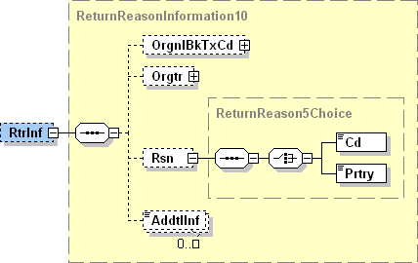

| **ISO Index** | **Item Name** | | **XML Tag** | **Cardi-nality** | **Data type** | **Restrictions vs. ISO standard and additional info** |
| --- | --- | --- | --- | --- | --- | --- |
| **2.294** | OriginalBankTransactionCode | | OrgnlBkTxCd | [0..1] |  | See chapter 3.3.5.3.1.10.1. |
| **2.303** | Originator | | Orgtr | [0..1] |  | See chapter 3.3.5.3.1.10.2. |
| **2.304** | Reason | | Rsn | [0..1] |  |  |
| **2.305** | +Code | Only one of these elements is present | Cd | [1..1] | String [4] | Return reason according to ISO „ExternalReturnReason“ code-book. |
| **2.306** | +Proprietary | Prtry | [1..1] | String [35] | Proprietary return reason. |
| **2.307** | AdditionalInformation | | AddtlInf | [0..n] | String [105] | If present, the first instance contains the R-Message type.  Allowed values are REJECT, RETURN, RECALL, REFUND, REVERSAL, REVOCATION and REFUSAL, although only the first four are likely to appear on a client’s account.  Subsequent instances are not covered by the standard. |

OriginalBankTransactionCode

|  |  |
| --- | --- |
| **XPath** | / Document / BkToCstmrStmt / Stmt / Ntry / NtryDtls [1] / TxDtls / RtrInf / Orgnl BkTxCd |

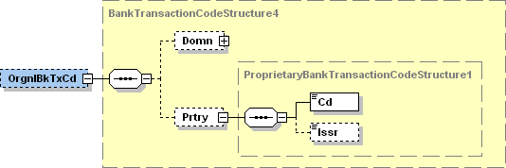

| **ISO Index** | **Item Name** | **XML Tag** | **Cardi-nality** | **Data type** | **Restrictions vs. ISO standard and additional info** |
| --- | --- | --- | --- | --- | --- |
| **2.295** | Domain | Domn | [0..1] |  |  |
| **2.300** | Proprietary | Prtry | [1..1] |  | Always present. |
| **2.301** | +Code | Cd | [1..1] | String [35] | SBA transaction code of the original transaction.  For a list of allowed values see chapter 4.3.3. |
| **2.302** | +Issuer | Issr | [1..1] | String [35] | Always present, always has the value “SBA”. |

Originator

|  |  |
| --- | --- |
| **XPath** | / Document / BkToCstmrStmt / Stmt / Ntry / NtryDtls [1] / TxDtls / RtrInf / Orgtr |

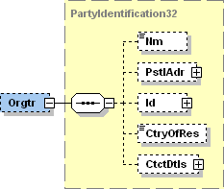

| **ISO Index** | **Item Name** | **XML Tag** | **Cardi-nality** | **Data type** | **Restrictions vs. ISO standard and additional info** |
| --- | --- | --- | --- | --- | --- |
| **9.1.0** | Name | Nm | [0..1] | String [70] | The name of the subject that initiated the R-Message. |
| **9.1.1** | PostalAddress | PstlAdr | [0..1] |  | The address of the subject that initiated the R-Message.  See chapter 3.3.5.3.1.10.2.1. |
| **9.1.12** | Identification | Id | [0..1] |  |  |
| **9.1.33** | CountryOfResidence | CtryOfRes | [0..1] | String [2] |  |
| **9.1.34** | ContactDetails | CtctDtls | [0..1] |  |  |

PostalAddress

|  |  |
| --- | --- |
| **XPath** | / Document / BkToCstmrStmt / Stmt / Ntry / NtryDtls [1] / TxDtls / RtrInf / Orgtr / PstlAdr |



| **ISO Index** | **Item Name** | **XML Tag** | **Cardi-nality** | **Data type** | **Restrictions vs. ISO standard and additional info** |
| --- | --- | --- | --- | --- | --- |
| **9.1.2** | AddressType | AdrTp | [0..1] | String Enumeration |  |
| **9.1.3** | Department | Dept | [0..1] | String [70] |  |
| **9.1.4** | SubDepartment | SubDept | [0..1] | String [70] |  |
| **9.1.5** | StreetName | StrtNm | [0..1] | String [70] |  |
| **9.1.6** | BuildingNumber | BldgNb | [0..1] | String [16] |  |
| **9.1.7** | PostCode | PstCd | [0..1] | String [16] |  |
| **9.1.8** | TownName | TwnNm | [0..1] | String [35] |  |
| **9.1.9** | CountrySubDivision | CtrySubDvsn | [0..1] | String [35] |  |
| **9.1.10** | Country | Ctry | [0..1] | String [2] | International country code according to ISO 3166-1 alpha-2.  Format [A-Z]{2,2} |
| **9.1.11** | AddressLine | AdrLine | [0..7] | String [70] | Unstructured address line. |

# External sources and appendices

## ISO 20022

### camt.053

<http://www.iso20022.org/documents/messages/camt/schemas/camt.053.001.02.zip>

### 

<http://www.iso20022.org/documents/general/b2c_camt_PaymentsMaintenance2012.zip>

### Code lists

<http://www.iso20022.org/documents/External_code_lists/ExternalCodeLists_1Q2013_7May2013_v1.xls>

<http://www.iso20022.org/documents/External_code_lists/BTC_ExternalCodeListDescription_16June09.doc>

<http://www.iso20022.org/documents/External_code_lists/BTC_Codification_24June2009.xls>

## SEPA

### SCT

[SEPA Credit Transfer Rulebook Version 6.1](http://www.europeanpaymentscouncil.eu/knowledge_bank_detail.cfm?documents_id=551)

[SEPA Credit Transfer Scheme Inter-Bank Implementation Guidelines Version 6.0](http://www.europeanpaymentscouncil.eu/knowledge_bank_detail.cfm?documents_id=536)

[SEPA Credit Transfer Scheme Customer-to-Bank Implementation Guidelines Version 6.0](http://www.europeanpaymentscouncil.eu/knowledge_bank_detail.cfm?documents_id=537)

More documentation on <http://www.europeanpaymentscouncil.eu/content.cfm?page=sepa_credit_transfer>

### SDD

[SEPA Direct Debit Core Rulebook Version 6.1](http://www.europeanpaymentscouncil.eu/knowledge_bank_detail.cfm?documents_id=553)

[SEPA Direct Debit Core Scheme Inter-Bank Implementation Guidelines Version 6.0](http://www.europeanpaymentscouncil.eu/knowledge_bank_detail.cfm?documents_id=542)

[SEPA Direct Debit Core Scheme e-Mandate Service Implementation Guidelines Version 6.0](http://www.europeanpaymentscouncil.eu/knowledge_bank_detail.cfm?documents_id=544)

More documentation on <http://www.europeanpaymentscouncil.eu/content.cfm?page=sepa_direct_debit_(sdd)>

## SK code-books

### Regulated subject identifiers

| **Identifier description** | **SchmeNm** | | **Issr** | **Id format restrictions** |
| --- | --- | --- | --- | --- |
| **Tag** | **Value** |
| **IČO** | Prtry | ICO | ORSR | [0-9]{6,8} |
| **DIČ** | Cd | TXID | DUSR |  |
| **Client ID** | Cd | BANK | *bank’s BIC-11* |  |

Table 4: Regulated identifiers of corporate subjects.

| **Identifier description** | **SchmeNm** | | **Issr** | **Id format restrictions** |
| --- | --- | --- | --- | --- |
| **Tag** | **Value** |
| **IČO** | Prtry | ICO | ORSR | [0-9]{6,8} |
| **OP** | Cd | NIDN | MVSR |  |
| **RČ** | Prtry | RC | MVSR | [0-9]{6,6}/[0-9]{1,4} |
| **Passport** | Cd | CCPT | MVSR |  |
| **Driving Licence** | Cd | DRLC | MVSR |  |
| **Client ID** | Cd | BANK | *bank’s BIC-11* |  |

Table 5: Regulated personal identifiers.

### Balance types

|  |  |
| --- | --- |
| Type | Description |
| OPBD | Ledger balance at the beginning of the specified bank date. |
| OPAV | Available balance at the beginning of the specified bank date. |
| CLBD | Ledger balance at the end of the specified bank date. |
| CLAV | Available balance at the end of the specified bank date. |
| PRCD | Closing balance at COB preceding the specified date by one reporting period (e.g. if the balance date is 30.4. and the statement reporting period is two weeks, the balance refers to COB on 15.4.). |
| ITBD | Intermediate intra-day balance on the date and time specified. Could not be used with SubType INTM. |

Table 6: Balance types.

If code INTM in <SubTp> tag is present, balance typesare defined as intermediate balances in multi-page satatement (in this case is ITBD prohibited).

### Transaction codes



## Sample statements

### A statement without pagination



### A statement divided into three parts using pagination



1. No.284/2002 of the Laws, as amended